Guidelines for Transportation Management Systems Maintenance Concept and Plans


Submitted to:
Federal Highway Administration

Contract # DTFH61-C-00048

Technical Support for ITS Initiatives
Work Order PB-F0010

Submitted by:
PB Farradyne

3200 Tower Oaks Boulevard
Rockville, MD 20852

December 2002

Notice
This document is disseminated under the sponsorship
of the Department of Transportation in the interest of
information exchange. The United States Government
assumes no liability for its contents or use thereof.

The United States Government does not endorse products
or manufacturers. Trade and manufacturers’ names appear
in this report only because they are considered essential
to the object of the document.

1. Report No.  FHWA-OP-04-011 | 2. Government Accession No. |  |  | 3. Recipient's Catalog No.
4. Title and Subtitle  Guidelines for Transportation Management Systems Maintenance Concept and Plans |  |  |  | 5. Report Date  12/31/02
6. Performing Organization Code
PB Farradyne
7. Author(s)  Mr. Cary Vick, P.E.  Mr. Roy Sumner |  |  |  | 8. Performing Organization Report No.  NA
9. Performing Organization Name and Address  PB Farradyne  3200 Tower Oaks Blvd.  Rockville, MD 20852 |  |  |  | 10. Work Unit No. (TRAIS)  PB-F0010
11. Contract or Grant No.

DTFH61-C-00048
12. Sponsoring Agency Name and Address  Federal Highway Administration  400 Seventh Street, S.W.  Washington, D.C. 20590 |  |  |  | 13. Type of Report and Period Covered  Technical Report
14. Sponsoring Agency Code
FHWA
15. Supplementary Notes

16. Abstract
This report summarizes traffic management systems maintenance practices utilized by state and local transportation Agencies, identifies lessons learned from those practices, and offers professional analysis and recommendations for development of a comprehensive traffic management system maintenance program.
17. Key Word  Transportation Systems Maintenance, TMS, Systems Maintenance, Maintenance, ITS Maintenance |  |  | 18. Distribution Statement  This document may be distributed without restriction.
19. Security Classif. (of this report)  None |  | 20. Security Classif. (of this page)  None |  |  | 21. No. of Pages  111 | 22. Price

Table of Contents
Table of Contents iv
List of Tables vii
List of Figures ix
1. Introduction 1-1
1.1. Scope of System Maintenance 1-1
1.2. Purpose 1-1
1.3. Why This Document IS Needed 1-2
1.4. Intended Audience of this Document 1-3
1.5. Definitions and Concepts 1-3
1.6. How to Use this Document 1-4
1.7. Document Organization 1-5
2. Maintenance Considerations and Activities 2-1
2.1. Introduction 2-1
2.2. What is Maintenance? 2-2
2.3. Maintenance Policies 2-3
2.4. Procuring Maintenance Services and Products 2-5
2.5. Maintenance Management System and Software 2-9
2.6. Support Services, Resources, and Tools 2-9
3. TMS Maintenance Concept & Requirements 3-1
3.1. Introduction 3-1
3.2. What is a Maintenance Concept? 3-2
3.3. Configuration Management, Traceability, and the Maintenance Concept 3-5
3.4. Sample Applications of a Maintenance Concept 3-7
3.5. Planning a Maintenance Program 3-8
3.6. Risk Management and Probability of Multiple Failures 3-11
3.7. Sample Costs 3-11
3.8. Traffic Operations and Maintenance Programs 3-12
3.9. Maintenance Measures of Performance 3-14
3.10. Design Life and MTBF 3-14
3.11. Timely Responses 3-15
3.12. Pre-Bid Meetings 3-15
3.13. Partnerships 3-16
3.14. Procedures for Control Centers 3-17
4. Maintenance Considerations for the Life-Cycle of a TMS 4-1
4.1. Introduction 4-1
4.2. Key Phases in the Life-Cycle of a Transportation Management System 4-2
4.3. Considerations for Maintenance throughout the TMS Life-Cycle 4-7
4.4. Staffing and Training Considerations 4-8
5. TMS Maintenance Program 5-1
5.1. Introduction 5-1
5.2. Introduction to Maintenance 5-1
5.3. Development of a Maintenance Program 5-3
5.4. Defining Mission and Objectives 5-5
5.5. Budgeting 5-5
5.6. Implementation Options 5-6
5.7. Maintenance Procedures 5-7
5.8. Performance Measures 5-9
5.9. Inventory, Databases and Asset Management 5-9
5.10. Managing a Maintenance Plan 5-10
5.11. Policies, Contracts, and Procedures 5-13
5.12. Coordination with Operations 5-14
6. TMC Maintenance Program: Multi-Year Plan 6-1
6.1. Introduction 6-1
6.2. The Cycle of Procurement 6-1
6.3. Lifetimes and Salvage Values 6-2
6.4. Performance Metrics and Monitoring 6-3
6.5. System Overlaps and Multi-Year Phasing 6-3
7. Maintenance Program Support Services 7-1
7.1. Introduction 7-1
7.2. Options for Contracting 7-1
7.3. Asset Management Tools 7-4
7.4. Contracting Types 7-5
7.5. Vendor Warranties and Service Agreements 7-7
7.6. Warranties and Service Agreements 7-7
7.7. Generic Contract Format 7-8
7.8. Acceptance Testing 7-8
7.9. Supplies, Tools, and Spares 7-10
8. Glossary 8-1
9. References 9-1
APPENDICES A-1
APPENDIX A: Example Trouble Reports A-1
APPENDIX B: MAINTENANCE PROCEDURES FOR ITS DEVICES B-1
Closed-Circuit Television Camera Preventive Maintenance B-1
Camera Preventive Maintenance at Pole Level — Every Six Months B-1
Camera Preventive Maintenance at Cabinet Level — Every Three Months B-1
Camera Preventive Maintenance at Control Center — Weekly B-2
Gates/Barriers System Preventive Maintenance B-2
Preventive Maintenance at the Gate Cabinet – Every Three Months B-2
Preventive Maintenance at the Gate Control Cabinet — Every Three Months B-2
Lane Control Signal Preventive Maintenance B-2
Lane Control Signal from Control Room — Weekly B-2
Lane Control Signal Local Field Control (from field) — Weekly B-2
Lane Control Signs Preventive Maintenance — Every Three Months B-3
Dynamic Message Signs (DMS) Preventive Maintenance — Annually at the Sign; Every Three Months at the Cabinet B-3
Back up Battery Assemblies — Annually B-3
Air Conditioning Unit Preventive Maintenance — Every Three Months B-3
Spread Spectrum Preventive Maintenance — Annually B-3
Ramp Meter Preventive Maintenance — Monthly B-3
Loops and Piezo Detectors Preventive Maintenance B-4
Loop Preventive Maintenance — Annually B-4
At the Cabinet Level B-4
Piezoelectric Detector Preventive Maintenance — Every Three Months B-4
APPENDIX C: GENERIC CONTRACT FORMAT C-1
CONTRACT SCOPE C-1
Contract Objectives C-1
Definitions C-1
General Requirements C-1
Form of Contract C-2
Monthly Status Meetings C-2
Equipment to Be Maintained C-3
Maintenance Procedures C-3
Record-Keeping Procedures C-4
Equipment Control C-4
Bar Code System C-5
STAFFING/MANAGEMENT PLAN C-5
Staffing Qualifications C-5
Safety Plan C-6
Utilities C-6
Contractor’s Responsibility for Utility, Property and Services C-6
Performance of the Contractor C-6
Geographic Scope C-7
Initial Equipment Inventory to be Maintained C-8
Preventive Maintenance Procedures C-8
Equipment Minimum Response Time (Hours) C-9
APPENDIX D: EXTENDED WARRANTY BETWEEN ACME INTEGRATORS AND AGENCY D-1
EQUIPMENT WARRANTY, SOFTWARE REGISTRATION, AND SERVICE MAINTENANCE CONTRACT D-2
Equipment Warranty D-2
Commercial Software Registration D-3
Traffic Control System Software Registration D-3
Service Maintenance Contract D-3

List of Tables
Table 1-1 Job Title and Suggested Chapters 1-5
Table 2-1 Contracting Procurement Issues 2-6
Table 2-2 Contracting Options 2-6
Table 2-3 Example of Inventory 2-6
Table 3-1 Steps in the System Engineering Process and Their Implications for TMS Maintenance 3-3
Table 3-3 Sample Staffing Estimate Spreadsheet 3-9
Table 3-4 Sample Annual Maintenance Costs 3-12
Table 4-1 Sample Life Expectancy of TMS Components 4-5
Table 4-2 Crosscutting Activities that Support Life-Cycle Maintenance Requirements Analysis 4-7
Table 5-1 ITS User Services for Maintenance & Construction 5-10
Table 5-2 Market Packages and Equipment Packages for Maintenance & ConstructionITS User Services for Maintenance & Construction 5-10
Table 7-1 Example of Procurement Types 7-3

List of Figures
Figure 1-1 MD CHART Traffic Management Center 1-1
Figure 1-2 INFORM Operator I-495 Long Island 1-2
Figure 2-1 VMS near Disney, Orlando Florida 2-1
Figure 2-2 Interstate-70 Glenwood Canyon, Colorado 2-3
Figure 3-1 INFORM Maintenance Crew at Work, NY 3-1
Figure 3-2 Systems Engineering Life Cycle Process 3-2
Figure 3-3 Incorporation of the Maintenance Concept into the Systems Engineering Process 3-4
Figure 3-4 Three-Year Report of Equipment Availability 3-6
Figure 3-5 Importance of Traceability and Configuration Management to the
Maintenance Concept 3-7
Figure 3-6 Lightning Causes EMP Damage Remotely 3-10
Figure 3-7 Risk Assessment Matrix 3-10
Figure 3-8 Flooding Damages ITS as well as Structures 3-10
Figure 3-9 Annual Maintenance Costs by Device Type 3-12
Figure 4-1 The System Engineering Life-Cycle Applied to an Evolutionary
System Deployment Model 4-1
Figure 4-2 Overlapping Activities 4-2
Figure 4-3 PM versus Annualized Maintenance Costs 4-8
Figure 5-1 Relationships Among Maintenance Program Components 5-3
Figure 5-2 Responsive Maintenance Process 5-8
Figure 5-3 Training Underway 5-14
Figure 6-1 Telecommunication Rack - lights indicate status 6-2
Figure 6-2 Multi-year Development Phasing 6-4
Figure 7-1 H3 Hawaii Inspection of Elevated Section 7-2
Figure 7-2 Generic Asset Management System Components 7-5
Figure 7-3 Telecommunications Tower 7-9
Figure 7-4 Multiple Potential Points of Failure 7-10
Figure 7-5 Fiber-Optic Testing, Norfolk, Virginia 7-11

Introduction

Scope of System Maintenance
Transportation Management Systems (TMS) are complex, integrated amalgamations of hardware, technologies, and processes for performing an array of functions, including data acquisition, command and control, computing, and communications. Disruptions or failures in the performance of these functions can impact traffic safety, reduce system capacity, and ultimately lead the traveling public to lose faith in the transportation network. System failures also have the potential to cause measurable economic loss and increase congestion, fuel consumption, pollutants, and traffic crashes. The problem is further complicated by the fact that today’s systems, subsystems, and components often are highly interdependent, meaning that a single malfunction can critically impact the ability of the overall systems to perform their intended functions.
System maintenance refers to a series of methodical, ongoing activities designed to minimize the occurrence of systemic failures and to mitigate their impacts when failures do occur. These activities include replacing worn components, installing updated hardware and software, tuning the systems, and anticipating and correcting potential problems and deficiencies. Maintenance includes the development and implementation of action plans for responding quickly, efficiently, and orderly to systemic failures. It also includes an infrastructure and procedures for measuring and monitoring maintenance activities.
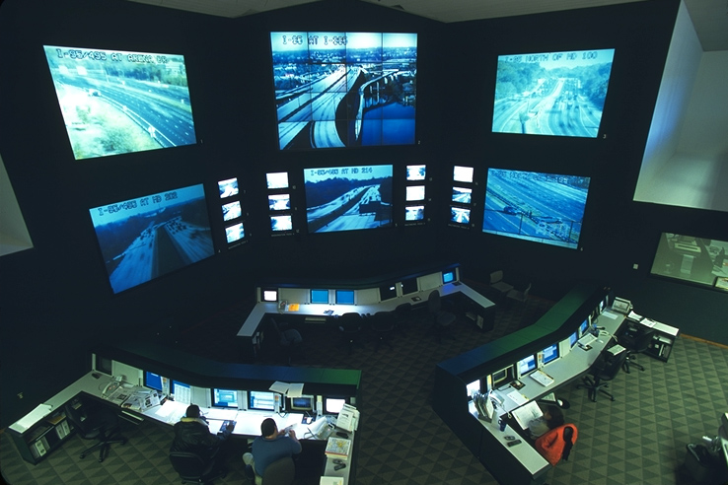
In real-world settings, TMS failures will, of course, occur. Consequently, transportation Agencies must plan for and respond to these expected failures. This requires the Agencies to anticipate and furnish the resources, capabilities, and services necessary to maintain the systems throughout their productive lives.
Figure 1-1 MD CHART Traffic Management Center
Maintenance plans should be tailored to the technologies comprising the TMS and to the level of maintenance support the Agency is capable of providing. Indeed, it is important the level of maintenance that an Agency can support be integrated from the outset into the planning process and design of the system.

Purpose
This document offers technical guidance to practitioners on (1) defining a system’s maintenance concept, (2) determining the elements to include in the concept, and (3) integrating the maintenance concept into all phases of the system life-cycle.
Currently available documents on TMS maintenance tend to focus on day-to-day issues or on specific maintenance tasks. These documents have not provided detailed information that could guide practitioners on how to systematically integrate maintenance into their program planning, resource allocation, policies, system planning and design, and other related activities that occur throughout the TMS life-cycle. This document provides this guidance and identifies:

- How to identify, justify, and document the potential components of a maintenance program. Such a program can provide the necessary resources, environment, policies, procedures, and support services needed to maintain a TMS.
Figure 1-2 INFORM Operator I-495 Long Island
Figure 1-1 MD CHART Traffic Management C 0

Figure 1-1 MD CHART Traffic Management C 0

- A multi-year maintenance program plan, including the (a) potential components, (b) processes, (c) stakeholders to be involved, and (d) resources required to support the program.
- The idea of a “maintenance concept,” the appropriate elements comprising a mainte-nance concept, how the maintenance concept can be used to develop system and functional requirements, and how the maintenance concept can be used to develop an operations concept for TMS.
- Policies, procedures, system and functional requirements, equipment, resources, and services, and other potential activities needed to maintain and support the TMS.
Examples of the sorts of concrete practitioner queries answered by this document include the following:
- How can I justify a maintenance program for my TMS?
- What types of resources (manpower, hardware, software, etc.) are needed to maintain the high technology involved in a TMS?
- What are the criteria and trade-offs for choosing whether to outsource TMS maintenance or perform the function in-house using Agency resources?
- What issues should I consider in programming maintenance resources over the multi-year life-cycle of my TMS?
- What tools or techniques are available to calculate the estimated cost of maintenance for my TMS?
This document is to be used as a technical reference manual — a resource document that provides an overview of the institutional and technical issues associated with the maintenance of a TMS. It will provide the user with a better understanding of the considerations required to develop a multi-year maintenance program for TMS. For many of the technical issues, excellent reference materials exist that provide detailed information, in more of a “how-to” format. These materials are referenced throughout the document.
This document summarizes, at a high level, the problems, challenges, and barriers that Agencies are facing. These barriers include lack of commitment, shortage of resources, and dearth of knowledge regarding tools and techniques for securing and allocating scarce maintenance resources throughout the TMS life-cycle.

Why This Document IS Needed
The practice and procedures related to capital expenditures for TMS construction and implementation have been standardized around the Federal rules and regulations regarding transportation funding. This is because of the very large role that Federal funding takes in capital spending for transportation. Until recently, however, Federal funding for operations and maintenance has been a relatively small proportion of the total expenditures. One consequence of this low-level Federal involvement in operations and maintenance (O&M) has been a lack of standardized approaches to performing and funding O&M activities. A 1997 National Cooperative Highway Research Program (NCHRP) study that addressed O&M issues received organizational charts from 42 Agencies outlining each Agency structure. No two organizations were alike.
Widely cited research in this area includes the following:
- Traffic Signal Control Systems Maintenance Management Practices, NCHRP Synthesis of Highway Practice 245, 1997.
- Transportation Management Center Functions, NCHRP Project 20-5, January 1999.
- A Recommended Practice for Operations & Management of Intelligent Transportation Systems, ITE, March 1999.
- Traffic Signal Installation and Maintenance Manual, ITE, February 1999.
- Guidelines for Funding Operations and Maintenance of Intelligent Transportation Systems/ Advanced Traffic Management Systems, Transportation Research Record 1588, Paper No. 971390.
- Institute of Transportation Engineers Handbook, Traffic Control System Operations — Installation, Management and Maintenance, 2000.
This report builds on the research and recommendations developed in the referenced materials. Detailed examples are provided, as appropriate, as well as specific references to supporting documentation from the literature research.

Intended Audience of this Document
This document is targeted at Federal, State, and local practitioners involved in the implementation, operation, or maintenance of a TMS. The intended audience includes public and private stakeholders with direct or indirect TMS involvement. The managers, supervisors, engineers, planners, technicians, etc. involved in the development and operation of a TMS will find guidance and recommendations in this document for maintaining the system.
This document is also intended to provide information to those practitioners developing a maintenance plan. It builds on the experiences of maintenance organizations that have had to keep equipment operating without benefit of standard guidelines document or operating procedures.

Definitions and Concepts
In this document, use of the term “Transportation Management System (TMS)” refers to an integrated system that includes the Transportation Management Center (TMC), the computer and other automated components, field devices and other peripherals, and the communications infrastructure. The term “TMC” will be used only when discussing the center and/or its contents.
Other terms will be standardized, primarily as an attempt to bring consistency to the practice of TMS maintenance, but, secondarily, to simplify the reading of this document. Take, for example, the term “maintenance model.” This term means something completely different to at least two States and, in both cases, has crosscutting implications for development of a maintenance program.
In Arizona, a 1998 report (Ref. 1) documented the Arizona DOT’s enhancement of its Performance Controlled System (PECOS), a highway maintenance management system, into a tool that could also model the costs associated with the State’s intelligent transportation infrastructure (ITI). In this case, the “maintenance model” referred to a model of the costs associated with maintaining and repairing ITI (also known as TMS) elements.
In contrast, in Oregon, the Western Transportation Institute prepared a very detailed ITS Maintenance Plan in 1999 (Ref. 2). In this report, one of the key issues identified for the Oregon DOT was the need to standardize its “maintenance model” for dealing with ITS elements. In this case, the “model” referred to the sequence of events and procedures for dealing with maintenance (i.e., how system or device failures were reported, who responded, priorities, etc.).
Both of the “maintenance models” described in this example are important parts of developing a maintenance program. Each model, however, describes a different concept. It is, therefore, the practice of this report to discuss technical issues as generically as possible and to minimize the use of terms or jargon that might be misunderstood.
Several key terms used in this report are defined below. Additional terms are presented in the Glossary.
TMC (Transportation Management Center): The building or room where monitoring, command, and control of automated systems, field devices, and/or external information feeds is conducted.
TMS (Transportation Management System): The integrated system that includes the TMC, the computer and other automated components, field devices and other peripherals, and the communications infrastructure.
Maintenance Plan: A documented plan defining a detailed approach to system maintenance. It describes application of the maintenance program to a specific system or set of systems. It typically identifies the maintenance activities, priorities, timetables, and resource commitments and expenditures.
Maintenance Program: Identifies an organization’s general approach to system maintenance. It includes the organizational structure and funding support needed to implement the program.
Maintenance Activity: The sequence of actions needed to conduct preventive, periodic, or repair maintenance on a device or subsystem. Typically refers to a specific component (e.g., camera) or subsystem (e.g., computer network).
Operational Concept: Also known as “concept of operations” (or ConOps), it defines the environment in which the TMS will operate. The environment includes the relationship between the system and the Agency’s responsibilities, the physical environment, and expectations (performance and life).
Maintenance Concept: Defines the level-of-effort necessary to maintain system availability, reliability, and the functionality necessary to fulfill the operational concept.
Responsive Maintenance: The repair or replacement of failed equipment and its restoration to safe, normal operation. Typically unscheduled, it is in response to an unexpected failure or damage.
Preventive Maintenance: Also called “routine” maintenance, it is the activity performed at regularly scheduled intervals for the upkeep of equipment. Includes checking, testing and inspecting, recordkeeping, cleaning, and periodic replacement when called for in the preventive maintenance schedule.
Emergency Maintenance: Emergency maintenance is similar to responsive maintenance in that it is initiated by a fault or trouble report. However, in this case, the fault is more serious and requires immediate action. Events such as knockdowns, spills, exposed electrical wires, road blockages, etc. are examples of event reports that may require emergency maintenance. Of course, there can also be operational emergencies — e.g., stuck barriers on dedicated HOV lanes or failed lane control signs —that need to be dealt with quickly in order to minimize hazardous circumstances.

How to Use this Document
This is a resource guide for practitioners in a range of job categories. In most instances, practitioners will not need to read the entire document, but can simply refer to those sections of the report containing materials relevant to their assignments. Table 1-1 identifies representative job titles or descriptions, followed by a list of the chapters or sections associated with the job categories. Study the pertinent chapters or sections. Then use the remainder of the document as a resource guide, which can be consulted as needed.

Table 1-1 Job Title and Suggested Chapters
Position or Job Title | Suggested Chapter(s) and/or Section(s) in this Document
Administrator, DOT Secretary | Chapters 2, 3, and 7
Program Director, Program Manager | Chapters 2, 3, and 7
Project Manager | Chapters 2, 3, 4, and 5
Transportation Engineer | Chapters 2, 3, 4, and 5
Communication Engineer | Chapters 3. 4, 5, and Glossary
Maintenance Supervisor/Foreman | Chapters 5, 6 7, and Glossary
Shift Supervisor | Chapters 5, 6, 7, and Glossary
System Operator, Dispatcher | Chapters 5, 6, 7, and Glossary

Document Organization
The remaining chapters in this guide are listed below, along with the major topics discussed in each chapter:
2. Maintenance Considerations & Activities
An overview of what needs to be included in maintenance activities. Several examples are provided along with references to additional detail on key aspects of maintenance.
- Key Definitions & Terminology
- Maintenance Types/Procedures/Practices
- Maintenance Requirements
- Maintenance Costs
- Agency Organizational Structures for Maintenance
3. Maintenance Concept & Requirements
Introduction and description of the maintenance concept and how this can be used to develop detailed maintenance requirements. These maintenance requirements can and should be used as part of the design process, but can also be used in other phases of the project life-cycle.
- What is a Maintenance Concept?
- Linkage to Operational Concept
- Linkage to System Functional Requirements
- Inputs & Outputs of a Maintenance Concept
4. Maintenance Considerations for the Life-Cycle of TMC
Expanding on the maintenance concept, how traceability from the operational concept to system performance can be used to continually evaluate maintenance needs.
- Key Phases in a TMC Life-Cycle
- System Engineering Process
- Crosscutting Activities throughout the Life-Cycle
- Performance Metrics & Monitoring
5. TMC Maintenance Program Guidelines
A listing and discussion of the activities and factors to be considered in the development of a formal maintenance program.
- Definition of a Maintenance Program
- Range of Activities to be Included (Minimum, Recommended, Optional)
- Mission & Objective of Program
- Strategies for Implementation
6. TMC Maintenance Program Planning — Multi-Year Considerations
Expanding on the basic guidelines for a maintenance program, there are special considerations for long-term viability and effectiveness of a TMS. This section addresses the life-cycle of a TMS, including system expansion, evolution, and eventual replacement.
- Program Planning Practices & Procedures
- Relationship between Maintenance Program and Operations Program
- Strategies for Long-Term Funding & Support
7. Maintenance Program Support — Tools & Techniques
Maintenance management and analysis tools to help justify and optimize the allocation of resources. Key performance indicators that can be used to maintain program accountability.
- Maintenance Management Systems
- Configuration Management/Traceability
- Maintenance Contracts & Procurement Issues
- Performance Monitoring/Evaluation
8. Glossary
9. References

Maintenance Considerations and Activities

Introduction
This chapter provides an overview of the issues and activities associated with the maintenance of traffic management centers and the ITS devices they control. It introduces the topic and examines various aspects of maintenance and how an Agency might plan maintenance to ensure operational effectiveness as the TMS is used in the future.
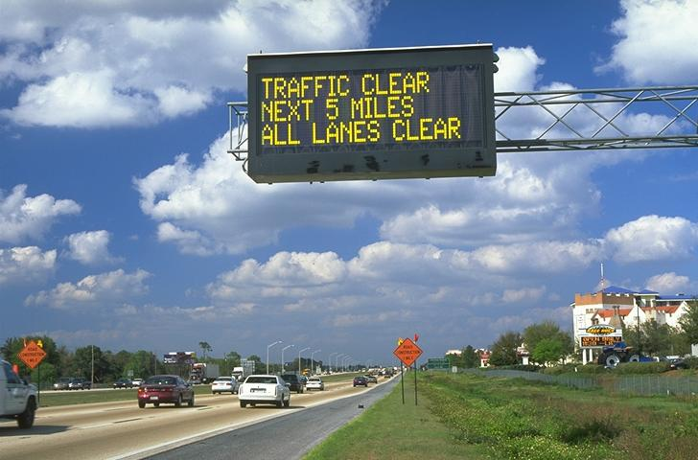
The dictionary definition of maintenance is: “the upkeep of property or equipment.” There are a range of TMS components that require upkeep. These fall into three categories: control central, roadside, and communications. From a maintenance viewpoint, these categories make sense in that the work at the roadside requires differing equipment, techniques, procedures, and skills that are typically required at control central. Note that the communications system requires a different set of skills, unique from the others.
Figure 2-1 VMS Near Disney, Orlando Florida
The property or equipment in a TMS that needs some form of maintenance includes, but is not limited to, the following:
Control Center
- Power supply, generators, batteries, and related equipment
- Video displays
- Internal communication networks
- Computer hardware
- Computer software
- Control systems
- Weather systems
- Other COTS products
- Media connections
- Web sites
Roadside
- Closed Circuit Television (CCTV)
- Dynamic Message Signs (DMS)
- Lane Control Signal
- Ramp Meter
- Vehicle detectors
- Inductive Loops
- Piezoelectric detectors
- Radar Detectors
- Vehicle Classification System
- Remote Control Gates
- Blank Out Signs
Communications
- Multimode Fiber-optic cable plant
- Single mode Fiber-Optic cable Plant
- Coaxial Cable Plant
- Coaxial cable Plant
- Twisted Pair
- Nodes/Hubs
This chapter describes the various types of maintenance, their requirements and the support activities that are needed. It describes how a maintenance plan can be developed and how maintenance services can be procured. It also discusses staffing estimates and describes the maintenance procedures for both central and roadside devices.
The maintenance needs for ITS devices are very diverse. Because the range of potential maintenance actions is so broad, a wide variety of expertise and skills is required. A listing of preventive maintenance actions by device type is included in Appendix B. These detailed actions for each ITS device are typical examples. The various devices from differing manufacturers may have other maintenance requirements. The author of a maintenance plan should start with the manufacturer’s procedures to ensure that needs of the particular equipment are satisfied and that any warranties are kept valid.
The maintenance concept is designed to articulate the essential reliability and performance measures necessary to meet stated operational concepts. Just as the concept of operations drives the system functional requirements, the maintenance concept drives the Maintenance Requirements. The use of concepts as part of the guidelines development is contained in Chapter 3, TMS Maintenance Concept & Requirements.
The development of a maintenance plan includes design and implementation procedures it is also life-cycle process. It needs to recognize that most systems are built incrementally and are expanded over time. Expansion can be both functional and geographical, both of which impact that maintenance planning. There is a need to provide feedback and assessment of the maintenance operations with each incremental deployment phase so that future phases build on and expand the system, rather than simply replace elements of the earlier phases. The development of maintenance plans within the life-cycle of the system in expanded upon in Chapter 4, Maintenance Considerations for the Life-Cycle of a TMC.
A maintenance program provides a plan on what maintenance is, how it is performed, how it can be budgeted, and why it is needed. It is a document that describes the needs to persons outside the direct department with maintenance responsibilities and provides guidance to those within that department. Chapter 5 describes the development of a TMS maintenance program. It defines maintenance program planning, including objective, institutional issues and implementation procedures. This Chapter also describes the relationship with operations programs.

What is Maintenance?
Maintenance is essential to keeping a TMS running in the manner for which it was designed. Lack of maintenance leads, almost inevitably, to escalating decline. Just as not painting a wooden house can lead to expensive structural damage, lack of TMS maintenance has severe consequences. In one location, lack of maintenance of the communications structure caused so many cameras to stop working that the program for video monitoring was abandoned and the investment lost. In another location, lack of maintenance of roadside emergency telephones was so poor that the majority did not work. This resulted in such negative public outcry that the system had to be abandoned.
Most maintenance activities can be grouped into one of three categories: preventive, responsive, and emergency.
Preventive maintenance consists of scheduled operations performed to keep the systems operating. Preventive maintenance includes mundane operations, such as cleaning camera housing faces and the front of DMS. It can include mechanical functions, such as greasing barriers for tollbooths and ramp control. In some cases, preventive maintenance requires sophisticated technology, such as optical testing equipment to ensure that the fiber-optic used in the communications system is operating within acceptable parameters. Preventive maintenance is initiated by a schedule.
Responsive maintenance refers to operations that are initiated by a fault or trouble report. The report can come either from a person or from software that is monitoring parts of the system. Most general faults fall into the responsive maintenance category. The table in Appendix A shows a list of typical trouble calls from the control center in Northern Virginia. Most of these calls are responded to by the maintenance crews within a few hours. However, some faults can require days or weeks to repair. Problems can occur in securing new parts, e.g., when new power connections are needed from the local utility company, etc.
Emergency maintenance is similar to responsive maintenance in that it is initiated by a fault or trouble report. However, in this case, the fault is more serious and requires immediate action. Events such as knockdowns, spills, exposed power supplies, and road blockages are clear examples of reports that may require emergency maintenance. There can also be operational emergencies, such as stuck barriers on dedicated HOV lanes or failed lane control signs, such as those indicating shoulder usage. These sorts of conditions often constitute emergencies that need to be dealt with quickly in order not to create additional hazards.
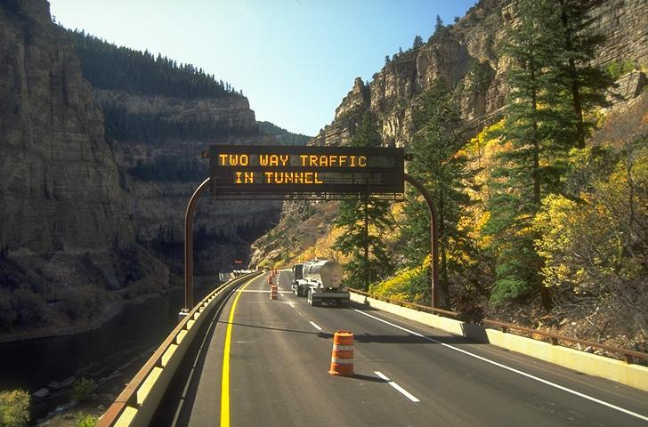
Agencies, when developing a maintenance program, should plan for each set of maintenance conditions. The various types of actions that the maintenance staff provides should be categorized to ensure the most efficient use of resources. To have staff or contractors available on a permanent basis is an expensive option. Typically, preventive maintenance is undertaken “loosely” as scheduled and responsive maintenance is performed as needed. Emergency maintenance nearly always takes precedent.
Figure 2-2 Interstate 70, Glenwood Canyon, Colorado

Maintenance Policies
Although most public Agencies do not have formal policies concerning maintenance of their TMS, there are some policy issues that need to be considered in the design of a maintenance system. The first is creating a balance between preventive and responsive maintenance. More preventive maintenance will cause the equipment to be in a better state of repair, meaning it will likely break down less often, thus requiring less responsive maintenance. Consequently, it is generally judicious for an Agency to select preventive maintenance as its priority. This approach is supported by evidence indicating that to rely solely on responsive maintenance (i.e., waiting for things to break) is not good policy. After all, malfunctions are generally first noticed when a device is used, which is the worst time to detect a failure.
In cases where there are very large numbers of devices, it may be judicious to adopt a policy stating what percentage of specific devices should be operable. Although it is desirable to have all devices fully functional, in some cases there are inadequate resources to achieve this state. Examples could include the number of operating loops or the numbers of bulbs that need changing. Such policies can assist the maintenance staff in their scheduling efforts.
In general, an Agency’s maintenance policies should be comprehensive and compatible with the broader policies of the Agency and its traffic program generally. Obviously, a traffic operation that is mission critical should receive greater maintenance priority than should a trivial system. For instance, barriers and gates associated with high occupancy vehicle (HOV) entries or various other flow control mechanisms should be given high priority. For these and other systems containing similar devices, there needs to be a contingency for the event of control failure.
For example, if a system has a series of barriers and signs that control the direction of flow on an HOV facility and the control system fails, it is unacceptable — and dangerous — for the facility to remain inoperative while programmers are trying to restart the control system. A suitable maintenance policy would mandate back operations that, firstly, ensure safety and, secondly, allow the facility to operate without a control system. This is typically accomplished by a technician physically driving through the system and manually closing the gates and setting the appropriate signs. Later, he or she reverses the procedure to open the facility in the opposite direction.
Other facilities, such as tolled elements, may wish to allocate other priorities, e.g., revenue collection. The original design for the Oakland Bay Bridge control system was based on a flow-and-revenue maximizing routine using micro-loops on the top of the bridge to control the signals at the access point. From a maintenance perspective, the priority in the Singapore electronic road pricing (ERP) system places a large premium on maintenance of revenue. The control equipment is housed in a series of small air-conditioned buildings throughout the controlled part of the network. The air conditioners are not always reliable — temperature monitors close down the ERP when the air conditioners fail. Their policy is to maximize revenue and thus backup air conditioners are used to keep the ERP operational. Backups, various levels of redundancy can all be used to support the policy mandated for the system. These often express themselves as graceful degradation as part of the reduced operations as systems fail. However, such operational processes need to have the equipment maintained and, most importantly, be regularly checked by exercising the components that come into play during a failure mode.
Other elements that may be adopted as policy issues include:
- Allowing supervisors a credit limit and access to funds that can be used during a crisis. For example, the purchase of a new computer peripheral or the replacement of failed wiring cannot wait for the formal budgetary allocation process.
- Limiting access to the equipment and spares by staff above a certain level in the organization. This usually requires a closed area inside a maintenance workshop where valuable items are stored.
- Not allowing direct connection to the control system network by external applications.
- Keeping virus detection software current.
- Developing a policy for the sharing (or not) of traffic and video data (see http://ops.fhwa.dot.gov/Travel/App2VDOT.htm for a sample policy from the Virginia Department of Transportation).
- Defining the length and form of passwords and mandating how often they change.
- Ensuring that physical access to the control center is limited to authorized individuals.
- Changing passwords and access codes whenever employees depart.
- Policies on privacy.
- Policies on Internet access.
- Only allowing data on the network to get to the web via a firewall.
- Applying minimum qualification standards to employees empowered to perform specific tasks. (In addition to individual expertise requirements for technical tasks, drivers should be trained in the safety elements associated with stopping and working on the roadway shoulders.)
Quality-control programs are also tools that can be used within a maintenance program. The large systems that depend on traceability, such as ISO 9000, are probably not suitable for a maintenance department. However, Agencies could, as a matter of policy, adopt a range of quality control procedures that would enhance their maintenance programs. These would need to be adapted to each Agency’s services but could include such items as:
- Inspection and testing of all incoming goods.
- Defined procedures related to storage and rotation of goods to minimize shelf times.
- Bar-coding and tracking inventory.
- Recordkeeping to determine patterns of failures in components.
- Applying quality-control criteria to subcontractors and vendors.
Any maintenance policy should be developed within the framework of all the other policies that are in operation by the Agency. Several of the broader policy issues mentioned above are common in many State Departments of Transportation. Existing policies should be reviewed in light of the operations of a maintenance program. For example, some states have policies relating to working above moving traffic (say, a requirement that all tools and removable devices be tethered when no safety net is present). This type of policy affects the design of installed devices, the tools the maintenance crew uses, and the procedures that take place during maintenance tasks.
Maintenance policies should be regularly reviewed and made part of the maintenance program and incorporated into employee training.

Procuring Maintenance Services and Products
A continuing problem for many government Agencies is recruiting and retaining personnel that possess the skills necessary to operate and maintain the sophisticated hardware associated with computer-based traffic systems. Proper maintenance of systems can require salary schedules higher than typical maintenance or electrician rates, which Agencies are often unable to pay. Accordingly, some Agencies have determined that the best alternate is to use outside contractors. These contractors can also be hired to supplement regular staff and to stock specialized spare parts during emergencies.
In some cases the Agency may have restrictions on hiring new staff. This usually means that the maintenance must be outsourced to an independent third-party company. States tend to be familiar with this process as it is often used for less technological work such as mowing, restriping, or bulb changing. Thus maintenance contracts are frequently in place, which allows TMS maintenance to be procured. However, TMS maintenance is different in that there is a range of technical skills that are not readily available. Furthermore, it is frequently the case that TMS maintenance needs to be performed in a more timely manner then responding to emergency maintenance calls. This requirement to respond within a prescribed number of hours is not common in more routine maintenance operations.
Another aspect of the procurement of maintenance is whether it is the control center, the roadside equipment, or the communications system for which plans are being prepared. Maintenance of the control center often requires unique software skills that force the Agency to use either the developer or another equally adept company to do the work to keep the system operational. Similarly, the communications network has a unique requirement for technical equipment for fault finding and repair of fiber-optic networks. Roadside maintenance operations require another set of hardware, such as bucket trucks and traffic diversion equipment. Therefore the Agency, when contemplating maintenance, may consider a combination of contracting and Agency personnel to address all aspects of the TMS. The table, below, summarizes some of these issues.
Some Agencies split the maintenance operations along the lines suggested in Table 2-1. For instance, it is fairly common to contract out the communications system on an as-needed basis. This makes sense as there are no required preventive maintenance procedures associated with fiber-optic networks. They either work or they are broken and to keep a technically qualified employee waiting for a communications failure is not a good use of resources.
It is rare, but there are examples of state Agencies keeping programming staff as full-time employees to develop and maintain control systems. Although this gives an Agency greater flexibility to make changes and monitor the work of contractors, the state is vulnerable if the employee resigns — this can be a significant problem when such skills command high wages during technology booms. Additionally, it is sometimes difficult to find a career path within an Agency for an employee who is operating in an area often staffed by younger persons who have recently learned the latest technology. Although assistance in software development has its advantages, it can be considered to be more advantageous for Agencies to use their limited maintenance staff resources in other arenas.

Table 2-1 Contracting Procurement Issues
TMS Category | Agency |  | Contractor
TMS Category | Pros | Cons | Pros | Cons
Control Center | In-house system skills remove dependencies on possibly unstable businesses. Gives career path to employees. | Difficult to keep and reward competent programming staff. Long hours not popular. | Already has system knowledge and can more readily deal with software bugs. Wider skill range. Not subject to union restrictions. More flexibility in staffing choices. | Expensive. However, true cost comparisons need to include all costs, pensions, benefits, etc.
Roadside | Agency often owns much of the needed equipment. Can coordinate schedules with other Agencies. | Requires a staff increase sometimes institutionally unacceptable. Private contractors can be more responsive. | Reduces Agency staff needs. Provides wider range of skills. Can more readily operate outside of office hours. | Pricey and the Agency can loose some control over job priorities. Contractor needs real estate and plant.
Communications | In-house skills provide more job satisfaction for Agency employees | Difficult to keep and reward competent staff. Specialized equipment, expensive and little used. | Has system knowledge and likely to be more timely in response. Can rent specialized services and equipment quickly. | Expensive.

When deciding whether to contract out maintenance and, if so, which elements to outsource, the following should be considered:
- What level of staffing is required in each area?
- Does the Agency wish to purchase and operate the required equipment?
- What skill level is available from in-house staff and what level can the Agency afford to employ?
- If outsourced, does the Agency have the right people to manage a contractor?
There are several ways in which the Agency can slice the maintenance pie. The slices can be central, roadside, or communications. It can also be preventive, responsive, or emergency. Any combination of these options can be contracted out or performed by Agency staff. Each Agency will need to consider how the maintenance of these elements can best be performed for its circumstances.

Table 2-2 Contracting Options
 | Central | Roadside | Communications
Preventive | ? | ? | ?
Responsive | ? | ? | ?
Emergency | ? | ? | ?

An alternative approach is to attach maintenance requirements to the initial contract to purchase the goods or services. This is particularly applicable for the case of the central software where, although the Agency may have all the source code and the build environment, it may lack the software maintenance skills. Also, even if the Agency has the required skills, it will take considerable time for the staff to become familiar with the detailed design of the software. However, if the TMS installation is considered successful, the addition of more ITS devices of a similar type to those already installed should not require the programming expertise. In this case, the modifications need to be database entries that can be performed by non-programmers.
The use of extended maintenance agreements with the contractor or vendor can be problematic. In one case, a low-bidding vendor front-end loaded all the maintenance costs. By the time the maintenance period occurred, the vendor had gone out of business and the Agency had almost no money left to pay for maintenance by other vendors. To avoid this problem, the costs for maintenance need to be expressed in the scope of work as some percentage of the item costs that is large enough to ensure that the contractor will stay around to maintain the system. In one instance, the maintenance contractor was paid a fixed monthly amount for maintaining a series of traffic signals. Each month the signals were inspected for correct operation and the maintenance contractor was paid its maintenance fee proportional to the percent of equipment operating correctly. Thus the maintenance contractor routinely conducted its own inspection and ensured that everything was operating correctly prior to the Agency’s inspection.
Management of contractors that are working on the preventive maintenance tasks has caused concern for some Agencies. Various Agencies can have huge numbers of devices spread over several hundred miles of road. Field inspection and verification of work completed is not always feasible. There is a need to keep track of the contractor, at least on some type of sampling basis, rather than wait for the monthly invoice to arrive and hope the work has been done. When structuring such maintenance contracts, it is advisable to require recordkeeping procedures ensuring that invoices can be verified against the work performed.
One method for solving this problem when responsive maintenance actions are involved is to require the contractor to record pertinent data on a control center database. The following types of data may be recorded:
- Date and time of failure report,
- Person or source of the report,
- Location of device,
- Description of failure or symptom,
- Name of person responding,
- Arrival time at location of reported failure,
- State of the equipment upon arrival,
- Weather and condition of the site,
- Actions taken,
- Date and time of rectification,
- Equipment inventory updates, and
- Consequential events (e.g., failure to operate or secondary failure).
Keeping the data current and available at the TMC allows the Agency to be prepared when claims are made and also permits tracking and control of inventory. An important maintenance activity is the prediction of failures and retention of spare parts. Ensuring that the contractor keeps this data up-to-date will facilitate these processes.
In the case of preventive maintenance, management of the contractor needs to be more flexible, since often the same crews are used. When no response calls are pending, the crews perform preventive maintenance, but are immediately reassigned when trouble reports are received. One solution is to allow the contractor remote access to the maintenance PC in the control center in order to log the next day’s activities into the system. This makes the operators in the control center aware of the current activities. Since cleaning and repairs can be disruptive of traffic, coordination with the system operations staff should be a requirement. Another requirement should be to ensure voice communications between the operators and the crews at the roadside. This is important for both operational and safety reasons. Maintenance crews at the roadside can, for example, confirm that barriers rise and fall or that signs show the right messages.
Other examples of extended maintenance include Agencies paying fairly significant annual payments for hardware, in this case LED message signs that never failed and never had any maintenance performed. Thus an Agency contemplating maintenance contracts needs to anticipate the likely frequency of trouble calls and structure the contract differently for items likely to need little service.
When an Agency is structuring a maintenance contract for TMS elements, it should consider additional elements apart from the performance of preventive, responsive, or emergency maintenance. For example, a contract that is structured to maintain roadside devices needs to take into account inventory control and possibly the bar-coding of devices. Contracts to maintain the central software should address configuration management, back-up procedures, and disaster recovery. Addressing these types of issues will both structure the maintenance contracts and provide Agencies with a more integrated approach that is reflective of the complexity of the TMS components.
Outside contractors have been used successfully for operations and maintenance of traffic systems. For example, the New York State Department of Transportation has used outside contractors for operations and maintenance of INFORM since the inception of the system. Similarly, the Connecticut Department of Transportation uses outside contractors for operations and maintenance of its I-95 Incident Management System.
The contracting mechanism for many of the more sophisticated items, such as computer motherboards, hard drives, signal and DMS controllers, and communications equipment, is to require replacement under warranty for the first few years and then merely send the equipment back to the vendor for repair and replacement as-needed. This approach makes sense since much of this equipment is reliable, requires no preventive maintenance, and most of the units will work for years without a problem. However, this approach does rely on the equipment manufacturer to remain in business and, therefore, it is advisable to add a longevity criterion to the procurement terms. In other words, the supplier should be required to certify that it has been in this business for some minimum number of years and/or that more than a specified number of units have been installed. This approach also creates a need for a larger spare parts inventory to give the Agency more time to recover when a particular product no longer is available.
The types of contracting options that exist and which ones to consider for the various options are described in Chapter 7.
An Agency assessment will be needed to identify the capabilities, services required to support all maintenance activities, and the tasks to support the maintenance program. For example, if it is required that 95 percent of all detectors should be operable at any one time, then this can be used in the assessment of whether this particular component should be contracted out or performed by in-house staff. There is a wide variation in these elements of a maintenance program. To develop a framework to assist the Agency in deciding to contract out each of the nine elements in the table, above, criteria conforming to the Agency’s maintenance vision must be established. Stating that all the devices must work all the time does not help. Setting unrealistic goals will not assist the decision process. The reality is that many detectors are not working at any one time. Communications systems regularly fail and software hangs up. Within each contracting option a level needs to be determined that can be met both by a contractor and the Agency staff. When this is known, the decision concerning the best option to meet the maintenance program objectives can be made.

Maintenance Management System and Software
Maintenance software applications can be of particular value to TMS operations. The ranges of functions they can perform include:
- Maintaining equipment inventories across warehouses, shops, and sites.
- Recording trouble calls and repairs regarding equipment in the maintenance system.
- Recording technician information pertaining to trouble calls and equipment repairs.
- Accessing logged information regarding equipment movement and repair information.
- Generating reports to show reliability metrics on equipment in the system, such as the MTBF
discussed in this report.
- Transferring data from a bar-code scanner into the maintenance database tables.
- Managing all information and making corrections where appropriate.
Such software applications provide a series of screens that allow the operator to enter and view the current status of trouble calls and to view which ones are currently open. By using the repair data, comparisons can be made between equipment types, such as whether one camera manufacturer requires more repairs than another. These applications can hold inventory data and accept bar-code inputs. They provide location information for users. As systems grow, the number of devices that must be maintained can get quite large. The table, below, illustrates an approximate device count for the Northern Virginia Smart Traffic Center of VDOT in 2001. As shown, the number of devices is significant and knowing their location can become a problem. Devices move for a variety of reasons. The site can be abandoned; it can disappear as part of reconstruction or a maintenance activity. Equipment gets moved as repairs are made. In some cases, components of old equipment are used to repair other devices. Some Agencies have what is known as portable/permanent variable message signs (VMS). These are portable VMS’s that are installed on a concrete pad with power and are used in that location during a seasonal period, e.g., to direct beach traffic. Knowing where everything is becomes a problem that can be addressed by some combination of inventory control software.

Support Services, Resources, and Tools
Support for the maintenance staff needs to include a variety of service resources and tools including administration, space, inventory storage, parking, and a variety of testing equipment.
Table 2-3 Example of Inventory
The administration/support requirements for mainte-nance include staff hours to log actions that are taken, update inventory, keep track of contractor invoices, purchase orders, ensuring that training is performed, and making certain that responsive and emergency maintenance requests are addressed in a timely manner. In addition, if the maintenance is contracted, support is required to check invoices and monitor contractor performance.
Device | Quantity
Cameras | 110
DMS | 203
Lane Control Signal | 31
Ramp Meter | 25
170 Controller | 161
Classification site | 23
Remote Control Gate | 150
Inductive Loops | 1500+
Piezo Electric | 500
Blank Out Signs | 29
Space is required in a secure environment to keep inventory. The value of 5-10 percent of the total installed hardware can be significant. Access to inventory may require some form of control. Space is also required for maintenance staff offices and for parking the maintenance vehicles that are likely to include a range of trucks and a cherry picker.
The specific tools required, in addition to the more obvious common tools used by technicians in workshops, could include:
- Optical Time Domain Reflectometers (OTDR),
- Oscilloscopes,
- Spectrum Analyzers,
- Network Analyzers,
- Waveform Generators,
- Sweep Generators,
- Frequency Counters,
- Multi-Meters,
- Inductance Meters, and
- Power Meters.

TMS Maintenance Concept & Requirements

Introduction
As defined previously, responsive maintenance is the repair or replacement of failed equipment and its restoration to safe, normal operation. Preventive maintenance is the activity performed at regularly scheduled intervals for the upkeep of equipment.
This chapter provides an introduction and overview of a maintenance concept and the linkage and traceability of the TMS maintenance concept to the Operational Concept for the TMS. The idea of a maintenance concept and a resulting set of maintenance requirements build on the proven Systems Engineering approach. The systems engineering approach is recommended as the preferred method for developing ITS projects with FHWA’s Rule 940 (Ref. 3). Systems engineering is a structured technique for thinking about systems development and begins with a concept of operations. A “concept of operations” summarizes what the system is supposed to accomplish and under what conditions it will be done. From this concept, a set of requirements can be developed. It is these requirements that drive the rest of system design and implementation.
A “concept of operations” is designed to articulate the vision, roles and responsibilities, practices, and procedures to be realized in a TMS. Likewise, the “maintenance concept” is designed to articulate the essential reliability and performance measures necessary to meet stated operational concepts. Just as the concept of operations drives the system functional requirements, the maintenance concept drives the Maintenance Requirements. These maintenance requirements then become enabling requirements for input into the system design phase and other implementation and operation phases in the TMS life- cycle.
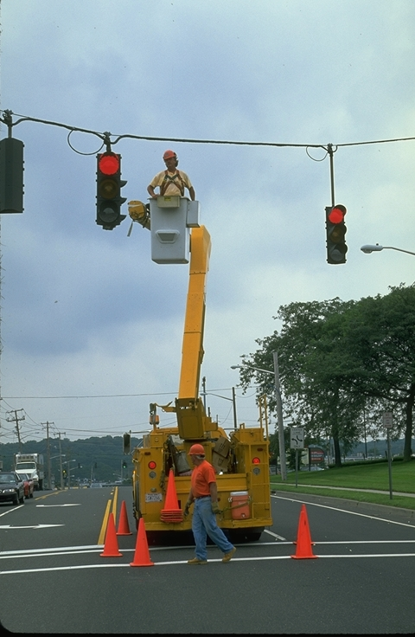
Several references from the literature research offer suggestions for maintenance programs, such as setting goals and objectives for a maintenance plan. Often, measures of performance are used to set maintenance levels or even as the basis for maintenance budgeting. These are very useful techniques; however, this approach can sometimes miss the bigger picture. For example, a maintenance goal of keeping 95 percent of all CCTV cameras available at all times does not answer the bigger picture of why are CCTV cameras needed in the first place, since there is no traceability back to the original concept of operations.
Figure 3-1 INFORM Maintenance Crew at Work, NY
The main impetus for recommending a structured systems engineering approach for ITS project development was the need to improve the chances of success. Without a structured systems approach, ITS success stories, unfortunately, have not been a common occurrence. The systems engineering approach was originally developed in the aerospace industry in the 1960’s to combat an alarming failure rate for large, complex missile and space programs. The systems engineering process does not guarantee success, but it has certainly improved the chances of getting there.
The systems engineering approach can also reduce costs. Another way of describing systems engineering is that it is a “requirements driven development process.” That is, user requirements are the overriding determinant of systems design, component selection, and implementation. There should be no “gold plating” and you only pay for what you really need.
As stated earlier, there are precious few funds available for TMS maintenance. Any funding that may be allocated is done so only after a significant level of justification. Once allocated, most Agencies must be very judicious in spending their maintenance funds and often worry about how to set priorities so as to not overspend in one area at the expense of another. Thus, the maintenance concept is a central element of any maintenance plan or program. The maintenance concept imposes a structured approach to the development of maintenance requirements that is traceable back to an operational concept.
This chapter details the maintenance concept and parallel activities in the systems engineering process. The main objective of this chapter is to introduce and describe a relatively new process that is designed to overlay and parallel the basic systems engineering process. The steps in the maintenance concept development process are described in enough detail to allow application to a wide range of systems. An example is provided to illustrate a particular application of the maintenance concept to develop, justify, and estimate maintenance requirements.

What is a Maintenance Concept?
Since the maintenance concept is designed to complement the systems engineering process, it is useful to start with a brief overview of systems engineering. Figure 3-2 is a graphical illustration of the steps in the systems engineering process. This “V” diagram is one of many ways to depict the systems engineering process. This particular representation, however, is the model presented in the FHWA/NHI course entitled “Introduction to Systems Engineering.”

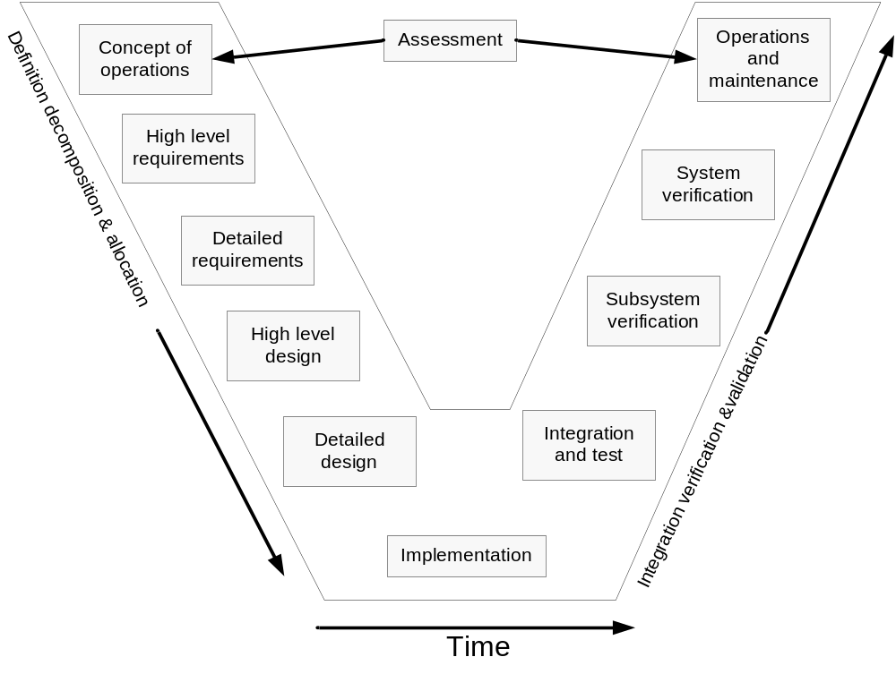
Figure 3-2 Systems Engineering Life-Cycle Process
Table 3-1 summarizes each of the steps in the systems engineering process outlined in the “V” diagram and identifies how each step can potentially impact the maintenance requirements of the system.

Table 3-3 Steps in the System Engineering Process and Their Implications for TMS Maintenance
Step in the Process | Description | Implications for Maintenance
Regional Architecture/Vision | Not shown in “V” diagram, this is an input into the Systems Engineering process. | May require maintenance of external interfaces.
Concept of Operations | Articulates the scope and reason for the system, roles, and responsibilities for all stakeholders, including, but not limited to, practices and procedures, environmental and utilization requirements. | Operational, environmental and utilization requirements establish baseline maintenance requirements.
High-Level/  Detailed Requirements | No technology selection yet. This is the “what” not the “how”.  Process of decomposing very high-level concepts into greater levels of detail. A walkthrough process provides validation that requirements capture the concept of operations. | Requirements such as reliability, systems life-cycle costs, and performance requirements directly influence maintenance requirements.
High-Level/  Detailed Design | Includes the allocation of detailed requirements to system components or modules. This step describes “how” the requirement will be met. | This step provides the best opportunity to control maintenance costs through the design alternatives analysis.
Implementation | Implementation of the approved design. Construction and/or software development. | Inspection and process quality-assurance help minimize surprises in the testing phase.
Integration, Verification, and Validation Testing | Recomposition of subsystems. Testing for performance verification. Validation that design requirements met by integrated system. | Verification tests whether or not the system was built right.  Validation tests if the right system was built.
Operations and Maintenance | TMS is commissioned and accepted. | Execution phase further validates maintenance requirements.
Assessment | A crosscutting activity that can be performed at any step, but typically done after commissioning (i.e., how well did we do?). | Maintenance experience will be useful for the next evolution of the system.
Traceability & Configuration Management | Another crosscutting set of activities that documents and maintains the linkage between all the steps in this process. | Provides the documentation roadmap to support and simplify TMS maintenance.

Sometimes referred to as an “enabling requirement,” an inherent system requirement is the maintainability of the system. By simply following the systems engineering process, systems maintainability and reliability can be captured in the design alternatives analysis. For example, a requirement for 99.9 percent availability of the system database computer has significant implications on the computer hardware and network design. Design alternatives such as redundant power supplies or redundant computers must be evaluated against the total system costs. The drawback of this straightforward approach is that that the life-cycle maintenance costs may not be fully considered during design. A low-capital cost solution for this example could be to utilize an off-site backup computer during a failure of the primary computer. Having multiple computers in multiple locations, however, can greatly increase maintenance costs by adding significant travel and lost time to everyday maintenance activities.
A more comprehensive approach is to develop a “maintenance concept” that parallels the concept of operations. Figure 3-3 shows the system engineering process along with and parallels the maintenance concept and requirements development steps. It is important to note that the maintenance concept does not require changes in the systems engineering process, but rather provides a way to emphasize maintenance within the context of the systems development process.

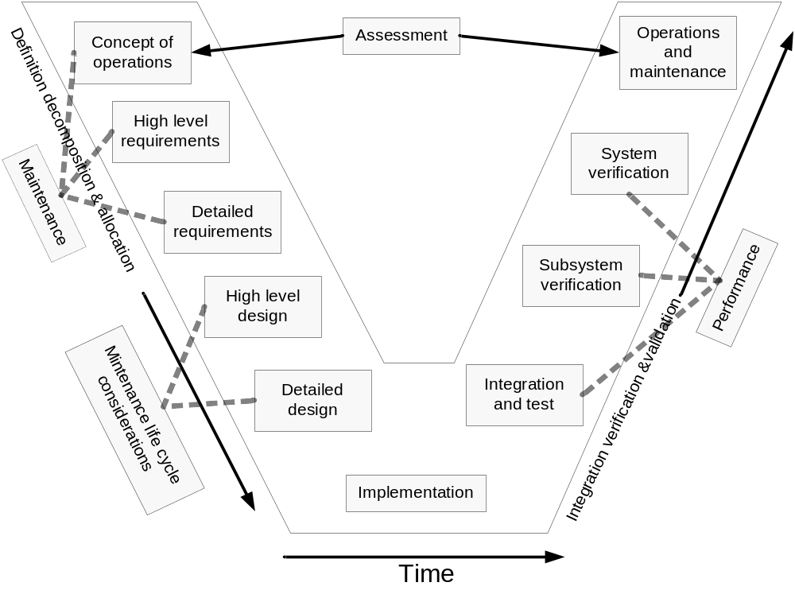
Figure 3-3 Incorporation of the Maintenance Concept into the Systems Engineering Process

The maintenance concept leads to high-level and detailed maintenance requirements. Implementation of the system coincides with implementation of the maintenance management program, which, in turn, provides verification that the system is maintainable as designed. The crosscutting activity of system validation during the operations phase parallels validation that the maintenance concept was captured in the management of the system and confirms that the maintenance requirements are being met.
Maintenance Requirements
The maintenance concept described above leads to a series of requirements for a maintenance plan. These requirements include:

- Configuration management and traceability,
- Qualifications of staffing,
- Planning a maintenance program,
- Risk management,
- Cost estimating,
- Measures of performance,
- Design life considerations,
- Partnerships, and
- Procedures.
These requirements are addressed in the sections that follow.

Configuration Management, Traceability, and the Maintenance Concept
There is growing recognition of the need for an on-going configuration management plan and process for TMS. Configuration management (CM) is defined as a process for establishing and maintaining consistency of a product’s performance, functional and physical attributes throughout the product’s design, implementation, operations, and maintenance phases (Ref. 4). The more complex a system becomes, the greater the range of variables that impact system performance. With more variables, the potential for permutations and variations on possible configurations grows exponentially. Without a rigorous configuration management process that documents all changes and modifications to the system, it is nearly impossible to diagnose what changes may have caused a system malfunction.
The maintenance concept and tracking of maintenance requirements relies on two key outputs of the CM process: baseline documentation and on-going performance monitoring. A baseline is any fully documented configuration found to meet current operational concepts and system requirements. Maintenance management systems (discussed in detail in Chapter 7) typically provide key performance indicators, such as mean time between failures (MTBF), mean time to repair (MTTR) as well as availability percentage for various system components. By pairing a baseline with a set of key performance indicators, a system operator can monitor selected measures and, if there is a problem, can very quickly narrow down the number of potential causes.
For example, the INFORM system on Long Island, New York tracks the percentage of devices online and maintains a trend analysis. Figure 3-4 shows the statistics for three years of operations. A configuration management process will keep track of the changes in the system and can be compared with the output of the performance monitoring process. Subtle changes in system availability or device performance may not be immediately obvious; however, they will likely be evident over the long term.
Figure 3-4 Three-Year Report of Equipment Availability
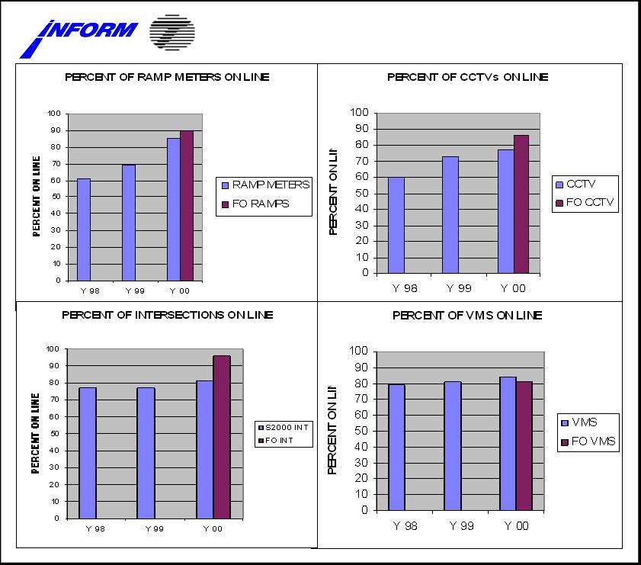
Traceability is an important crosscutting activity in the systems engineering process. Its importance can be illustrated in the example diagramed in Figure 3-4. In this diagram of a vehicle detection subsystem within a TMS, there are certain wiring configurations in the field, which are eventually mapped to fields in the systems database. There is a typical wiring configuration, but the number of lanes can vary by location. There is a critical need for good up-to-date documentation of all of these configurations. The cost of maintenance or troubleshooting of this subsystem will increase dramatically if the system technician has to visually verify all cabinet wiring configurations before making database changes.

Sample Applications of a Maintenance Concept
Consider the following examples of how maintenance concepts can parallel the development of operational concepts:
Field
Cabinet
Vehicle
Detector
Comm.
Driver
DBMS
GUI
Large Screen
Display
Communications
Detector
No.
Back-Panel
Connector
Link
#
Graphical
Symbol
An Agency is considering the implementation of adaptive traffic signal control to help with arterial congestion. The initial concept of operations is to upgrade all of the Agency’s signals to adaptive control. As the concept is further defined into systems requirements, the maintenance concept is also developed. The maintenance concept recognizes that the new technology being proposed cannot impose drastically higher maintenance requirements on the Agency without some beneficial trade-offs. Adaptive control algorithms require significantly more detector data to operate successfully. More detectors will require a higher level of field maintenance. Prior to completing the final design, the scope of the adaptive control project is scaled back to just the critical intersections. Even though there will be some increase in field maintenance of the new detectors, this effort is offset by better performance through the critical intersections and reduced engineering time revising timing plans. In this example, the feedback from the parallel development of a maintenance concept and requirements has resulted in a refined concept of operations and related system requirements that are more in tune with both the operational and maintenance funding of the Agency.
Figure 3-5 Importance of Traceability and Configuration Management to the Maintenance Concept
In another example, an Agency is designing a new freeway management system and requires a method of verifying reported incidents and determining appropriate response measures. A closed-circuit TV (CCTV) camera system is selected through the design process. The design alternatives analysis recognizes that even good quality CCTV equipment occasionally fails for one reason or another. Research has indicated that large systems can expect an average of 5 to 10 percent failures. For example, for a 50-camera system, between two and five cameras will not be operational at any given time. Based on an operational concept that requires “full CCTV coverage” of the roadway, the designer has to consider the maintenance concept required to meet this requirement. One alternative is to increase maintenance funding to procure additional bucket trucks and CCTV spares to enable faster responsive time and more rapid repairs, thereby reducing the average number of failed cameras. Assuming the initial funding could be obtained, the total life-cycle cost of maintaining such a resource would be much greater than the cost of repairs. A re-evaluation of the design is a better solution. Adding a few more cameras and adjusting their locations to provide for more overlap of CCTV viewing angles will reduce the probability that any single camera failure will result in significant blind spots. Even with a few more cameras to maintain, there is less of a requirement for a large maintenance fleet and spares inventory and the total life-cycle costs are reduced.

Planning a Maintenance Program
In the planning of a maintenance program, a very important issue is the acquisition of a consistent budget stream to continue the upkeep of the various systems and devices. Some Agencies have limited their approach to extended warranties and sometimes one or two years of additional support from the system integrator to maintain the computers and software. As with other highway programs, maintenance costs are a significant percentage (around 5 percent) of the capital costs. However, using a fixed percentage for cost estimation of maintenance is not a very reliable process. The variations in functionality, weather, and geography among differing systems necessitates that cost estimates be made on a case-by-case basis. Also, planning a maintenance program needs to include an estimate of the staffing requirements. One way is to use a spreadsheet that calculates the maintenance labor hours necessary for preventive and responsive maintenance activities. The table (Ref 5) indicates Maintenance Staffing levels in variety of TMS’s.

Table 3-4 Sample Staffing Levels
 | Boston | Toronto | Long Island | Detroit | Milwaukee | Atlanta | Phoenix | Houston
Number of Maintenance Staff | N/A | 3+ | N/A | 3 | 3 | * | 3+ | 3+
Organization Responsible for Maintenance | Installation Contractor | Agency, Contractors | Maintenance Contractor | Agency District Office | Agency District Office, Communication & Maintenance Contractors | Agency, System Manager, PM Contractor | Agency District Office TMC Systems Team | Agency District Office
Special Maintenance Elements | None | None | None | None | Information Technology Specialist | Information Technology Team | Systems Team | None
Centerline Miles | 7.5 | 60 | 165 | 180 | 63 | 220 | 254 | 122
Types of Field Equipment | SCADA, VMS, Loops, CCTV, Gates, Over height, FO Network, AM/FM Rebroadcast | VMS, Loops, CCTV, FO Network, Ramp Meters, RWIS | VMS, Loops, CCTV, Coax Network, Ramp Meters, Traffic Signals | VMS, Loops, CCTV, Coax & FO & Microwave Network, HAR, Ramp Meters | VMS, Loops, Microwave Detectors, AVC, CCTV, Ramp & Freeway Meters HAR, RWIS | VMS, Loops, Radar, VIDS, CCTV, FO Network, Ramp Meters | VMS, Loops, PAD, CCTV, FO Network, RWIS | VMS, LCS, Loops, CCTV, Gates, FO Network, Ramp Meters

TMC maintenance is not clearly separable from other maintenance functions. The types and number of devices that are included is site specific but using the brief definition of each spreadsheet column heading, below, a staffing estimate can be made. The column heading can include:
- Field Device: Is the ITS equipment and components out in the field?
- Device Count: Total count of devices.
- Preventive Maintenance Schedule: Total vendor-recommended periodic maintenance trips during the service period. Typically at 3-, 6-, or 12-month intervals.
- Labor Hours per Person: Labor effort needed to perform the recommended maintenance procedures.
- Number of Persons per Crew: Is Assess adequacy of the number of personnel and crews to perform the preventive maintenance procedures safely and efficiently.
- Travel Time One-Way: Average distance to be traveled one-way to the maintenance location.
- Labor Hours + Travel Time (Round-Trip): This formula calculates the total time in hours for the crew size and travel times.
- Total Hours for Labor/Travel and Devices: This formula calculates the total time needed to perform the preventive maintenance for each ITS field device type.
- Average Number of Responsive Maintenance Visits per Year: This average comes from other ITS Agency’s maintenance reports and vendor information given for their devices.
A sample spreadsheet is shown in Table 3-3, below.

Table 3-5 Sample Staffing Estimate Spreadsheet
 | Device count | Preventive Maintenance (Hours)
Field Device | Device count | Preventive Maintenance Schedule | Labor Hours Per Person |  | Number of People per crew | Travel Time |  | Labor Hours + Travel Time |  | Total Hours for Labor/ Travel & Devices
Variable Message Sign | 25 | 6 months | 2.0 |  | 3 | 3.0 |  | 15.0 |  | 750
Highway Advisory Radio | 5 | 12 months | 3.0 |  | 2 | 2.0 |  | 10.0 |  | 50
Weather / Pavement Sensor | 10 | 12 months | 2.0 |  | 2 | 3.0 |  | 10.0 |  | 100
Camera – CCTV | 40 | 6 months | 2.0 |  | 3 | 2.0 |  | 12.0 |  | 480
Non-Intrusive Count Station (Video or Radar) | 60 | 12 months | 2.0 |  | 2 | 2.0 |  | 8.0 |  | 480
Permanent Count Stations (Connected to STC) | 1 | 12 months | 1.0 |  | 2 | 2.0 |  | 6.0 |  | 6
Permanent Count Stations (Not Connected) | 20 | 12 months | 1.0 |  | 2 | 2.0 |  | 6.0 |  | 120
Video Detection at Signals | 20 | 12 months | 2.0 |  | 2 | 2.0 |  | 8.0 |  | 160
 |  |  |  |  |  |  |  | Total hrs = |  | 2146
 |  | Responsive Maintenance (Hours)
 |  | Labor Hours Per Person |  | Number of People per crew | Labor Hours + Travel |  | Average Number of Visits Per Year (1/3 of Devices) |  | Total Hours for Labor/ Travel & Devices
Variable Message Sign |  | 4 |  | 2 | 14.00 |  | 8.3 |  | 116
Highway Advisory Radio |  | 2 |  | 2 | 8.00 |  | 1.7 |  | 13
Weather / Pavement Sensor |  | 2 |  | 2 | 10.00 |  | 3.3 |  | 33
Camera – CCTV |  | 2 |  | 2 | 8.00 |  | 13.2 |  | 106
Non-Intrusive Count Station (Video or Radar) |  | 2 |  | 2 | 8.00 |  | 19.8 |  | 158
Permanent Count Stations (Connected to STC) |  | 2 |  | 2 | 8.00 |  | 0.3 |  | 3
Permanent Count Stations (Not Connected) |  | 2 |  | 2 | 8.00 |  | 6.6 |  | 53
Video Detection at Signals |  | 2 |  | 2 | 8.00 |  | 6.6 |  | 53
 |  |  |  |  |  |  | Total hrs = |  | 534
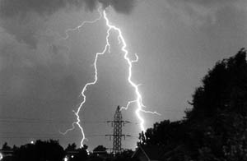
Supervisory staff are typically added according to local policies and conditions.
Figure 3-6 Lightning Causes EMP Damage Remotely (Photo: FEMA)
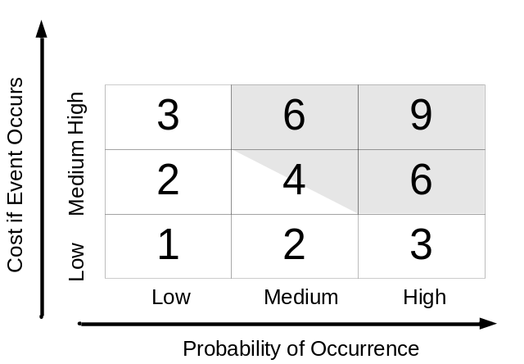
TMS’s are rarely static. If successful, they are liable to be expanded; if not particularly successful, they can be modified or replaced. In addition, due to budget constraints, the procurements are often made over several years. Thus, at any one time, there is often a varied mix of technologies and ages of equipment. For example, having a variety of message signs is common. In some cases, the manufacturer may have gone out-of-business — a fairly regular occurrence in this industry. This leaves the Agency with a confluence of devices: some new and possibly being maintained by vendors; others aging and possibly being maintained by Agency staff. In addition, there can be items that should be scrapped, but which are politically difficult to remove. This particularly applies to DMS’s that drivers are used to seeing. Over the past decade, there have been several DMS manufacturers that have gone out-of-business, leaving Agencies with no sources for spares. In those situations, the best that can be done if items are not to be scrapped is to either selectively remove selected less critical components and use them for spares, or try to re-engineer replacement components.
Figure 3-7 Risk Assessment Matrix
To mitigate these problems, a maintenance plan should incorporate scrapping items and ensure that spares and replacements are anticipated. Particular attention should be paid to DMS’s and cameras since sign messages and video feeds to the public are quickly missed when either removed or non-operational. Budgeting for replacement items is the key to avoiding these problems.

Staffing Qualifications
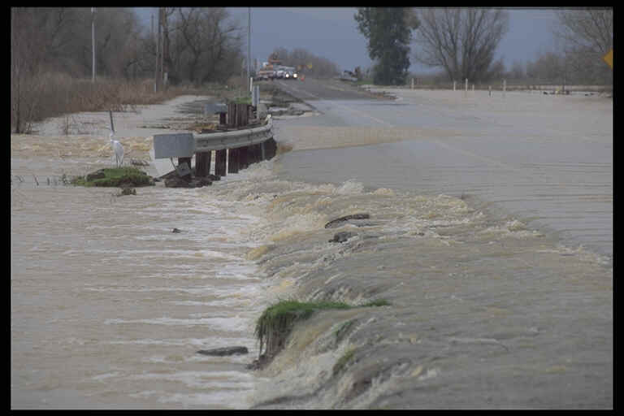All staffing associated with any TMS project must be qualified for the work that is to be performed. Typically technicians under contract that are responsible for the electronic components should have a minimum of a two-year associate degree plus two years relevant work experience or equivalent. This type of requirement should be included in any statement of work for contractors. An equivalent to this qualification would be more than five years of relevant experience directly with the Agency. A problem reported by some of the surveyed Agencies involved qualified staff being proposed by the winning contractor, but different, less capable staff being used on the job when the project began.
Figure 3-8 Flooding Damages ITS as well as Structures (Photo: University of Nebraska)

Risk Management and Probability of Multiple Failures
With regard to planning for knock downs, lightening, floods, and other unforeseen events, some allowance needs to be made. The FHWA guidelines require that roadside devices are either thirty feet from the carriageway or they are protected by a guardrail. One ITS system in Virginia with over 1,000 roadside devices suffers from approximately one knockdown per year.
Lightening is extremely variable and, despite the best attempts towards protection, electromagnetic pulses (EMP) can damage the electronics — even when the devices are not directly hit. In fact, most damage to equipment is not caused by direct lightening strikes, but by induced voltages on conductors from nearby strikes. ITS devices are often electronically sensitive devices placed in open areas on top of electrically conducting metal poles. To make things worse, these devices are often connected to both power and communication systems via long-conducting copper wires. There have been examples of ITS camera installations in Florida where all of the PTZ units were rendered inoperative by a single storm where the damage came through the power supply.
Flooding too can cause major problems to ITS devices. In Bombay, India, the controller bases are four feet high to protect them from the monsoons. Obviously, the risks to ITS components will vary significantly in different geographies and climates across the US.
Each Agency that is trying to assess the maintenance need could undertake a simple risk analysis whose objectives would be to:
- Identify those issues and factors that are liable to occur.
- Assess the costs associated with these factors.
- Determine appropriate mitigation solutions.
A simple assessment matrix can be used to assess the potential significance of each area of risk.
Each potential risk needs to be assessed for its probability of occurring and the costs. Information on historical weather patterns can be obtained from the National Environmental Satellite and Information Service (NESIS) at: http://www.nesdis.noaa.gov/. NESIS has significant information on weather history that may help in assessing the probability of events for specific states. Although the scoring of the probability can be arbitrary, the areas that are shaded indicate higher probability and higher cost impact. The information can be used as tool to assist in the evaluation and risk.
Knowing which areas are at-risk can assist in maintenance planning in:
- Design aspects that that will lower the impact of disasters. These could include raising elements above potential floodwater or increasing lightning protection.
- Making allowances in the number and types of spares that are needed.
- Having a contingency fund for exceptional conditions — similar to those that some states have for snow plowing during severe winters.
Although the approach to risk evaluation does contain a series of subjective estimates, it has been found worthwhile as it allows the plan development to consider the likelihood and consequences of these types of events.

Sample Costs
Table 3-4 indicates a sample of annual maintenance costs. Such numbers are often included with maintenance and are frequently not readily available.

Table 3-6 Sample Annual Maintenance Costs
System | Annual Maintenance Costs ($000’s) | # of Miles | # of Devices | Cost per Device
ODOT—ARTIMIS | 1,000 | 88 | 1,200 | $833
VDOT—N. VA | 2,800 | 150 | 2,743 | $1,020
Orlando | 150 (preventive only) | 39 | 223 | $672
Caltrans (1) | 2640 | NA | 2212 | $1,193

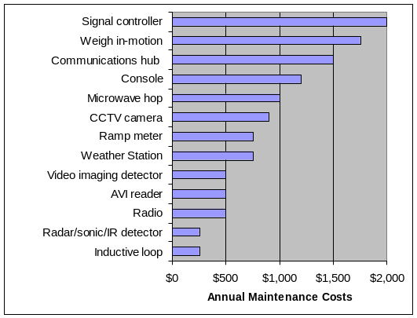
Inspection of the data in the table above leads to the conclusion that average annual maintenance costs are approximately $1,000 per device. However, the majority of devices in these systems are traffic detectors that are fairly reliable. This value would not be appropriate for systems that contain a high number of devices that are more expensive to maintain. Daniels et al. (Guidelines for Funding Operations and Maintenance of Intelligent Transportation Systems/Advanced Traffic Management Systems, Transportation Research Record 1588) provided costs for maintenance by device type and these are shown in the Figure 3-9.
Figure 3-9 Annual Maintenance Costs by Device Type

Traffic Operations and Maintenance Programs
Effective management of operations and maintenance staff must begin during the planning and design phases. This activity is particularly important in fostering an acceptance of the new traffic system among Agency personnel. Fear of the unknown, coupled with a potential misunderstanding of the system's purpose and concerns that personnel may have regarding job security, can detract from full and efficient utilization of the new system. As previously noted, the following opportunities for staff involvement can be provided through the pre-start-up process, thereby breaking down the natural barriers to system acceptance:
- Early involvement in system plans and designs to ensure proper consideration of reliability and maintainability issues.
- Assurance of thorough training tailored to staff needs.
- Participation in construction inspection and acceptance testing.
- Exposure to similar systems through field services with operations staff.
After the system is operational, several important management functions need to be completed. One is to schedule and conduct in-house, on-the-job training programs. This ongoing training is necessary because of personnel turnover, advancement of personnel to other positions, or terminations. Such a program should be initiated as soon as practical after systems implementation. The in-house training program can be supplemented by sending operations and maintenance staff to attend outside training or to visit similar systems, as appropriate.
At the San Antonio TransGuide Traffic Management Center, TMS operators have been successfully utilized in assisting experienced maintenance personnel in performing preventive, responsive, and emergency maintenance. TMS operators were also used in acceptance testing. The benefits of doing this include the following:
- Provide much-needed assistance to maintenance personnel.
- Provide in-house training for operators without additional cost.
- Give TMS operators a change of pace from their normal routine and help prevent operator burnout.
- Reduce equipment down time.
There are both operational and budgetary connections between a TMS operations program and its maintenance plan. Operationally, the staff in the control center needs to be aware of current and planned maintenance crew activities. Some activities require that specific devices be controlled from on-site. When communications to the central control system are disrupted (typically when somebody removes the plug to connect a local device), the central software should provide a communications failure message. Control software applications should have the ability to take specific devices off-line. This should be done prior to the maintenance tasks. Although contractors and maintenance crews can schedule their activities in coordination with the operators, these often do not take place on time. Weather and the demands of responsive and emergency maintenance disrupt schedules. It is recommended that the maintenance crews and the operators at the central control room be in voice contact through radios or cell phones at all times.
In addition, there are circumstances when the control system operators may wish to halt or divert the maintenance crew. Any presence on the highway can be disruptive to traffic flow. During the course of special events, is not a good time to perform maintenance. Cooperation between the two groups is needed to ensure that preventive maintenance tasks — and lower priority responsive maintenance tasks — are not being performed at inappropriate times.
With regard to budget, all new TMS items and functions need to consider both maintenance and spares. Spares become a major item within a maintenance program, given that much of today’s hardware cannot be mended by the local electrical technician. Historically speaking, the replacement of small parts in electronics effectively disappeared as integrated circuits developed. Most components today are comprised of a series of integrated circuits soldered onto boards. This tendency leads to returning all components to the manufacturer. The manufacturer can replace some parts at the component level, but in many cases the pieces are scrapped and replacements furnished. To some extent, this trend leaves the electrical technician with an easier task in terms of replacing failed components. However, it does mean that the maintenance plan and its budget must make allowance for adequate spares. The range of 5-10 percent of all items is used for estimating the needs. This is not a trivial amount of money and it is worthwhile, during the development of maintenance plan, to develop data on the mean time between failures (MTBF) for individual components. Having this data, the Agency can then adopt a policy regarding the time period of spares they wish to keep on hand. For example, if the PTZ motors on camera mounts have an MTBF of six years and the Agency has 50 cameras, it can expect that 50/(6*12), or 0.7, motors will fail per month. If the Agency adopts a policy of maintaining six months of spares, it will need to keep five spare motors on the shelf. The hard issue here is arriving at good MTBF data. Products change and these types of information are often not readily available. In some cases, the manufacturer can assist. However, many specification sheets quote numbers based on calculations made for each component of the device which provides guidance, but does not account for the effects that various components may have on each other, such as heating.
Each Agency should attempt to develop MTBF data for the specific devices for several reasons, including:
- To assist in determining the number of spares to keep on hand.
- To determine ordering policy for obtaining components.
- To assist in the estimating of responsive maintenance calls.
- To provide feedback on how reliable individual ITS devices are, i.e., whether a change in supplier should be considered.

Maintenance Measures of Performance
The following parameters are useful data when evaluating products. Nevertheless, the reader of product specifications should be vigilant about marketing hyperbole:
- Mean Time between Failures: The average time between hours of exposure for all like products divided by the number of failures (Be advised that warned this is not the “design life.”
- Mean Time to Repair: Number of hours to make good the failed item.
- Average Cost to Repair: Approximate cost to make the item fully functional again.
- Design Life: Discussed below.
- Salvage Value: Although often zero, this value can be important when upgrades are being made.
There is a second-hand market for traffic signal controllers. Reselling older hardware and replacing it with compatible new equipment can oftentimes be cheaper than developing software to control two different hardware varieties.

Design Life and MTBF
This type of information is available at some vendor’s websites — this example is for industrial quality Ethernet switches:
“Based upon 1,715 units delivered to our customers in the first twelve months of manufacture. We computed an installed running time based upon the above conservative estimates of 2,810,808 hours. With only four applicable failures during this one-year period, the calculated MTBF is: 2,810,808 Hours / 4 Failures = 702,702 Hours MTBF.”
Other examples quoted include:
- Industrial Video Cameras — 20-80,000 hours (2-9 years);
- Radar detectors — 100,000 hours;
- Video projectors — 30,000 hours; lamps — 1500 hours; and
- Uninterruptible power supplies — 100,000 hours
Design life and MTBF is not the same thing for all ITS devices. In some cases, equipment can last decades if it is well maintained and necessary repairs are made. For example, a truck will operate for decades if well maintained. However, to last decades it will need lots of tires and may need an engine. On the other hand, a hard drive, that may have a MTBF of 50 years, a design life of 5 years and a warranty for 2 years will cause an ITS system to crash and usually cannot be repaired. When considering the spares and replacements of ITS devices the developer of the plan needs to consider the most appropriate measure for that device on their facility. Taking one value for a whole system’ s lifetime, say 10 years, would overestimate the life of a hard drive and underestimate the life of a cherry picker. If spares inventory and replacement budgeting are being calculated, the design life needs to be used.
There is significant variation between similar products. The developer of the plan should attempt to determine the likely design life of the specific product. Generally speaking, components that move break first. Things that get hot also tend to have shorter lives. In traffic signal controllers, the power supply is the most unreliable component, followed by the load switches, then the conflict monitor. Electronic devices that are not switching power and have no moving parts can operate virtually indefinitely as illustrated by computers from the early eighties and amplifiers from the seventies. However, on these devices, knobs and drives usually have had to have been replaced. The impact of these effects should be considered in product selection. Although maintenance needs may be secondary to specifying a required functionality, if there is a choice between differing devices with similar functionality, then these effects on maintenance need to be considered.

Timely Responses
When specifying responsive maintenance time, Agencies have a tendency to require excessively rapid response. From the contractor’s perspective, keeping staff available 24 hours per day seven days per week costs a lot of money. If the required response time is less than the time for the alerted worker to travel from home, then somebody is required to be on-site full time. One full time position requires five employees. This cost is generally too high for the benefit that will be achieved. Even if the TMC is operational at all times, the chances that a failure of a particular device will affect operations is low. When writing the scope of work for the maintenance component of a contract, the Agency needs to consider how the contractor is going to cost the response. Even if Agency staff are being used to react to responsive and emergency calls, there are often working rules that either prohibit this or require significant overtime costs to be paid.
A reasonable balance needs to be developed between timeliness and costs. Some Agencies use the following type of wording:
“The contractor is required to provide two years of maintenance on all elements of the system following acceptance by the State of each element.
The contactor shall provide one phone number that will be the State’s sole contact point for requesting maintenance. The timing for the maintenance response shall begin with the phone call to the contractor. The contractor shall ensure that the phone is answered or a message system is always available.
The contractor shall be on-site and commence work within four hours of being informed by the State that a repair is required. Only business hours (7:00AM-4:00PM) will be counted for the maintenance response time.”
Changing the various time periods within the above wording can be done to suit the Agency. Of course, the implications of the changes to the costs need to be considered.

Pre-Bid Meetings
A real understanding of the needs of the maintenance contract is critical to success in these efforts. In one Agency, a request for proposal (RFP) was developed and advertised with a non-compulsory pre-bid meeting. The contract was for two years of maintenance. One company attended the pre-bid meeting, but did not bid the job. A single high-end bid was received. Since one bid was not allowed, the procurement was suspended. At that point, a survey was made of all the potential contractors to determine why they did not bid and would they be interested in a new bid. Some stated that they missed the announcement; others said there was too much uncertainty. Thereafter, a meeting was held at the Agency facility where all potential contractors and their potential subcontractors were invited to discuss the upcoming procurement. This was not a pre-bid conference. The Agency described what was needed from the contractor and the scope of work was discussed. Several comments were made by the contractors that were used to modify the RFP in accordance with input from the contractors. These comments included the following:
- Contractors did not want to buy equipment using their money to be reimbursed later by the Agency without some compensation. This process reduces the credit available to the contractor and, in some cases, it would be too burdensome on the contractors (e.g., during those periods between major spares purchases and submission of invoices). Their point was they did not want to be the Agency’s bank. A markup of the equipment costs was subsequently permitted by the Agency.
- The original RFP asked that the work be done during an extended standard workday. However, contractors wanted the ability to work at nights and weekends in order to maximize the usage of their labor and equipment. A cherry picker that trims trees during the day can clean signs at night, thus lowering costs.
- Contractors were very wary of their ability to meet response times under system situations that could cause major failures. These include snowstorms, tornados, and major power failures. The RFP was modified to forgive response times during certain conditions
- The original RFP was for a one-year contract that was annually renewable. The contractor’s could not obtain space (i.e., warehouse for inventory, an office, and parking) on annual contracts. Most commercial real estate contracts are for two or three years. Thus the contractors put the entire value of the lease into the first year as they did not know if the contract would extend to later years. The RFP was changed to an initial two-year period that was renewable annually.
- Several contractors stated that they were interested in only parts of the job, e.g., video or communications systems only. Consequently, the meeting attendance list was circulated to all attendees who were encouraged to form alliances in order to provide responses to all the required functions.
- Additional minor changes were made — mostly relating to local conditions and some ambiguities.
A revised RFP was then published. A mandatory pre-bid meeting was convened and the changes to the solicitation were explained. Three bids were received and a contract was negotiated with the winning bidder that was approximately $2.5M less than the bid received prior to the revision of the RFP.
This process seemed successful in that a better understanding of the Agency’s requirements was attained. Also, a reduction in risk on behalf of the contractor resulted in a better contract and saved money.

Partnerships
There are a variety of arrangements between government Agencies, institutions, academia, toll authorities, airports, and others concerning maintenance activities. For example, the City of Charleston maintains the ITS devices in Mount Pleasant and Goose Creek in exchange for funding contributions. New York State University provides maintenance of the video system for NYSDOT in Albany. The Ohio DOT and the Kentucky Transportation Cabinet own the ARTIMIS TMS under a bi-state agreement and contract out the maintenance, with the management of the contract alternating between the two Agencies. In Houston, TxDOT has a shared services agreement with the State Thruway Authority that covers maintenance.
The form of these agreements is also varied. Sometimes there are no written agreements at all, just an understanding concerning who will do what. In other instances, there are memoranda of understanding (MOU) between the parties that more formally spell out the relationships and responsibilities. In some cases, there are firm contractual documents definitively defining tasks and timeliness requirements.
Agencies should look closely at the functions and hardware that are in locales in an effort to find areas of cooperation not just in maintenance activities, but also in operations. Historically, the functions of traffic signal system maintenance have often been shared by adjacent jurisdictions, e.g., where the State traffic signal maintenance group may take responsibility for a county or a city within its boundaries.
The structure of these MOU’s usually includes such items as:
- The nature of the agreement and the naming of the parties.
- The intent of the parties and a definition of the form of the agreement.
- A scope of services that states what is to be done.
- Separate sections on the responsibilities of each of the involved parties.
- The duration of the agreement.
- A termination clause.
- A definition of responsibilities for ownership and maintenance.
- Other legal sections on assignments, audits, discrimination and a signature section.
- Exhibits defining equipment, shared space, payments, scope, and responsibilities.

Procedures for Control Centers
When considering failures of components, the general rule “if it moves, it will break” still applies. Particular attention should be taken with hard drives that contain the critical data to enable operations. Hard drives are typically quoted with MTBF of 300,000 or 500,000 hours. These periods (34 and 57 years) are nonsense since such long lifetimes cannot be verified; also, the same specification sheets nearly always warranty the product for three years or less. Experience has shown that for new equipment that turns over every three years, about 2 percent of hard drives will fail per year. Although not a large percentage, this can have a devastating effect on operations. It is recommended that as part of the maintenance activities for the central servers and workstations, disk mirroring or other redundancy features be incorporated together with regularly scheduled back-ups. Additionally, making all hard drives “hot swappable” with a common specification will enable the maintenance staff to readily replace the systems most key component.
Central servers can also fail and there are a variety of approaches that can be taken to ensure fairly continuous operations. In order of increasing costs these include:
- Obtaining a Ghost image of the hard drive — this is a direct copy of everything on the hard drive including the operating system and all its patches. Such imaging enables direct replacement of the system at the time the image was made. This is a good maintenance action that is cheap and can be performed regularly.
- Providing a redundant computer that has the operating system (which can be copied from the Ghost image) and can replace the server or workstation as appropriate. Such an approach will only update the system status and its database files since the last back-up. Most office systems currently operate on networks and thus the redundant computer can be ready on the network in anticipation of a failure.
- Providing a database replication process using the redundant computer, but adding an application that copies the database to the redundant machine at regular intervals. This provides a high level of redundancy, but does not replicate the data held in the machine’s memory.
- Furnishing a “hot” standby so that a second machine is mimicking all the processes that are taking place on the primary machine. An additional application monitors the operation of the primary machine and automatically transfers control to the secondary machine when a failure is detected. This approach is expensive and is not available on all operating systems. It is usually considered too expensive for ITS applications.
Whichever option is chosen, there are back-up procedures that need to take place as part of a regular preventive maintenance schedule. These tasks need to be coordinated with the operators using the machines.
Configuration management of the other components that require maintenance in the control center include:
- Video display units — the projection variety often go out of tune and require frequent adjustment to the projection devices. In some devices, tuning must be performed monthly; in others, it is never required.
- Server and workstation operating systems that may require updates and renewals of pertinent licenses.
- Application software that needs to have certain procedures, e.g., downloading logs, associated with traffic data files and operator actions. Some applications also require to be restarted on a regular basis.
- Replacing video tapes, CDs, and backup tapes in archiving systems.
- Checking weekly for security updates and virus software updates.
- Checking monthly to clear temporary folders and the various files produced by applications that are no longer needed.
- Maintenance of contact lists.
The processes involved with these maintenance tasks in the control center are specific to the needs of the individual component or the requirements of the software application. However, the developer of a maintenance plan will need to make allowances for these tasks.

Maintenance Considerations for the Life-Cycle of a TMS

Introduction
The Systems Engineering process is more than just steps in systems design and implementation; it is a life-cycle process. It recognizes that most systems are built incrementally and expand over time. The basic steps in the process do not change. There is an even stronger need to provide feedback and assessment with each incremental deployment phase so that future phases build on and expand the system, rather than simply replace elements of the earlier phases. The “V” diagram used to depict the systems engineering model in Chapter 3 can be used to illustrate this evolutionary deployment process. Figure 4-1 shows how successive “V” diagrams illustrate the multiple deployment phases with each phase following the systems engineering process of definition, decomposition, implementation, recomposition, integration, and testing. Not shown in this graphic, but implied, is the feed-back and assessment crosscutting activities that both validate older requirements and generate new requirements in each subsequent version.
As defined in Chapter 1, responsive maintenance is the repair or replacement of failed equipment and its restoration to safe, normal operation. Preventive maintenance is the activity performed at regularly scheduled intervals for the upkeep of equipment.

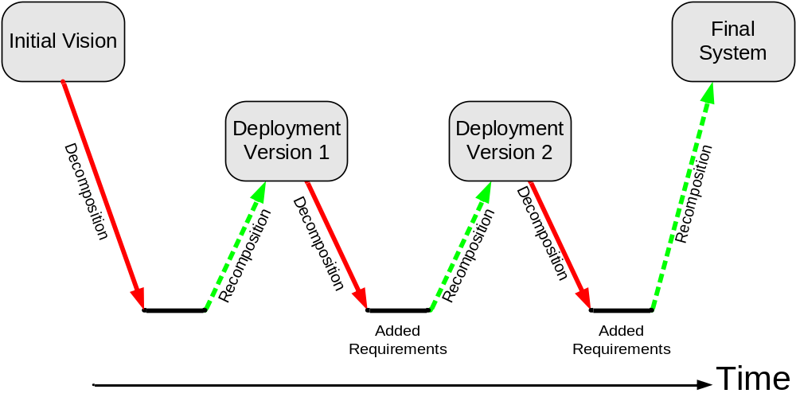
Figure 4-1 The System Engineering Life-Cycle Applied to an Evolutionary System Deployment Model

It is important to stress that as each phase or version is deployed, the maintenance concept and requirements are going to change. The concept of operations is also changing as each set of additional requirements is implemented.
This chapter is the logical follow-on to the previous chapter, which introduced the maintenance concept and its context within the systems engineering process. This chapter also describes a systems approach and structure to support multi-year maintenance program planning, as presented in Chapter 6. Another way to view the life-cycle of a multi-phase evolutionary deployment project is to lay out the activities on a time line. Figure 4-2 shows a typical time line with overlapping sets of activities.
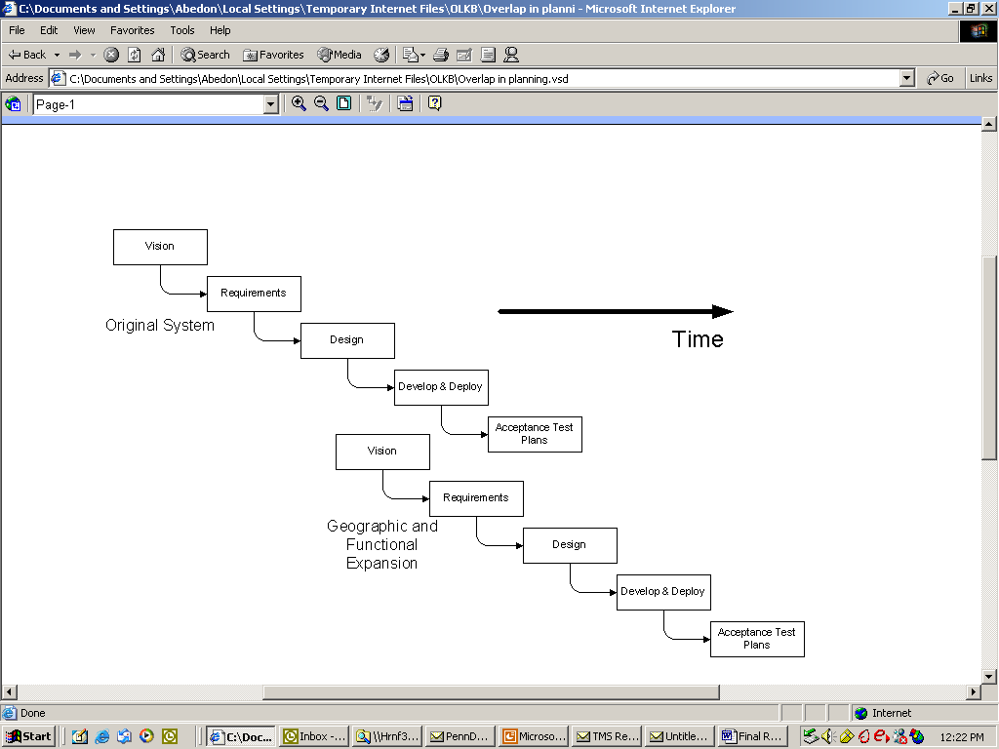
The following sections address the key phases in the life-cycle of a typical TMS and show how the maintenance concept and requirements should be considered and adapted for each phase.
Figure 4-2 Overlapping Activities

Key Phases in the Life-Cycle of a Transportation Management System
There are several dimensions to the life-cycle of a TMS, moving through the process of planning, design, implementing, and operating a multi-phase deployment. As part of the systems engineering process, the initial vision will generate a more-or-less complete list of requirements for what the final system will do. These requirements must then be prioritized, either by need, cost, or technological feasibility. These priorities are use d to determine what requirements will be met in each phase.
The ability to defer, or even eliminate, requirements based on a quantitative assessment and priority ranking is a key element in the life-cycle planning of a system. The prioritization of requirements provides the flexibility needed to adjust schedule and budget over the life of the project.
Just as there are different priorities for functional and operational requirements, there are different priorities for the corresponding maintenance requirements. Whatever method or exercise is used to prioritize functional requirements can be used to rank maintenance concepts and requirements. Depending on the number and diversity of stakeholders, it can be difficult to achieve consensus on the ranking of priorities. Some examples of techniques include the “utility weighting” approach, which assigns a utility or weight to each requirement, and then each stakeholder “scores” the relative importance of that requirement compared to others. The product of weights times the score is summed across all stakeholder to develop a composite score that determines an overall ranking. There are also Delphi techniques for soliciting input from a very diverse group of stakeholders.
The decomposition steps of a TMS design should each consider the maintenance aspects and the implications for future recurring costs. These steps are described in the section below.
Operations and Maintenance Concept
At this early stage the maintenance issues that need to be included are such issues as:
- Location of property,
- Institutional responsibilities,
- Staffing levels and reporting requirements, and
- Whether or not to use contractors.
Strategic placement of property can assist in the later maintenance activities. Often the maintenance and operations centers are co-located. This has significant efficiencies in that building and facilities can be shared and communications is enhanced.
A definition of the institutional activities should be considered early in the planning process. Not just the responsibilities within the Agency should be included, but other Agencies in the same institutions and adjacent jurisdictions need to be included. Adjacent jurisdictions and other Agencies may either provide support or revenue in exchange for maintenance coverage beyond items that are owned by the Agency.
There are many significant issues associated with whether or not to contract out all or part of the maintenance activities. Options for contracting are described in more detail in Chapter 7.
Functional and Performance Requirements
Functional and performance requirements need to be considered right at the beginning of the life-cycle. These two effectively are inseparable in that when the function of a specific element is defined its performance should also be defined. Without a performance definition acceptance testing and performance monitoring has no standards with which to judge acceptability. Hence the developer of plan needs to not just define that a device meets some standard but also how long this can be maintained.
For example if the function being specified in the light output from a pixel on a Dynamic Message Sign (DMS) that includes bunches of Light Emitting Diodes (LED) then the initial function may be that each LED need to emit some number of lumens within a specified angle. This is a defined function that can be tested and accepted. However, the performance pixel also needs definition because, some LED’s may fail. How many failed LED’s constitute a failed pixel? How many failed pixels constitute a failed sign? How long should the pixel continue to exceed the light output requirement? Adding temporal criteria to the LED specification will ensure that the sign will perform as required for some period. For example stating that a percentage of the LED must maintain a light output over a number of years and less than some percentage of the LED must not fail in the time period is one way this can be done. However these types of performance requirements require a testing routine to be scheduled into the life-cycle of that particular device.
Thus the functional activities are defined at the beginning of the devices life-cycle but the performance requirements will occur regularly over time.
Acceptance Testing
Acceptance testing occurs at the beginning of the procurement cycle for a specific device. It is typically linked to a payment item. The maintenance plan can use the acceptance test procedures to repeat testing at later stages in the life-cycle to verify continuing conformance.
Configuration and Asset Management
Configuration management and asset management are continuous applied throughout the life-cycle of a TMS. IEEE Std-729-1983 states “Configuration is the process of identifying and defining the items in the system, controlling the change of these items throughout their lifecycle, recording and reporting the status of items and change requests, and verifying the completeness and correctness of items”.
Asset management is used more with physical infrastructure rather than systems and is concerned that the infrastructure be considered and managed to the end of its useful life. Both these operations can be a key component of the lifecycle of a TMS. More detains of configuration management can be found in Chapter 3 and information on asset management is contained in Chapter 7.

Preliminary and Final Design
Within the life-cycle, the maintenance input to the preliminary and final designs is critical. Preliminary designs tend to be more conceptual and it is at this stage that the maintenance planning needs to consider its requirements carefully. Coordination and cooperation between departments is essential. Specifications need to include facilities to ease maintenance. Gantries on variable message signs facilitate access. Co-locating devices can both reduce the costs of installing communications as well as enhance maintenance. For example, many Agencies now specify that traffic detectors must be above ground. However, there are Agencies that are still installing inductive loops. Loops are a significant maintenance burden and, in most cases, are unreliable, expensive to repair, and cause major disruptions to traffic. Having maintenance input in the early design stages can significantly aid the maintenance work.
Final designs tend to get more involved with locations, detailed functions, and connectivity. Maintenance groups should get involved with the final design to ensure that roadside devices:
- Can be accessed. Examples abound of:
- Cameras that cannot be accessed by a cherry picker,
- Communication links that are lost,
- Signs that cannot be seen,
- Communication equipment where every cable was black and unlabeled,
- Controller cabinets that are buried by snow plows, and
- Signs installed by the operations department and then removed by a construction project from another department.
- Can be accessed safely. The shoulders of freeways are dangerous locations and ensuring that maintenance crews can park behind the guardrails is advisable.
- Are protected from the environment. Nearby bridges are usually good locations for equipment cabinets.
- Are easily visible. Foliage that threatens to block signs, etc. must be routinely trimmed.
- Are properly marked and labeled. Contractors should mark signs according to maintenance group formats.
- Have available power sockets and in-cabinet lighting.
The maintenance staff needs to be involved with all levels of design from the conceptual picture of location, institutional, and contractual options down to the level of specifying the additional ports on the board in the controller that will assist in fault-finding.
Implementation
Maintenance group activities during implementation should include inspection and acceptance testing. This could be the group’s first opportunity to see the equipment, determine access, and ensure correct operations, labeling, and documentation. Even if the responsibility for the implementation is with the contractor, this is an opportunity for the maintenance group to get their hands dirty. In addition, oversight from the maintenance group will help ensure correct installation.
Management and Operations
Maintenance needs support from the management and operations on an ongoing basis. The coordination with the operations functions is described in Chapter 5.
Maintenance Procedures
Maintenance procedures for all common ITS devices are contained in Appendix B. This appendix includes the frequency of maintenance for each device. These increments need to be scheduled on a regular basis and become part of the ongoing TMS life-cycle.
Monitoring and Evaluation
Monitoring and evaluation of the system for maintenance consists of two components that need to be incorporated into the life-cycle. First is the preventive maintenance that consists of the actions for each device referred to earlier and defined in the Appendix. Second is the responsive maintenance that results when the system or its operators initiate trouble reports.
Both of these need to be considered ongoing activities. Although the preventive actions can be planned, these are often a background task for most Agencies that concentrate on the response tasks. When allocating manpower and resources, Agencies need to be aware of the relationship between preventive and responsive maintenance and do their best to spread their limited resources appropriately.
Another dimension of the TMS life-cycle includes the degradation and obsolescence of system components as they age. Ultimately, the TMS may either be completely replaced or even decommissioned. Many of the technology components in a modern TMS become obsolete rather quickly. Desktop computers can typically be replaced after only three years by a new model that is twice as powerful and costs the same or less as the old one did originally. Other components, such as communications gear (modems, multiplexors, etc.), vehicle detectors, DMS controllers and display components, have somewhat longer life spans. Infrastructure items, like DMS structures and cabinets, have much longer life spans.
An example of life expectancy for ITS and TMS components is shown in Table 4-1. This table is summarized from the ITS Deployment Analysis System (IDAS) and MitreTek/JPO Cost and Benefits Database (March 2002).

Table 4-7 Sample Life Expectancy of TMS Components
Subsystem | Lifetime (Years)
Roadside Telecommunications (RS-TC)
DS3 Communication Line |  | 20
Wireless Communications, High Usage |  | 20
Call Box |  | 10
Roadside Detection (RS-D)
Inductive Loop Surveillance on Corridor |  | 5
Remote Traffic Microwave Sensor on Corridor |  | 10
Remote Traffic Microwave Sensor at Intersection |  | 10
CCTV Video Camera |  | 10
CCTV Video Camera Tower |  | 20
Environmental Sensing Station (Weather Station) |  | 25
Roadside Control (RS-C)
Signal Controller Upgrade for Signal Control |  | 20
Signal Preemption Receiver |  | 5
Signal Controller Upgrade for Signal Preemption |  | 10
Ramp Meter |  | 5
Software for Lane Control |  | 20
Lane Control Gates |  | 20
Fixed Lane Signal |  | 20
Roadside Information (RS-I)
Roadside Message Sign |  | 20
Wire line to Roadside Message Sign |  | 20
Variable Message Sign |  | 20
Variable Message Sign Tower |  | 20
Variable Message Sign – Portable |  | 14
Highway Advisory Radio |  | 20
Highway Advisory Radio Sign |  | 10
Roadside Probe Beacon |  | 5
LED Count-down Signal |  | 10
Roadside Rail Crossing (R-RC)
Rail Crossing 4-Quad Gate, Signals |  | 20
Rail Crossing Train Detector |  | 20
Rail Crossing Controller |  | 10
Rail Crossing Pedestrian Warning Signal, Gates |  | 20
Rail Crossing Trapped Vehicle Detector |  | 10
Parking Management (PM)
Entrance/Exit Ramp Meters |  | 10
Tag Readers |  | 10
Database and Software for Billing & Pricing |  | 10
Parking Monitoring System |  | 10
Hardware |  | 5
Toll Plaza (TP)
Electronic Toll Reader |  | 10
High-Speed Camera |  | 10
Electronic Toll Collection Software |  | 10
Electronic Toll Collection Structure |  | 20
Remote Location (RM)
CCTV Camera |  | 10
Integration of Camera with Existing Systems |  | 10
Informational Kiosk |  | 7
Integration of Kiosk with Existing Systems |  | 7
Kiosk Upgrade for Interactive Usage |  | 5
Kiosk Software Upgrade for Interactive Usage |  | 5
Transit Status Information Sign |  | 10
Smart Card Vending Machine |  | 5
Software, Integration for Smart Card Vending |  | 20
Emergency Response Center (ER)
Emergency Response Hardware |  | 10
Emergency Response Software |  | 10
Emergency Management Communications Software |  | 20
Hardware, Software Upgrade for E-911 and Mayday |  | 10
800 MHz. 2-way Radio |  | 5
Transportation Management Center
Hardware for Signal Control |  | 5
Software, Integration for Signal Control |  | 5
Hardware, Software for Traffic Surveillance |  | 20
Integration for Traffic Surveillance |  | 20
Hardware for Freeway Control |  | 5
Software, Integration for Freeway Control |  | 5
Hardware for Lane Control |  | 5
Software, Integration for Lane Control |  | 10
Software, Integration for Regional Control |  | 10
Video Monitors, Wall for Incident Detection |  | 5
Hardware for Incident Detection |  | 5
Integration for Incident Detection |  | 20
Transit Management Center
Transit Center Hardware |  | 10
Transit Center Software, Integration |  | 20
Upgrade for Auto. Scheduling, Run Cutting, or Fare Payment |  | 20
Integration for Auto. Scheduling, Run Cutting, or Fare Payment |  | 20
Further Software Upgrade for E-Fare Payment |  | 20
Vehicle Location Interface |  | 20
Video Monitors for Security System |  | 10
Hardware for Security System |  | 10
Integration of Security System with Existing Systems |  | 20
Commercial Vehicle Check Station (CC)
Check Station Structure |  | 20
Signal Board |  | 10
Signal Indicator |  | 20
Roadside Beacon |  | 10
Wire line to Roadside Beacon |  | 20
Check Station Software, Integration |  | 20
Check Station Hardware |  | 10
Detection System |  | 10
Software Upgrade for Safety Inspection |  | 20
Handheld Safety Devices |  | 5
Software Upgrade for Citation and Accident Recording |  | 20
Weigh-In-Motion Facility |  | 10
Wire line to Weigh-In-Motion Facility |  | 10

Table 4-8 Crosscutting Activities that Support Life-Cycle Maintenance Requirements Analysis
Crosscutting SE Activities | Implications for Life-Cycle Maintenance Requirements
Risk Management | Examine potential system failure modes; root cause analysis of system failures; risk of obsolescence; failure to meet stakeholders’ expectations.
Configuration Management (Traceability) | Adjust maintenance concept and requirements to maintain system performance measures; documentation of system modifications and repair history for long-term tracking of system reliability measures.
Validation and Verification (Traceability) | In addition to acceptance testing, periodically conduct a validation of the maintenance concepts and requirements and adjust to any changes in operational concepts or functional requirements.
Performance Metrics & Monitoring | Key performance indicators provide the tools needed for technical management of the maintenance program and allow the optimization and cost-effective allocation of resources.

Considerations for Maintenance Throughout the TMS Life-Cycle
The same crosscutting activities that take place during the systems development life-cycle should also encompass the maintenance concept and maintenance management activities throughout a TMS life-cycle. Table 4-2 compares the crosscutting activities in the systems engineering process with the corresponding maintenance concept and requirements analyses.

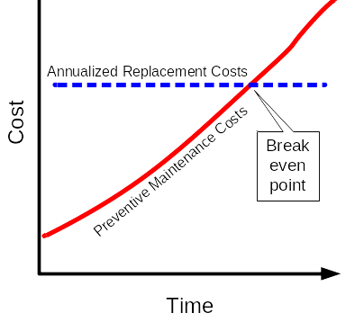
As mentioned above, a key decision is whether to replace aging or obsolete components. While it is recognized that preventive maintenance will allow most types of equipment to operate longer, it is also generally understood that there will be a point of diminishing returns. That is, at some point, there is little more that can be done to keep a worn out or obsolete device functional and the cost of preventive maintenance exceeds the annualized cost of replacement. Figure 4-3 presents a generic representation of preventive maintenance cost per year versus the cost of replacement, annualized over the expected life span of the device. The point where the preventive maintenance costs per year are the same as the annualized replacement costs is considered break-even and it would be wasteful to continue to keep the old equipment in service.
Figure 4-3 PM Versus Annualized Maintenance Costs
Significant amounts of empirical data are needed to calculate or forecast this break-even point. The only feasible way to collect these data and perform this type of analysis is via a computerized maintenance management system (CMMS). The minimum data required for this type of analysis includes the original purchase price, replacement cost, PM and repair cost history, MTBF, and MTTR. Chapter 7 discusses the characteristics of CMMS and other maintenance analysis tools. The use of a CMMS tool is highly recommended because it provides a way to allocate maintenance, repair, and replacement budgets more efficiently. The CMMS will also provide much of the history, documentation, and justification for the maintenance budget.
A life-cycle analysis of communications alternatives is critical to every TMS. There are both policy and technical issues that should be considered for the operation and maintenance of this communications infrastructure.
- Agency-Owned Versus Leased: This is often more of a policy decision than a technical one. Many of the TMS’s referenced in the research, especially those built prior to 1996, have a communications infrastructure that is owned entirely by the Agency. Since 1996, the year the Telecommunications Act was passed, competition in the commercial data communication market has (somewhat) improved both the cost and reliability of leased communications service. Tennessee DOT evaluated the life-cycle cost of leased service versus owned and concluded, based largely on the cost of maintaining a fiber-optic communications plant, that leased services were more cost effective. This decision was also influenced by the fact that the State of Tennessee had a favorable existing contract for leased services that included a service level agreement for on-going maintenance.
- Design Alternatives and Their Impact on Maintenance: The evaluation the life-cycle cost of TMS design should be considered when developing alternatives. This is particularly important for the communications infrastructure, since it is typically the most expensive element of a TMS in terms of both the capital and O&M costs.

Staffing and Training Considerations
The availability of properly skilled and trained staff throughout the life-cycle of the TMS is critically important to getting the most out of any system and assuring that it meets its intended concept of operations throughout the system’s intended life-cycle. There were several practices related to this critical need that were noted in the literature research and interviews. These include:
- Pre-Qualification of Contractors: Often a general pre-qualification process exists for many Agencies. However, as the skills change and complexity increases in a typical TMS, the pre-qualification process must be upgraded to match.
- Training by Vendors: Procurement contracts should include a requirement for on-site training of Agency staff in maintenance and operations of the equipment, preferably conducted by the vendor.
- Training by Contractors: Procurement contracts should also include a requirement for on-site training of Agency staff in the maintenance and operation of the assembled systems, including software, hardware, and devices.
- Training Library: The operating Agency should maintain a library of system documentation and, if available, a videotape library of training.
- Staff Retention: This can be difficult in a high-tech environment, but there are ways to improve retention, such as providing for additional training, allowing travel to technical conferences, and workshops and other non-salary related perquisites for Agency staff.
- Staffing Qualifications: If procuring contract maintenance staff, specify minimum qualifications by position and require that contractor personnel submit resumes and proof of required certifications. Periodically check on contractor personnel and require pre-approval of new staff prior to approving invoices for their work.
- Estimating Staffing Numbers: Staffing guidelines are often Agency-specific, due to the different organizational structures across the country. However, there were several references found in the literature that provide methodologies for calculating workload and using these workload estimates to generate full-time-equivalent (FTE) staff position descriptions.
Keep in mind that the only constant is change. Not only will the system change over time, but also the concepts of operation and requirements will also likely change, as will the stakeholders who generated the requirements. The key to success in this environment is flexibility and a good understanding of priorities for both operational and maintenance concepts and requirements.

TMS Maintenance Program

Introduction
The objective of this chapter is to guide the practitioner in developing a maintenance program. A maintenance program provides a plan on what maintenance is, how it is performed, how it can be budgeted, and why it is needed. It is a document that describes the needs to persons outside the direct department with maintenance responsibilities and provides guidance to those within that department.
This chapter lays out the logistics for producing a maintenance program. Many of the details contained within the plan are available in other chapters of this report. The practitioner will need to adapt the plan to suit the local institutional and organizational conditions and to meet the needs of the Agency’s ITS hardware.
As defined in Chapter 1, responsive maintenance is the repair or replacement of failed equipment and its restoration to safe, normal operation. Preventive maintenance is the activity performed at regularly scheduled intervals for the upkeep of equipment.
Maintenance is the upkeep of property and equipment. Within the context of TMS maintenance activities, it covers a wide range of activities — from extreme emergencies, when roadway crashes may have caused state property to fall and block the freeway, through scheduled activities such as cleaning camera housings and backing up hard drives that keep the control systems running.
The topics covered in this chapter mirror the contents of a maintenance program. They include:
- Introduction to Maintenance: Describes what maintenance is and how a maintenance program can be considered as a part of a larger statewide or Agency-wide effort and why considering the program this way is advantageous.
- Development of a Maintenance Program: Defines the overall objectives and how they may be measured.
- Institutional Issues: Discusses the relationships between a maintenance program and other parts of the same Agency and external institutions.
- Budgeting: Examines how budgets can be developed and supported.
- Implementation Options: Covers such issues as contracting and warranties.
- Maintenance Procedures: Defines what is maintained, what actions are performed, and how often they are performed.
The remaining sections of this chapter define how a plan can be created materials in other sections of this document.

Introduction to Maintenance
Maintenance programs for TMS elements are best considered as part of the larger and more conventional maintenance activities of an Agency. Resurfacing, safety, and rehabilitation programs are all ongoing activities in that all Agencies are involved. Considering TMS maintenance as a critical part of the wider maintenance activities allows such an Agency program to be considered the within the framework of Agency operations.
Having a mission is an effective tool in selling maintenance to individual Agencies and other institutions. The following example is from the Caltrans Division of Maintenance:
“The Division of Maintenance's mission is to protect public safety and preserve California's Highway system by maintaining and repairing the system and responding to emergencies so travelers and goods reach their destination safely and efficiently.
Our vision is to be the World Leader in Maintaining a Safe and Efficient Highway system. Through the efforts of dedicated and skilled employees, we will:
- Put employee and public safety first.
- Protect the public's investment by doing the right thing at the right time.
- Enhance the quality of travel.
- Be recognized for our professionalism, innovation and responsiveness.”
A maintenance program should be developed during the initial design stages of an ITS program. Section 8 of the National Architecture for ITS (Version 4) states:
“ITS shall provide Maintenance and Construction Operations (MCO) functions to support monitoring, operating, maintaining, improving and managing the physical condition of roadways, the associated infrastructure equipment, and the required resources. MCO shall focus on four major functions: 1) the Maintenance Vehicle Fleet Management function, to monitor and track locations and conditions of fleets of maintenance, construction, and specialized service vehicles; 2) the Roadway Management function, to monitor and forecast conditions and manage treatment of roadways during various travel conditions; 3) the Work Zone Management and Safety function, to support effective and efficient roadway operations during work zone activities; and 4) the Roadway Maintenance Conditions and Work Plan Dissemination function, to coordinate work plans and to communicate conditions. This User Service will utilize ITS systems and processes to support interchange of information among diverse groups of users, to improve efficiency and effectiveness of operational, maintenance, and managerial activities.” (See http://www.dot.ca.gov/hq/maint/)
There are significant advantages in emphasizing the maintenance program in the early stages of ITS design. During ITS architectural development, institutional issues and connections between jurisdictions are made and agreements are forged. The maintenance program in many locations operates services across these boundaries and maintenance should be included as a component of the institutional agreements. During the early stages of ITS design, the locations for control centers and depots are considered. The staffing of a maintenance program is critical to keeping the system running.
Early planners of ITS often locate maintenance depots on an expedient basis of what land is available to the state and adjacent to a highway. The needs of the maintenance staff should be included in such plans. Maintenance staff need to access specific hardware often in the middle of the night (snow plows, diggers, cherry pickers, etc.). Staff access staff to maintenance depots needs to be considered in the light of their operations. For example, the Washington State DOT maintenance depot at Hyak on I-90 east of Seattle is at the summit of Snoqualmie Pass; it is there that the big equipment and the central computer are housed. The location is often inaccessible, although the facility is outfitted with beds and a kitchen for long-term stays. Some locations allow the maintenance crews use of Agency vehicles to commute home at night in order to reduce response times to access equipment outside of normal operational hours. Activities and geography need to be accommodated within the staffing issues associated with early stages of ITS planning.
During the early stages of the plan development process, specific ITS devices are selected. The awareness of maintenance difficulties are often now included in the selection of, for example, non-intrusive detectors, ensuring that the maintenance activity does not cut into the road surface. However, this process should be taken further by incorporating the extent of the work, the frequency, and the level of staffing expertise into the device selection criteria. For instance, the maintenance requirements of dynamic message signs might include the ability to:
- Readily remove individual character modules.
- Require no special tools.
- Provide access while traffic still flows.
- Provide wiring diagrams inside each unit.
- Allow additional data ports to easily support on-site debugging and testing.
- Provide diagnostic testing tools and indicators.
Getting the maintenance staff involved in the specification writing to include these types of elements will save effort and make the system, when installed, easier to maintain. The concept of ensuring that all activities that affect maintenance should be considered as part of the program will help later with institutional issues. In some cases, there are separate departments that are used for planning and design rather than operations and maintenance. In these instances, it is harder to develop system designs that accommodate maintenance activities and additional efforts should be made to ensure coordination.

Development of a Maintenance Program
The development of a maintenance program requires that there be input from a variety of other plans and budgets within the Agency. It is common for operations and maintenance to be considered together. This results from the fact that operations and maintenance are frequently funded as a single budget item. Operations are more evident than maintenance, because the former have a more immediate impact on traffic and because operational control centers are designed with public relations in mind.
The development of a maintenance program needs to define the mission and vision of the program put into the context of the other programs and activities within the Agency. Getting maintenance into the minds of the related departments and institutions may require a selling the whole program. The intent is to ensure that the maintenance goals and missions are included in the thinking of others. Web pages, short brochures, and full maintenance plans have all been used to achieve this end. In some cases, these plans as formalized (as noted in the Caltrans’ example, above; Oregon DOT has a formal maintenance plan). In other cases, the maintenance activities for TMS are combined with operations and budgeted and funded as an integral unit.
A maintenance program is intrinsically linked to the operations and design of the Agency’s traffic management center. It is also linked to the other broader aspects of the Agency’s programs insofar as the staff is often part of that department. There are unfortunate examples where the operations group has added ITS devices that the separate maintenance group did not, or could not, maintain and the system fell into disrepair. Setting relationships to the TMC staff, the relevant police, fire, and emergency Agencies, as well and those organizations responsible for incident management, will assist in the development of a program. The issue of a formal memorandum of understanding is discussed in Chapter 2 of this report.

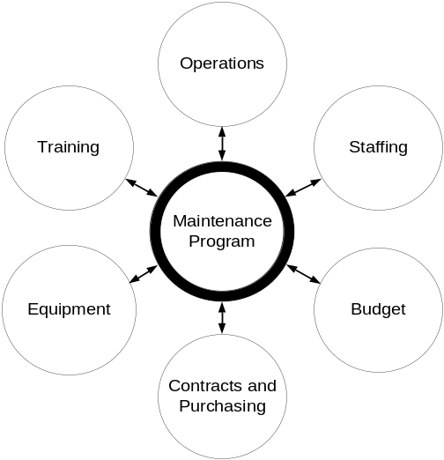

Figure 5-1 Relationships Among Maintenance Program Components

As illustrated in the Figure 5-1, a maintenance program requires a close and well-defined relationship with:
- Operations,
- Training,
- Equipment,
- Contracts and Purchasing Department,
- Budgetary Processes, and
- Staffing.
A maintenance program needs to be developed in conjunction with the operations group. The program development should, at a minimum, consider:
- Policy concerning the missions and objectives.
- Goals in terms of operational levels concerning what percentage of devices need to be working at any time.
- The procedures and processes to keep the investment operating.
- Safety procedures for the various staff with particular emphasis on workers on-site.
- Costs and staffing levels necessary to keep the plant at a suitably high operational level.
The operations group within an Agency will need to be involved with the maintenance program development. There are operational aspects that affect the timing and frequency of the maintenance program. There are few aspects of operations that do not affect such a program. Backing-up of operating systems, replacing video displays, coordinating the cleaning operations centers, and site visits all need to be considered as a part of the program. In some circumstances, the operations staff are used to ensure that contractors are on-site at the right time and are following the correct safety procedures. The operations group needs to be in constant audio contact with the maintenance staff and the program needs to ensure that radios or cell phone facilities are planned and budgeted.
Training is an important part of the maintenance program. Maintenance staff training will often include the Agency’s safety and operational procedures; the detailed maintenance procedures for the individual devices; and the operation and calibration of test equipment. In addition, the maintenance staff often needs to be trained in the use of differing vehicle types such as cranes, heavy plant equipment, etc. The development of a maintenance program should allocate budget for training new employees, training employees on new technologies and providing refresher courses to keep all staff aware of the safety procedures. Maintenance of data archives, updating various databases, and running configuration management on the various pieces of software in the TMC should also be part of a maintenance program. These elements of the program require specialized computer skills and such staff capability should be included in the program.
Maintenance operations require a range of equipment from the highly specialized electronics used for fault finding and repairing fiber-optics, through large trucks used to spread material in response to spills and inclement weather. A maintenance program needs to include detailed estimates of the entire Agency’s requirements, and how they are to be purchased and maintained. The maintenance staff is likely to have to allocate time to the maintenance of their own plant. Lifetimes, salvage values, and replacement also need to be considered as equipment wears out and is lost or broken. This is one aspect that can feed into the decisions concerning the use of contractors. Expensive equipment, such as fusion-splicing equipment to mend fiber-optic, requires trained personnel. In addition, the number of times such facilities are needed is infrequent. Contracting options or keeping such skills on hand by use of retainer payments may form part of the maintenance program.
Other contracting options are described in earlier sections of this report. However, a maintenance program should involve the contracting and purchasing departments of the Agency to ensure that invoicing, payments, contracting options, and all the relevant terms and conditions are accommodated. Some contracting options and payment procedures, particularly those for responsive maintenance, can become complex. These procedures should form part of the maintenance program planning.
The staffing of a maintenance program is often the key factor in its success. Estimates of staffing levels can be found in Chapter 3. TMS’s are often an accumulation of many years of growth spread over a wide range of contracts. Maintenance staff tend to accumulate a lot of details concerning the quirks and idiosyncrasies of their particular communications network and the devices being operated. Keeping these staff on-board, and providing them with an attractive career path, is one of the major problems in developing a maintenance program. The Agency management needs to provide a rewarding working environment to ensure that vital staff assets are not lost.

Defining Mission and Objectives
The inclusion of a mission-and-objectives definition is a useful and salutary exercise for the developer of a maintenance plan. By defining the objectives the maintenance operations, the developer of the plan has to provide a balance between the various resources available. Some Agencies insist that all items that break are fixed as soon as possible. Others are continually trying to catch up with the required responsive maintenance. Others consider preventive maintenance a luxury they have no time or budget for. A mission statement that defines the priorities can assist in the development of a plan.

Budgeting
Traditionally, maintenance funding has been the responsibility of the operating Agency. In a few cases, such as Virginia, there is a statutory requirement that maintenance funds come “off the top” of the budget, i.e., that maintenance is funded first and then capital projects. In the case of TMS projects, O&M costs are rarely included beyond the first year of operation. Typically, the capital cost for implementing TMS elements are programmed for one category of funding while the O&M must come from another funding category.
The ISTEA legislation and later TEA-21 legislation have relaxed certain FHWA restrictions on federal aid funding operations and management of TMS activities. CMAQ funds can be used for certain O&M activities. There are still roadblocks to using these categories for TMS. The CMAQ funding is limited to certain qualifying projects and has a three-year time limitation. Federal funding for O&M must compete with capital projects for prioritization. This means it often loses out to the larger more visible projects.
The Volpe National Transportation Systems Center (VNTSC) recently interviewed several cities and MPO’s regarding the funding of O&M activities. These interviews indicated a lack of knowledge about the availability of, and guidelines for, use of federal funds for O&M. Those interviewees that had some knowledge of the availability of O&M funding indicated some reluctance to pursue this source of funding because of the competition with capital projects and the level of effort involved (i.e., it takes the same amount of effort to secure funding for a large capital project as it does for a relatively small O&M project).
The relative newness of TMS projects means that many Agencies do not have much experience with maintenance requirements. There are quite a few references (Ref 1, 7,) available, however, to assist in developing budgets for TMS maintenance. Also, the maintenance budgets presented by some of the survey sites may be helpful in comparison.
The Caltrans District 7 Maintenance Plan (Ref. 8) is unique in that a detailed methodology is used to develop workload standards for maintenance of each device type. This methodology uses mean time between failure and mean time to repair (MTTR) for corrective maintenance activities, as well as time spent in preventive maintenance. An average travel time to conduct each activity is calculated based on the location of the maintenance facility and the mean distance to all devices of a given type. Using these data, an estimated labor workload can be calculated for each device type (per unit per year).
Funding of maintenance programs has proven to be very troublesome in many Agencies. ITS implementations are typically justified on the grounds that they will reduce congestion and provide information to the public. The many references on the FHWA benefit cost website (Ref. 9) show justification for these expenditures. However, maintenance programs that can be justified as a way to ensure the continuation of these benefits are often harder to sell. The continued operation of hundreds of roadside devices can also be jeopardized by the costs of running the TMC that is using the information these devices provide. It is important to emphasize the relationship between surveillance, operations, and the delivery of data to the public.
The budgeting section of a maintenance program needs to emphasize the fact that operations and maintenance costs can be similar. Generally there are about half as many maintenance positions as there are operator positions within a TMC. This ratio can vary according to the type of ITS, geography, and the specific structure of the various responsibilities. However, this can be used as a starting point in the budgeting process. Later in this chapter, processes for calculating the staffing and inventory levels are described. Inventory, staffing, plant, and vehicles, as well as contracted services, all make significant contributions to the cost of maintenance.
Although the use of Federal funds is allowed for maintenance projects, there are impediments to using these. Some states maintain that federal funding is not available for maintenance.
“But federal funds are not available for maintaining state roads, the Department said.” (The Associated Press, June 1, 2002, concerning reductions in maintenance in Alaska.)
Since Federal funds are available, the developer of the maintenance program should investigate opportunities with the local FHWA representative.
The funding of some maintenance programs is enhanced by monies from other jurisdictions including local cities and counties that use state maintenance staff for their devices. The state signal shop providing maintenance to county signals is one example of this. In the case of the City of Charleston, the City maintains the signals in the adjacent jurisdictions in return for an annual fee. Similar opportunities are available with toll authorities and large sporting complexes that may have extensive video systems.
Current practice with the funding of maintenance programs is varied. It is difficult to determine the size of individual budgets as there is no common basis on how funding occurs. In some Agencies, operations and maintenance are combined and a group of staff are dedicated to both functions and the budget item for maintenance may be just for keeping inventory current. In other locations, there may be an entirely independent budget for TMS; this seems more common where the maintenance activities are contracted out and therefore a specific budget item is required. Some Agencies do not have separate budgets for TMS’s — the upkeep of the devices and the centers become another item within the entire Agencies’ budgets.
Within these frameworks, budgets are often allocated by district; structures can be very different between adjacent jurisdictions in the same state. Given this complexity of choices, the developer of the maintenance program should consider multiple approaches to fund maintenance and develop arguments and justifications for the budget that are more liable to be successful in each area. For example, putting long-term warranties to cover maintenance activities on devices may be included in the construction budget. Caltrans installed most of its ramp metering system by ensuring that the standard construction plans for a ramp included all the appropriate devices, power, and communications connections. Connecticut DOT when contracting for DMS, incorporated maintenance contracts in the bid for the signs.
The process for developing an estimate for the budget for a maintenance program includes:
- Estimating staffing requirements by system.
- Estimating the management needs — normally one or two persons for a typical TMS.
- Calculating the ITS device’s annual inventory replacement costs — see Design Life and MTBF.
- Estimating maintenance for vehicles and plants, including salvage and replacement values.

Implementation Options
There are two basic options for conducting TMS maintenance: (1) in-house resources, or (2) contract maintenance. For the vast majority of TMS locations cited in the literature, there was some combination of in-house maintenance and contract operations. Our survey also was reflective of this hybrid approach to providing maintenance, but included two extremes. Cincinnati has a turnkey O&M contract that covers all system maintenance. The local Ohio DOT district office was scheduled to assume more responsibility and involvement in the ARTIMIS system beginning in April 2002, and this may change in the future. The Department explained that one of the drawbacks of a turnkey O&M contract is that lack of involvement sometimes means a lack of control.
The other end of the spectrum is the Albany, New York system. Here, the New York State DOT handles practically all system maintenance for this 35-mile freeway system. Some maintenance responsibilities for the TOC are shared with the State Police who are co-located in the same facility. They have recently negotiated an agreement with the State University to provide maintenance on the CCTV cameras. A software maintenance agreement with the vendor of the central system software was also recently executed as part of an overdue upgrade.
The use of, and experience with, device and system warranties was examined in the survey. The general consensus was that while warranties are useful and desirable, they tend to be difficult to administer. Warranties generally cover the replacement of failed hardware components; they do not, however, usually cover the labor costs to repair the components or install replacement hardware. Of course, during the bid process, the installation contractor could theoretically be required to provide the repair labor — doing so, however, can make it difficult for contractors to compete. Retainage of a percentage of the contractor’s funds until the end of the warranty period presses the contractor to minimize the warranty length. On the other hand, eliminating the retainage leaves the contractor with less incentive to furnish warranty and repair labor service.
Maintenance contracts sensitive to the needs of contractors are more likely to be successful than are those which are substantially oblivious to these needs. For example, in Virginia, VDOT initially advertised for contract maintenance of a large freeway management system. This was to be the first such contract covering all field devices. The RFP requirements included little detail about the status of existing system devices and lots of stringent requirements for response time and repair time. The few contractors choosing to respond all priced the project much higher than the amount anticipated in the Department’s budget, primarily because these contractors perceived the risk to be so high. A subsequent re-advertisement of this maintenance contract was preceded by a pre-bid conference at which many details about the existing system were discussed and feedback solicited from the potential contractors. The result was a much more competitive procurement with prices within the Department’s budget.
The program in this area needs to consider the breakdown of operations to determine which, if any, elements of the maintenance procedures should be contracted out. Section 7.2, Options for Contracting, describes the contract options available to Agencies and how to make informed decisions. It also includes a sample contract.

Maintenance Procedures
There are several elements to the procedures:
- Inventory: See Section 2.5, Maintenance Management System and Software.
- Preventive Maintenance Procedure: Defined in Appendix B, Maintenance Procedures for ITS Devices.
- Responsive Maintenance and Emergency Maintenance: See Section 1.5, Definitions and Concepts.
The developer of the maintenance program will need to determine responsibilities for each of these elements. Then a procedures document should be prepared that offers guidance to the maintenance staff and provides a basis for the staff estimating spreadsheet.
Most Agencies do not currently have maintenance plan documents. Agencies often have lists of maintenance procedures and references to maintenance in operations documents. However, dedicated maintenance plans are not readily found.
The maintenance program must specifically identify the TMS elements to be included in preventive maintenance. For corrective maintenance, a predetermined priority list is a minimum requirement. Ideally, a process can be defined for assigning priorities for corrective maintenance as problems occur.
The maintenance program should include descriptions of maintenance actions and frequencies for the following minimum elements:
- TMC Hardware,
- TMC Software,
- Video Walls,
- Communications Plant,
- Surveillance Devices,
- Signal Controllers,
- Video Systems,
- Web Pages,
- Dynamic Message Signs,
- Highway Advisory Radio,
- Environmental Sensor Stations, and
- Public Information Dissemination.
The information on the specific procedures for maintaining devices is contained in Appendix B. The procedures associated with starting a maintenance action can come from a variety of sources, as illustrated in Figure 5-2 that indicates the typical flow process when dealing with a responsive maintenance activity.

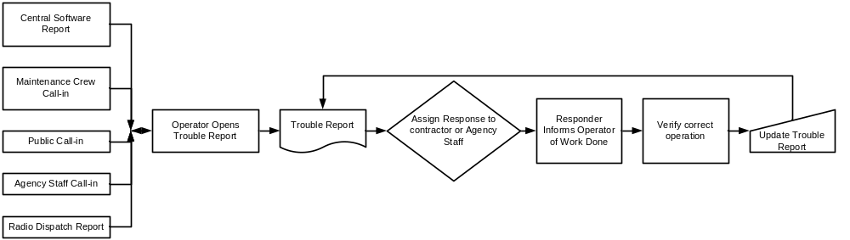
Figure 5-2 Responsive Maintenance Process
After the Maintenance operator receives notification, he or she opens a trouble report. Examples of such reports are shown in Appendix A. There are existing maintenance programs that keep track of trouble calls and incidents. These features are sometime integrated with the central control software; stand-alone products are also available.
Regardless of the Agency’s procedures, the appropriate responder is notified, the responder acts on the response, the responder reports back on the outcome to the Maintenance operator, and the operator verifies that the work is done and updates the trouble report.

Performance Measures
Measuring the performance of the maintenance program provides information both on organization and management issues, in addition to the reliability of various ITS devices. Having metrics of the system provides continual feedback on how well the system is operating.
The metrics associated with the structure of the plan could include:
- Down time of the entire system,
- Time required to handle responsive maintenance,
- Time required to handle emergency maintenance,
- Negative calls from the public, and
- Adverse press.
The program developer will need to consider these and possibly other metrics that help the Agency assess the success of the program. Although the list above reflects negative issues only, this is to some extent a consequence of maintenance. There is no good news as if all the maintenance is not performed. The best that can be hoped for is that everything works all the time and minimum expectations are met.
The metrics associated with the individual components could include:
- For each device type:
- Time to detect failure
- Mean time to respond
- Mean time to repair
- Failure rate
- Down time of the entire system
- Number of times the system is down

Inventory, Databases and Asset Management
A clear message from all resources and participants involved is that whatever type of maintenance program is selected for a TMS, it must be well-organized and efficient. One of the best tools to help with this is a Maintenance Management System that includes, at a minimum, an inventory or database of all major devices and subsystems within the TMS.
A step-up from a simple inventory based MMS is an Asset Management System (AMS). AMS’s are available from a variety of commercial vendors and are widely used in both public and private practice. Typical features will include the use of bar codes or similar identification procedures for tagging each item in the inventory; tracking of MTBF and MTTR measures; comparative analysis of maintenance activities by location, vendor, time of year, etc.; and reporting of various maintenance and inventory characteristics.
In setting up MMS’s and AMS’s, the following key considerations should be taken into account:
- Detail to Inventory: Determine the level of detail to maintain in the inventory. Typically, the Agency should inventory down to the lowest level of device repair or replacement. For example, if traffic signal controllers are repaired at the circuit board level, then the inventory should cover both controller assemblies and their circuit boards.
- Maintain a Structured Inventory: The inventory should be able to separately track where the TMS devices reside and whether they are installed in the field or TMC or stored in a warehouse, shop, or repair facility; and whether they are held by contractors or kept in maintenance vehicles as ready-spares.
- Bar-Code or Tag System: Similar to the UPC codes on retail packaging, the Agency should consider using a bar-code system to facilitate the inventory. The bar-code or tag is tracked in the inventory to the device serial number. Hand-held scanners are optional, but can quickly read the tag as the inventory is updated during maintenance activity.
- Automated Event Logging: The use of a bar-code or tag system and hand-held scanners in conjunction with an MMS can be used to swiftly capture inventory and maintenance event tracking data. This largely eliminates time-consuming paper tracking.

Managing a Maintenance Plan
With the maintenance plan developed, approved, and funded, there must be a structured practice for managing the plan. The basics of plan management are similar to other practices and should include:
- Performance Monitoring: Regular checking of plan metrics and budgets against the maintenance plan projections.
- Oversight Support: Support of the plan over time and its relationship to training and staffing issues.
- On-Going Multi-Year Planning: Plan for changes in TMS components, emerging issues, changes in the process, and new or evolving needs of stakeholders. Check that the level of effort and resources are appropriate to support a multi-year maintenance program plan.
- Operational Needs: Confirm that the maintenance concept is consistent with operational concept.
- Safety Considerations: Verify that maintenance activities are being performed according to required safety procedures.
- Documentation: Create and maintain reports on TMS status and maintenance activities, problems, concerns, etc. This should include status reports for TMS and Agency administration.
- Configuration Management: Document and approve those maintenance activities that modify system configuration, such as replacing a failed TMS device with an upgraded model.
There are tools, such as commercially available asset management systems, that can help with the operation and management of a maintenance plan. There is also a new User Service within the National ITS Architecture that can help describe and specify a function to support the maintenance of a TMS. This service, “Maintenance and Construction Operations,” is introduced in the new version of National ITS Architecture (Version 4.0).
The following are requirements of the user service “Maintenance and Construction Operations” that an ITS device should provide (the numbering scheme is the same used in the National ITS Architecture):
Table 5-9 ITS User Services for Maintenance & Construction
8.1.0 | ITS shall provide Maintenance and Construction Operations (MCO) functions to support monitoring, operating, maintaining, improving, and managing the physical condition of roadways, the associated infrastructure equipment, and the required resources. MCO shall focus on four major functions: (1) the Maintenance Vehicle Fleet Management function, to monitor and track locations and conditions of fleets of maintenance, construction, and specialized service vehicles; (2) the Roadway Management function, to monitor and forecast conditions and manage treatment of roadways during various travel conditions; (3) the Work Zone Management and Safety function, to support effective and efficient roadway operations during work zone activities; and (4) the Roadway Maintenance Conditions and Work Plan Dissemination function, to coordinate work plans and to communicate conditions. This User Service will utilize ITS systems and processes to support interchange of information among diverse groups of users, to improve efficiency and effectiveness of operational, maintenance, and managerial activities.
8.1.1 | Maintenance and Construction Operations shall provide a Maintenance Vehicle Fleet Management (MVFM) function to (1) schedule and dispatch; (2) monitor and track location; and (3) monitor operational conditions and maintenance requirements of public and contracted fleets of maintenance, construction, and specialized service vehicles. This function includes interactions among Traffic Managers, Supervisors, Dispatchers, Field Crews, Construction Crews, Vehicle Maintenance Crews, Equipment Maintenance Crews, Weather Services Organizations, and Information Service Providers.
8.1.2 | Maintenance and Construction Operations shall provide a Roadway Management (RWM) function to (1) monitor traffic, road surface, and environmental conditions; (2) forecast traffic and road surface conditions to support management of routine and hazardous road condition remediation; and (3) communicate changes in conditions. This function includes interactions among Traffic Managers, Supervisors, Dispatchers, Field Crews, Construction Crews, Asset Managers, Planning Agencies, and Weather Services Organizations.
8.1.3 | Maintenance and Construction Operations shall provide a Work Zone Management and Safety (WZMS) function to provide support for the effectiveness, safety, and efficiency of roadway operations during all work zone activities. This function includes interactions among Traffic Managers, Supervisors, Dispatchers, Field Crews, Construction Crews, Public Safety Organizations, Information Service Providers, and Travelers.
8.1.4 | Maintenance and Construction Operations shall provide a Roadway Maintenance Conditions and Work Plan Dissemination (RMCWPD) function to provide inter- and intra-Agency coordination of work plans. This function includes interactions among Traffic Managers, Supervisors, Planning Agencies, Public Safety Organizations, and Information Service Providers.

Defined in the National ITS Architecture, the Maintenance and Construction Management Subsystem monitors and manages roadway (and TMS) infrastructure construction and maintenance activities. Representing both public Agencies and private contractors that provide these functions, this subsystem manages fleets of maintenance, construction, or special service vehicles. The Maintenance & Construction Vehicle subsystem resides in maintenance, construction, or other specialized service vehicles or hardware and provides the sensory, processing, storage, and communications functions necessary to support highway maintenance and construction. All types of maintenance and construction vehicles are covered, including bucket trucks, heavy equipment, and supervisory vehicles.
Additionally ten Market Packages, defined by sets of equipment packages required to work together (typically across different subsystems) to deliver specific transportation services and the major architecture flows between them and other important external systems, which support the user service of are given as following:
Additionally, ten ITS “market packages” are identified to support the user service of “Maintenance and Construction Operations”:
- Maintenance and Construction Vehicle Tracking,
- Maintenance and Construction Vehicle Maintenance,
- Road Weather Data Collection,
- Weather Information Processing and Distribution,
- Roadway Automated Treatment,
- Winter Maintenance,
- Roadway Maintenance and Construction,
- Work Zone Management,
- Work Zone Safety Monitoring, and
- Maintenance and Construction Activity Coordination.
Not all of these market packages are necessary for every MMS, but demonstrate the range of possibilities. Table 5-2 shows subsystem and equipment packages associated with the Maintenance and Construction market packages.
Table 5-2 Market Packages and Equipment Packages for Maintenance & Construction
ITS Market Package | Required Subsystems | Required Equipment Packages
Maintenance and Construction Vehicle Tracking | Maintenance and Construction Management  Maintenance and Construction Vehicle | MCM Vehicle Tracking  MCV Vehicle Location Tracking
Maintenance and Construction Vehicle Maintenance | Maintenance and Construction  Management  Maintenance and Construction Vehicle  Vehicle | MCM Vehicle and Equipment Maintenance Management  MCV Vehicle System Monitoring and Diagnostics  Vehicle Safety Monitoring System
Road Weather Data Collection | Emergency Management  Emergency Vehicle Subsystem  Information Service Provider  Maintenance and Construction Management  Maintenance and Construction Vehicle  Roadway Subsystem  Traffic Management  Transit Management  Transit Vehicle Subsystem  Vehicle | Emergency Environmental Monitoring  On-Board EV Environmental Monitoring  ISP Probe Information Collection  MCM Environmental Information Collection  MCV Environmental Monitoring  Roadway Environmental Monitoring  Roadway Probe Beacons  TMC Environmental Monitoring  TMC Probe Information Collection  Transit Environmental Monitoring  On-Board Environmental Monitoring  Smart Probe
Weather Information Processing and Distribution | Emergency Management  Information Service Provider  Maintenance and Construction Management  Traffic Management  Transit Management | Emergency Environmental Monitoring  Basic Information Broadcast Interactive Infrastructure Information  MCM Environmental Information Processing  TMC Environmental Monitoring  Transit Environmental Monitoring
Roadway Automated Treatment | Maintenance and Construction Management Roadway Subsystem | MCM Automated Treatment System Control  Roadway Automated Treatment
Winter Maintenance | Maintenance and Construction Management  Maintenance and Construction Vehicle  Traffic Management | MCM Maintenance Decision Support  MCM Winter Maintenance Management  MCV Winter Maintenance  TMC Incident Dispatch Coordination/Communication
Roadway Maintenance and Construction | Maintenance and Construction Management  Maintenance and Construction Vehicle  Roadway Subsystem  Traffic Management | MCM Maintenance Decision Support  MCM Roadway Maintenance and Construction  MCV Infrastructure Monitoring  MCV Roadway Maintenance and Construction  Roadway Infrastructure Monitoring  Traffic Maintenance
Work Zone Management | Maintenance and Construction Management  Maintenance and Construction Vehicle  Roadway Subsystem  Traffic Management | MCM Work Zone Management  MCV Work Zone Support  Roadway Work Zone Traffic Control  TMC Work Zone Traffic Management
Work Zone Safety Monitoring | Maintenance and Construction Management  Maintenance and Construction Vehicle  Roadway Subsystem | MCM Work Zone Safety Management  MCV Vehicle Safety Monitoring  Roadway Work Zone Safety
Maintenance and Construction Activity Coordination | Emergency Management  Maintenance and Construction Management  Traffic Management  Transit Management | Emergency Response Management  MCM Work Activity Coordination  TMC Work Zone Traffic Management  Transit Center Multi-Modal Coordination

Policies, Contracts, and Procedures
The specific structure of a maintenance policy is less important than simply having one in the first place. There are practices and procedures that are helpful in implementing the maintenance policies. For instance, if contracting for maintenance, one should recognize what it may take for a maintenance contractor to economically provide maintenance on short-notice or even a full-time basis. This may mean increasing the overall scope of the maintenance contract so that there is enough work to justify assigning contractor personnel to the TMS project. Similarly, the duration of the maintenance contract will have an impact on how many potential bidders it attracts and how the contract is staffed. A longer contract — i.e., two years or more with additional option years — may enable the contractor to relocate staff to the TMS area.
Once there is a general agreement that maintaining the TMS is part of the Agency’s policy, several key factors should govern details of the policy. For instance, an important policy objective should be protection of the investment — built on the rule-of-thumb that equipment maintenance is generally less expensive than equipment replacement. If systems fail and basic operations degrade, a significant portion of the initial financial investment is lost.
Configuration Management should be included as part of a maintenance policy; this helps ensure that the original functionality of the system is maintained throughout its life. Management of the Maintenance plan, described in the previous section, like many TMS-related functions, requires level-of-effort on the part of the Agency, regardless of whether it is contracted out or performed in-house. The literature research and site interviews indicated that this work is often added to the duties of existing positions within the Agency, leaving little time to get everything accomplished.
The Level of Service (LOS) encompassing operations and maintenance focuses on providing the traveling public with an operational system and the functions and benefits of that system. Those LOS measures that can be used as part of maintenance policies include:
- Mean time between failures for each device type.
- Percentage of down time of the control system.
- Average number of inoperative cameras.
- Annual maintenance costs.
- Time taken to repair each device type.
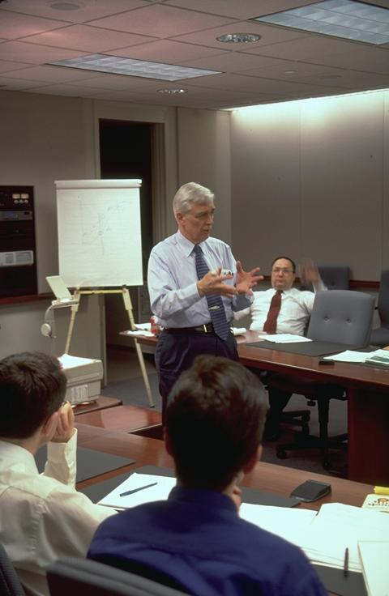
Each Agency should include in its policy appropriate metrics for the LOS of maintenance. This will allow the effectiveness of the various procedures to be quantitatively evaluated. It will also facilitate the identification and monitoring of trends over time; these can be indicators of improvements or degradation of service.
Figure 5-3 Training Underway
Staffing and Training
The availability of properly skilled and trained staff is critically important to getting the most out of any TMS and assuring that it meets its intended concept of operations throughout the system’s intended life-cycle. Several practices related to this critical need were noted in the literature research and interviews, including:
- Pre-Qualification of Contractors: Often a general pre-qualification process exists for many Agencies; however, as the skills change and complexity increases in a typical TMS, the pre-qualification process must be upgraded to match.
- Training by Vendors: Procurement contracts should include a requirement for on-site training of Agency staff in maintenance and operations of the equipment, preferably conducted by the vendor.
- Training by Contractors: Procurement contracts should also include a requirement for on-site training of Agency staff in the maintenance and operation of the assembled systems, including software, hardware, and peripherals.
- Training Library: The operating Agency should maintain a library of system documentation and, if available, a videotape library of training.
- Staff Retention: This can be difficult in a high-tech environment, but there are ways to improve retention, such as providing for additional training, allowing travel to technical conferences and workshops, and other non-salary related perquisites for Agency staff.
- Staffing Qualifications: When procuring contract maintenance staff, minimum qualifications by position should be specified and contractor personnel should be required to submit resumes and proof of the required certifications. Procedures should be in place for pre-qualifying new contractor staff.
- Estimating Staffing Workloads: Although staffing requirements are often Agency-specific due to differences in organizational structures, there are general methodologies in the literature for calculating workload. These workload estimates can be used to generate full-time-equivalent (FTE) staff position descriptions.

Coordination with Operations
The basic Systems Engineering Life-Cycle process, described in Chapter 3, concludes with “operations and maintenance.” We have extended the engineering process to encompass a parallel maintenance concept that provides a structured procedure for validating and confirming maintenance requirements and execution, thus supporting the original concept of operations.
To validate the process, there must be a close coordination between maintenance and operations. The following is a list of key functions and activities that can help achieve this coordination:
- TMS operational methods that provide assistance to maintenance: Equipment checklists should ideally be filled out daily, but no less than once a week.
- Operating ITS devices from the TMC during maintenance activities: Maintenance events should be coordinated during less busy periods of TMS activity to allow assistance by the system operators.
- System monitoring by operators: In addition to regular checklists, operators should be provided with Troubleshooting Guides that will allow them to provide more information to maintenance personnel than just an “It Doesn’t Work” report.
- Communications: Set up a dedicated media for communications between operations and maintenance staff. This may be a simple as cell phones, but could also include voice circuits from the TOC to field cabinets and 2-way radios.
TMS operators should have input into system availability status reports, beyond a simple listing of failed devices. TMS operators need to be able to convey to maintenance personnel the impact that system degradation has on their ability to perform important TMS functions. This will assist the maintenance staff in prioritizing responsive maintenance. Before leaving the site, the maintenance staff should ensure that the TMS operator is actually able to control the device that has been repaired.

TMC Maintenance Program: Multi-Year Plan

Introduction
Several aspects of the maintenance program are influenced by the consideration of a multi-year plan. These include:
- The purchasing, warranty, and preventive maintenance cycles.
- The influence of lifetime and salvage values on the purchasing and replacement plans.
- The overlapping phases of:
- Vision,
- Concept of Operations,
- Requirements,
- Design,
- Develop and Deploy, and
- Acceptance Test Plans.
As defined in Chapter 1, responsive maintenance is the repair or replacement of failed equipment and its restoration to safe, normal operation. Preventive maintenance is the activity performed at regularly scheduled intervals for the upkeep of equipment.
The objective of this chapter is to provide the user with the implication of multi-year planning of maintenance. Although budgets and plans usually have a time resolution of one year, there are several aspects that cover time periods of several years, including developing specifications for follow-on bidding, salvage times, etc.

The Cycle of Procurement
The procurement of ITS hardware follows a cycle of purchasing warranty and then preventive maintenance. The designed of a maintenance program needs to consider these three phases of the procurement cycle in terms of their influence on staffing, contractors, storage, and budget.
Purchasing hardware for ITS systems can be problematic due to the slowly moving changes in state procurement rules compared with the rapid changes in technology. For example, if a state over the next several years wishes to purchase some piece of electronic technology, and the equipment needs to be rebid each year on a competitive basis, there are often special circumstances that may need to be accommodated. Theoretical scenarios could include the following:
- After an initial hardware acquisition, the next year of competitive bids is won by another vendor with incompatible hardware.
- The version of the firmware in the hardware has changes causing this year’s equipment to be incompatible with last year’s.
- The equipment is no longer manufactured or the company has gone out of business.
- The initial hardware has proven unsatisfactory; the Agency selects an alternative vendor whose hardware is incompatible with the previous vendor’s equipment.
These types of problems nearly always occur during multi-year procurements. Some of the issues can be mitigated by adoption of standards. However, the specification of NTCIP as appropriate can only address those devices for which standards have been published. For the case where the standard specifies Management Information Base (MIB) information, some of these are obligatory and others can be vendor-specific. The writer of the specifications needs to consider that if this hardware is to be procured in separate phases over several years (often the case due to annual budgets), then the form of the MIB needs to be generic enough that the hardware from other vendors will allow compatibility.
For the ITS pieces that are not covered by NTCIP, the specifications writer needs to define a protocol and standard that will ensure compatibility in future years. For example, MPEG4 has been an ISO standard for digital television and distribution of video since 1999. There are vendors that sell their own proprietary video distribution products. Not specifying globally recognized standards would undoubtedly cause problems in similar procurements in later years. There are other groups that can provide open specifications for many TMS components — e.g., Internet Protocol (IP), Extensible Markup Language (XML), and other data-transfer specifications.
One technique successfully used by some states is to competitively procure ITS devices and add them to the state procurement list. Bidding items on statewide procurement allows compatibility for the duration of the contract. However, in some cases, there are time limits in the statewide procurement rules that limit the practicality of this approach. When it can be used, the approach is advantageous in that it allows for a much shorter procurement cycle after the item is added to the statewide procurement lists. For example, a typical order time for a message sign is 90 days. This means that 90 days before the required delivery date, the sign construction can be initiated with a purchase order. Normal procurement often takes a year or more. Another advantage to fast turnaround is that it avoids the problem of the manufacturer’s warranty running down while the equipment sits in the maintenance yard awaiting installation.
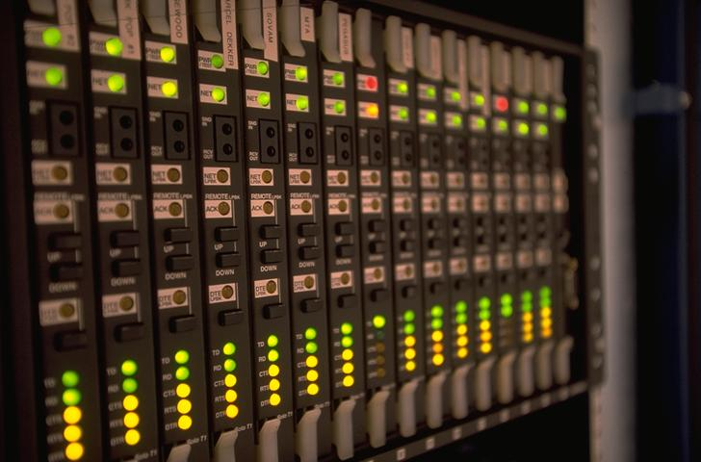
Keeping firmware current can be a problem in terms of maintenance over several years. Without some form of configuration control over firmware versions, there can be long-term pro-blems — e.g., various devices that externally look the same may actually have different features as a result of differing firmware. The preferred approach is to ensure that the vendor will provide firmware updates as they are released for several years after the component purchase. Generally this is not considered onerous by the vendors and is not likely to be expensive. In some cases, it means the replacement of one chip. However, with technological advances, particularly in electronics, it is now often possible to acquire and install the updates on-line.
Figure 6-1 Telecommunication Rack—Lights Indicate Status

Lifetimes and Salvage Values
In Table 4-1, Sample Life Expectancy of TMS Components, the lifetimes of components is shown to vary between 4 and 20 years. Although technological changes happen quickly, the procurement cycles for most Agencies do not. Many systems in the U.S. operate on 10-year old computers that are incapable of running current word-processing programs. In addition, there are hardware components in the field —e.g., electromechanical controllers — that have been operational for many decades.
When developing a multi-year program, the various procurement cycles have a significant impact on the budget. Therefore, Agencies should consider developing a budget line item based on the replacement costs of items when they are due to expire. Some Agencies have found that it is not politically acceptable to scrap DMS’s as motorists are familiar with their messages. However, the aging of these DMS’s and the fact that many of the vendors are no longer in business, sometimes makes it necessary to dismantle the older signs as the only practical source of spare parts when the capital budgets did not include the cost of new replacement signs.
Information in this report and throughout the literature can be used to reasonably estimate component lifetimes. However, the preferred course of action is to use data from the maintenance database developed locally to assist in making key replacement decisions — for instance, which components are least reliable and should be replaced earlier. In particular, the environment has a significant impact on component lifetime (e.g., loops are much less reliable in northern states than in other parts of the country) and gathering data from jurisdictions with a similar climate can assist in the planning process.
When to scrap and salvage the central software is an item that needs particular attention with respect to multi-year maintenance. ITS control systems, communication network management systems, inventory control systems, and various equipment vendor software are all subject to updates. Some updates add functionality and others eliminate bugs in the programs. From a maintenance perspective, the typical control system consists of four parts: (1) the control system, (2) the database, (3) the operating system, and (4) the hardware. All of these come in a variety of versions with service packs and various updates. It is, therefore, critical that the system as built and installed does not have any changes applied without assurance from the control system vendor that the entire environment has been configured and tested as a set. Additionally, if hardware upgrades are required for maintenance purposes, all the software components should remain unchanged. Changing the hardware while simultaneously performing software upgrades is possible, but it is more difficult to debug. If one group, either at the Agency or contractor, is responsible for the upgrades then that one group can fix problems. However, independently buying hardware, getting a database upgrade, and then expecting a control system to install and operate is not a recommended approach. Long-term maintenance upgrades to system require extensive planning, budgeting, and testing.

Performance Metrics and Monitoring
Maintenance activities and quality control procedures require that there be metrics if the performance is to be monitored. These issues, discussed in Chapter 5-8, have an influence on multi-year planning. Monitoring performance provides indicators to the Agency about whether the correct investments have been made. Metrics also provide maintenance engineers with component-level information that supports the decision-making concerning the need for additional responsive measures and the purchasing of spares.
Although metrics should be part of an annual maintenance program, long-term monitoring can provide significant data to assist in planning future maintenance and determining whether investments are worthwhile. Performance metrics can be used to develop future years’ purchasing and replacement strategies that can help ensure fewer surprises when systems need replacement.

System Overlaps and Multi-Year Phasing
The multi-year maintenance plan has to accommodate the fact that TMS’s are not stationary systems. They are typically expanded from a basic system implementation on the most congested section of freeway approaching a metropolitan area. Once established, there is a natural inclination to expand the basic system, particularly when the initial experience has been successful. This expansion is often both functional and geographical. As the system is expanded, the input to maintenance planning is best applied to all the phases of the project, including the various elements shown in Figure 6-2.
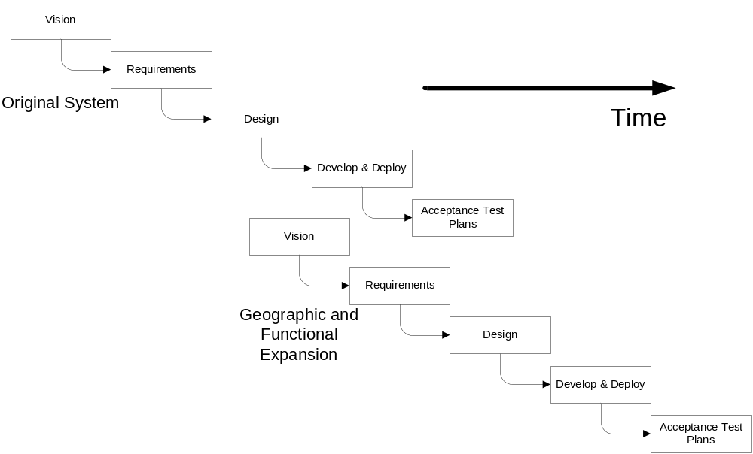
Figure 6-2 Multi-Year Development Phasing
There is virtually no ITS system where the expansion is not in one of these phases, even when the vision is awaiting an allocation of budget. From the maintenance planning perspective, the input of the maintenance group to geographic or functional expansions need to be considered.
During the vision phase, a system expansion — and sometimes additional or distributed control systems — are contemplated. The maintenance implication of these elements can be considerable as they can involve relocation of staff and equipment. New technologies in the design and the requirements phase can necessitate new training for the maintenance staff. Geographical expansion requires additional devices and potentially additional staff. During development and deployment, the disruption to existing system needs to be planned for and accommodated. Often the communications system is interrupted during system expansions. The maintenance planner needs to remain cognizant of these issues and ensure that the requirements detailed in earlier sections of this report are adequately considered and acted upon appropriately.

Maintenance Program Support Services

Introduction
This chapter describes the variety of support services can assist in the development of a maintenance program. The reader should use this chapter as a list of reminders to determine if any of these items are appropriate for use in the development of his or her Maintenance program. The support items considered here should be considered individually for each TMS component under consideration. Some of these items are not applicable for all components. The items include:
- Services,
- Differing contract types,
- Vendor warranties and service agreements, and
- Contract examples.
As defined in Chapter 1, responsive maintenance is the repair or replacement of failed equipment and its restoration to safe, normal operation. Preventive maintenance is the activity performed at regularly scheduled intervals for the upkeep of equipment. The topics covered in this chapter include how these maintenance activities may be supported by Federal funding and how they may be contracted out to industry. The supporting tools of assessment management are included as well as information on warranties. A sample contract for maintenance is also presented along with details on acceptance testing procedures that can assist in the development of a Maintenance plan.
These types of support services can provide value to any Agency that is developing a Maintenance plan. However, some of these services, such as asset management, can initially require a significant level of start-up costs and time. However, the value of contracting out components of maintenance can add significantly to the capabilities of the Agency in terms of technical expertise and extended hours of coverage. Each of these support services should be carefully evaluated by each Agency considering the trade-offs among costs, responsiveness, and impacts on staff.
One example of how the value of support from other Agencies can be applied is the effectiveness of distributed maintenance centers in Agencies with large geographical coverage. A state Agency with a low population requires the central maintenance staff to fly to remote locations in order to reset controllers where the conflict monitor has been tripped by lightning. In another state, the signal controllers are many hours drive away and an overnight trip is required. Although the responsive action of resetting the controllers is essential, there are a range technological options and local contracting alternatives that should be considered when such inefficiencies arise.

Options for Contracting
The maintenance component of TMS is expensive. For large systems, annual costs can be a few million dollars per year. In Texas, the annual ITS/ATMS budget request for Fiscal Year 1997 was $8.7M from Routine Maintenance and $5.0M from Highway Construction for rehabilitation and maintenance. For a large ITS in Northern Virginia, VDOT has contracted out the maintenance at a cost of over $2M annually. Washington has an annual combined O&M budget of $1.9M for 800 signals and 120 miles of freeway surveillance. Maryland has an operations budget of $3.5M for 375 miles of freeway surveillance and a maintenance budget of $1.0M. For the ARTIMIS system, ODOT contracts over $1.0M per year for maintenance. These are fairly large numbers and Agencies do need to analyze the options associated with contracting out maintenance.
Agencies should consider that Federal funding is available for maintenance.
The Federal-aid Eligibility Policy Guide (Ref 10) states:
“The operating costs for traffic monitoring, management, and control systems, such as integrated traffic control systems, incident management programs, and traffic control centers, are eligible for Federal reimbursement from National Highway System and Surface Transportation Program funding. For projects located in air quality non-attainment and maintenance areas, and in accordance with the eligibility requirements of 23 USC 149(b), Congestion Mitigation and Air Quality Improvement Program funds may be used for operating costs for a 3-year period, so long as those systems measurably demonstrate reductions in traffic delays. Operating costs include labor costs, administrative costs, costs of utilities and rent, and other costs, including system maintenance costs, associated with the continuous operation of the system.”
Each Agency should consider a range of issues when planning whether to contract for maintenance or conduct the work in-house, including those items concerning contracting procurement issues. The decision to contract out is often made in an environment where the addition of several new members of staff in a transportation department would be considered not politically judicious.
Virtually all Agencies have some form of contracting in their maintenance programs — these contracts are most common in the repair of communications systems, as these require sporadic repairs and very specialized equipment. Given no political constraints on the employment of new staff, adequate physical space for equipment inventory, and personnel, it is likely that the costs of in-house maintenance would generally be less than outsourcing the work. Lack of overhead and no profit on the project virtually ensures that in-house maintenance is cheaper when viewed in terms of an annual budget. However, the nature of employment in government Agencies involves long-term commitments and their associated costs, including medical benefits, pension plans, vacations, and other costs. When these are taken into account, the financial balance moves in the direction of contracting out at least some of these services.
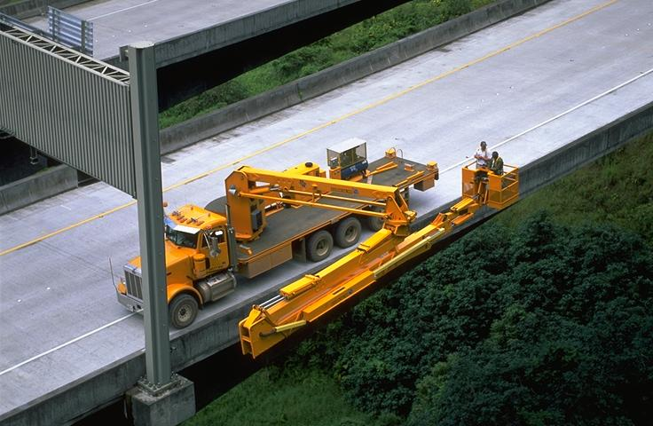
Which maintenance tasks to contract out can depend on the type of Agency in terms of the in-house skills, hours of operation, and the equipment space and facilities that are available. The in-house skills can affect the decision in that some Agencies have competently-trained staff and equipment to provide roadside maintenance of the ITS devices. In some cases, this competence results from the Agency installing the devices themselves. This approach results in a familiarity with the equipment and access procedures and enables the in-house staff to perform preventive and responsive maintenance. Operational requirements can also influence which maintenance activities to contract out. If the Agency wishes to operate the system either for extended periods or full-time, then the staff may not wish to be on-call 24 hours per day. In these circumstances, responsive and emergency operations outside office hours can be used to supplement the work performed by in-house staff.
Figure 7-1 H3 Hawaii Inspection of Elevated Section
An example of one in-house maintenance operation is provided by Denver CO (Ref 11). The Colorado Transportation Management Center (CTMS) Maintenance Division is responsible for deployment, maintenance, and development of ITS field devices. The staff includes one Electronic Engineer working as crew supervisor, one Electronic Specialist I, one Electronic Specialist II, and one Electronic Specialist Intern. Additional support is provided by two contract maintenance staff members.
The primary function of the CTMC maintenance crew is the upkeep of ITS field equipment that is controlled by the Colorado Traffic Management Center. This equipment includes variable message signs, highway advisory radio transmitters, CCTV cameras and video switchers, roadside emergency call boxes, wireless communication devices, highway traffic sensors, and fiber-optic equipment. Additional equipment is continually being added to the inventory as the ITS infrastructure grows. Although the majority of ITS devices are located north and west of Denver, equipment locations maintained by the CTMC range from Vail on I-70 to as far south as Pueblo, Wolf Creek Pass in the southwest, and north to the Wyoming border. The number of devices maintained by the CTMC is now in excess of 100.
The CTMC Maintenance Department has also been charged with deployment of field devices. Everything from installation of highway advisory radio equipment to closed circuit television cameras is handled by the CTMC crew. The CTMC has a fleet of 10 portable variable message signs at its disposal. Used for road information and in support of law enforcement DUI check points, these signs are deployed by the maintenance crew within a 100-mile radius of Denver. The CTMC maintenance fleet also includes a bucket truck with an 80-foot reach and a dedicated “network support” vehicle used to diagnose problems with CDOT's fiber-optic network.
The CTMC Maintenance Department also designs and fabricates new electronic systems used to assist the motoring public. These systems frequently make use of both fiber-optic and wireless communications devices. For example, they are working on the development of remote controlled “trailblazer” signs that utilize wireless technology. These signs are used to direct traffic flow when detours are required because of various road conditions.

Western Transportation Institute (Ref 2) cited in its study for ODOT the following deficiencies in the ODOT Maintenance Program:
- Inadequate staffing levels and/or conflicting priorities,
- Ambiguous responsibilities,
- Inadequate training,
- Poor logging and tracking systems, and
- Non-standardized devices.
The development of a series of problem definitions can assist in both the production of a Maintenance plan and the decision to contract out part of the work. Those areas that are not being adequately maintained tend to be perceived as problems. Sometimes these are functional, occurring in areas where there is little or no in-house expertise. In other situations, the problems may occur in one geographic area where a certain districts lack either expertise or adequate staff.
When making decisions about contracting, each Agency needs to look at its individual deficiencies and needs in terms of functions and geography. The advantages of contracting out maintenance include:

- The ability to start and stop the process on specific dates. (However, some Agencies report scheduling problems when, for example, equipment is procured in one budget cycle, but the maintenance contract is not let until another cycle.)
Contract Type | Procurement Type
Furnish & Install Field Devices | Engineer-Contractor
Furnish & Install Software | Systems Integrator
ITS Operations | In-House
ITS Maintenance | Engineer-Contractor
Table 7-10 Example of Procurement Types
- Access to specialized skills, equipment, or space that may not be otherwise available to the Agency, or that the Agency only needs for a short-period of time.
- Situations in which the workload is such that Agency staff dedicated to maintenance are not needed on a day-to-day basis.
- Situations where Agency resources are not available for hiring or training maintenance staff.

Asset Management Tools
Another issue that the Agency needs to consider when developing a plan is the relationship between preventive and responsive maintenance activities. Doing more preventive maintenance will necessitate less responsive maintenance. There is no subjective evidence to quantify the extent of this relationship in the ITS industry. There are, however, numerous examples in asset management models, fleet operations, and the steel industry that evaluate production capacity and uptime as a function of maintenance expenditure. There are diminishing returns — i.e., beyond a certain point, the use of funds for preventive maintenance is not cost-effective. There will always be a need for responsive maintenance due to inherent equipment failures, knock downs, lightening strikes, etc. However, money spent on meeting the basic maintenance requirements specified either by the manufacturer or using the procedures outlined in this guide will reduce responsive maintenance incidents and be more cost- effective.
The FHWA and AASHTO (Ref 12) define asset management as follows:
“Asset management is a systematic process of maintaining, upgrading, and operating physical assets cost-effectively. It combines engineering principles with sound business practices and economic theory, and it provides tools to facilitate a more organized, logical approach to decision-making. Thus, asset management provides a framework for handling both short- and long-range planning.”
The same reference defines a series of questions to ask when developing an asset management system. These include:
- What is our mission? What are our goals and policies?
- What is included in our inventory of assets?
- What is the value of our assets? What are their functions? What services do they provide?
- What was the past condition and performance of our assets? What is the current and predicted future condition and performance of our assets?
- How can we preserve, maintain, or improve our assets to ensure the maximum useful life and provide acceptable service to the public?
- What resources are available? What is the budget level? What is the projected level of future funding?
- What investment options may be identified within and among asset component classes? What are their associated costs and benefits?
- Which option, or combination of options, is “optimal?”
- What are the consequences of not maintaining our assets? How can we communicate the impact of the condition and performance of our assets on the system and end user?
- How do we monitor the impact of our decisions? How do we adjust our decision-making frame-work when indicated?
- How can we best manage our assets in order to least inconvenience the motoring public when we repair or replace these facilities?
There are a number of suppliers of asset management systems whose web sites provide useful information:
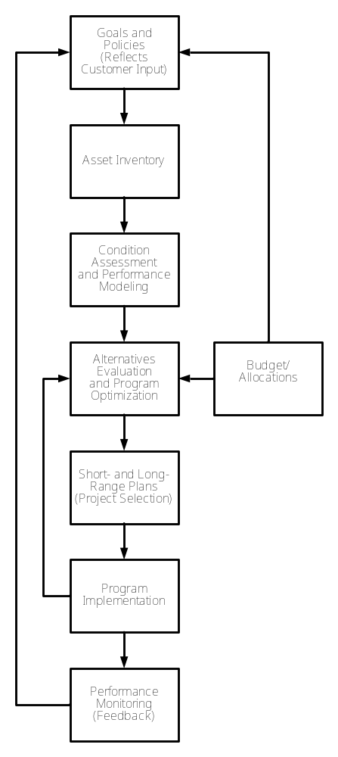
Hansen - http://www.hansen.com/
Figure 7-2 Generic Asset Management System Components
Exor - http://www.exor.co.uk/
Cartegraph - http://www.cartegraph.com/
Azteca - http://www.azteca.com/
Figure 7-2 indicates a generic asset management system that can be applied to any type of asset, including TMS. Asset management systems are often initiated to keep track of the condition of the highways and the bridges within an Agency. If the Agency has a system in place, it can also be used for monitoring TMS assets.
Some Agencies do no preventive maintenance, considering it a luxury. This is unfortunate. Waiting for devices to fail is inefficient and leads to compromised operations. It is inefficient insofar as the damage done when devices fail can be significantly more expensive than undertaking preventive measures. Individual components will eventually fail and need to be replaced — this is, almost invariably, a more expensive option than cleaning, greasing, measuring, etc. Additionally, the responsive actions that will occur more frequently when preventive maintenance is not performed will happen at indeterminate times. Preventive maintenance can be scheduled to not disrupt traffic flow and be considered part of the workday of Agency or contractor staff. The operational effects of waiting until things break causes the failure to be noticed when the device is used. This is the worst time as the device is needed by the operator, the traffic in the area may be subject to an incident, and the staff is busy.

Contracting Types
If an Agency determines that some component of their maintenance is to be contracted out, there are a variety of procurement options. Some of these may not be available to individual Agencies due to local restrictions on procurement procedures.
The list below covers most of the procurement options that are used for TMS. Some of these are applicable for operations and maintenance, and others are not:
Engineer-Contractor: Plans and detailed specifications are developed by an engineer. Selection of a contractor is by low-bid only.
System Manager: Plans, specifications, and system software are developed by an engineer. Selection of the equipment and installation contractor is by low-bid. The engineer provides system integration.
System Integrator: Similar to System Manager, but the contractor has the ability to procure hardware and services, usually by low-bid, on behalf of the Agency and then functions as an integrator.
Best-Value Contracting: Used where the contractor must provide some technical designs or configurations. The selection of a contractor is based on a combined technical score and price.
Design-Build (DB): A set of performance specifications are let for bid by teams of engineers and contractors. Selection is usually based on combined technical and price factors.
Design-Build-Operate-Maintain (DBOM): The same as Design-Build, but with a requirement that the contractor operates and maintains the system for some time.
Franchise or Lease: Also known as Design-Build-Own-Transfer. The contractor provides initial financing, engineering, and construction in exchange for a lease payment over a period of time. Eventually the equipment and activities are transferred to the Agency.
These procurement options and their applicability to the procurement of maintenance are discussed below.
The Engineer-Contractor method is not normally considered advisable for the procurement of ITS software and design services. The lack of close association between the client and the software developer and the selection of a very technical service through a low-bid mechanism has proven disastrous. However, many Agencies when contracting for basic maintenance services have used this process with some success, particularly when the work has involved low-skilled tasks, such as lighting and tree-trimming. However, there have been unfortunate occurrences where unqualified contractors have been used to perform routine tasks — e.g., cleaning — and then have not been capable of responsive maintenance that requires additional technical skills. Other instances have occurred where the low-bid preventive maintenance contractor has bid certain staff that meet the technical requirements of the specification, but are not used when the contract is underway. It is recommended that the technical level of the maintenance staff be specified in the contract and that the contract include terms that allow the Agency the right to approve staff changes. In summary, using the low-bid approach in low-technology maintenance projects can often be successful, provided the Agency ensures sufficient contractual terms and management resources are used to adequately monitor and enforce the process.
System-Manager or System-Integrator contracting can take on the maintenance of software and the control centers. This approach frequently makes sense as most of the work done by the system manager’s staff is associated with the control center equipment and the software running on it. At least for the first few years following an implementation, using the system manager to do the TMC maintenance can be successful for fixing software bugs and providing assistance with processes such as database changes and map updates. However, system managers and system integrators are not generally equipped to furnish preventive and responsive maintenance directly. Most of the companies doing this type of work are nationwide firms that operate over large areas — their markets tend to be spread thinly. The companies usually do not have the capability to provide local, less technical staff; if they take on this type of project, they often subcontract with a local electrical contractor or other supplier that meets the specifications. Using a subcontractor to do the less technical operations, with the prime functioning as an integrator, is an approach that has oftentimes been successful. However, the Agency needs to be careful that the qualifications of the proposed subcontractor staff meet the same criteria as that of the prime.
The outcome of Best-Value contracting is substantially dependent on the thoroughness and quality of the Agency’s solicitation. Specific provisions can be included in the solicitation’s selection criteria that may affect the quality of maintenance furnished under the contract. For example, offerors may be asked to provide a plan on how they would meet the requirements for preventive, responsive, and emergency maintenance. The Agency may wish to rank the quality of the plan and use it in their selection criteria.
For DB, DBOM, and Franchise or Lease types of contracts, maintenance becomes a critical issue. The reason is the duration of the contract and the contract terms that relate to the condition of the equipment when it is handed back to the Agency or turned over to a new contractor. When assessing a bid for the supply of equipment for a DB project, the contractor will pay no attention to the costs of maintenance of the equipment that is provided. Selecting more expensive hardware, such as LED signals that will cost less to operate and maintain in the long run is not to his or her advantage. If the evaluation criterion of the proposal is low-bid, then the contractor really has no option. If the offer meets the requirements of the scope of work, then the cheapest option will always be delivered. To avoid this problem, these types of contracts need to specify what is in the best interest of the Agency over the long term. When the contract is a DBOM and the maintenance is also the responsibility of the contractor, the Agency needs to be cognizant of the likelihood that the contractor will perform little or no maintenance. Normal maintenance needs to include replacement as part of the annual budgeting, purchasing, and installation cycle. Major problems can occur when old equipment is not replaced. From the contractor’s perspective, older equipment needs more and increasing work to keep it running. Should the Agency specify a certain level of availability, the contractor will have difficulty estimating the manpower required for maintenance. The DBOM contract needs to include clauses specifying that the equipment provided to the contractor at the start of the maintenance period should be returned to the Agency in similar condition, subject to expected wear-and-tear. It should also specify the maintenance procedures and maintenance frequency as requirements.

Vendor Warranties and Service Agreements
Companies that win bids for the maintenance of ITS devices are typically local electrical contractors, sometimes working with specialist subcontractors. Generally they are not experts in ITS as these opportunities are rare. Most of their work is for commercial clients on new buildings and facilities. In some cases, they may have experience with other surveillance systems or cell tower installations and this should be considered as a plus during selection. However, it is most likely that the winning bidder does not have expertise in most of the devices that they are installing. Vendor warranties on items such as DMS’s are normally for periods of 1-2 years. From the Agency’s perspective, this is a high-risk situation — these devices are generally unreliable and it is rare to come across a sign in the field with all pixels operating correctly.
More reliable devices such as cameras and communications electronics are also only usually warranted for only one year. Most vendors will provide an extended warranty for a price. If the warranty terms are passed through a third-party contractor, the extended warranty costs will undoubtedly get marked-up. The Agency may wish to consider purchasing the warranty directly from the hardware manufacturer and making the Agency staff responsible for managing the warranty repairs.
The record-keeping system should provide information concerning the performance measures of the various devices. The Agency should attempt to estimate the mean time between failures together with the cost to repair/replace the equipment — that information can then be used to judge whether the extended warranty is worthwhile. A simple calculation taking the mean time to repair and the number of devices should provide the annual expected number of failures; multiplying this by the mean cost to repair will provide the annual cost, and this can be compared with the quote from the vendor. However, allowance should be made for the costs associated with removing, replacing, contacting the vendor, handling and shipping, and purchase order production.

Warranties and Service Agreements
The standard warranties and service agreements that come along with the purchase of a new product are usually dated from the time that the device left the factory. Contractors tend to order equipment early in the project if the costs can be billed to the Agency. This approach allows the contractor to invoice early and become familiar with the equipment. The permitting, construction of concrete bases, and the provision of electrical power and communications can often take more than a year. Thus the situation can readily arise that the device is not fully tested on site until the warranty has expired. It is, consequently, prudent for the purchaser to time the delivery of devices such that the warranty starts when the device is installed and operational.
Extending the warranty period will affect the price, though sometimes less than anticipated. Since the contractor will use the original vendor warranty for the initial period, the contractor has few costs during this time. Additionally, some devices tend to have most of their failures during the first few weeks of operation.
Some Agencies do not encourage extended warranties, requiring instead that the construction contractors manage everything. These sorts of issues need to be considered as part of the procurement process. If necessary, a supplemental contract can be used for extended warranty.

Generic Contract Format
Each Agency will need to develop its own contract and apply its own procurement procedures and the associated boilerplate text that is required.

Contract Forms and Pricing
The scope-of-work and the level-of-effort can be defined for preventive maintenance. Since the number of devices and their maintenance frequency is known and the duration of each operation can be estimated, potential bidders can provide cost estimates for preventive maintenance that have reasonably low-levels of risk. If a well-defined scope-of-work is used, the preventive maintenance can be bid as a lump-sum contract.
The responsive and emergency maintenance components of the contract need to have sufficient definition to encourage bidders to bid and be formulated to minimize their risk. One approach is to specify that a certain staffing level — e.g., defining the number of persons and hours of operation — be made permanently available to the TMC manager. This approach is suitable for large systems where the number of staff working on purely responsive operations is sufficient to justify paying them for full-time positions. However, when preventive and responsive maintenance are performed by the same crew, there are significant efficiencies in terms of reduced plant and staff. The maintenance crews can perform preventive maintenance until called upon to do responsive or emergency maintenance. If there is more than one crew in the field, the response time can be reduced by using the crew nearest the fault.
One solution to this problem is to develop an estimate of how many responsive calls are liable to be made and make the pay item per call for a specific type of device. Thus, the Agency estimates how many calls should be used in the basis for the bid. The bidder will bid per responsive call type. Using this approach, a bidder’s costs can be readily calculated and the Agency can still select the low bidder on a lump-sum contract. This approach does mean that there is an administrative effort required by both the bidder and the Agency to keep track of the number and type of responsive and emergency calls and to verify these with the monthly invoices.
Note that most contractors will not bid on an ill-defined responsive maintenance contract that was lump- sum. If they did bid, there would be a very large contingency to account for their risk. Consequently, each Agency, when developing the contractual terms and scope-of-work, should consider the calculations that will be made by the bidders. Preliminary meetings between bidders and Agencies to help define each others’ concerns, together with a clear scope of what is required, is more likely to lead to a successful maintenance contract.
Outreach to all bidders in the region and, in some cases nationally, will significantly assist the Agency in getting more bids. There are national electrical contractor sources that can provide lists of potential bidders by region. This can be searched on-line at http://www.thebluebook.com/.
In addition to adjacent jurisdictions, there are other external maintenance companies that should be included. These could include companies that maintain cellular towers, external lighting, and private security systems. Providing lots of detail on the potential work and a contact number to answer questions will assist in broadening the list of potential bidders.
Appendix C contains a generic contract that can be used as a basis by Agencies developing a maintenance contract scope-of-work.
Appendix D includes a generic contract based on software procurement for the maintenance of a central system. This can be used as the basis of a purchase order or contract between a software system integrator and an Agency. In addition, this appendix contains an example of a purchase order form of contract that can be used as a model.

Acceptance Testing
Acceptance testing is an intrinsic part of all TMS implementations. It provides the Agency with reassurance that the TMS functions are operable and the required hardware is in place. It also provides the maintenance staff with an introduction to specific equipment in particular locations.

Acceptance Test Plans
The Agency should provide detailed acceptance test plans for all system components. Although the contractor can produce these plans, the Agency will need to conduct a detailed review of such plans to help ensure it is getting what it wants.
In the case of software acceptance tests, there should be traceability between the original requirements and the tests. At each level of the decomposition of the original requirement, more details and functions should appear. The acceptance test plan for the software should trace each individual test back through the detailed design into the original requirement.
The contractor, under supervision by the Agency or its representative, will often conduct the tests. The test results should be documented and the documentation delivered to the Agency. Any failures during the testing process must be documented and then fixed by the contractor and the test repeated and again documented.

Factory Acceptance Tests
Factory acceptance tests provide the Agency with an early useful view of products with which they may be unfamiliar. The look of a DMS, the shape of a structure, or the color of a cabinet is difficult to specify and there are many such items that the maintenance staff may wish to review during the construction. Objections to an item that was not specified, after the products have been produced and delivered to the site, generally cannot be accommodated.
During factory acceptance testing, the manufacturer can demonstrate their construction techniques and quality-control procedures.

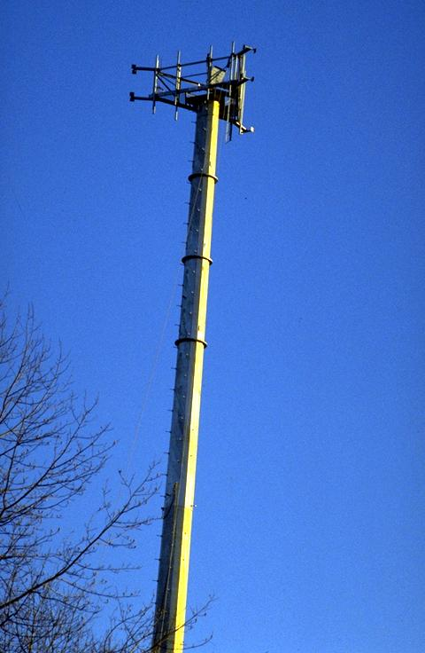
Communications System Acceptance Tests
Figure 7-3 Telecommunications Tower
Many ITS implementations are late and often over budget. A major reason for this is the communications system. It is usually very complex, can involve multiple jurisdictions and commercial suppliers, and often involves implementation of new technology.
The test of the communications system should ensure that communications are functioning as specified in the statement of work. The contractor should conduct a series of communications tests designed to prove that the system can properly carry and pass through all the messages required to operate the system. These communications tests often include end-to-end bit error rate tests, data and message integrity tests, and other assessments demonstrating proper operation.
A Test document, describing the means and methodology of the communication tests, should be presented to the Agency some time in advance of the start of testing. Testing should not begin until the Agency has approved the testing plan. As before, all testing procedures should be documented while the testing takes place.
If the communications system consists of multiple “legs” that are controlled by disparate institutions, it is advisable to split the acceptance test into components. For example:
- The wiring of the computers to the communications hardware may be performed by the systems integrator.
- The wiring in the control center from the communications racks to the external street connection may be done by the building contractor.
- At this point, the communications system may be taken over by one of the major communications providers.
- At a point of presence closest to the device, the communications system may revert to Agency ownership, but be installed by the external contractor.
Thus there is a long chain of differing responsibilities and the maximum opportunity for finger pointing when the data does not arrive. This problem can be minimized by performing separate tests on each link in the chain.

Stand-Alone Site Tests
Individual test plans should be prepared for each component and be performed at each site in the presence of the Agency, or its representative.
The stand-alone test plan shall determine that each element at the individual sites is operating correctly in isolation. For example, all DMS suppliers provide software driving their signs that can be run on a laptop. Running through their test program on-site can test the sign in isolation from the communications system. Similar approaches can be used for video and surveillance components.

Integration Tests
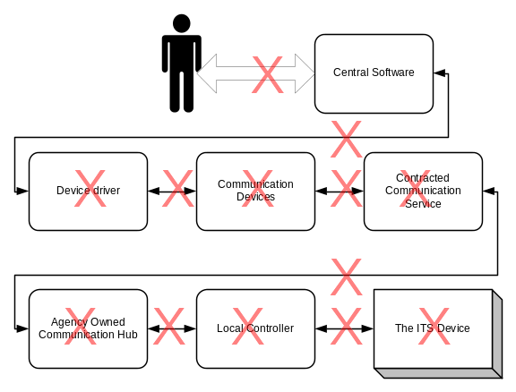Integration test plans should also be prepared. These plans determine that individual system elements at each site are operating correctly in an integrated manner.
Integration tests occur following successful demonstrations of the stand-alone tests.
There are multiple points of potential failure in most systems and an effective acceptance test plan for the integrated system will need to consider each element.
The acceptance testing is usually linked to payment milestones. For example, the installation of a DMS might have milestone payments split into three components, as follows:
Figure 7-4 Multiple Potential Points of Failure
- A first payment for all hardware delivered to contractor’s depot, Agency facility, or on-site — 50 percent of site lump sum.
- A second payment following demonstration according to the test plan of correct operation of all devices on-site in an isolated manner — 20 percent of site lump sum.
- A final, third payment for integrated complete operation according to the test plan from the traffic management center and delivery of as-built plans — 30 percent of site lump sum.

Supplies, Tools, and Spares
It should be realized that virtually no component of a TMS can be repaired by anybody other than the original manufacturer or a qualified distributor. The process of responsive maintenance typically involves replacements of boards and modules.
The provision of adequate spares (usually 10 percent of the total installed) and locating them in an easily accessible manner will have the biggest impact on reducing down time.
The maintenance of a TMS typically requires the kinds of support tools that a maintenance department is likely to have on hand. These include trucks, cherry pickers, sign boards, back hoes, etc. In addition, more specialized equipment specific to the electrical nature of the work are likely to be needed. This equipment can include:
- Optical Time Domain Reflectometers (OTDR),
- Oscilloscopes,
- Spectrum Analyzers,
- Network Analyzers,
- Waveform Generators,
- Sweep Generators,
- Frequency Counters,
- Multi-meters,
- Inductance Meters, and
- Power Meters.
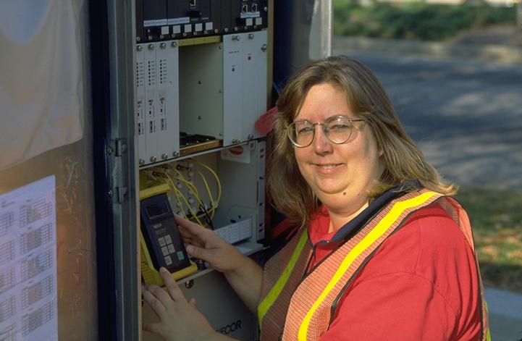
For responsive maintenance, these types of devices are used to determine what and where the problems may be. For the communication elements, for example, the OTDR is used to determine where on a communications network any break in the connection may have appeared. Following this determination, the traffic control, back hoes, and fiber fusion equipment is needed. In addition, when the fiber is fixed, packages of bonding material and various resins are used to replace the cover to the fiber. Following this, the cable is retested and the holes filled in. This process needs to take place either as a contracted activity or as an operation performed by the Agency’s staff. Regardless, substantial equipment, exper-tise, manpower, and materials are required.
Figure 7-5 Fiber-Optic Testing, Norfolk, Virginia

Glossary
AASHTO: American Association of State Highway and Transportation Officials.

ACC: Adaptive Cruise Control.

CAN: Automated Collision Notification system.

AHS: Automated Highway System. The AHS is a highly advanced system that will redefine the current vehicle-highway relationship by shifting many tasks from the vehicle operator to the roadway itself. The first demonstration of the AHS concept was in San Diego in August 1997.

APTS: Advanced Public Transportation Systems. Collection of technologies to increase the efficiency of public transportation systems; they offer users greater access to information on system operations.

Architecture: An overarching framework that allows individual ITS services and technologies to work together, share information, and yield synergistic benefits. The National ITS Architecture was released as a final document in June 1996.

ARTS: Advanced Rural Transportation Systems. These are ITS technologies aimed at addressing the specific needs of rural communities, particularly the issues of mobility and road safety.

ATIS: Advanced Traveler Information Systems. ATIS technologies provide travelers, businesses, commercial carriers, and transportation professionals with the information they need to make decisions, from daily individual travel decisions to larger-scale decisions that affect the entire system, such as those concerning incident management.

ATMS: Advanced Traffic Management Systems. ATMS technologies apply surveillance and control strategies to improve traffic flow on highways and streets.

AVI: Automatic Vehicle Identification. A system which combines an on-board tag or transponder with roadside receiver for the automated identification of vehicles. Used for electronic toll collection, stolen vehicle recovery, using vehicles as traffic probes, etc.

AVCSS: Advanced Vehicle Collision and Safety Systems. These systems employ mostly in-vehicle technologies to help drivers avoid collisions, monitor driver performance, and automatically signal for emergency aid immediately upon collision.

AVL: Automatic Vehicle Location system. Computerized system that tracks the current location of fleet vehicles, to assist dispatching, etc.

CVISN: Commercial Vehicle Information Systems and Networks. A network that connects existing Federal, State, and private-sector information systems to improve commercial-vehicle movement.

CVO: Commercial Vehicle Operations. ITS program to apply advanced technologies to commercial-vehicle operations, including commercial-vehicle electronic clearance; automated roadside safety inspection; electronic purchase of credentials; automated mileage and fuel reporting and auditing; safety status monitoring; communication between drivers, dispatchers, and intermodal transportation providers; and immediate notification of incidents and descriptions of hazardous materials involved.

DASCAR: Data Acquisition System for Crash Avoidance Research. A portable, on-board vehicle data-gathering system that monitors and records vehicle performance and the driver’s physical reactions.
DGPS: Differential Global Positioning System. A technique that can be applied by civilian GPS users to improve GPS accuracy to 1-10 meters.

DOT: Department of Transportation. When used alone, indicates U.S. Department of Transportation. In conjunction with a place name, indicates State, city, or county transportation Agency (e.g., Illinois DOT or Los Angeles DOT).

DSRC: Dedicated Short-Range Communications. Wireless, short-range digital communications. Uses electronic readers, tags, and software.

EDI: Electronic Data Interchange. A recognized technology format and standard for moving “packets” of data.

EDP: Early Deployment Plans.

EMS: Emergency Management Services. Services designed to optimize the response time to incidents.

ERP: Emergency Response Providers Enabling Research. Applied research that advances existing technologies, enabling them to support ITS applications. This research has refined technology for eventual field testing, developed evaluation methods to determine potential benefits and cost effectiveness, developed human factors guidelines, and established performance specifications and criteria.

ENTERPRISE: Program standing for Evaluating New Technologies for Roads Program Initiative in Safety and Efficiency. International public sector cooperative initiative to facilitate the rapid development and deployment of ITS technologies. Participants include Arizona DOT, Colorado DOT, Dutch Ministry of Transport, FHWA, Iowa DOT, Maricopa County, AZ, Minnesota DOT, New York DOT, Ontario Ministry of Transportation, Transport Canada, Virginia DOT, and Washington State DOT.

FCC: Federal Communications Commission.

FHWA: Federal Highway Administration, which is part of USDOT.

FMS: Freeway Management Systems. Network systems giving transportation managers the capability to monitor highway and environmental conditions on the freeway system, identify recurring and non-recurring flow impediments, implement appropriate control and management strategies, and provide collection and dissemination of critical real-time information to travelers.

FOT: Federal Operational Test.

FRA: Federal Railroad Administration, which is part of USDOT.

FTA: Federal Transit Administration, which is part of USDOT.

GCM: Gary-Chicago-Milwaukee corridor. One of the ITS Priority Corridor projects as defined by ISTEA to receive funding for applying ITS to assist in reducing extreme or severe ozone. The initial GCM priority is real-time data acquisition and the sharing of information across the corridor that is useful to both multi-modal system operators and travelers.

GIS: Geographic Information System. Computerized data management system designed to capture, store, retrieve, analyze, and report on geographic/demographic information.

GPRA: Government Performance and Results Act.
GPS: Global Positioning System. Government-owned system of 24 Earth-orbiting satellites which transmit data to ground-based receivers and used to determine the precise position of vehicles on the ground. Provides extremely accurate latitude/longitude ground position.

HRI: Highway-Rail Intersection. User service that integrates ITS technology into already existing HRI warning systems to enhance safety effectiveness and operational efficiency. At railroad grade crossings, HRI technologies located both in-vehicle and along the roadside ensure that train movements are coordinated with traffic signals and that drivers are alerted to approaching trains.

Human Factors Research conducted to understand the impact of automated technology on human decision-making and driving behavior. For instance, studies are being done to investigate whether the use of cellular phones while driving distracts drivers to the extent that more accidents occur with their use.

ICC: Intelligent Cruise Control. A crash avoidance technology that automatically adjusts vehicle cruise speed to maintain safe following distances.

IMS: Incident Management Systems. Monitoring and surveillance systems that identify the occurrence of incidents in real-time so that they can be quickly located and removed.

Intermodalism: Seamless integration of multiple travel modes.

Interoperability: The ability to integrate the operation of diverse networks and systems. The vision of the intelligent transportation infrastructure is a seamless interoperable coast-to-coast network that allows drivers and information to flow through the system without barriers.

In-Vehicle Navigation Technology: Allows drivers to access route guidance information while en-route. Includes location referencing technology, in-vehicle display units, map information, and audio/text delivery technology.

ISTEA: Intermodal Surface Transportation Efficiency Act of 1991. Federal law providing primary Federal funding for highway and other surface transportation programs in the United States through 1997. ISTEA contains the Intelligent Vehicle-Highway System Act. Directs the establishment of a National ITS program and requires inclusion of a strategic plan for ITS in the United States, implementation and evaluation of ITS technologies, development of standards protocols, an information clearinghouse, the use of advisory committees (one of which is ITS America), and funding for ITS research, development, and testing in such efforts as the corridors program.

ITS: Intelligent Transportation System(s). The application of advanced technologies to improve the efficiency and safety of transportation systems.

ITS America: Intelligent Transportation Society of America. A nonprofit, public/private scientific and educational organization that works to advance a national program for safer, more economical, more energy efficient, and environmentally sound highway travel in the United States. The USDOT uses ITS America as a Federal expert advisory resource and panel.

IVHS: Intelligent Vehicle-Highway Systems. Now known as “intelligent transportation systems.”

IVI : Intelligent Vehicle Initiative.

JPO: Joint Program Office for ITS. This office resides in FHWA.

Kiosk: An information center for traffic or travel data located in shopping malls, parking decks, hotels, airports, businesses, transit terminals, etc. These kiosks are normally outfitted with interactive computer capabilities.

LAN: Local Area Network. A method of connecting several computers together using either high- or low-bandwidth communication media.

Location Referencing: Technology that identifies locations of vehicles, incidents, and travelers. Used with GPS and AVL technologies. Supports user services such as Mayday, EMS, CVO, ATMS, ATIS, and AVCSS.

Mainstreaming: The act of bringing ITS technology into everyday use by travelers and transportation professionals.

Mayday: An ITS program designed to link travelers in trouble with transportation officials in real-time. Uses location-referencing technologies and communications systems.

MDI: Model Deployment Initiative. A program designed to develop model sites demonstrating integrated intelligent transportation infrastructures and successful jurisdictional and organizational working relationships. The program is also designed to demonstrate the benefits of integrated transportation management systems that feature strong regional, multimodal traveler information services.

MPO: Metropolitan Planning Organization. Regional policy body, designated by local officials and the governor of the State, that is responsible in cooperation with the State and other transportation providers for carrying out the metropolitan transportation planning requirements of Federal highway and transit legislation.

NAHSC: National Automated Highway Systems Consortium.

NHTSA: National Highway Traffic Safety Administration, which is part of USDOT.

NTCIP: National Transportation Communications for ITS Protocol. Required for traffic management operations. Allows for wireline communications between traffic management centers and field equipment.

OCD: Operation Concept Development.

Operation Timesaver: Federal initiative aimed at reducing congestion by building an intelligent transportation infrastructure in 75 of the Nation’s largest metropolitan areas within 10 years. The goal is to reduce travel times by 15 percent by the year 2005.

PCB: Professional Capacity Building program.

Priority Corridor: One of the first ITS programs established by ISTEA. Originally designed to showcase technology and hardware, it has created communication channels and organization frameworks among the numerous Agencies that must coordinate in order to successfully implement ITS.

Protocol: “Envelopes” used to package data for interoperable flow of ITS information. Protocols can include information on addressing, security, priority, and other handling information.
Public-Private Partnerships: Agreements with private-sector companies to participate in the deployment of ITS through commitment of time, services, products, or capital investment. These partnerships are the foundation of the ITS strategic plan’s financial strategy for ITS deployment.

PSAP: Public Safety Answering Points.

R&D: Research and Development.

RF: Radio Frequency.

RFP: Request for Proposals.

RSPA: Research and Special Programs Administration, which is part of USDOT.

RT-TRACS: Real-Time Traffic-Adaptive Control System. Next-generation traffic signal control management system. An advanced dynamic control strategy that uses state-of-the-art traffic signal control based on real-time demand.

SAFER: The Safety and Fitness Electronic Records System, which is a component of CVISN.

SAVME: System for Assessing the Vehicle Motion Environment. A roadside measurement system to quantify the movement of vehicles in real traffic.

SDO: Standards Development Organization. Standard specifications that are established to address the need for various technologies, products, and components from different vendors to work together.

TMC: Traffic management center or transportation management center.

TMDD: Traffic Management Data Dictionary. A source of standardized information that defines how data is exchanged and how it flows between ITS devices and systems. The TMDD standardizes message sets for national interoperability.

TMS: Transportation Management Systems.

TRB: Transportation Research Board. Part of the National Academy of Sciences, National Research Council. Serves to stimulate, correlate, and make known the findings of transportation research.

TSCS: Traffic Signal Control Systems. Advanced systems that adjust the amount of “green” time for each street and coordinate operation between signals to maximize traffic flow and minimize delay based on real-time changes in demand.

User Services:. Services available to users of an ITS-equipped roadway, as set forth by ITS America. The 31 services are arranged in seven categories as follows:
1) Travel and Transportation Management
2) Travel Demand Management
3) Public Transportation Operations
4) Electronic Payment
5) Commercial Vehicle Operations
6) Emergency Management
7) Advanced Vehicle Control and Safety Systems

WAN: Wide Area Network.

WWW: World Wide Web.

References
- PECOS – ITI Data Models (ADOT) Final Report. Arizona DOT 1998.
- http://www.odot.state.or.us/its/documents/documents.htm
- http://www.fhwa.dot.gov/legsregs/directives/fapg/cfr0940.htm
- http://www.faa.gov/cm/standards.htm
- Metropolitan Transportation Management Center Concepts of Operation A Cross-Cutting Study FHWA-JPO-99-020
- http://www.odot.state.or.us/its/ITSDocs/ITSStratPlan10-98fin.pdf
- Daniels, Ginger and Starr, Tim, Guidelines for Funding Operations and Maintenance of Intelligent Transportation Systems/ Advanced Traffic Management Systems, Transportation Research Record 1588, Paper No. 971390.
- http://www.dot.ca.gov/dist07/divisions/maint/index.shtml
- http://www.benefitcost.its.dot.gov)
- http://www.ampo.org/mpo_issues/funding/Ops-guid.doc
- http://www.cotrip.org/its/mainten.html
- Asset Management: Advancing the State of the Art into the 21st Century through Public-Private Dialogue. Federal Highway Administration and the American Association of State Highway and Transportation Officials, 1996.

APPENDICES

APPENDIX A: Example Trouble Reports
VDOT / SMART TRAFFIC CENTER  Maintenance / Service Request Ticket |  |  |  |  |  |  |  |  |  |  |  |  |  |  |  | Job Number
 |  |  |  |  |  |  |  |  |  |  |  |  |  |  |  | 11474
EQUIPMENT INFORMATION
Written By |  | A. Stewart |  |  |  |  | Date |  | 5/15/02 |  |  |  |  |  | Time |  |  | 19:47
Type | VMS |  |  |  | ID# |  |  | 1890 |  |  |  | Location |  |  |  | I95
Note Problem
Failed with congestion message displayed
Control Room
[ ] Radio Dispatch |  |  | Forwarded To |  |  |  |  |  |  |  | Date |  |  |  |  | Time
[X] Assigned |  |  | James Allen |  |  |  |  |  |  |  | 5/15/02 |  |  |  |  | 19:47
MAINTENANCE SUPERVISOR
Maintenance Priority Level |  |  |  |  |  | [ ] High |  |  |  |  | [ ] Medium |  |  |  |  |  | [ ] Low
[ ] Radio Dispatch |  |  |  | Forwarded To |  |  |  |  |  |  |  |  | Date |  |  |  |  | Time
[X] VDOT Technician |  |  |  | Will |  |  |  |  |  |  |  |  | 5/16/02
[ ] Contractor
VDOT SERVICE TECHNICIAN
[X] YES – Work was completed |  |  |  |  |  | Power problem lighting hit filter AC service protector ACP 340 125 VAC 50-70 Hz (Pwr OK)
[ ] NO – Work was not completed
Repair Time Hrs. |  |  |  |  |  | Date |  |  |  | 5/16/02 |  |  |  | Time |  |  | 15:00
Supervisor Signature |  |  |  |  |  | Service Tech Signature

VDOT / SMART TRAFFIC CENTER  Maintenance / Service Request Ticket |  |  |  |  |  |  |  |  |  |  |  |  |  |  |  | Job Number
 |  |  |  |  |  |  |  |  |  |  |  |  |  |  |  | 11088
EQUIPMENT INFORMATION
Written By |  | Ty |  |  |  |  | Date |  | 5/20/02 |  |  |  |  |  | Time |  |  | 2010
Type |  |  |  |  | ID# |  |  | 20 |  |  |  | Location |  |  |  | 66EB
Note Problem
FAILED
Control Room
[ ] Radio Dispatch |  |  | Forwarded To |  |  |  |  |  |  |  | Date |  |  |  |  | Time
[ ] Assigned
MAINTENANCE SUPERVISOR
Maintenance Priority Level |  |  |  |  |  | [ ] High |  |  |  |  | [ ] Medium |  |  |  |  |  | [ ] Low
[ ] Radio Dispatch |  |  |  | Forwarded To |  |  |  |  |  |  |  |  | Date |  |  |  |  | Time
[X] VDOT Technician |  |  |  | Kenny |  |  |  |  |  |  |  |  | 5/21/02
[ ] Contractor
VDOT SERVICE TECHNICIAN
[ ] YES – Work was completed |  |  |  |  |  | Found Ramp Controller demand + PASS locked on Reset Ramp Controller OK
[ ] NO – Work was not completed
Repair Time Hrs. |  |  |  |  |  | Date |  |  |  | 5/24/02 |  |  |  | Time
Supervisor Signature |  |  |  |  |  | Service Tech Signature

VDOT / SMART TRAFFIC CENTER  Maintenance / Service Request Ticket |  |  |  |  |  |  |  |  |  |  |  |  |  |  |  | Job Number
 |  |  |  |  |  |  |  |  |  |  |  |  |  |  |  | 10614
EQUIPMENT INFORMATION
Written By |  | Serena |  |  |  |  | Date |  | 8/9/01 |  |  |  |  |  | Time |  |  | 14:30
Type | VMS |  |  |  | ID# |  |  | 1990 |  |  |  | Location |  |  |  | I95
Note Problem
FAILED
Control Room
[ ] Radio Dispatch |  |  | Forwarded To |  |  |  |  |  |  |  | Date |  |  |  |  | Time
[X] Assigned |  |  |  |  |  |  |  |  |  |  | 8/22/01
MAINTENANCE SUPERVISOR
Maintenance Priority Level |  |  |  |  |  | [ ] High |  |  |  |  | [ ] Medium |  |  |  |  |  | [ ] Low
[ ] Radio Dispatch |  |  |  | Forwarded To |  |  |  |  |  |  |  |  | Date |  |  |  |  | Time
[ ] VDOT Technician
[ ] Contractor
VDOT SERVICE TECHNICIAN
[ ] YES – Work was completed |  |  |  |  |  |  | Assign T. McDean (8/?/01 – VDOT 1047)
[X] NO – Work was not completed
Repair Time Hrs. |  |  |  |  |  |  | Date |  |  |  |  |  |  | Time
Supervisor Signature |  |  |  |  |  |  | Service Tech Signature

VDOT / SMART TRAFFIC CENTER  Maintenance / Service Request Ticket |  |  |  |  |  |  |  |  |  |  |  |  |  |  |  | Job Number
 |  |  |  |  |  |  |  |  |  |  |  |  |  |  |  | 11071
EQUIPMENT INFORMATION
Written By |  | Fred |  |  |  |  | Date |  | 5/20/02 |  |  |  |  |  | Time |  |  | 5:36
Type | CCTV |  |  |  | ID# |  |  | 810 |  |  |  | Location |  |  |  | I95
Note Problem
No Control
Control Room
[ ] Radio Dispatch |  |  | Forwarded To |  |  |  |  |  |  |  | Date |  |  |  |  | Time
[ ] Assigned
MAINTENANCE SUPERVISOR
Maintenance Priority Level |  |  |  |  |  | [ ] High |  |  |  |  | [ ] Medium |  |  |  |  |  | [ ] Low
[ ] Radio Dispatch |  |  |  | Forwarded To |  |  |  |  |  |  |  |  | Date |  |  |  |  | Time
[ ] VDOT Technician
[ ] Contractor
VDOT SERVICE TECHNICIAN
[X] YES – Work was completed |  |  |  |  |  | No power at Cam #820, informed Mike – OK now
[ ] NO – Work was not completed
Repair Time Hrs. |  |  |  |  |  | Date |  |  |  | 5/20/02 |  |  |  | Time
Supervisor Signature |  |  |  |  |  | Service Tech Signature

VDOT / SMART TRAFFIC CENTER  Maintenance / Service Request Ticket |  |  |  |  |  |  |  |  |  |  |  |  |  |  |  | Job Number
 |  |  |  |  |  |  |  |  |  |  |  |  |  |  |  | 10976
EQUIPMENT INFORMATION
Written By |  | B. A. Hunt |  |  |  |  | Date |  | 5/18/02 |  |  |  |  |  | Time |  |  | 14:00
Type | VCS |  |  |  | ID# |  |  | 20 |  |  |  | Location |  |  |  | I66 EB Exit 53
Note Problem
Failed – not collecting data
Control Room
[ ] Radio Dispatch |  |  | Forwarded To |  |  |  |  |  |  |  | Date |  |  |  |  | Time
[ ] Assigned
MAINTENANCE SUPERVISOR
Maintenance Priority Level |  |  |  |  |  | [ ] High |  |  |  |  | [ ] Medium |  |  |  |  |  | [ ] Low
[ ] Radio Dispatch |  |  |  | Forwarded To |  |  |  |  |  |  |  |  | Date |  |  |  |  | Time
[X] VDOT Technician |  |  |  | Kenny |  |  |  |  |  |  |  |  | 6/1/02
[ ] Contractor
VDOT SERVICE TECHNICIAN
[X] YES – Work was completed |  |  |  |  |  | Found bad power supply NO-12v nor5vdc – replaced p/s VCS#20 – back online
[ ] NO – Work was not completed
Repair Time Hrs. |  |  |  |  |  | Date |  |  |  | 5/22/02 |  |  |  | Time
Supervisor Signature |  |  |  |  |  | Service Tech Signature

VDOT / SMART TRAFFIC CENTER  Maintenance / Service Request Ticket |  |  |  |  |  |  |  |  |  |  |  |  |  |  |  | Job Number
 |  |  |  |  |  |  |  |  |  |  |  |  |  |  |  | 11425
EQUIPMENT INFORMATION
Written By |  | Ed Bowers |  |  |  |  | Date |  | 5/8/02 |  |  |  |  |  | Time |  |  | 15:38
Type | GCS |  |  |  | ID# |  |  | 150 |  |  |  | Location |  |  |  | I95N (S. Term.)
Note Problem
2 gates broken off at South Terminal
Control Room
[ ] Radio Dispatch |  |  | Forwarded To |  |  |  |  |  |  |  | Date |  |  |  |  | Time
[ ] Assigned |  |  | Marlowe Dixon |  |  |  |  |  |  |  | 5/8/02 |  |  |  |  | 15:41
MAINTENANCE SUPERVISOR
Maintenance Priority Level |  |  |  |  |  | [ ] High |  |  |  |  | [ ] Medium |  |  |  |  |  | [ ] Low
[ ] Radio Dispatch |  |  |  | Forwarded To |  |  |  |  |  |  |  |  | Date |  |  |  |  | Time
[X] VDOT Technician |  |  |  | Tuan |  |  |  |  |  |  |  |  | 5/16/02
[ ] Contractor
VDOT SERVICE TECHNICIAN
[ ] YES – Work was completed
[ ] NO – Work was not completed
Repair Time Hrs. |  |  |  |  |  | Date |  |  |  |  |  |  |  | Time
Supervisor Signature |  |  |  |  |  | Service Tech Signature

APPENDIX B: MAINTENANCE PROCEDURES FOR ITS DEVICES
The lists below include examples of preventive maintenance procedures for a variety of common device types. Maintenance staffs need to develop their own sets of procedures based on the devices they have and the information from the manufacturer. Keeping documentation of the procedures and when they are performed will put the Agency in a better position in the case of disputes concerning warranties and in providing the MTBF data discussed earlier.

Closed-Circuit Television Camera Preventive Maintenance

Camera Preventive Maintenance at Pole Level — Every Six Months
- Check camera housing pressure (typically 5psi +/- 1psi). Pressurize with dry nitrogen if not within limits and document readings on sheet provided
- Visually inspect camera housing
- Clean glass with suitable glass cleaning agent
- Inspect pan and tilt mechanism and adjust limit switches where applicable
- Inspect housing mounting for corrosion.
- Remove any bird nest around the camera housing following approval from the Environmental Department
- Check and inspect the integrity of all cable harness and connectors. Replace defective item where applicable
- Check integrity of surge protector - replace where applicable
- Check wiper blades and wiper assembly unit - replace defective units
- Replace filter in camera housing
- Check operation of thermostat inside camera housing
- Check for corrosion of terminal inside housing

Camera Preventive Maintenance at Cabinet Level — Every Three Months
- Check integrity of all cables and connectors
- Check raw video from the camera with a waveform monitor (raw video shall measure 1.00Vp/p). Adjust per specifications in specialty camera manual
- Check all local functions (Pan, Tilt, Zoom in, Zoom out, Focus Far, Focus near)
- Check integrity of surge protectors
- Check and ensure that all relays are firmly seated on the control board
- Check operation of auto-iris and adjust for correct operation per operational and maintenance manual
- Check circuit box at the base of the camera pole to ensure that the terminal strips are corrosion free
- Check proper function thermostat
- Check fan and replace where applicable
- Clean and vacuum inside of cabinet
- Inspect and change filter where applicable
- Check light bulb and replace where applicable.
- Check incoming power for proper voltage and correct if not within tolerances
- Check cabinet door for proper closure

Camera Preventive Maintenance at Control Center — Weekly
- Using the waveform monitor, perform the following measurements and ensure that the results recorded are within manufacturers specifications. Document the results:
- Check raw video
- Measure peak white
- Measure color burst
- Measures synch pulse.
- Check integrity of all connectors
- Check all camera video at night (to determine which cameras need back focusing)

Gates/Barriers System Preventive Maintenance

Preventive Maintenance at the Gate Cabinet – Every Three Months
- Perform visual inspection of the high voltage side of the cabinet (Use extreme caution and observe all safety rules)
- Check oil level - add oil if needed
- Grease all grease nipples and wipe excess
- Check for oil leaks in the gate housing
- Test gate opening and closing sequence using the open and close buttons in the gate cabinet
- Verify that the lights on the gate flash when the gate arm moves between opening and closing.
- Verify that the lights stop flashing and remain on solid when the gate arm is in closed position
- Verify that the lights stop flashing and remain off when the gate arm is in the open position
- Turn off power to the gate cabinet and use hand crank to open or close gate (this is to ensure that the gate can be opened or closed in the event of power failure)
- Replace all burnt out bulbs
- Perform physical inspection of the gate arm and replace broken or rotten wood
- Check reflectors and replace where necessary
- Check adjust gate clearance from road surface
- Check and adjust limit switches if needed

Preventive Maintenance at the Gate Control Cabinet — Every Three Months
- Open and close gate group from control cabinet
- Adjust gate opening and closing timing sequence
- Check isolators associated with the controller for damage and repair or replace

Lane Control Signal Preventive Maintenance
The lane control signal preventive maintenance requires planning and coordination with control room. Since changing the “X” and arrow has impact on the traffic movement, it is important to set up traffic control for this operation.

Lane Control Signal from Control Room — Weekly
- Check that all signal heads can be controlled from Central and document results

Lane Control Signal Local Field Control (from field) — Weekly
- From each control cabinet in the field, verify that the signal heads can be changed
- Document results
- Clean cabinet interior
- Replace filter if required

Lane Control Signs Preventive Maintenance — Every Three Months
- Check and ensure that both lamps in the signal head are in good working order
- Wipe and clean signal head
- Check wiring and terminal block for corrosion. Replace where necessary

Dynamic Message Signs (DMS) Preventive Maintenance — Annually at the Sign; Every Three Months at the Cabinet
- Photo Cell - clean photo cell aperture
- Ventilation - clean filters
- Lexan cleaning - clean front surface with approved detergent
- Cabinet Filter - clean or change filters
- Fans - check fan condition and thermostat settings
- Vacuum cabinet and clean
- Test - Row and Column Check
- Test - All “ON” and ALL “OFF”
- Test - check alpha numeric characters

Back up Battery Assemblies — Annually
- String voltage - measure /record
- Individual Voltages - measure /record
- Pilot unit Voltage - measure /record
- Ambient temperature - measure /record
- Unit interconnection - inspect, clean, retorque
- The unit must be cleaned quarterly to remove dust from covers.
- If signs of corrosion, clean with a solution of baking soda and water or isopropyl alcohol
- If corrosion reoccurs, report to the Department

Air Conditioning Unit Preventive Maintenance — Every Three Months
- Air Filter - remove and clean or replace
- Blower unit - check for bearing noise
- Compressor - check functions - reset thermal overload
- Refrigerant loss - check refrigerant level and pressure, check cracks & leaks in pipe lines

Spread Spectrum Preventive Maintenance — Annually
- Check and inspect antenna in the field
- Check antenna alignment (both receive and transmit end)
- Measure antenna gain
- Measure the VSWR (Voltage Standing Wave Ratio)

Ramp Meter Preventive Maintenance — Monthly
- Check the operation of the Blank Out sign - replace any defective bulbs
- Check the operation of the Ramp Controller - repair as needed
- Check stop line and make sure that this is clearly visible - make notation for any line that is not visible and report immediately to road marking crew for remarking
- Check advisory signs to ensure accurate words and facing the motorist
- Check signal light head for correct operation
- Replace any burnt out bulbs
- Check and adjust signal head to face the correct direction
- Check and adjust where necessary the ramp meter time clocks in accordance with schedules
- Check the function of the QUEUE loop
- Document all results on the ramp meter maintenance check list
- Request control center to send command to turn on or off and verify

Loops and Piezo Detectors Preventive Maintenance

Loop Preventive Maintenance — Annually

At the Cabinet Level
- Disconnect loop
- With LCR meter measure and record inductance of the loop (L= µH)
- With LCR meter measure and record resistance (R= ohms)
- With a MEGGER meter measure and record the insulation resistance (100 meg >)
- If readings are outside specification, disconnect lead-in at the splice box and check all three parameters at that level
- From the readings determine whether loop or the lead-in need repair

Piezoelectric Detector Preventive Maintenance — Every Three Months
- Check cracks in the asphalt at the shoulder
- Check cracks in the sensor at the shoulder
- Check cracks in the sensor at the wheel tracks
- Check cracks at the sensor /asphalt interface
- Using LCR meter measure capacitance (C= µF)
- Using LCR meter measure resistance (R = ohms)
- Use manufactures recommended procedure for checking detectors

APPENDIX C: GENERIC CONTRACT FORMAT
The example, below, is one contract format without most of the local Agency legal terms. The contractual wording is in italics to distinguish it from the comments.
This is the start of the sample contract.

CONTRACT SCOPE

Contract Objectives
AGENCY’s Objective is to select a Contractor to provide preventive and responsive maintenance for the equipment associated with the AGENCY’s ITS. The Contractor will provide these preventive and responsive maintenance activities for all the AGENCY’s equipment within the boundary defined in the geographic scope.

Definitions
Clear definitions are required to help prevent frequent misinterpretation between contractor and Agency.
Preventive maintenance consists of regularly scheduled activities such as, but not limited to, electrical testing, replacement of necessary parts, cleaning, and lubrication.
Responsive maintenance consists of responding to the daily log of faults reported concerning the various components of the System. It is the responsibility of the contractor to meet the minimum time requirements to reach the site and begin repairs.
Emergency maintenance is similar to responsive maintenance; however, it has a higher priority and needs a much shorter response time.

General Requirements
The Contractor shall manage all assets within the project limits and will perform work that produces end results in accordance with the Department Specifications (including all Supplemental Specifications and Special Provisions these include, but are not limited to:
AGENCY Construction Manual
Each Agency will need to add its appropriate manuals.
AGENCY Work Area Protection Manual
Manual on Uniform Traffic Control Devices
AGENCY Road and Bridge Specifications
AGENCY Road and Bridge Standards

Proper health and safety measures will be taken to insure safety for the traveling public, AGENCY employees, contractor employees and subcontractor employees.
The contractor and agents are required to pay all tolls.
Maintenance of traffic is solely the responsibility of the contractor. Under no circumstances will maintenance of traffic be an additional pay item.
AGENCY will pay all highway electric bills. Responsibility for maintaining power to devices will be as follows:
From the utility to the meter – local power company
From the meter to the control cabinet or breaker – AGENCY’s current roadway lighting contractor
From the control cabinet or breaker to and within the devices – this contractor
The contractor shall maintain a responsive maintenance log, which shall detail all complaints or requests and the dispositions of the items contained in the log. The complaint log will be kept on the maintenance computer within AGENCY.
The contractor shall comply with AGENCY’s lane closure restrictions/requirements. In some locations this may require the work to be performed at night. All overhead work over impacted traffic lanes shall include proper lane closures.
The contractor is required to provide at all times all operational crews with working cell phones. In addition the contractor shall provide a single phone contact for the contractor’s supervisor. The contractor shall provide to AGENCY and keep current all cell phone contact numbers. It is essential that the operating crews can contact AGENCY’s control center to ensure correct operation of equipment and verify equipment status in the control center.
The existing AGENCY Technicians will act as contract administrators with the responsibility of ensuring that work is done to a specified standard. These standards will be in accordance with the workload guidelines supplied by AGENCY. They will be responsible for signing off on the job when the contractor satisfactorily completes the work. The technician supervisor will be responsible for the overall assignment of work to the contractor.

Form of Contract
Under the terms of this contract, there are four requirements:
- The first requirement will be for performing the preventive maintenance. This will be a fixed-price contract.
- The second requirement is for storing, purchasing and maintaining the inventory. This will be fixed-price.
- The third requirement is for performing responsive maintenance. Payment will be by type of item repaired and number of repairs undertaken.
- The forth requirement is for additional work at the request of AGENCY. The contractor must provide a minimum two-man team and all necessary incidental equipment for additional work. This will be an hourly reimbursable item.
These are examples. The issue of contract form and pricing is examined in a subsequent section.

Monthly Status Meetings
Each month, the contractor shall hold a status meeting with AGENCY. At these meetings the contractor shall discuss the previous month’s repairs, anticipated work for the next month, spare purchases for the month and other operational problems that may arise. The contractor is responsible for taking and distributing the minutes of these meetings. These minutes must be transmitted to AGENCY within seven days for approval by AGENCY.
Expansion of the system during maintenance contracts has proven problematical. This allows some growth within constraints that a contractor can cost.
Geographic Scope
The geographic coverage of this contract includes all of the field and ITS devices used by the AGENCY system as proscribed in the map shown in Appendix A – Geographic Scope.
AGENCY reserves the right to increase the number of devices to be maintained within this area by up to 2% on any specific device type. The contractor is not entitled to additional payment resulting from such an increase.
AGENCY reserves the right to increase the geographical scope of this contract at any boundary for a distance not more than five miles. The contractor is not entitled to additional payment resulting from such an increase.

Equipment to Be Maintained
The equipment is to be included in this contract includes:
- Gates and Controls
The contractor needs to be told what is and what is not included to know if they have the requisite skills.
- Variable Message Signs VMS (including blank-out signs used for ramp metering)
- Close Circuit Television (CCTV)
- Vehicle detectors both loop and piezoelectric
- External communication plants including optical fiber, coaxial, and copper cabling, conduit, cabinets, pull boxes, etc.
- AGENCY’s TMC communication plants including modems, multiplexers, telephones, leased service through Bell Atlantic and other service providers
- AGENCY’s computer hardware including servers and workstations running UNIX and MS Windows. Software is not included
- AGENCY’s video equipment including matrix switches, monitors, wall displays, etc.
Preventive maintenance shall be applied to all of the above equipment. Responsive maintenance may be applied to any of the equipment at the discretion of AGENCY.

Maintenance Procedures
The initial numbers for each equipment type are contained in Appendix B - Initial Equipment Inventory. For each equipment type there are defined preventive maintenance procedures. These procedures are defined in Appendix C – Preventive Maintenance Procedures. Each component’s preventive maintenance procedure has a fixed period between procedures. These are defined in Appendix D – Preventive Maintenance Frequency. Appendix E provides guidance on the required Equipment Repair Response Time. Appendix F defines the manufacturer’s procedures proscribed by the manufacturers.
The start time for these periods shall begin upon notification to proceed. However, it is required that all equipment be subjected to a preventive maintenance within 50 percent of the time between maintenance procedures. For example, those items that need to be maintained every 6 months must have their initial maintenance activity performed within the first 3 months. Should individual items be found to be faulty such that preventive maintenance cannot be performed these items must be reported to AGENCY. Should any defects or problems be found during the preventive maintenance activities then the contractor should remedy these at that time with no additional compensation.
This clause prevents the contractor from being rewarded for doing a poor job and then billing twice.
Additional work will be performed at the request of AGENCY.
Should the contractor perform a responsive maintenance action and within 5 days the same fault is reported on the same piece of equipment then it is the contractor’s responsibility to make the second and any subsequent repairs at no cost to AGENCY. Should a particular device persist in its failures then upon AGENCY’s instruction such device can be removed from the list of items to be maintained. The contractor may petition AGENCY to remove items from the list of preventive maintenance.

Record-Keeping Procedures
The contractor shall provide and install at a location within AGENCY a computer running Microsoft Access. This will be known as the maintenance computer. The Contractor shall configure and install the Access database to show all preventive and responsive maintenance activities. This computer shall also keep the inventory of current spares. This database must be updated daily at the end of each day. The contractor must configure the system to be accessible remotely. Any required communication charges will be at the contractor’s expense. In addition it is required that the contractor at the end of each day communicates the next day’s planned activities in an electronic form to the maintenance database. The records on the Maintenance PC shall at a minimum include:
- Date and time of failure report
- Person or source of the report
- Location of device
- Description of failure or symptom
- Name of person responding
- Arrival time at location of reported failure
- Weather and condition of the site
- Actions taken
- Date and time of rectification
- Spare part details
- Any consequential events – such as, but not limited to, failure to operate or secondary failure.
The contractor shall maintain accurate and complete records of all work activities, status reports, meeting notes, cost proposals, invoices, inventory records, etc. As-Built documentation shall be required when equipment or cable is reconfigured. As-Built documentation shall consist of, but not limited to modifying cabinet drawings, fiber-optic block diagrams and fiber allocation drawings. All project records will be the property of AGENCY and shall be returned to AGENCY prior to final payment of the contract.

Equipment Control
At the commencement of the contract, AGENCY will provide some spares to the contractor. At the end of the contract the contractor must return all spares to AGENCY.
Although some Agencies do not allow mark up on hardware the contractors will not buy inventory and hold it without compensation for both labor and use of money. Some form of payment is required.
The contractor shall maintain sufficient inventory of spares to ensure the repair response time specified in the appendices. These spares will be purchased by the contractor and owned by AGENCY. The contractor can invoice AGENCY for spares added to inventory if it is not more often than once per month. The contractor shall not maintain the inventory in excess of 10 percent of items on a per item basis. A 15 percent markup is allowed on the purchase of spares. Shipping, insurance and purchase costs should be paid by the contractor and billed to AGENCY. AGENCY must give prior written approval (within 5 working days) for each monthly order made by the contractor. The contractor shall maintain and make readily available the maintenance of the PC, as well as, the location of all spares. Spares records are to include as a minimum:
- Manufacturer
- Model number
If the Agency has no inventory control system, a maintenance contract can be an opportunity to acquire one.
- Descriptive title
- Serial number
- Location
- Purchase date
- Date installed – when applicable
- Location of installation – when applicable
The contractor is fully responsible for these spares. The contractor shall insure all AGENCY property against all hazards or loss and name AGENCY as the beneficiary in the case of loss. A copy of the insurance documents must be provided to AGENCY. AGENCY has the right to audit the inventory at any reasonable time by providing the contractor with five days notice.

Bar-Code System
The contractor shall purchase a bar-code system that is compatible with AGENCY’s old system. AGENCY’s approval of the new bar-code system is required prior to purchase. The contractor shall ensure that all new and replacement equipment has bar-code labels attached that are compatible with AGENCY’s current system. The contractor shall add new bar-code labels to all equipment that is currently unlabeled as part of the initial preventive maintenance tasks. Data corresponding to each equipment item must be recorded in the bar-code system at the AGENCY. The contractor will not be responsible for adding the data from the old system to the new system. The contractor will obtain approval from AGENCY for a bar-code system and invoice AGENCY for the total bar-code system costs without markup. AGENCY will pay for the bar-code system in the same manner, as it will for the other inventory items being held by the contractor. The implementation of the bar-code system must be completed by the contractor and commence operation within three months of the notice of process.

STAFFING/MANAGEMENT PLAN
The proposal shall include a Staffing/Management Plan defining the key staff for ITS Maintenance and the Project Management Team. Resumes for the key staff must be provided. During the project life, changes to the key staff and Project Management Team shall require approval of the AGENCY project manager prior to use of the staff on the project. The AGENCY project manager shall have the right to reject any proposed replacement staff and request another replacement. If at any time the Department deems the contractor’s personnel unacceptable, AGENCY reserves the right to cancel the contract.
The staffing/management plan should include:
Location, size and nature of primary office to centralized project activities and in which the contractor’s project manager will reside.

Location(s) of resources (offices, equipment, manpower, spares and materials) to be utilized.

Proposed plan for communication and coordination among the Team and key staff.

Proposed maintenance schedule for all ITS devices.

Qualifications of all personnel.

Staffing Qualifications
All staffing associated with this project must be qualified for the work that is to be performed. Specifically technicians, that are responsible for the electronic components, must have a minimum of a two year associate degree plus two years relevant work experience or equivalent. An equivalent to this qualification would be more than five years of relevant experience. Any proposed equivalent must be approved by AGENCY.

Please note: The Contractor is required to furnish labor with expertise in the following equipment.
Item # | Equipment | Manufacturer | Model No. | Location | End Use
1
2
In the table, above, enter Agency’s list of equipment types.

Safety Plan
Within 30 days of the contract signing, the contractor shall provide a Safety Plan for the project. The contractor is required to follow all applicable safety laws, regulations, and AGENCY standard safety procedures. The Safety Plan shall ensure compliance to the requirements of the Manual on Uniform Traffic Control Devices (MUTCD), OSHA, and others as appropriate. Appropriate safety attire for personnel in the field, clear markings, and functional lights on vehicles must be part of the safety plan.

Utilities
The contractor shall ensure the protection of all utilities, conforming to all regulations applied to work within the State. Before work shall be undertaken, the contractor shall be responsible to mark and identify all utilities, which are adjacent to the work area.

Contractor’s Responsibility for Utility, Property and Services
At points where the contractor’s operations are adjacent to the properties of any utility, including railroads, and damage to which might result in considerable expense, loss, or inconvenience, work shall not commence until arrangements necessary for the protection therefore have been completed.
The contractor shall cooperate with owners of utility lines so that removal and adjustment operations may progress in a reasonable manner, duplication of adjustment work may be reduced to a minimum, and services rendered by those parties will not be unnecessarily interrupted.
Should the contractor as a result of his working cause a cut in any communications media, it is the contractor’s responsibility to repair that cut within one hour of the cut occurring.
If any utility service is interrupted as a result of accidental breakage or of being exposed or unsupported the Contractor shall promptly notify the proper authority and shall cooperate with the authority in the restoration of service. If utility service is interrupted repair work shall be continuous until service is restored. No work shall be undertaken around fire hydrants until the local fire authority has approved provisions for continued service. When the Contractor’s work operations require the disconnection of “in service” fire hydrants the Contractor shall notify the locality’s fire department or communications center at least 24 hours prior to disconnection. In addition the contractor shall notify the locality’s fire department or communications center no later than 24 hours after the reconnection of such hydrants. The contractor shall be responsible for any damage to utilities that are attributable to his neglect or methods of performing work.

Performance of the Contractor
Throughout this contract, AGENCY may conduct a review of the various works performed by the contractor. These reviews shall be to determine the compliance of the contractor’s operations with the maintenance requirements, the terms of the contract, and the policies and procedures of AGENCY. The contractor shall fully cooperate with these reviews. If deficiencies are found AGENCY shall inform the contractor of this in writing. The contractor shall take immediate remedial action to cure any deficiencies. No additional compensation will be due to the contractor associated with such remedial actions. AGENCY reserves the right to use it’s own staff for any maintenance activities at its discretion and may prioritize response calls at their discretion.
Locally specific penalty clauses will need to be configured for each Agency to ensure that their contracts are enforceable.
The contractor is required to maintain the AGENCY’s devices uniformly and consistently throughout the contract period meeting both AGENCY and, as appropriate, the manufacturer’s performance specifications. Continued poor performance of work or failure to perform shall cause the contractor to be declared in default of the contract. Failure to meet the maintenance requirements specified in this contract shall result in a written notice from AGENCY. This information shall inform the contractor of non-compliance, as well as the disincentives that will occur when the daily average for the month being requested falls below 90 percent of the items that were scheduled to be repaired. Items where the failure to repair is beyond the control of the contractor, will not be included in this calculation. Disincentives will be assessed based on the percentage of outstanding work below 90 percent. The outstanding percentage of deficient work will be deducted from the monthly payment as liquidated damages to compensate the Department for the loss of use of such failed equipment. Under no circumstances will any monies deducted as liquidated damages be returned to the Contractor. The contractor is required to submit a remedial schedule for the outstanding percentage of work within 5 days of receipt of the written notice of the failure to meet maintenance requirements. Failure of the contractor to bring the percentage of work back into compliance within 30-days shall result in the contractor being declared in default of the contract.
It is not the intent of AGENCY to unfairly penalize the contractor for events beyond his control such as acts of God, vehicle hits, severe weather conditions, major power failures, etc. Failure to repair or perform preventive maintenance during such periods will not be used to penalize contractors. The costs for such calls may at the discretion of AGENCY be paid for under the additional work item payment category.
One reason given by contractors for high bids is uncertainties over which they have no control.
The contractor must ensure that all warranties remain valid. To achieve this, the contractor shall perform all the preventive work specified by the manufacturer within the periods specified by the manufacturer for all equipment. If these tasks are covered by the standard preventive maintenance then both conditions apply. AGENCY shall provide copies of all existing relevant warranties.
The contractor shall provide vehicular equipment such as, but not limited to (bucket trucks, inspection trucks), field engineering equipment, tools, materials, cellular phones and other equipment necessary to perform the work. An approved vendor as per the equipment specification requirements shall calibrate all electronic maintenance and measurement equipment. These items include but are not limited to:

Optical Time Domain Reflectometers (OTDR)
Oscilloscopes
Spectrum Analyzers
Network Analyzers
Waveform Generators
Sweep Generators
Frequency Counters
Multi-meters
Inductance Meters
Power Meters

The contractor shall provide conveniently located secure premises to store all spare parts inventory. The contractor shall provide workbench facilities to enable diagnostic testing and remedial work.
The following sections can be included as attachments to the contract.

Geographic Scope
A map of the site provides a check for the contractor to ensure that more remote locations will not be added by the Agency.
In addition to the roadside equipment shown the on the map below and the TMC the contractor is responsible for equipment at:
Other locations such as remote sites, other Agency building, maintenance depots, etc.

Initial Equipment Inventory to be Maintained
AGENCY reserves the right to substitute equipment on this list as repairs and upgrades occur. Substitutions such as, but not limited to, replacing coaxial cable with fiber-optic, replacing VMS of one manufacturer with a VMS from another manufacturer will occur.
item | EQUIPMENT DESCRIPTION | QUANTITY
1
2

Preventive Maintenance Procedures
Preventive maintenance procedures for a selection of ITS devices are included in this report in the Appendices.
All supplies and parts used in the maintenance of equipment shall meet the manufacturer’s requirements for the unit being serviced.
Preventive Maintenance (PM) Frequency

Equipment | PM | Wkly | BI-monthly | Monthly | Quarterly | ½ Yearly | Yearly

Equipment Minimum Response Time (Hours)
Equipment  When defining the minimum response time, be aware of the costs associated with asking for a quick response. Ask a contractor how he or she would go about calculating the cost. | Reported Problems | Minimum
In this section, the bidder needs to be made aware of the maintenance requirements to keep warranties current in order to cost this effort.
Manufacturer’s Procedures
The following sections define the equipment under warranty and vendor’s recommended maintenance procedures and frequencies.
This is the end of the sample contract.

APPENDIX D: EXTENDED WARRANTY BETWEEN ACME INTEGRATORS AND AGENCY
This agreement between Acme Integrators Incorporated (hereafter “Acme”) will provide Agency (hereafter “AGENCY”) is effective as of the ______ day of _____________, 20__.
Whereas, Acme and AGENCY desire to enter into an agreement to provide extended warranty support for the DEFINED ITEM for the term of this contract, beginning on the effective date listed above and remaining in effect for ____ year(s). This Extended Warranty Support Agreement will automatically be renewed for a period of _____ year(s) at the option of the AGENCY by paying the invoiced of the then current fee for additional Extended Warranty Support. The Extended Warranty Support Agreement will be terminated upon termination of the associated software license agreement or upon non-payment of invoice for additional Extended Warranty Support. During the effective period of the Extended Warranty Support Agreement, the Scope of Services includes the following items:
ACME will provide the AGENCY with error resolution support, responding to customer-identified problems. This support will be during normal ACME business hours (8:30 a.m. to 5:00 p.m. EST, Monday through Fridays, excluding holidays). Notification should be in the form of a written error report as outlined in Paragraph 5(b) below.
ACME will provide AGENCY with telephone response to application use related queries. This support will be during normal ACME business hours (8:30 a.m. to 5:00 p.m. EST, Monday through Friday, excluding holidays). Should the issue be deemed by ACME to be an error, a written notification must be made as covered in Paragraph 1, above.
ACME will provide the AGENCY with support in the correction of software errors where such errors prevent the operation of the application or have a significant impact on the application’s use.
ACME will make one site visit to Albany, NY as a part of this agreement during the contract year. The visit will be for a period of three days, by one systems engineer to review operations and provide general support services as directed/needed. The support services are to be for the operations and maintenance support of the ACME SOFTWARE® system.
The AGENCY responsibilities are as follows:
- Keeping employees trained in the Acme system usage. If additional training is required, this may be supplied at prevailing ACME time-and-materials rates.
- Timely notification of errors encountered. These notifications should be in writing and may be posted by mail, fax, or e-mail. Notification should include the time and date of error, the machine that exhibited the error, a full description of the error encountered, the name and direct phone number for the person that experienced the error, and the state of the system and environment at the time of the error.
- Upgrading to the latest available release of Acme software within a one year of the date that it is made available.
- Allow dial-in access to the ACME SOFTWARE®, system by ACME for support by providing a modem and phone line.
- Keep all computers associated with ACME SOFTWARE®, acting as a Server or Operator Interface free of any software that was not delivered with the ACME SOFTWARE® system or subsequent releases.
- Not allow ACME SOFTWARE® software to be modified in any way by anyone other than ACME.
Specifically excluded from the Extended Warranty Agreement:
- All hardware issues. These may be covered under the supplier’s warranty, which are the responsibility of the AGENCY to keep enforced.
- Support of any software that is modified from that delivered by ACME. Any support needed on software that has been modified will be charged to AGENCY at the then prevailing ACME Time & Material rate.
- The costs of supplying additional hardware or non-ACME SOFTWARE® software, which may be pre-requisites for the application enhancements.
- Non-application specific engineering support at any time. Such support, if requested, will be charged to Customer at the then prevailing ACME Time & Material rates on a quotation basis. Should a reported problem turn out to be a non-ACME SOFTWARE® software issue, ACME retains the right to bill the AGENCY for services supplied in an effort to resolve the issue.
- All reasonable travel, accommodation and per diem expenses incurred as a result of visits to customer's site, at customer's request and ACME’s agreement.
ACME will provide the above support services to the AGENCY based on the selected rate option from the table below. All of the dollar amounts are to be paid to ACME in US dollars. Billings will be made annually in January for the following 12 months of support. The payments are due within 30 days of invoice.

Number of
Contract |  |  | Total
Support |  |  | Support
Year(s) | Start | End | Investment
1 | Jan-00 | Jan-01
2 | Jan-00 | Jan-02
3 | Jan-00 | Jan-03
4 | Jan-00 | Jan-04
5 | Jan-00 | Jan-05

Executed By ACME
Authorized
Signature: ________________________
Title: ______________________________
Date: ______________________________
Executed By AGENCY
Authorized
Signature:_____________________________
Title:______________________________
Date______________________________

The following is a second sample format covering ITS devices:

EQUIPMENT WARRANTY, SOFTWARE REGISTRATION, AND SERVICE MAINTENANCE CONTRACT

Equipment Warranty
Until final acceptance, the Contractor shall be responsible for the function and operation of each component of the system control equipment. The Contractor’s responsibility includes, but is not limited to, all pickup and delivery of defective, repaired or replacement components.
Each component of the system control equipment that is a vendor-supplied component and is covered wholly or partially by a manufacturer’s warranty shall include the provision that they are subject to transfer to the maintaining Agency as named by the Department prior to final acceptance of the Contract. The Contractor is responsible for ensuring that the vendor or manufacturer supplying the component and providing the equipment warranty recognizes the Department’s designee as the original purchaser and owner of the equipment.

Commercial Software Registration
All Commercially available software installed on the system control equipment shall be purchased new specifically for use by the Department as part of the ATMS and shall be registered to the Department, Charlotte County and the City of Punta Gorda as the end-users of that software.

Traffic Control System Software Registration
The Contractor shall grant in writing to the Department and its authorized representative non-exclusive, non-transferable, perpetual irrevocable registration on the traffic control system software. The registration shall give the Department the right to copy and use the traffic control system software at any site established by the Department or its authorized representatives, for the sole purpose of traffic signal system control in the City of Punta Gorda or in Charlotte County. The Department shall have the right to expand the number of traffic signals included in the Charlotte County ATMS to the full capacity of the Contractor-provided system software.
The Department agrees that the traffic control system software is proprietary information and will not sell, transfer or otherwise make available the software to other entities for any purpose other than for traffic signal system control in Charlotte County.

Service Maintenance Contract
The Contractor shall provide a service maintenance contract that completely covers each component of each item in Sections <name sections here> of this Technical Special Provision, excluding the traffic control system software. The Contractor is responsible for ensuring that the supplier of the service maintenance contract recognizes the Department’s designee as the original purchaser and owner of the component as new. The Contractor shall submit to the Engineer for approval copies of the proposed service maintenance contract prior to the commencement of system control equipment testing. The service maintenance contract shall be provided by the Contractor for a period of one calendar year to begin not more than 15 calendar days prior to final acceptance of the project by the Department.
The service maintenance contract shall cover all parts, labor and other costs associated with the diagnosis, adjustment, removal, transportation, repair and reinstallation of any component of any item of the system control equipment. The service maintenance contract shall provide for complete on-site service with a maximum on-site response time of one working day after request for service. The service maintenance contract shall include temporary replacement of components for those defective major components as necessary for proper operation of the traffic signal control system. Major components shall include but are not limited to microcomputer assemblies and line printer. Installation and removal of temporary replacement components shall be included in the service maintenance contract. All software, firmware and hardware configuration and transfer necessary for the fulfillment of any covered service shall be included in the service maintenance contract. The service maintenance contract shall include periodic preventive services as appropriate.
Payment to the Contractor for the service maintenance contract shall be included in the unit bid price for the units covered by the service maintenance contract and no additional compensation will be provided by the Department.

U.S. Department of Transportation
400 7th Street, S.W. (HOTM)
Washington, DC 20590
Toll-Free “Help Line” 866-367-7487
www.ops.fhwa.dot.gov

Publication No. FHWA-OP-04-011
EDL Document No. 13882

