CHAPTER SIX
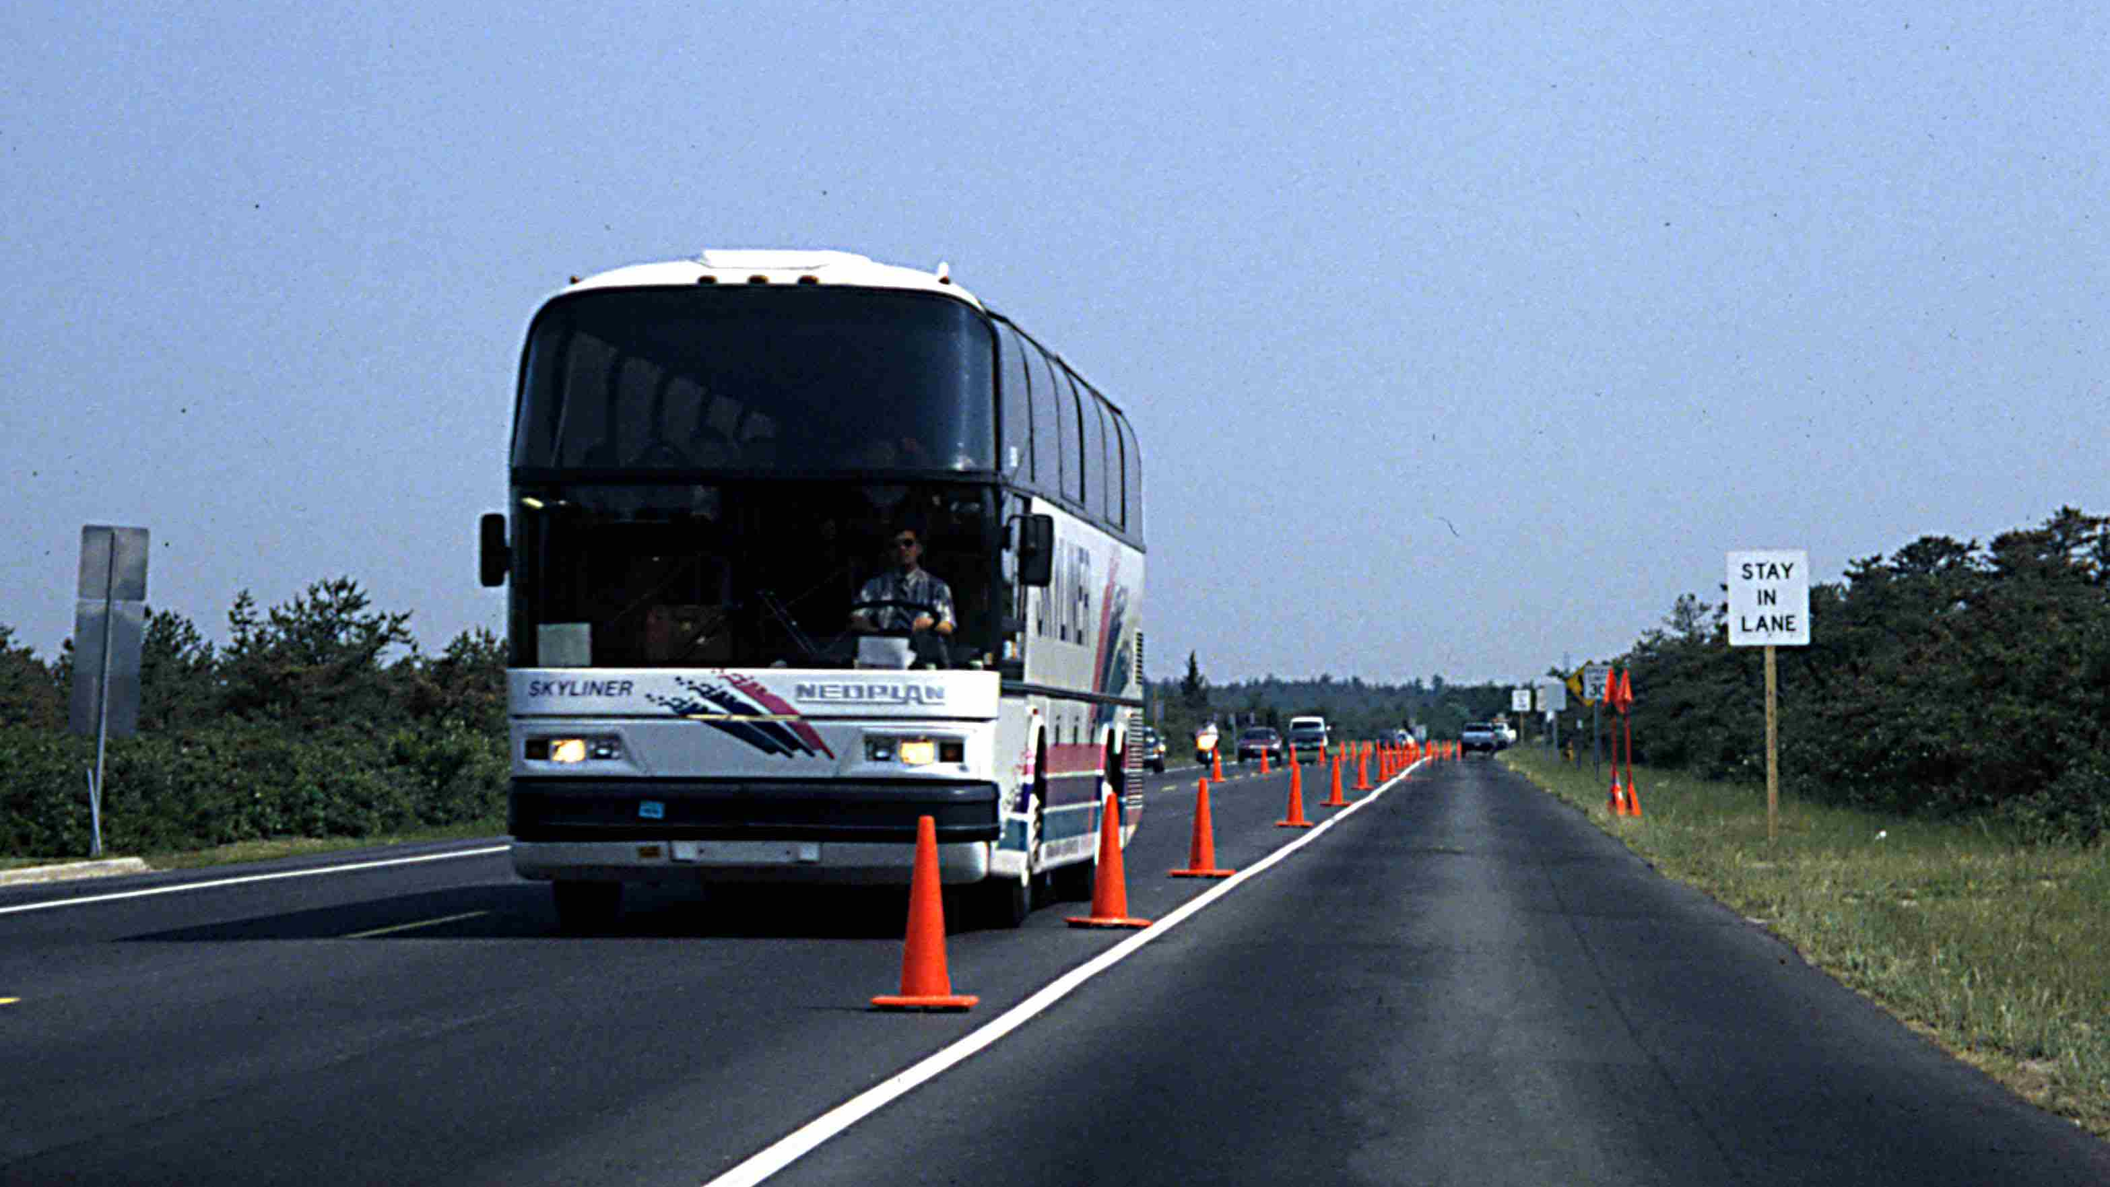
TRAFFIC MANAGEMENT PLAN

Figure 6-1
Temporary Reversible Lane Operation





PURPOSE

This chapter details the components of the traffic management plan, which represents the main product of the event operations planning phase. A traffic management plan indicates how traffic, parking, and pedestrian operations will be managed on the day-of-event. The plan contains strategies and tactics for mitigating travel impacts identified in a planned special event feasibility study analysis (Chapter 5). It also accommodates travel demand management initiatives aimed at improving transportation system operations on the day-of-event.

This chapter provides data, guidelines, procedures, and checklists, supported by numerous example applications, to assist practitioners in developing a traffic management plan. A comprehensive plan consists of a site access and parking plan, pedestrian access plan, traffic flow plan, traffic control plan, en-route traveler information plan, traffic surveillance plan, and traffic incident management and safety plan. Sections on plan components and analysis and modeling further guide practitioners by presenting a fundamental background on traffic management plan development and evaluation. The organization of this chapter allows practitioners to conveniently extract information on developing a particular traffic management plan component. At the same time, this chapter guides the user in integrating the components into an overall plan.
INTRODUCTION
After identifying traffic operations deficiencies in the planned special event feasibility study, the next step for the event planning team is to develop a traffic management plan that details traffic, parking, and pedestrian management techniques to mitigate any and all anticipated problems on the day-of-event. The challenge to stakeholders involves not only developing a strategy to mitigate a potential congestion or safety hot spot, but also ensuring each tactic does not defeat the objectives of another.

A breakdown (e.g., pedestrian flow) occurring at the venue, parking areas, site access roads, transit system, local street system, or regional corridors serving the event can yield a potential snowball effect on other integrated components of the transportation system. A proactive traffic management plan for planned special events prohibits individual transportation system components from impeding one another. It represents a flexible plan that can adapt to and optimize proposed transit service changes and travel demand management initiatives.

The scope of a traffic management plan varies for each planned special event, even for events happening in the same jurisdiction or region. Different strategies and tactics are successful in handling different categories of planned special events occurring in metropolitan, urban, and rural areas. A successful traffic management plan satisfies both the: (1) customer requirements of all transportation system users and (2) allotted budget for personnel and equipment resources assigned to the day-of-event operation. From a program planning perspective, the deployment of automated systems at a particular venue improves travel management for all future planned special events at the venue. Similarly, a portable system obtained for use during a particular planned special event may be used by practitioners to manage future planned special events in a region.

PLAN COMPONENTS

Overview

Managing travel for planned special events involves developing a transportation management plan that contains operations and service strategies specific to managing traffic, transit, and travel demand. A transportation management plan consists of three key components:

- Traffic management plan
- Transit plan
- Travel demand management initiatives

A transportation management plan represents an extension of the feasibility study, referencing study input data and analysis conclusions, then expanding the analysis to include mitigation strategies and tactics. These strategies create a physical change in travel pattern flow, and tactics describe available tools or management approaches to meet the associated strategy.

The feasibility study results influence the scope of the transit plan and other travel demand management initiatives by identifying traffic capacity deficiencies and community (e.g., residential and commercial business) impacts. Transit agencies may work off-line to develop a transit plan detailing schedules and necessary equipment and personnel resources. The transit plan may specify one of more categories of transit operation that include:

- Existing service plus additional vehicle hours (e.g., more frequent service or expanded hours of operation)
- Existing service plus route deviation (e.g., includes new stop at transit station(s) near venue)
- Express service (e.g., new route and schedule)
- Charter service (e.g., contract service)

Numerous factors affect the category and extent of service provided. Public transit agencies must consider service boundaries and Federal Transit Administration regulations, particularly with regard to charter service. Profitability and resource availability, particularly if the planned special event occurs during a commute or high-recreational traffic period, governs decision-making as well. A traffic management plan incorporates the transit plan by accommodating proposed services and/or mitigating service deficiencies. It also promotes special travel demand management strategies, such as designating parking in preferred locations for high occupancy vehicles only.

A traffic management plan includes operations strategies for managing event-generated and background traffic within the local and regional area impacted. The plan also specifies techniques to facilitate site access, parking, and pedestrian access. Table 6-1 lists objectives of a planned special event traffic management plan. Pedestrian accommodation involves handling pedestrians arriving to a planned special event venue via all available modes of travel. To ensure the dissemination of credible traveler information, the event planning team should include media representatives and partnerships developed if necessary. The traffic management plan should include mechanisms for dissemination of accurate and up-to-date information. The plan should state expected transportation conditions, categorized by mode of travel (e.g., expected travel time by car, transit, express/charter service, etc.), with congestion mitigation measures. Safety provisions include prevention of secondary traffic incidents, reduced driver confusion, and reduced vehicular and pedestrian conflicts.
Table 6-1
Traffic Management Plan Objectives

OBJECTIVE
- Facilitate safe and quick travel to/from the event site for spectators and participants.
- Utilize excess transportation system capacity.
- Maximize efficiency of parking operations and internal circulation.
- Accommodate pedestrians.
- Automate traffic control tasks.
- Disseminate useful and credible traveler information.
- Maximize safety.
- Minimize impact on affected residents and businesses.

As shown in Table 6-2, the key components of a traffic management plan for planned special events include:

- Site access and parking plan
- Pedestrian access plan
- Traffic flow plan
- Traffic control plan
- En-route traveler information plan
- Traffic surveillance plan
- Traffic incident management and safety plan

Not all plan components represent a distinct formal plan but warrant consideration, either individually or in concert with another component. For instance, a traffic incident management (TIM) plan may reference an existing TIM manual for a region but include new operations details (e.g., freeway service patrol routes and quick clearance strategies) specific to the planned special event.

The event planning team in-charge of developing the traffic management plan also should consider the number and operating characteristics of traffic management team command centers to be used on the day-of-event. Figure 6-2 shows three command center arrangements for traffic management team operations on the day-of-event. Stake-

Table 6-2
Traffic Management Plan Components
COMPONENT | CONSIDERATION | COMPONENT | CONSIDERATION
Site Access and Parking Plan | - Lot assignment  - Vehicle access and circulation  - Parking area ingress  - Pick-ups and drop-offs  - Parking area egress  - Parking area design and operation  - Process component  - Park component  - Parking occupancy monitoring  - Parking regulations  - Traveler information | Pedestrian  Access Plan | - Pedestrian control  - Pedestrian routing  - Pedestrian crossing  - Disabled accessibility  - Shuttle bus service  - Service design  - Station design  - Management  - Cost
Traffic Flow Plan | - Route planning  - Corridor traffic flow route  - Local traffic flow route  - Alternate routes  - Emergency access routes  - Background traffic accommodation  - Transit accommodation | Traffic Control Plan | - Freeway traffic control  - Traveler information  - Interchange operations  - Street traffic control  - Alternative lane operations  - Route marker signing  - Monitoring  - Intersection traffic control  - Turning movement lane balance  - Traffic signal operations
En-route  Traveler  Information Plan | - Static signing  - Changeable message signs  - Highway advisory radio  - Media  - Other technology applications | Traffic  Surveillance Plan | - Closed-circuit television systems  - Field observation  - Aerial observation  - Media reports
Traffic Incident Management and Safety Plan | - Crash prevention  - Signing  - Public information safety campaign  - Service patrols  - Traffic incident quick clearance initiatives

holders may utilize one to all command center types during the day-of-event. The tactical approach presented in the traffic management plan depends on what command centers are planned. A transportation management center (TMC) allows for the automation of several traffic surveillance and control tasks. Agencies dispatching a mobile command post on the day-of-event may take responsibility of developing a traffic management plan for the road system segment within their jurisdiction. In turn, the agency: (1) coordinates critical elements of the plan (e.g., freeway to street connections) with other pertinent stakeholders during event planning team meetings, (2) formally distributes the plan during the implementation activities phase, and (3) staffs a supervisor at an interagency command post on the day-of-event. Therefore, for a single planned special event, the traffic management plan may include one plan developed by an interagency event planning team or a series of plans specific to each affected

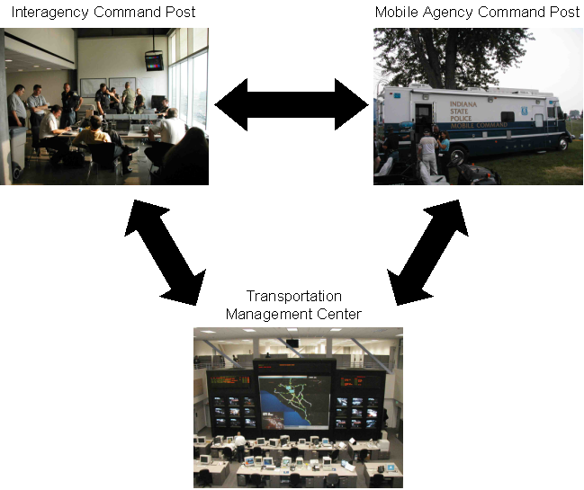

Figure 6-2
Traffic Management Team Command Centers on the Day-of-Event

jurisdiction or each transportation system component (e.g., freeways, streets and intersections, and venue site).

Development Process and

Integration

The following principles steer the traffic management plan development process: (1) provide a satisfactory level of service to all transportation system users, and (2) achieve balanced transportation system operations. Figure 6-3 illustrates the fundamental relationships in transportation system operations that drive the consideration and evaluation of mitigation measures throughout this process. Characteristics of demand include volume, route of travel, and mode of travel. Transportation system characteristics include:

- Existing infrastructure (e.g., number of travel lanes, parallel roadways, etc.)
- Operational policies and regulations (e.g., scheduled transit service, traffic signal control, etc.)
- Monetary costs (e.g., parking fees, tolls, etc.)
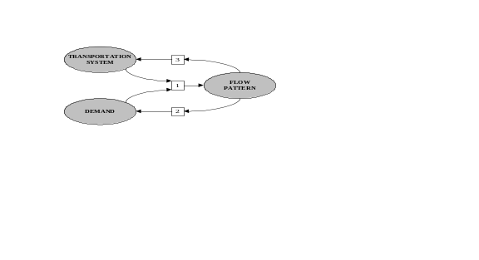
Figure 6-3
Fundamental Relationships in
Transportation System Operations

In Chapter 5, the feasibility study evaluated the flow pattern created by the transportation system and demand (relationship #1). The traffic management plan development process begins with an assessment of this flow pattern. First, practitioners should recognize that flow pattern influences travel choice and, therefore, demand (relationship #2) as long as other attractive (e.g., higher utility) travel alternatives exist. For instance, a feasibility study may identify a roadway capacity deficiency, but an effective traveler information plan can alleviate the deficiency by informing transportation system users of other, underutilized travel alternatives (e.g., alternate routes or modes). This effort achieves balanced transportation system operations by equalizing the utility of all available travel choices and may succeed in providing a satisfactory level of service for all system users.

Flow pattern also influences the transportation system (relationship #3), causing planners to implement capacity improvements or changes in transportation system operations. Simple changes include establishing temporary regulations or revising monetary charges (recouped from event organizers) to influence travel choice utility. Other infrastructure and operations mitigation measures required to manage travel for a planned special event are developed by the event planning team and specified in the traffic management plan. Such measures, when analyzed or implemented, cause a flow pattern change.

The most cost-effective and preferred set of strategies for planned special event travel management utilizes the existing transportation system infrastructure and services. This represents the recommended initial focus of the event planning team; Achieve balanced transportation system operations, then evaluate system level of service.

Planned Special Event Activity Networks

Figure 6-4 outlines the various activity networks that may serve a planned special event venue. Each activity network describes the inter-modal movements and transfer points from origin to venue destination. Integration of the traffic management plan components involves meeting the service requirements of these activity networks. For example:

- A pedestrian access plan must accommodate pedestrian trips connecting various modes of travel.
- A courtesy shuttle bus operation may service both public transit stations and satellite parking areas within the venue site area.
- Traveler information plans must account for all activity networks.
- Impacts to non-attendee transportation system users occur on the regional level, and activity network components within the site area level impact local residents and businesses near the venue.

For smaller planned special events, the event planning team may target one activity network, such as improving automobile access to designated parking areas or improving public transit usage. For larger events, the team must coordinate and achieve seamless operation among several activity networks.

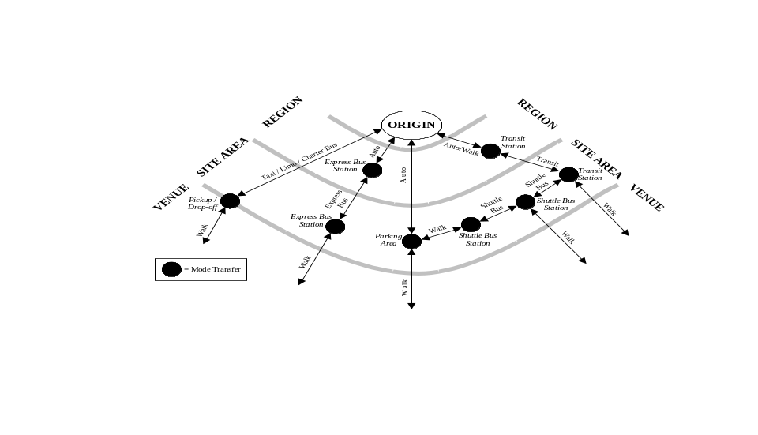

Figure 6-4
Planned Special Event Activity Networks

Special Considerations

The event planning team must create a flexible traffic management plan that accommodates modifications on the day-of-the-event as well as special considerations that surface prior to the planned special event.

Table 6-3 lists the various groups that either attend or have a direct interest in a planned special event. Throughout the traffic management plan development process, the event planning team must regularly monitor and communicate any special considerations that arise in conjunction with the needs of the groups attending the event.

Table 6-3
Groups Attending a Planned Special Event

GROUP
- Participants
- Spectators
- Event sponsor
- Dignitaries
- Media
- Non-ticketed visitors
- Street vendors

Dignitaries

Ensuring the security of dignitaries traveling to and from an event venue requires added traffic control measures and constant surveillance while a motorcade is in motion. This includes the implementation of a rolling roadblock as the motorcade traverses a planned route in addition to the use of aerial surveillance for monitoring motorcade progress and downstream traffic conditions. In fact, the transport of dignitaries represents a planned special event in itself, regardless of travel purpose. Dignitaries may not announce a visit until the last minute, well after the event planning team finalizes the event traffic management plan. Also, non-security personnel, including transportation agency officials, may not receive information on the actual dignitary arrival time or motorcade travel route until a short time before the motorcade commences travel. In turn, the event planning team must maintain special provisions within the traffic management plan, such as alternate road closures based on motorcade route, to allow a motorcade unimpeded access to its destination.

Event Participants

Event participants not only require secure transport, but maintaining their travel itinerary is of critical importance. In particular, regional/multi-venue events may require event participant transport while ingress/egress operations take place at adjacent planned special event venues. Here, stakeholders may elect to outfit vehicles used to transport participants with an Automatic Vehicle Location (AVL) system. The traffic management team can continually monitor the exact location of vehicles transporting participants and other VIPs from a TMC or command post and implement special traffic control (e.g., change traffic signals to a green indication) as needed.

Media

Media often arrives to a planned special event well before spectators and marks one of the last groups to depart the event. However, media crews may conduct broadcasts outside the event venue. Coverage of a street use event involves special accommodations as well. The event planning team should coordinate with media groups on where: (1) media trucks will park, (2) cameras positioned, and (3) cables run.

Street Vendors

Under normal day-to-day traffic operations, side friction generally refers to the frequency of parking maneuvers and transit stops occurring in and out of travel lanes. Street vendor activities during planned special events, shown for example in Figure 6-5, impede traffic flow as event patrons slow or stop to conduct transactions (e.g., buy event tickets or merchandise). Motorist safety becomes a concern when street vendors traverse the right-of-way of freeways and arterial roads. Elements of a traffic incident management and safety plan should include tactics for eliminating illegal street vendor activities.
Figure 6-5
Street Vendor Activity
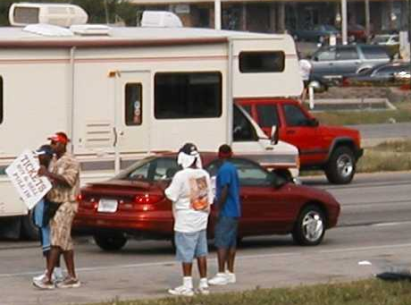

Contingency Planning

Contingency planning represents event insurance. While stakeholders may consume additional time and resources during advance planning for a planned special event, the availability of contingency plans helps mitigate a potential systemic breakdown of the transportation system during an unexpected event occurring at or near the same time as the planned special event. Key steps in contingency planning include:

- Develop a traffic management plan that is scenario-based. This concept applies to various plan components as well as to pertinent tactics. Each developed plan should include response actions for different unplanned scenarios. Plans and tactics may consider identical and different scenarios. A response action under one plan may warrant implementation of a contingency response described in another plan. For example, heavy rains that force the closure of a parking area triggers traveler information message changes to an alternate planned set.
- Consider and plan for a range of possible unplanned scenarios. Table 6-4 provides a contingency plan checklist for planned special events. This checklist includes the risk scenarios presented in the previous chapter. An emergency management agency may maintain a separate emergency response plan that, if put into effect, supercedes the traffic management plan. Yet, the emergency management agency and other public safety agencies work as part of the event planning team to ensure adequate emergency access routes, pedestrian access routes, and evacuation destination areas exist to meet emergency management plan requirements.

Table 6-4
Contingency Plan Checklist

CONTINGENCY
- Weather
  - Severe weather outbreak
  - Flooding on event site access routes
  - Flooding in event parking areas
  - Parking during wet weather
- Security threat
- Major traffic incident
- Delayed event
- Event cancellation
- Absence of trained personnel and volunteers on the day-of-event
- Equipment breakdown
- Demonstration or protest
- Unruly spectator behavior
- Overcrowding
- Event patron violence

- Determine changes in operation due to unplanned scenarios. Aside from evacuation, the occurrence of a major traffic incident or security threat creates a multi-faceted problem for a traffic management team. This includes potential reallocation of personnel, from field crews to supervisors who must manage the unexpected event, and equipment resources. In addition, intra- and interagency radio communications may become deficient in servicing the unplanned event and planned special event if agencies failed to assign a dedicated channel for planned special event only communications.

Consider the level of response to a security threat, involving a suspicious truck stopped on a freeway, that occurred during the 2002 Winter Olympics:⁽¹⁾

Early in the Games, a semi-trailer truck was stopped on the I-15 freeway, just south of downtown Salt Lake City. Because the truck did not have the legally required markings and other reasons, the Utah Highway Patrol (UHP) considered the situation to be a potential safety threat. Additional law-enforcement resources were summoned to the scene. During the entire time, the staff in transportation management center Room 230 (regional transportation management stakeholders) monitored the situation closely, viewing it with a nearby CCTV camera as well as monitoring radio reports from the UHP officers at the scene. After almost an hour passed without a resolution, staff in Room 125 (senior Utah DOT traffic engineers) began preparing to invoke the contingency plan for closing the freeway in both directions. This Action Set would have diverted all freeway traffic to parallel arterials, with the appropriate traffic management actions (new signal timing on the surface streets, changeable message sign messages on the freeway), plus traveler information actions (issuing a CommuterLink Alert, media bulletin, etc.). Fortunately, it was soon determined that the cargo in the truck was benign and the “issue” was closed in Room 230.

Analysis and
Modeling

Overview

No planned special event transportation management plan, not even for a repeated special event, can be prepared and executed without detailed planning and without modifications as the event unfolds. To be successful, the event planning team has to anticipate, and therefore plan for, all the possible scenarios that will challenge the transportation network and the mobility of the plan.

A special event transportation and implementation plan includes elements such as personnel assignments, communications from various sources, communications between multiple agencies, and guidelines for accessing and utilizing remote equipment. All of these elements are used in various manners depending upon the existing conditions, and the plan should be flexible to allow modification throughout the event. In essence, a special event plan is a plan for multiple contingencies and multiple scenarios.

Many tools and techniques are available to analyze and assess the plans. Most are scenario-based and use techniques to simulate the event to ensure that the proper resources and communication protocols are in place and are efficient. These techniques address the many contingencies, and as such, numerous plans are developed prior to the event and implemented during the event, as they are needed.

It is important to note that the assessment and development of plans do not end when the event ends. At the conclusion of the event, stakeholders comprising the event planning team and traffic management team must evaluate the plan in order to improve the plan as well as to utilize the lessons learned in future traffic management applications. Further, this evaluation process is not restricted to post-event, but instead can and should be conducted throughout the event, and modifications to the plan made on-the-fly.

Analysis Techniques

Planners historically have used simple planning techniques as well as high-tech computer-assisted techniques to plan and manage for planned special events. These planning techniques take many forms, ranging from traditional incident management processes and traffic engineering processes to computer modeling of scenarios.

Three primary ingredients for successful event management are: (1) proper resources, both human and non-human, (2) a good communications plan (implementation plan), and (3) a firm understanding of the transportation system’s capabilities and, more importantly, its limitations. The best and most proven techniques for event operations planning are to model and test the scenarios using any and all contingencies.

Tabletop Exercises

Tabletop exercises bring all of the stakeholders together. During these exercises, scenarios are posed and escalated. These scenarios typically do not require modeled network information, as their primary purpose is to test the stakeholders as to how they would react and to fine tune the responsibilities of each stakeholder and the communications protocol between the stakeholders. Many scenarios that can cause disruptions to the event transportation are played out, and any loopholes in the operations planning are obvious to the participants. This type of exercise is supported by more detailed analyses, usually in the form of computer simulation.

Computer Traffic Simulation

In large-scale event planning, it is beneficial to understand the impact that the event will have on the existing roadway system. Where this network is complex and multiple alternatives may exist, each will need to be evaluated. The common approach to this function is to apply tools to model the network. Capacity and LOS analyses are useful tools for gauging the expected operating conditions along roadway segments and for determining the “order-of-magnitude” changes that will result from major changes in traffic flow (e.g., as caused by a planned special event) and roadway improvements (e.g., widening, bottleneck improvements). However, improvements provided by transportation management strategies and systems are typically not reflected in such procedures. Moreover, information on performance measures (e.g., vehicle delays, fuel consumption, emissions) is not provided by capacity analysis techniques. It may therefore be worthwhile to utilize computer traffic simulation models, which can examine the manner the roadway network performs under various sets of simulated conditions.

As implied by the name, traffic simulation models examine the manner in which the roadway network performs under various sets of “simulated” conditions. They provide an excellent means of estimating changes in roadway performance metrics (e.g., average speeds, travel time, delays, emissions) resulting from increased traffic, roadway restrictions, traffic management strategies and improvements.

Traffic simulation models can be divided into the following two general classes:

- Macroscopic models are based on deterministic relationships between roadway and intersection characteristics and traffic flow. Examples include TRANSYT-7F, FREQ, and the TRAF suite of models.

- Microscopic models simulate the movement of individual vehicles through the network being modeled. Examples include INTEGRATION, Paramics, Synchro/SimTraffic, and the TSIS suite of models.

Some simulation models are designed for analysis of individual intersections or specific types of facilities, while others are designed for network-level analysis. Models capable of network-level analysis include TRANSYT-7F, Synchro/SimTraffic, INTEGRATION, and Paramics. The TSIS (Traffic Software Integrated System) set of models includes NETSIM for network analysis, FRESIM for freeway analysis, and CORSIM, which is an integrated package of the network and freeway models. The TRAF set of models includes NETFLO for network analysis, FREFLO for freeway analysis, and an integrated package (CORFLO) of the network and freeway models. FREQ simulates corridor traffic operations including one freeway and one parallel arterial.

The individual models vary in their capabilities, limitations, and ease of use (a discussion of which is beyond the scope of this Handbook). A significant amount of effort generally is required to learn to use traffic simulation models, including setting up the appropriate inputs and parameters. A significant amount of effort may also be required to obtain traffic and network data to conduct the analysis and to calibrate the model to local conditions. Data requirements are proportional to the extent of the network being modeled. The required data can include characteristics of each link (e.g., length, number of lanes, auxiliary / HOV lanes, ramps, grade, speed limits, lane widths, pavement condition), link traffic flow information (e.g., entering / exiting volumes, ramp volumes, travel times, percent heavy vehicles and buses, lane changing characteristics) and other types of information such as detector locations, incident characteristics (e.g., effect of lane blockage on capacity), and ramp metering operations.

Simulation models generally require a non-trivial analysis effort. Moreover, any model-specific limitations should be taken into consideration when interpreting the outputs of simulation. Sensitivity analyses are important to developing an understanding of: (1) how reasonable the simulation estimates are and (2) how much confidence the analyst should place in them.

Site Access and Parking Plan

Overview

Chapter 5 detailed steps for conducting a parking demand analysis, including guidelines for evaluating the scope of parking area required to serve event patrons. In turn, a site access and parking plan contains operations strategies for managing automobile, bus, taxi, and limousine traffic destined to and from the following areas in the vicinity of a planned special event venue: (1) public parking area, (2) reserved (permit) parking area, (3) overflow parking area, and (4) pick-up/drop-off area. The event planning team must create a flexible plan that contains proactive strategies for responding to real-time event patron travel patterns driven by their choice of public parking areas, especially if parking fees vary from lot to lot. Traffic destined to the three other site areas has a fixed ingress and egress pattern as specified in the plan through lot assignments and permitted movements.

The site access and parking plan must fit seamlessly into other components of the traffic management plan. This includes the pedestrian access plan, traffic flow plan, and traffic control plan. For instance, the pedestrian access plan must accommodate pedestrians arriving to/from each parking area or pick-up/drop-off point while still achieving a manageable dispersion of pedestrian traffic. Parking area access and site circulation arrangements must correlate with street traffic control schemes.

Site access and parking plan development involves a three-step process: (1) access, (2) process, and (3) park:

- Access refers to getting event traffic from the adjacent street system to their destination, such as a parking area or pick-up/drop-off area, during ingress and vice versa during egress. The traffic management team manages the access operations component.
- Process involves activities necessary to “approve” vehicles for entry into a parking area. A fee transaction between a parking area operator and motorist represents a common process activity.
- Park involves handling vehicles from a process point to a parking space. A parking team and associated volunteers operate the process and park components. A breakdown in any one of the three components can result in congestion extending to the adjacent street system and possibly to freeway and arterial corridors serving the planned special event.

Parking Policies and Tactics

General Considerations

Table 6-5 presents three general considerations regarding proactive parking management for planned special events.

Table 6-5
General Parking Management
Considerations

CONSIDERATION
- Lot assignment
- Traveler information
- Contingency plans
Lot Assignment

The objectives of lot assignment include:

- Efficiently distribute the flow of traffic.
- Minimize the superimposition of traffic flow on a single access road section.
- Separate pedestrian, automobile, and bus/taxi/limo traffic.
- Accommodate group needs.

Table 6-6 lists the factors that influence this planning process. Key considerations for some of these factors include:

- Parking areas designated for disabled, reserved, and valet parking require on-site spaces with easy access to the event venue. However, the location of these lots must afford users the opportunity to egress immediately after the event without intersecting extreme levels of pedestrian traffic.
- Some planned special events draw a significant level of event patrons traveling in a recreational vehicle. These patrons typically arrive well before the event start, if not one day prior to the event, and tailgate after the event. As a result, a recreational vehicle parking area should exist adjacent to streets segments that the traffic management team may temporally close after the event to safely accommodate pedestrian traffic. This consideration also applies to the selection of media and participant parking areas. These groups arrive before and depart after the majority of event patrons and require parking near the venue, especially media who have to transport heavy equipment.
- For major special events, employees should park at a remote off-site lot with shuttle bus service.
- The section on site access and circulation will discuss taxi and limo operations.
- In evaluating parking areas for heavy vehicles (e.g., buses and recreational vehicles), the event planning team must verify that vehicles can execute all required turning movements during ingress and egress.
- If the use of any parking area requires a lease or third-party agreement (e.g., use of a commercial lot), then planners must have the agreement signed well before the day-of-event.

Table 6-6
Factors Influencing Lot Assignment

FACTOR
- On-site parking location
- Off-site parking location
- Disabled parking
- Reserved (VIP/permit) parking
- Participant parking
- Valet parking
- Media parking
- Employee parking
- Bus parking
- Recreational vehicle parking
- Taxi/limo staging

Traveler Information

Dissemination of traveler information on site access and parking utilizes several tools and approaches, including pre-trip and en-route:

- As part of pre-trip information dissemination, the event planning team should prepare a site and parking plan for stakeholder use and for distribution to event patrons via advertisements as well as the event or venue website. The event operator should include directions to specific parking areas with pre-event ticket and parking pass distribution.
- En-route information dissemination techniques begin with any combination of static signs, portable changeable message signs (CMS), and highway advisory radio (HAR) positioned on freeway and arterial corridors serving the event. Figure 6-6 shows a freeway CMS, operated by the Maryland State Highway Administration with real-time sign status posted on the Coordinated Highways Action Response Team (CHART) website, displaying access information for different parking areas.

Figure 6-6
Freeway CMS Displaying Parking
Information (Graphic courtesy of the Maryland State Highway Administration.)
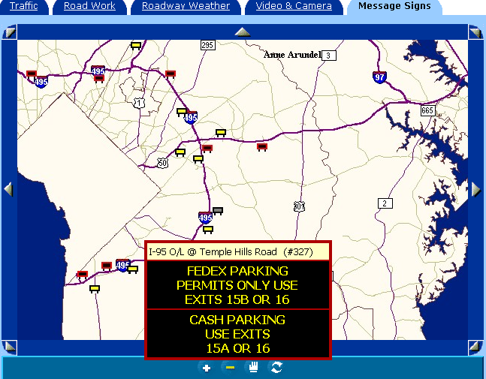
- As part of developing the site access and parking plan, the event planning team should prepare a signing plan and CMS/HAR message sets.
  - Default messages provide directions to assigned parking areas.
  - Stakeholders should maintain alternate message sets to divert traffic away from full lots to overflow parking areas.
  - Implementation of alternate message sets places a premium on interagency communications.
- On the day-of-event, the command post must process real-time information received from parking area operators and observers and, in turn, immediately communicate recommended changes to all agencies managing traveler information devices as the situation dictates.
- The signing plan indicates a network of trailblazer and guide signs from a freeway or arterial access point to various parking areas.
  - Top priority involves guiding event patrons and participants destined to reserved parking areas. Unlike most event patrons who will eventually accept any public parking area, travelers possessing a permit will circulate through the street system adjacent to the event venue until they encounter their designated parking area.
  - Figure 6-7 shows a temporary guide sign for event parking permit holders.
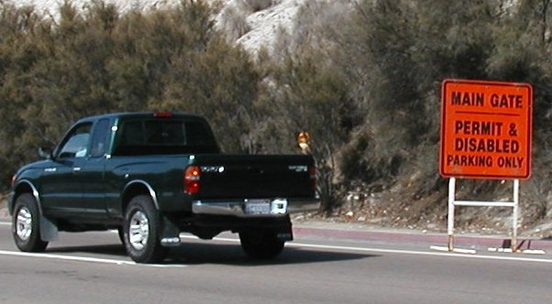
Figure 6-7
Guide Sign for Reserved Parking Areas

- Traveler information considerations during event egress include the provision of parking area identification landmarks, and guide signs to major freeway/arterial routes at parking area exit points and adjacent access roadways.
  - In the absence of parking staff, the guide signs assist motorists unfamiliar with the area in making critical turns to access known freeways and/or arterials when departing the event venue site.
  - Missed turns result in additional circulation through the site area and impacts street network operations during egress.
- Standard parking area identification landmarks at permanent venues include fixing a parking section banner to light posts or naming different levels of a parking garage. The lack of such permanent identification landmarks at unpaved parking areas can create significant pedestrian/vehicular conflicts, not to mention added delay for the event patron, as pedestrians scan the parking area for their vehicle.
  - Figure 6-8 shows an innovative parking area identification technique applied to unpaved parking areas, which represented a golf course, at the Rose Bowl. The technique involved attaching a numbered balloon to portable lighting trailers stationed at various unpaved parking areas. Some balloons were visible from inside the stadium.

Figure 6-8
Temporary Parking Area Identification Landmark

Contingency Plans

Contingency planning involves the development of traveler information message sets to divert and guide event ingress traffic to overflow parking areas:

- If unpaved parking areas are used, the traffic management team should have a contingency plan when wet weather prevents the use of unpaved lots. This includes using other paved areas, particularly lots serving an inactive land use or one adversely affected by wet weather such as a park, and/or allowing on-street parking.

Technology Applications

Technology utilized for day-to-day traffic management can greatly enhance parking management and efficiency of operation at permanent venues that serve numerous planned special events. In particular, use of technology can improve operator monitoring of parking areas and facilitate accurate, up-to-date dissemination of traveler information.
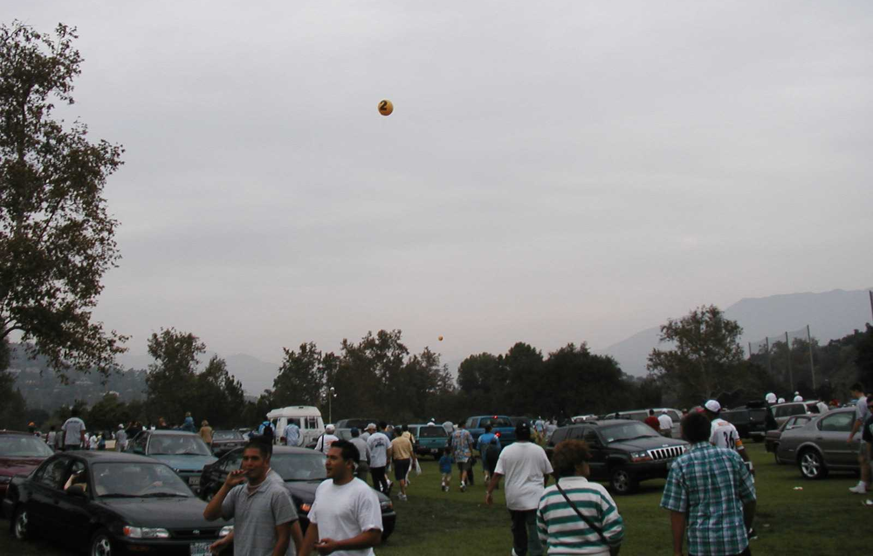


Advanced Parking Management System

A basic advanced parking management system allows operators, stationed at a transportation management center, to monitor parking areas and control traveler information devices used to disseminate parking information. Key considerations include:

- Advanced systems include electronic detection equipment that transmits real-time traffic volume counts and speeds to the TMC.
- The system surveillance and monitoring system incorporates pan-tilt closed-circuit television (CCTV) cameras for viewing parking areas and adjacent access roads.
- Traveler information devices include a CMS and HAR network coupled with strategically positioned blank-out signs that communicate parking area status information (e.g., lot full) to motorists.
- With real-time access to CCTV, TMC traffic signal system operators can implement timing modifications on demand.
- Operators at the TMC can integrate the advanced parking management system into the greater Advanced Traveler Information System for the region (e.g., automated information transmission to other agencies, websites, and kiosks).

Advanced Parking Information System

The deployment of advanced parking information systems have successfully occurred at some airports and metropolitan areas across the Nation. This system automatically disseminates accurate, up-to-date information regarding parking facility occupancy status to motorists upstream of the facility, coupled with routing directions to open facilities. From the perspective of planned special events, the system would function well for an event venue served by several parking facilities, such as one located in a downtown area. Electronic signs controlled by the system inform motorists of open parking facilities as soon as they exit the freeway system.

An advanced parking information system generally consists of the following four components: (1) vehicle detectors, (2) a parking control center, (3) information displays, and (4) a telecommunications network. Automated detection methods include inductive loop, ultrasonic, infrared, microwave, and machine vision, although studies have shown infrared detection functions best for advanced parking information systems. The parking control center receives and synthesizes data collected by detectors, and the center transmits messages pertaining to parking facility occupancy to information displays for motorists’ use. Operators at the parking control center can override the system during planned special events or unusual circumstances. Information displays include a combination of static and dynamic signs disseminating parking availability information and directions to open facilities. The system can incorporate other traveler information devices, such as HAR, the Internet, telephones, commercial television, and in-vehicle navigation.⁽²⁾

The Minnesota DOT, Federal Highway Administration (FHWA), City of Saint Paul Department of Planning and Economic Development, City of Saint Paul Department of Public Works, and one private partner conducted a one-year Saint Paul Advanced Parking Information System Operational Test for planned special events in the area.⁽³⁾ The stakeholders performed the test in the Civic Center/Rice Park area of downtown Saint Paul, and the test consisted of the following:

- Determination of parking stall occupancy by participating parking operators during planned special events in downtown Saint Paul and instantaneous transmission of available parking to the Saint Paul Traffic Control Center (TCC).
- Instantaneous transmission of information on available parking by the Saint Paul TCC to electronic message signs.
- Wireless, automated parking advisory signs placed at appropriate locations to display the number of stalls available at parking garages or lots with direction arrows to the garages or lots.

Table 6-7 summarizes some key findings yielded by the operational test.

Vehicle Access and Circulation

In order to facilitate safe and quick spectator and participant travel to/from the event site, the site access and parking plan should specify tactics that prevent potential congestion on parking area access roads and allow for good circulation on roadways surrounding the event site. Table 6-8 indicates site access and circulation considerations applicable to the development of a site access and parking plan. The three considerations of: (1) parking area ingress, (2) pick-ups and drop-offs, and (3) parking area egress are discussed in the following subsections.

Table 6-7
Key Findings from Saint Paul Advanced Parking Information System Operational Test⁽³⁾

FINDING
- Advanced Parking is perceived beneficial to the participating parking operators and the city of Saint Paul.
- Most motorists responding to a mail-back survey thought the system has value.
- There were some improvements on the surface transportation system, but the improvements could not be attributed directly to Advanced Parking.
- Advanced Parking signs with full matrix displays have sufficient capabilities to support other traffic functions in downtown Saint Paul; Advanced Parking counter signs alone do not have sufficient capabilities.
- There were no institutional, legal, or other private sector issues, which had a significant effect on the operational test.
- Advanced Parking is transferable to other cities without significant modification.

The reader should review:

- Select street and intersection control tactics (e.g., alternative lane operations, turning movement lane balance, traffic signal operations) described in the “Traffic Control Plan” section of this chapter warrant review for possible mitigation of site circulation deficiencies.
- Traffic flow plan, traffic control plan, and parking area design provisions that impact the scope of mitigation required to provide adequate site access and circulation.

Parking Area Ingress

During event ingress operation, several factors influence the operation of access roads connecting the adjacent street system and parking areas:

- While the physical characteristics of the adjacent street system and associated traffic control may meter traffic flow destined to access roadways, the roads likely do not have sufficient capacity to service incoming traffic. As a result, the event planning team should designate contraflow (e.g., one-way) operation on the access road segment connecting a major feeder intersection and the relevant parking area. An advantage of implementing access road contraflow operation concerns the capability of handling two or more conflicting movements from a feeder intersection with proper channelization. In turn, the design of parking area access points should ensure accommodation of vehicles in all travel lanes.

Table 6-8
Site Access and Circulation Considerations
CONSIDERATION | TACTIC
Parking area ingress | - Right turn circulation pattern  - Contraflow operation  - Shoulder utilization  - Lane channelization  - Parking area overflow access points
Pick-ups and drop-offs | - Use of off-street areas  - Designation of pick-up/drop-off areas to avoid conflict with primary traffic ingress/egress routes  - Storage area
Parking area egress | - Right turn circulation pattern  - Preservation of adjacent street flow  - Provision of rapid parking area unloading

- Shown in Figure 6-9, shoulder utilization represents another strategy to gain additional access road capacity. As indicated in the figure, the temporary right shoulder lane services through traffic, and the inside lane provides direct access to a parking area.

Figure 6-9
Shoulder Utilization

- Figure 6-10 shows an example of lane channelization implemented on an access road serving venue parking areas. This control technique eliminates unnecessary lane changing, which reduces roadway capacity, in the vicinity of parking area access points. Advance signing can inform motorists on which lane to use.

Figure 6-10
Lane Channelization
- The use of multiple access points to the same parking area provides an opportunity where vehicles traversing the left lane must enter the first access point and vehicles traversing the right lane has access to remaining downstream access points (e.g., left lane becomes exclusive lane to the next downstream access point).
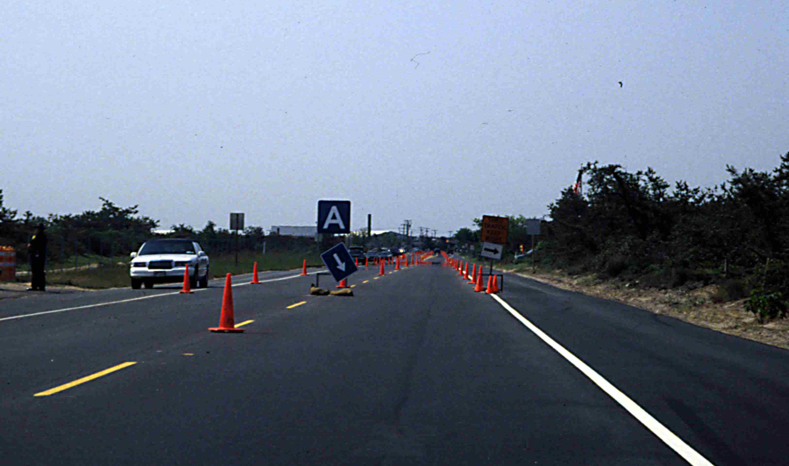
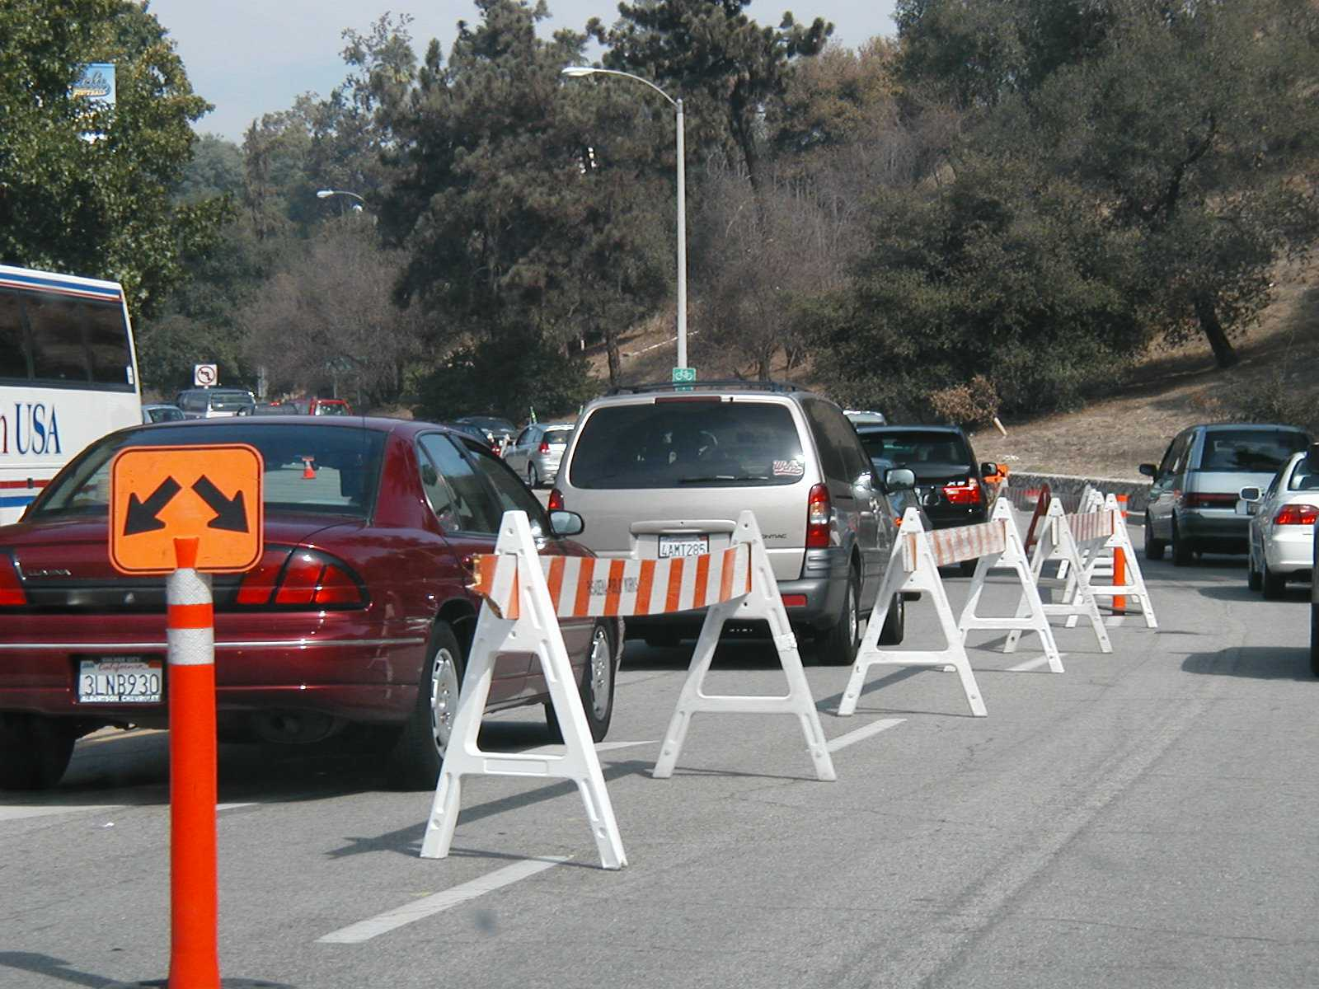
- A breakdown in either parking area process or park operations creates congestion on the access roadway serving the parking area. This is not a “lot full” situation but, instead, a situation characterized by excessive service time to conduct parking fee transactions or to park vehicles. If parking operators do not mitigate the breakdown quickly, congestion on the access road propagates to the adjacent street system. The use of overflow access points and on-call operators/volunteers can effectively limit and even reduce congestion until parking area operations return to normal.

Pick-ups and Drop-offs

Table 6-9 lists guidelines for designating pick-up and drop-off areas. Some considerations include:

Table 6-9
Guidelines for Designating Pick-up and Drop-off Areas

GUIDELINE
- Utilize off-street areas for private vehicles, taxis, limousines, and buses.
- Select areas that do not require vehicles to intersect heavy traffic flow to/from parking areas or pedestrian access routes.
- Designate separate areas for different vehicle classes.
- Ensure adequate space exists within the off-street area to accommodate vehicle storage and turnaround.

- A site vehicle circulation rule of thumb involves implementing a right turn pattern of ingress and egress to achieve maximum street system capacity. The quandary with pick-ups and drop-offs concerns accommodating two-way vehicle travel, departing traffic during event ingress and arriving traffic during event egress.
  - First, recognize these motorists will encounter resistance only in exiting the immediate site area during ingress and vice versa during egress. They likely will travel in the opposite direction of peak flow on freeway and arterial corridors serving the event venue.
  - Second, vehicles may have to turnaround after a pick-up/drop-off.
- The utilization of off-street parking areas for taxi and limousine event service eliminates taxi/limo cruising at the end of a planned special event. For example, limousine drivers would have to meet their customers after the event and escort them back to the parked limousine. This strategy has proven successful at reducing pedestrian/limousine conflicts at intersections near the Staples Center in Los Angeles, CA.⁽⁴⁾
- For private vehicles, an off-street lot provides a convenient meeting location.
- Pick-up and drop-off area capacity represents another key concern that practitioners must address.
- A queuing system, discussed in the next section on parking area design and operation, can describe the operation of pick-up/drop-off areas for taxis and drop-off areas for private automobiles, limousines, and buses.
- In the case of pick-ups involving private automobiles, limousines, and buses, the event planning team must designate an off-site parking area of sufficient capacity, as determined through a parking demand analysis, to stage vehicles operated by drivers intending to pick-up a specific event patron(s). In an effort to avoid conflict with heavy egress traffic, or as a client courtesy, drivers typically arrive at a designated pick-up area before the end of the event.
- Practitioners can estimate and compare the service rate (vehicles per hour) of all lanes comprising a particular pick-up/drop-off area to the peak arrival rate of traffic using the area. The service flow rate for one lane equals one hour divided by the time to process (i.e., service time) one vehicle picking-up/dropping-off event patrons. If an average pick-up/drop-off service time is two minutes, then the service rate of one lane equals 30 vehicles per hour (60 minutes divided by 2 minutes per vehicle).
  - Personnel assigned to monitor pick-up/drop-off area operation on the day-of-event can enforce a particular service time or length of time a particular vehicle can stay in the pick-up/drop-off area.
- Note that a pick-up/drop-off area queuing system operates stochastically. Traffic arrival rates will vary, and individual service times that collectively determine the service rate will also vary.
- To handle a potential overflow situation at a pick-up/drop-off area, prohibit parking on the access road adjacent to the pick-up/drop-off area, and cone (when necessary) a vehicle stacking lane along the access road shoulder.

Parking Area Egress

Two basic strategies surround parking area egress operations. These contrasting strategies include: (1) preserving adjacent street flow and (2) effecting rapid parking area unloading. Several important considerations include:

- Regardless of strategy, planners should locate parking area access points as far away as possible from major intersections so that vehicles can exit immediately from the parking areas without disrupting the flow of traffic on the adjacent access road.
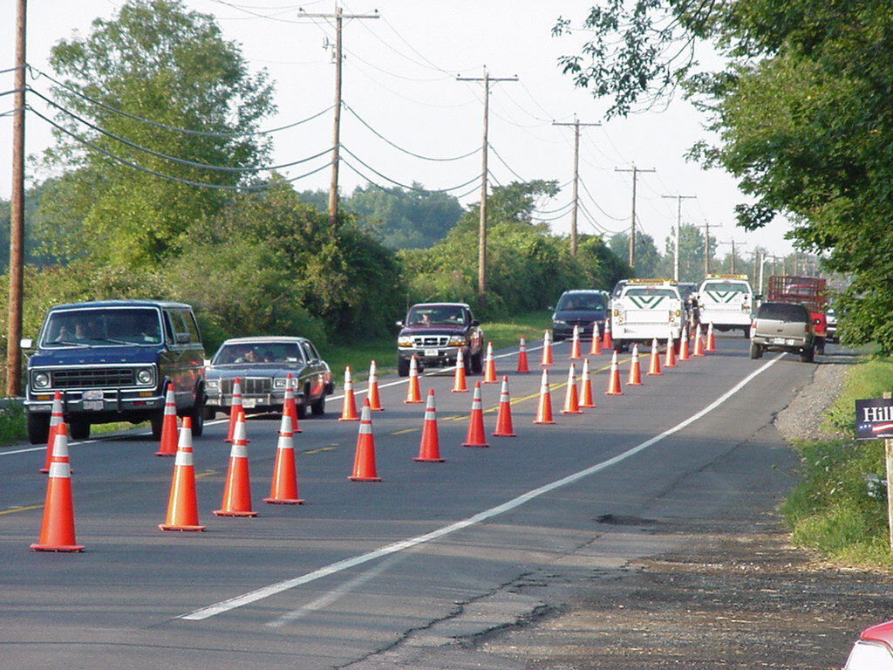
- When the adjacent street represents a collector or arterial roadway, the traffic management team generally seeks to preserve flow. This is accomplished either by manual or automated means. A manual operations approach involves traffic management team personnel monitoring parking exit points. Crews permit a maximum volume of traffic to exit the parking areas while still maintaining a smooth traffic flow on the adjacent roadway network. If traffic begins to queue downstream of an exit point, personnel would communicate via radio and movement out of the relevant parking areas stopped until mainline congestion dissipates.
  - This strategy worked successfully during two major rural events, the 1986 and 1995 U.S. Golf Open at Shinnecock Hills Golf Course in Southampton, New York.⁽⁵⁾
  - Instead of manually controlling traffic, traffic management team personnel could operate portable traffic signals placed at parking area access points.
  - If access points have a permanent traffic signal, operators can simply implement new timing plans in favor of either egress strategy.
- To effect rapid parking area unloading, consider providing multiple access points for each parking area.
  - For planning purposes, practitioners may either assume an access point capacity of 900 vehicles per hour per lane (e.g., 4 second headway between vehicles) or use computer traffic simulation software to gain a more precise estimate based on local conditions.
  - An alternate approach involves temporarily striping additional exit lanes, for a nominal distance (e.g., 1000+ feet) plus taper, on the adjacent access road to allow for multiple lanes of traffic out of the parking area. Figure 6-11 illustrates this strategy, implemented for a county fair in rural Dutchess County, New York. This approach works well when the parking area access point is centrally located and accommodates traffic from opposite ends of the parking area.

Figure 6-11
Access Road Traffic Pattern During Event Egress⁽⁶⁾

Parking Area Design and
Operation

Parking area operations consist of two distinct components: process and park. A significant breakdown in either component will, in turn, cause congestion to occur and propagate on the access road serving the parking area. The objective of designing and operating parking areas involves providing an access point capacity in excess of the peak rate of traffic flow that traverses the driveway.

Process Component

Any planned special event parking area that requires a fee or permit for access has a service facility in-place to process vehicles entering the lot. Therefore, a first-in-first-out queuing system exists. Figure 6-12 provides a schematic of this system. The queuing system is bounded by the service facility (e.g., parking area gate) and the queue storage area. Figure 6-13 illustrates a queuing system at the entrance of a venue parking area. From a parking area operations perspective, queuing system characteristics include:

Figure 6-12
Queuing System Schematic
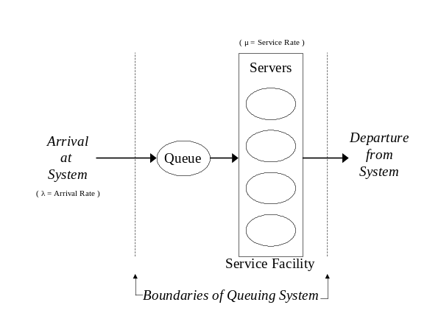
Figure 6-13
Permanent Venue Gate and Queue Storage Lanes

- The arrival rate, λ, denotes the number of vehicles traversing a single parking area access point over some period of time.
- The maximum arrival rate represents the lesser of: (1) access point capacity or (2) adjacent access road capacity.
- The service rate, μ, is the number of vehicles the service facility can process over some period of time. The magnitude of this rate depends on the number of servers (e.g., staff or automated gates) that comprise the service facility and server efficiency.
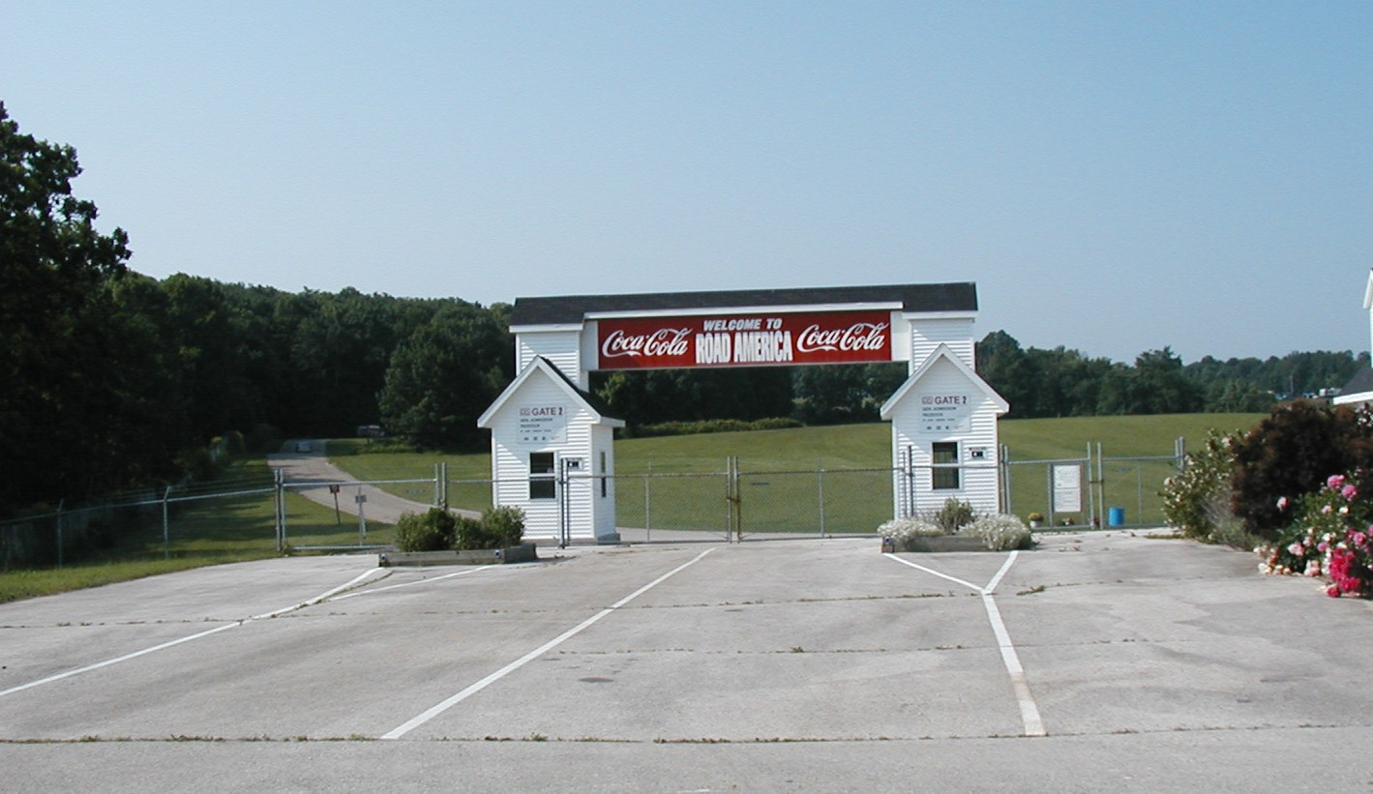
- Queuing happens when the arrival rate exceeds the service rate. For example, if the maximum arrival rate is 600 vehicles per hour and four parking area gates are open, then each server or staff person must process 150 vehicles per hour, or 1 vehicle in 24 seconds (e.g., the service time), in order to prevent vehicle queues from forming. Motorists will locate open servers, but the event planning team should utilize the queuing system concept, and consider predicted arrival rates, when staffing parking area access points.
- A parking area queuing system operates stochastically. Traffic arrival rates will vary, and individual transaction times that collectively determine the service rate will also vary.
- In designing a service facility for a planned special event parking area, select a conservative server service time (e.g., the time to serve one vehicle) and determine the required number of servers that can process the maximum anticipated arrival rate with one server on break.
- Service time may increase if law enforcement conducts random checks of vehicles entering a parking area.
- To avoid the occurrence of long service times, designate a turnout area adjacent to the gates for vehicles subject to a detailed security check.

Table 6-10 indicates three vehicle processing tactics.
Table 6-10
Vehicle Processing Tactics at Parking Area

TACTIC
- Manual transaction
- Permit display
- Automated transaction

Manual Transaction

Manual transaction refers to cash transactions made between a driver and human server. This tactic involves the longest and most variable service times, as servers have to periodically make change and even answer questions.

Manual transaction operation at parking areas closely resembles the operation of manual (cash) lanes at toll facilities. In both cases, signs inform drivers of the fee in advance of the service facility, and servers conduct cash-only transactions. Numerous publications on toll facility evaluation report the capacity of a manual toll lane ranges from 300 to 400 vehicles per hour. This equates to a service time of between 9 to 12 seconds per vehicle. Practitioners may assume a service time in the stated range, where 12 seconds per vehicle denotes a conservative service time, for individual servers handling cash transactions at a planned special event parking area.

Permit Display

The use of permits for planned special event parking has become increasingly common. Originally, permanent venue or recurring event season ticket holders received or purchased a parking permit as part of their season ticket package. Internet commerce has spurred venues and event organizers to sell reserved parking spaces in advance to event patrons. Typical offers involve obtaining a guaranteed parking space near the venue and main gate.

Advance parking sales provide a two-fold advantage from a parking operations perspective. First, event patrons will have advance information on exactly where to park at the event venue, and repeat customers will become familiar with the fastest route to the parking area. Second, the tactic eliminates cash transactions at reserved parking areas on the day-of-event, substantially reducing service time. In fact, a service facility is unnecessary if parking operators post proper signage and conduct a vehicle check for violators between event ingress and egress.

The operation of a permit-only parking area mirrors that of a free parking area. In determining the capacity of individual access lanes to a free or permit-only parking area, practitioners may assume a 4 second headway between vehicles (or 900 vehicles per hour per lane capacity). This represents the capacity assumption made by officials, during the planning process, for free parking areas used by spectators of the 2002 Winter Olympics.⁽⁷⁾ In order to account for roadway geometrics or special turning maneuvers, practitioners can determine the capacity of access lanes using computer traffic simulation software.

Automated Transaction

An automated transaction involves deployment of an electronic fee collection system, suitable for permanent venues hosting numerous events. Similar in operation to an electronic toll collection system, the system would require event patrons to have a transponder in their vehicle. Implementation of a small-scale system could involve distributing transponders to season ticket holders.

Park Component

Parking operators and volunteers must meet the following two requirements for parking vehicles:

- Park vehicles at the same rate as those being processed.
- Minimize pedestrian/vehicular conflicts inside parking areas.

When multiple servers process vehicles, operators should consider creating multiple vehicle streams from the service facility and, in turn, parking vehicles in different sections of the parking area. Each stream must maintain an adequate speed or congestion will occur within the parking area and spillback to the service facility. Prior to the event, parking operators should survey the parking area and note any features that may slow vehicles traversing a parking area. Such features include ditches, sand, and humps.

Figure 6-14 shows an excellent example of minimizing pedestrian/vehicular conflicts inside a parking area. Simply ensure that every vehicle entering a parking area parks as close to the adjacent pedestrian access route, leading to the venue or shuttle bus station, as possible. Erect pedestrian walkway signs and instruct volunteers to tell event patrons where to walk as soon as patrons exit their vehicle.

Figure 6-14
Minimizing Pedestrian/Vehicular Conflicts in Parking Areas

Parking Occupancy Monitoring

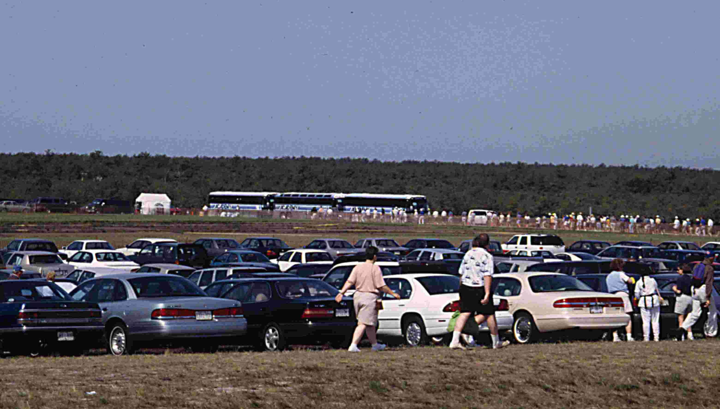
On the day-of-event, traffic patterns and parking area loading patterns may vary from event planning team predictions. As a result, some parking areas, particularly non-reserved lots, may load faster than other lots. The event planning team and traffic management team must, in advance of the event, develop a detail for monitoring parking area occupancy levels for the ingress period. The focus of this task involves making a “lot full” decision at a time when all vehicles between the parking area access point and traveler information devices directing motorists to the parking area (e.g., the pipeline) can still park at the subject lot. As soon as team personnel make a “lot full” call, TMC or command post operators change the message set communicated by traveler information devices in order to direct motorists to an alternate lot. The traveler information device(s) forming the upstream boundary of the pipeline must be located upstream of the access road serving an alternate parking area. In some cases, a parking area pipeline may extend to a freeway or arterial corridor serving the event venue.

Two methods for making a “lot full” decision in the field include: (1) vehicle count at parking area access points and (2) visual inspection. Both methods require field personnel to have an estimate of the pipeline capacity during load-in. That is, the defined pipeline length (account for multiple travel lanes) divided by average vehicle spacing. Consider that up until the parking area reaches capacity, vehicles traversing the pipeline will be moving. Therefore, average vehicle spacing equals vehicle length plus the space allotted by drivers between vehicles. Average vehicle spacing ranges from 30 feet (conservative) to 40 feet.

The vehicle count method involves conducting a manual or machine count at the downstream pipeline end beginning at the start of parking area load-in. This count represents the number of vehicles that have entered the parking lot. The following equation defines a “lot full” decision:
(Capacity of parking area) – (Vehicle count) – (Pipeline capacity) = 0 (Lot full)

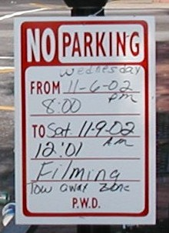
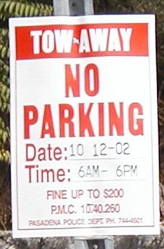
The visual inspection method involves the traffic management team or parking operators making a “lot full” decision based on comparing a visual estimate of available parking spaces to the pipeline capacity. The parking area access point(s) must denote the downstream pipeline terminus. Team personnel can obtain an estimate of available parking spaces on the ground, from an overhead vantage point, or from aerial observation. This method is not as precise as the vehicle count method, but the visual inspection method: (1) requires less personnel resources and (2) can be implemented in the latter stages of load-in, as necessary to assess conditions.

Table 6-11 summarizes the parking occupancy monitoring plan used during the 2002 Winter Olympics.

Table 6-11
2002 Winter Olympics Parking Occupancy Monitoring Plan(1)

STEP
- The observers at each lot reported hourly to the TMC command post on the percent of lot capacity in use.
- The status of all lots was tracked by the TMC command post.
- As any lot approached capacity, a backup lot was identified by the TMC command post.
- For each lot and backup lot, the upstream CMS locations were identified.
- Diversion messages were posted by the TMC at those CMS locations.
- Approaching motorists saw the CMS instructions and diverted to the new lot.

Parking Regulations

Planned special events require law enforcement and other stakeholders to consider various on-street and off-street parking regulations. On-street parking regulations involve day-of-event parking restrictions, as illustrated in Figure 6-15, to: (1) preserve parking for nearby residents and businesses and (2) increase capacity on critical access routes serving the planned special event. Table 6-12 lists some considerations for developing off-street parking regulations.
Figure 6-15
Parking Restriction Signs

Table 6-12
Off-street Parking Regulation
Considerations

CONSIDERATION
- Parking area opening and closing time
- Parking on grass adjacent to paved areas
- Parking on islands, medians, and berms
- Parking on the access road shoulder
- Private parking area regulations regarding the obstruction of traffic flow
- Obstruction of pedestrian access routes (e.g., sidewalks)
- Tailgating:
- Occupy one parking space only
- Saving of parking spaces
- Blocking of aisles

Practitioners should assess the use of private land (residential or business) for event patron parking. Owners entice arriving event patrons to use private parking areas by offering a reduced fee relative to event parking areas, or drivers recognize the convenience of the lot location with respect to accessing a freeway or arterial corridor needed to exit the area during egress. Problems may occur particularly during event egress when a continuous stream of traffic exiting a private lot(s) conflicts with heavy adjacent street traffic attempting to exit the local area surrounding the event site. Congestion on the adjacent street creates congestion that propagates upstream and toward the event site area. Solutions to mitigate the potential impact of private parking areas on adjacent street traffic flow during event ingress and egress include: (1) requiring owners of private land to obtain a permit to offer parking for a fee during a planned special event and (2) staffing traffic control officers at private driveways during egress to meter traffic flow out of the private parking area.

Three keys to successfully implementing a parking regulation include enforcement, advertising, and signing. Enforcement involves both ticketing and towing. Tow trucks assigned to the planned special event venue site can facilitate immediate removal of illegally parked vehicles. Prior to the event, the event planning team could designate an on-site area to serve as a repository for towed vehicles. Event patrons could access the area on foot and then would have to pay a towing charge to retrieve their vehicle.

The event planning team should inform affected local residents and businesses of parking restrictions via direct contact or mailing. To better meet community needs, stakeholders can setup a telephone hotline during the planned special event to field any complaints. This tactic assists law enforcement in identifying areas requiring greater enforcement. For multi-day events, law enforcement can base second-day enforcement patrols on first-day public comments.

Plan Specifications

The event planning team should design a site and parking plan to service both the traffic management team and event patrons. Pre-trip traveler information dissemination (via media, websites, mailings, brochures) should include elements of the site and parking plan. Table 6-13 contains a site and parking plan development checklist. Appendix H contains example site and parking maps prepared for permanent venues.

Event patrons primarily focus on information specifying time of operation, location, and cost. These elements define the utility associated with choosing a particular parking area or electing to drive to the event site altogether. As shown in Figure 6-16, the distribution of an annotated aerial map benefits event patrons unfamiliar with the immediate venue area. Figure 6-17 shows a downtown arena parking map that displays parking fees for various off-site parking areas within sufficient walking distance from the venue. Table 6-14 lists considerations for posting any planned special event plan on an Internet website.

Pedestrian Access Plan

Overview

A pedestrian access plan provides for the safe and efficient movement of pedestrians within the immediate area of the venue. This includes accommodating pedestrian trips to/from several mode transfer points in a planned special event activity network. These points, shown for example in Figure 6-18, include site parking areas, transit stations, express/charter bus stations, shuttle bus stations, and pick-up/drop-off areas. Moreover, some event patrons may make their entire trip, originating from home or work, on foot. In meeting the managing travel for planned special events goal of ensuring safety, the event planning team must develop a plan that: (1) accommodates pedestrians accessing an event via a network of safe walking routes and (2) minimizes pedestrian/vehicular conflicts.

Table 6-13
Site and Parking Plan Checklist
ELEMENT | PROVISION
Event patron  parking areas | - Highlight free, pay (state rates), and reserved (permit) parking areas.  - Indicate lots where tailgating is permitted.  - Show specific parking area access points and state restrictions.  - Indicate number of entrance/exit lanes (or servers) at each access point.  - Designate lots by a number or letter and provide lot-specific directions.  - State time parking areas open, particularly if time varies by parking area.  - Discuss features of each parking area (e.g., paved, staffed, lighting, security).  - State estimated walking time from each parking area.  - Indicate connecting pedestrian access routes.  - Show overflow parking areas, state distance from venue, and indicate criteria for operation (e.g., sell-out).  - Indicate parking areas for motorcycles.  - Indicate parking areas for recreational vehicles (e.g., overnight parking).  - Furnish map of available off-site parking areas.  - Include information on street regulations (e.g., one- or two-way) and connections to freeways and major arterials.  - State on-street parking restrictions.  - Specify private parking area regulations (e.g., egress control).  - Indicate location of entrance/exit points to off-street parking areas.  - Include rates if available.  - Show restricted off-site parking areas (e.g., residential neighborhoods, etc.)
Gate access  information | - Indicate gate names as shown on event patron tickets.
VIP information | - Show VIP (e.g., official guest / sponsor) parking areas.  - Show credential pick-up location.  - Show hospitality areas.
Shuttle bus route and stations | - Display shuttle route and all stations.  - State cost, and emphasize free services.
Drop-off / pick-up sites | - Show access points and circulation lanes for transit/taxi/limo/shuttle service.  - Show exclusive bus lanes.  - Show transit / express bus stations.  - Indicate general drop-off / pick-up sites where turnaround is permitted.  - Indicate valet parking drop-off.  - Show disabled drop-off / pick-up site.
Other parking areas | - Show express/charter bus parking area.  - Show limousine parking area.  - Show media parking area.  - Show venue employee parking area.
Disabled parking areas | - State specific location (e.g., first row) of disabled-only spaces in general parking areas.  - Indicate number of spaces available.
Other  considerations | - Show aerial map.  - Promote advance purchase (permit) options.  - Indicate towed vehicle (e.g., illegally parked) pick-up area.  - Emphasize new provisions (e.g., new parking areas, etc.).  - Present map in grid format for easy reference.  - Prepare maps for different venue events if parking plan varies.  - Draw map to scale.  - Show private property.  - Display landmarks.  - Indicate municipal fireworks viewing areas.

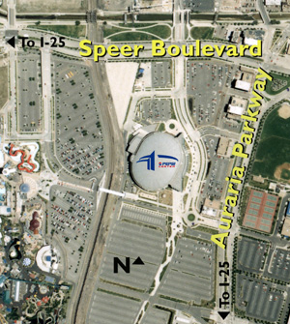

Figure 6-16
Annotated Aerial Map of Venue Site (Photo courtesy of the Pepsi Center.)

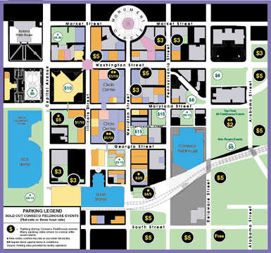
Figure 6-17
Downtown Area Venue Parking Map (Graphic courtesy of the Conseco Fieldhouse)
Table 6-14
Considerations for Posting Plans on an Internet Website

CONSIDERATION
- Recognize detailed plans and maps may be difficult to read, especially when compressed for easy downloading.
- Create an interactive plan to better present detailed information contained in the plan.
- Allow users to access information on specific entities via hyperlinks embedded in the plan.
- Provide a black and white version of plans for event patrons to download and print.
- Provide text directions to support plans.
- Provide maps and directions based on point of origin (e.g., city or roadway).

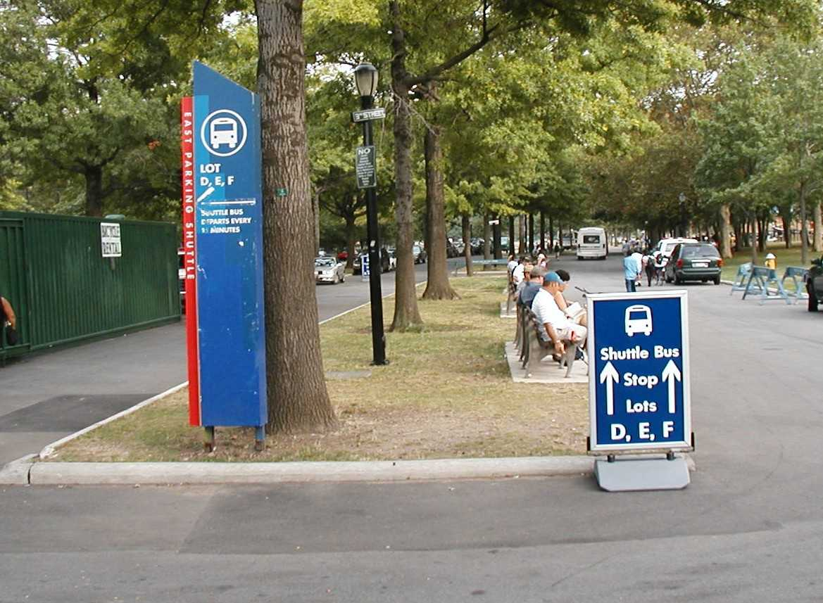
Figure 6-18
Mode Transfer Point

As with planned special event travel demand, peak event-generated pedestrian demand rates vary by event category:

- A discrete/recurring event at a permanent venue is characterized by high peak pedestrian arrival and departure rates. Maximum pedestrian demand occurs after the end of a discrete event, and the high demand level meters pedestrian flow to event parking areas and transit/shuttle stations, thus metering vehicle departures from the venue area.
- High attendance at continuous events and street use events yields high pedestrian traffic traversing the adjacent street system for a sustained period of time.

Existing pedestrian facilities, namely sidewalks and crosswalks as illustrated in Figure 6-19, can not adequately accommodate pedestrian traffic in the vicinity of a planned special event venue during ingress or egress. If stakeholders fail to implement proper pedestrian control measures, then pedestrians will risk exposure to moving traffic and traverse travel lanes, causing traffic congestion, under heavy flow conditions. Also, the popularity of planned special event transit service requires advance consideration of moving pedestrians between an event venue and nearby transit stations.

Figure 6-19
At-Grade Pedestrian Crossings Adjacent to a Venue Gate

A successfully implemented pedestrian access plan for planned special events permits rapid dispersion of pedestrian flow. Although high pedestrian volumes encompass the immediate venue area during ingress and egress, the plan effects efficient access through a radial network of pedestrian routes. It also includes time-sensitive strategies to minimize overcrowding conditions at venue gates and mode transfer points. The plan also considers a continuous shuttle bus service operations detail to handle event patrons destined to/from satellite parking areas and transit stations not easily accessible by foot.

Pedestrian Control

Pedestrian access routes are comprised of two components:

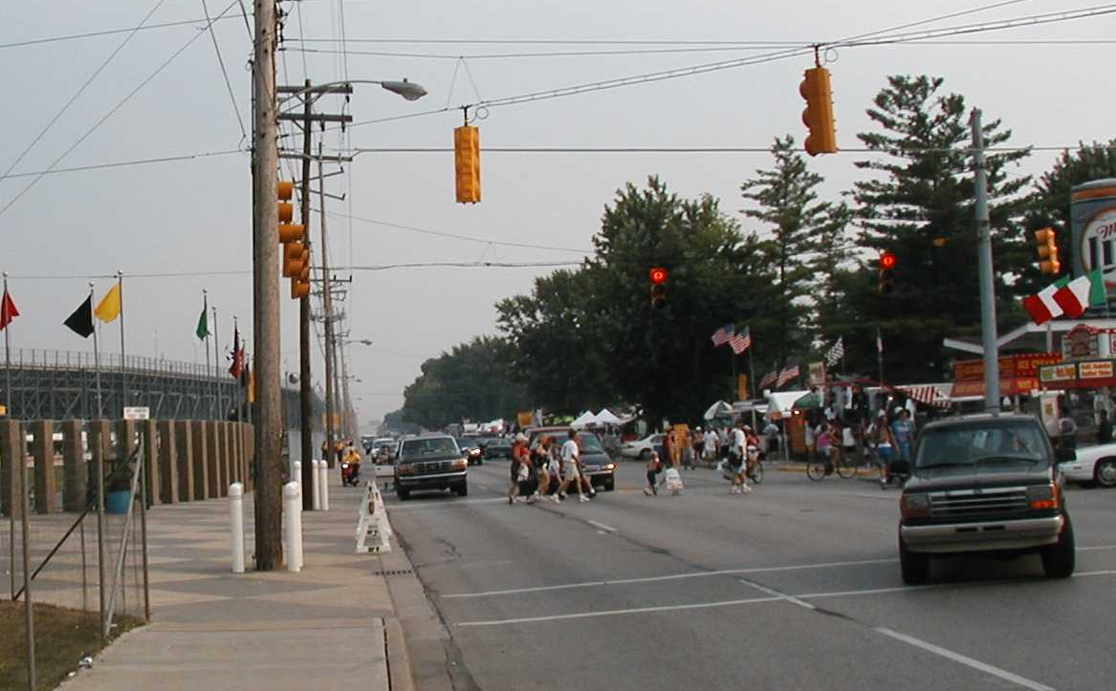
- A routing component, consisting of sidewalks or paths between street intersections.
- A crossing component, consisting of infrastructure or other vehicle control measure that allows pedestrians to cross a street safely.

Planned special event pedestrian management involves the implementation of integrated control tactics to facilitate pedestrian routing and crossing between a mode transfer point and the event venue. Key considerations include:

- Pedestrian access route capacity represents the smallest of its routing and crossing component capacities.
- In a radial network, where pedestrian volume is highest at the center or venue, the event planning team should design pedestrian access routes to provide increasingly greater capacity from site area to venue.
- Another important planning and operations consideration involves preventing the intersection of pedestrian access routes. This results in overcrowding at the intersection point and compromises pedestrian safety, particularly if two streams of pedestrians intersect at a street crossing.
- Practitioners should design each access route to exclusively serve a venue gate and implement control tactics to prevent routes from converging until reaching the event venue.
- Associated tactics include erecting pedestrian crossing barriers, as shown in Figure 6-20, at street intersections and deploying roving law enforcement patrols for pedestrian protection and crowd control.
Figure 6-20
Pedestrian Crossing Barrier

- Use of bicycle, equestrian, or all-terrain vehicle patrols allow officers to conveniently access and travel on streets, pedestrian access routes, and parking areas.
- A traffic operations agency can assist law enforcement in maintaining orderly pedestrian flow through the site area by using CCTV to monitor pedestrian travel and operations at critical crossing points. Shown in Figure 6-21, stakeholders managing travel for major events at the Daytona International Speedway successfully used portable CCTV cameras to monitor the pedestrian egress flow rate from the venue in addition to operations at several nearby street crossings.

Figure 6-21
Pedestrian Traffic Monitoring Via CCTV

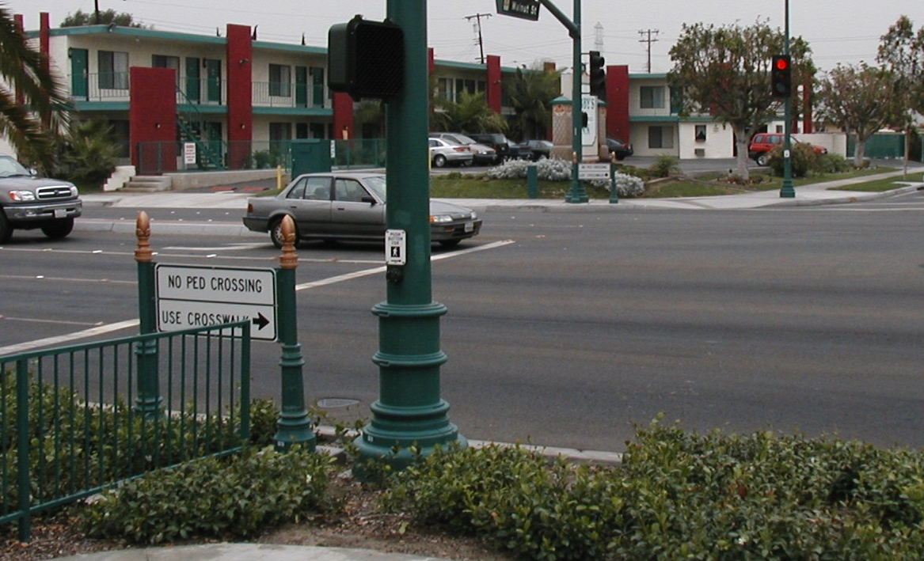
Pedestrian Routing
Two strategies for managing pedestrian flow on walkways during planned special events include:

- Locating access route termini.
- Providing additional, temporary pedestrian walkway capacity.

Key design aspects to consider include:

- The event planning team and parking area operators should avoid having a pedestrian access route and parking area access point intersect.
- Vehicle turning movements in and out of access driveways impact pedestrian safety and flow, and the implementation of special traffic control measures reduces vehicle arrival rate to parking areas and may create congestion on parking area access roads. Instead, stakeholders should provide an uninterrupted pedestrian walkway, connecting a pedestrian access route to parking areas, and station volunteers inside parking areas to prevent pedestrian/vehicular conflicts.
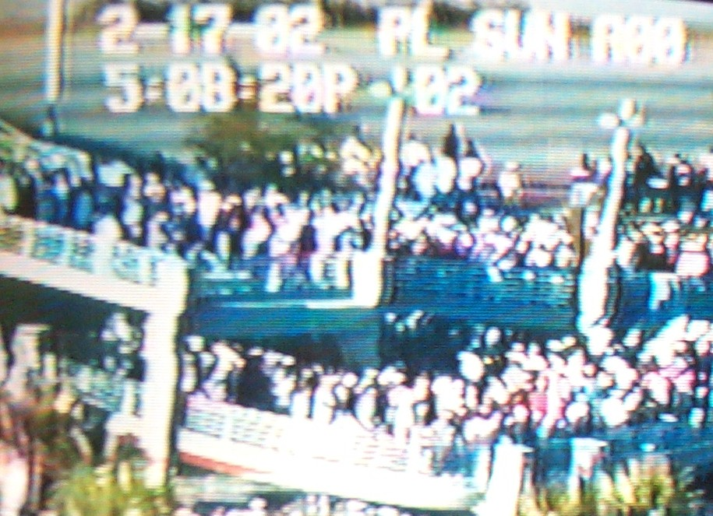
- To effect pedestrian dispersion in the immediate area of the venue, locate temporary transit stations a sufficient distance away from venues while still affording event patrons a convenient walking distance. As a result, potential station overcrowding during event egress does not impede pedestrians from accessing routes leading to other mode transfer points. This tactic also benefits transit users as traffic management team personnel can better manage station queues by cordoning loading/unloading areas and closing street curb lanes to furnish additional queuing area not available adjacent to the venue.

Obtaining additional pedestrian walkway capacity involves increasing walkway width. Tactics for achieving increased width include: (1) removing movable sidewalk obstacles, such as news racks and benches and (2) closing the adjacent street curb lane for pedestrian traffic. Key considerations include:

- Consider implementing the latter tactic between the event venue and access points to parking areas and pick-up/drop-off areas, but terminate the lane at street intersections if turning traffic can traverse the pedestrian-designated curb lane.
- Use barricades and drums, coupled with law enforcement patrol, separate traffic and pedestrian flow.
- To satisfy both public safety agency and pedestrian accommodation needs, consider closing street segments adjacent to an event venue. For example, as shown in Figure 6-22, a closed street can function as a pedestrian access route and emergency access route.
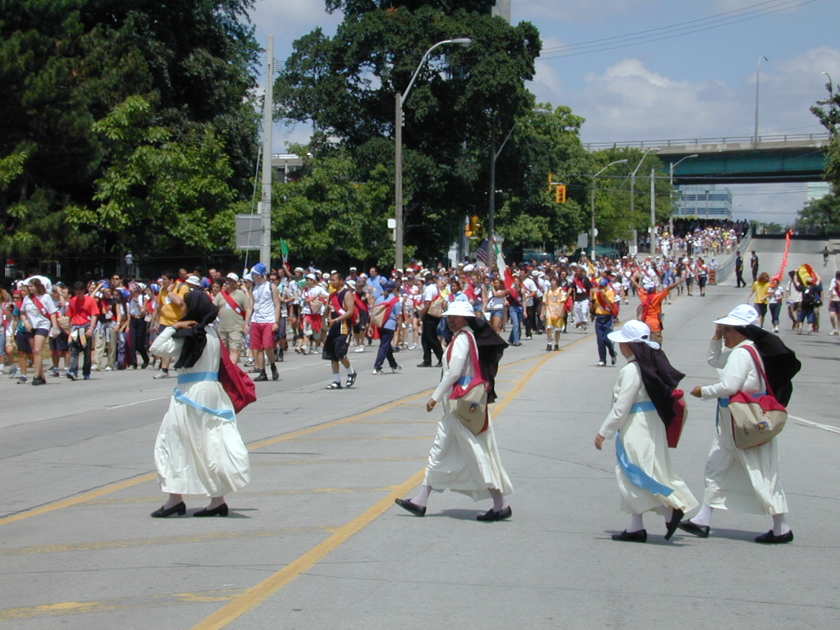
Figure 6-22
Pedestrian Access Route and Emergency Access Route⁽⁸⁾

Pedestrian Crossing

Table 6-15 describes tactics for improving the safety and capacity of pedestrian street crossings.

Table 6-15
Pedestrian Crossing Tactics
TACTIC | APPLICATION
Temporary pedestrian bridge | - Provides uninterrupted flow.  - Achieves total separation of pedestrians and vehicles.  - Enhances pedestrian safety.
Street closure | - Provides uninterrupted flow.  - Accommodates very heavy pedestrian volume.  - Allows pedestrian dispersion.  - Requires officer control.
Mid-block street crossing | - Provides interrupted flow.  - Avoids pedestrian conflict with turning vehicles.  - Requires officer control.
Staffed crossings | - Provides interrupted flow.  - Accommodates light pedestrian volume.

Use of a temporary pedestrian bridge represents an effective tactic for crossing wide streets or roadways where traffic throughput is emphasized. Advantages include safety and minimal traffic management team staffing requirements. Disadvantages include cost and the lack of access for disabled persons. Figure 6-23 shows a temporary, pre-fabricated pedestrian bridge that was successfully deployed during the 1995 U.S. Golf Open as a pedestrian crossing, over an arterial roadway and the Long Island Rail Road, between the event venue and two mode transfer points (transit station and VIP parking area).

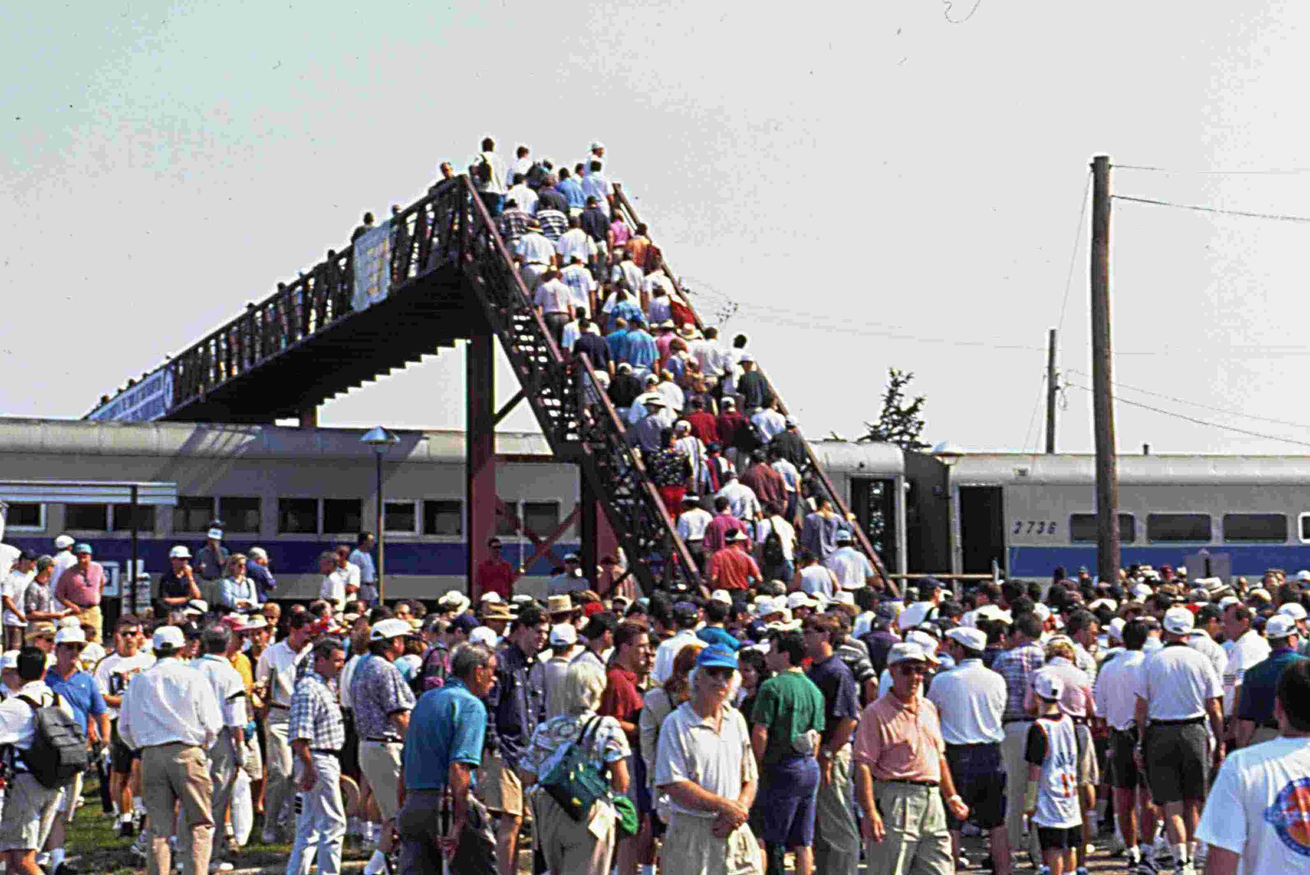
Figure 6-23
Temporary Pedestrian Bridge

Temporary street closures during event egress allow the venue to empty faster and permits pedestrians to disperse to a number of adjacent mode transfer points and pedestrian access routes. Recognize that heavy pedestrian flow on street crosswalks near venue gates significantly reduces traffic turning movement capacity. Therefore, total street closure mainly impacts cross street through traffic flow, traffic that can be diverted away from the immediate venue area. The traffic management team reopens the street when traffic signal phasing can accommodate remaining pedestrian demand. As shown in Figure 6-24, law enforcement may close a road segment(s) adjacent to the main gate of a continuous event to alleviate the need to staff multiple at-grade crossings as patrons arrive and depart throughout the event day.

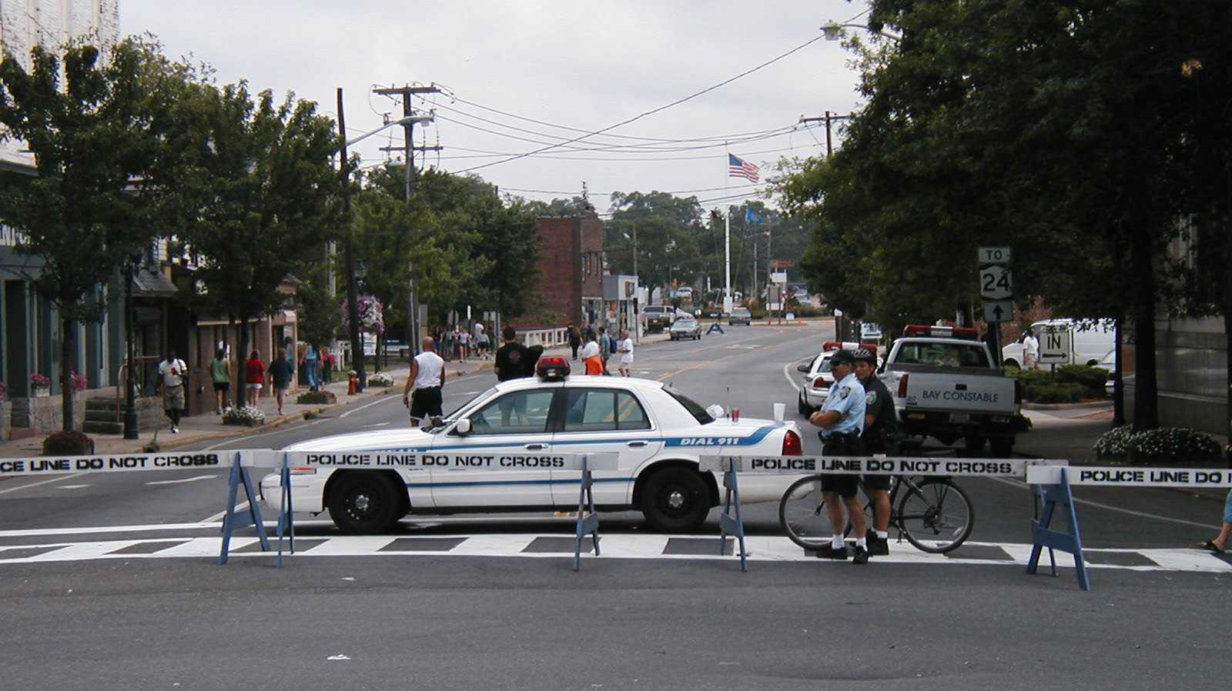
Figure 6-24
Road Closure Adjacent to Event Venue

Figure 6-25 shows a staffed, mid-block pedestrian crossing. Mid-block crossings not only reduce the likelihood of vehicle-pedestrian collisions, but accident severity as well. As with all staffed crossings, traffic management team supervisors should establish the relative priority of competing pedestrian and traffic movements and communicate that priority to officers controlling such crossings.

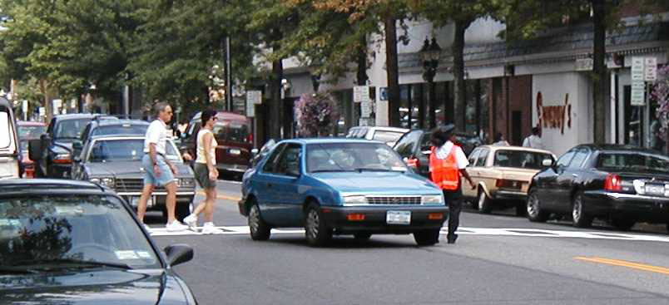
Figure 6-25
Staffed Mid-block Crossing

Analysis

Practitioners should analyze the level of service of major pedestrian access routes and crossings, first and foremost to ensure anticipated pedestrian demand levels do not exceed available capacity at any time during event ingress and egress. Overcrowding on pedestrian facilities compromises the safety of pedestrians and may interfere with adjacent street traffic flow.
The Highway Capacity Manual (HCM) includes procedures for computing capacity and level of service for various types of pedestrian routes and crossings, summarized in Table 6-16.⁽⁹⁾ With regard to capacity, a Level of Service E indicates design volumes approach the limit of facility capacity. The HCM also discusses characteristics of pedestrian flow and various performance measures.

Table 6-16
Pedestrian Facilities Covered in the
Highway Capacity Manual

FACILITY TYPE
- Walkways and sidewalks
- Pedestrian queuing areas (e.g., transit/shuttle stations and street crossing areas)
- Pedestrian crosswalks at signalized and unsignalized intersections
- Pedestrian facilities along urban streets (e.g., extended pedestrian facilities with both interrupted and uninterrupted flows)

Disabled Accessibility

The pedestrian access plan must accommodate disabled event patrons arriving via all travel modes serving a planned special event. This involves examining all routes that a disabled event patron may traverse and, in turn, ensuring the patron has an unimpeded path from mode transfer point to venue seat. Accessible pedestrian routes must: (1) maintain a minimum path width, (2) include curb cuts and temporary ramps for negotiating grade separations, and (3) conform to local Americans with Disabilities Act (ADA) regulations. If a particular route (e.g., from express/charter bus station or transit station) does not meet accessibility requirements, then accessible shuttles must operate between affected mode transfer points and accessible pick-up/drop-off areas.

Permanent venue parking areas have designated accessible parking and pick-up/drop-off areas that provide disabled event patrons with unobstructed access to event venue gates. This does not apply for temporary venues or locations of street use events. Disabled parking spaces at municipal and private parking areas serving continuous events and street use events may be located too far a distance from venue gates or event viewing areas. Each individual special event parking area includes a minimum number of disabled parking spaces to meet ADA regulations, thus rendering an on-demand, accessible shuttle operation from the lot impractical. As a result, the event planning team should sign and staff one parking area, nearest to venue gates or prime event viewing areas, for disabled parking. Figure 6-26 shows an access point to a municipal lot designated a disabled parking area for a downtown planned special event at a temporary venue.

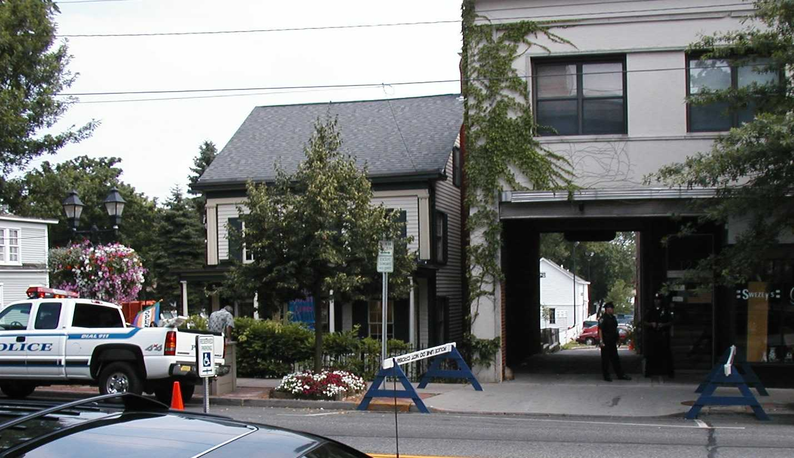
Figure 6-26
Special Event Disabled Parking Area Access Point

Shuttle Bus Service

A shuttle bus service should be operated continuously within the venue site area during event ingress and egress, with the service schedule revolving around event patron arrivals and departures. Common shuttle service to/from a planned special event venue include: (1) satellite parking area service, (2) transit station service, and (3) employee parking area service. A particular planned special event may involve multiple private and public (e.g., transit agency) shuttle service operators, all of whom must coordinate with the event planning team on service details and station locations.

The shuttle bus service planning process should incorporate the considerations listed in Table 6-17. These considerations impact the overall travel choice utility associated with the activity network supported by a shuttle bus service. Its design and operation on the day-of-event must satisfy a range of user needs, summarized in Table 6-18. These needs pertain to service and station provisions. Successful shuttle bus services positively influence the travel mode or destination (e.g., off-site) choice made by persons traveling to and from a planned special event. As illustrated by the event website promotion displayed in Figure 6-27, an event public information campaign may spotlight shuttle bus operations to promote alternate travel options, such as transit use or parking at a satellite parking area.

Table 6-17
Considerations in Shuttle Bus Operations(10)

CONSIDERATION
- Travel time
- Directness
- Avoidance of traffic problem areas
- Separation of shuttle buses from event traffic
- Boarding locations
- Ability to load/unload passengers simultaneously on several buses
- Pedestrian routing
- Neighborhood impacts

Table 6-18
^{Shuttle Bus Service User Needs}(11)

NEED
- Have less than a 5-minute wait time.
- Have a short or moving embarking queue.
- Have an on-time arrival.
- Be free of confusion.
- Be protected from weather conditions.
- Have less than a quarter-mile walk to/from the shuttle station.
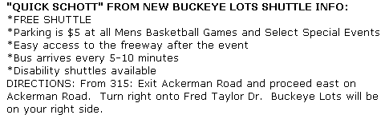
Figure 6-27
Shuttle Bus Service Promotion (Graphic courtesy of The Ohio State University.)

Service Design

The end result in shuttle bus service design involves determining the required number of buses to meet expected ridership levels. Based on event category and associated operations characteristics, the number of shuttle buses needed during event ingress and egress may vary. Discrete, recurring events at a permanent venue demand maximum service at the end of the event.

Primary service design inputs include event patron arrival and minimum service headway (e.g., time between bus arrivals). To estimate the magnitude and rate of arrival, consult parking demand analysis and travel forecast results applicable to the mode transfer point(s) (e.g., parking area or transit station) to be serviced by the shuttle bus. Utilize vehicle occupancy figures referenced in the event feasibility study to convert vehicle-trips to person-trips in order to develop shuttle ridership estimates. The shuttle bus service will serve approximately the same number of persons during egress operation as it does during ingress operation. As previously noted, demand rates likely may vary. On the day-of-event, service operators should utilize ingress passenger counts to reevaluate service needs before the planned special event ends.

Minimum service headway represents a function of route service time. The following equation defines route service time:

Route service time = (Round-trip travel time) + (Number of shuttle bus stations on route) * (Average passenger loading time at one station + Average passenger unloading time at one station + Average dwell time at one station)

Travel time estimates must reflect day-of-event operations and may vary depending on transit accommodation strategies contained in the event traffic control plan. The following equation defines minimum service headway:

Minimum service headway = (Route service time) / (Number of shuttle buses operating on a specific route at any given time)

The following steps describe how to determine the required capacity to successfully operate a shuttle bus service on a particular route:

- First, design the shuttle bus fleet size based on the criteria of providing a minimum service headway less than the maximum desired user wait time. Using the above equation for minimum service headway: (1) substitute the maximum desired user wait time for minimum service headway, (2) insert the route service time, and (3) solve for the number of shuttle buses required on the route, rounding up to account for the user wait time criteria. Note that the service headway between successive shuttle buses may be greater than the minimum service headway if the fleet of buses assigned to a particular route are not perfectly staggered to yield equal headways between buses.
- Second, compare the event patron rate of arrival to the rate of available shuttle bus seats per unit of time. To accommodate pedestrian flow during peak periods of ingress and egress, practitioners should consider a sub-hourly analysis (e.g., peak 15 or 30 minutes) using the highest anticipated event patron arrival rates. For analysis purposes, arrival rate refers to the rate of pedestrians arriving to a shuttle bus station at a parking area/transit station and at a venue during event ingress and egress operations, respectively. Practitioners should increase the number of shuttle buses serving a particular route, as necessary based on analysis results, to meet peak event patron arrival rates and avoid overcrowding at shuttle bus stations.
- Third, account for dwell time and event patron demand at all shuttle bus stations serviced by a particular shuttle route.

Station Design

A temporary shuttle bus station will exist at both a mode transfer point and at the event venue. Station design and operations should facilitate the rapid loading and unloading of shuttle passengers without impacting adjacent traffic operations and pedestrian movement. Because of the high concentration of pedestrian traffic at the event venue during ingress and egress, venue station design is critical. On-site shuttle bus stations should: (1) facilitate easy shuttle bus access, (2) provide a defined passenger waiting area, (3) promote an orderly queue formation, and (4) shield waiting passengers from adjacent vehicular and pedestrian traffic. Figure 6-28 shows an on-site shuttle bus station located adjacent to a roadway designated exclusively for bus use during a rural planned special event. Table 6-19 summarizes key considerations that surround shuttle bus station design.

Figure 6-28
On-Site Shuttle Bus Station

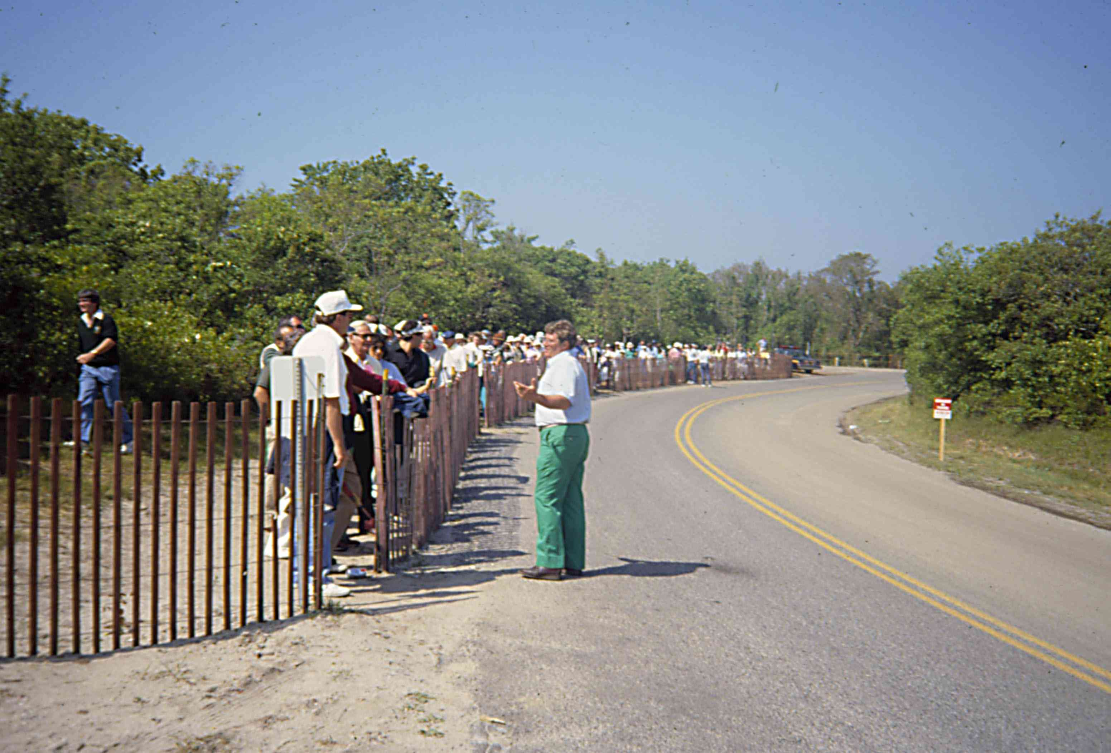
Management

Shuttle bus service operators should have access to pertinent traffic management team radio communication channels and/or consider stationing a supervisor in the event command post. Station volunteers can monitor passenger queuing and loading/unloading times. Bus operators can monitor passenger volume and communicate bus travel time and location. The service supervisor, in turn, directs service response to schedule delays, bus breakdowns, station overcrowding, and traffic incidents blocking service routes.

Table 6-19
Considerations in Shuttle Bus Station Design
CONSIDERATION | TACTIC | BENEFIT
Location at venue | - Designate an exclusive curbside bus lane on a road segment adjacent to the venue.  - Locate station adjacent to bus lane but away from venue gates.  - Design bus loading areas and turnarounds by using appropriate bus turning templates.  - Layout bus turnarounds in the field and use the selected bus size for a test drive to assure U-turns can be accommodated without requiring the bus to back-up. | - Avoids pedestrians using shuttle from crossing streets.  - Assures safe and efficient design for bus movements.
Pedestrian  management | - Connect stations to planned pedestrian access routes.  - Enclose passenger waiting area with temporary barriers (e.g., snow fencing or barricades) | - Improves passenger safety.  - Minimizes conflict with other pedestrian traffic.
Shuttle loading | - Designate sections within passenger waiting area that correspond to different shuttle bus destinations (if any).  - Erect signs disseminating information on fare structure, ticket purchasing, and important regulations.  - Deploy volunteers to answer questions and assist passengers in shuttle embarking and disembarking.  - Create ability to load/unload several buses simultaneously. | - Reduces shuttle loading time.  - Eliminates passenger confusion.
Passenger comfort | - Provide shelter over station (e.g., tent). | - Creates a landmark for identifying the station.  - Keeps passengers protected from weather conditions.

Shuttle bus operation contingency plans should include alternate shuttle routes in the event of a traffic incident occurrence. The alternate route should traverse a completely different set of streets than the preferred route. Service operators should maintain an operations and route detail for any parking areas denoted as an alternate (e.g., for overflow or weather reasons) to the primary lot served by the service. Other applicable contingency information includes temporary service locations for bus maintenance and fueling.

Cost

The operation of a shuttle bus service likely will realize greater efficiency for discrete events compared to continuous events such as fairs and festivals. Funding is obtained through satellite parking area fees, corporate sponsorship, or general event revenues. In some cases, parking is free, and the shuttle service charges a nominal fare to passengers. This arrangement may cause delays during passenger embarking, particularly if the bus operator must collect fares. Shuttle users likely will resist any fare charged for shuttle bus service from a transit station. Therefore, a fare-based shuttle service could significantly impact the utility that event patrons assign to transit when considering planned special event travel options.

Plan Specifications

Table 6-20 lists pertinent pedestrian access plan informational elements of interest to event patrons and participants. A traffic flow map or traffic control plan, prepared as a traveler information tool, may contain callouts to pedestrian facilities and day-of-event control tactics. Traffic management team personnel will require an implementation plan tailored to each pedestrian management initiative.
Table 6-20
Pedestrian Access Plan Checklist

ELEMENT
- Show recommended pedestrian access routes.
- Show pedestrian bridges and tunnels.
- Indicate special pedestrian crossing tactics (e.g., street closure or mid-block crossings)
- Show shuttle bus route, direction of travel, stop locations, and loading and unloading areas.
- Show vertical connections between infrastructure levels (e.g., stairs, escalator, elevator, ramps).
- Show designated pedestrian crossings at street use event venues.
- Indicate special regulations.
- Highlight pedestrian access routes and crossings suitable for disabled event patrons.

Traffic Flow Plan

Overview

The preparation of a traffic flow plan represents a required preliminary step to the design of a traffic control plan. The traffic demand analysis component of a feasibility study indicates the freeway/arterial corridors and local streets that event patrons will utilize to access the venue site area. In developing a traffic flow plan, the event planning team modifies predicted flow routes to maximize transportation system operating efficiency on the day-of-event while meeting public safety agency needs. In turn, a traffic control plan facilitates traffic flow on recommended flow routes through service-enhancing strategies and tactics that handle forecasted event traffic demand on these routes.

The advantage of developing a traffic flow plan is two-fold:

- Allows the event planning team to influence and control event patron patterns of ingress and egress. This improves transportation system operations and reduces the impact to neighborhoods surrounding the event venue.
- Provides important advance information for event patrons and participants regarding best access routes to the event. These directions provide event patrons, particularly those not familiar with the region, an increased level of comfort when traveling on the day-of-event. Event patrons also recognize that the traffic management team will sign, staff, and prioritize flow on designated routes. Non-attendee transportation system users benefit by gaining advance notice of event-designated traffic and transit routes.

Information Requirements

Table 6-21 lists various sources of data and information that drive the traffic flow plan development process. Key points that should be considered include:

Table 6-21
Traffic Flow Plan Information Sources

SOURCE
- Market area analysis
  - Regional directional distribution
- Traffic demand analysis
  - Local directional distribution
  - Day-of-event traffic demand
- Site access and parking plan
  - Parking area assignment
- Road closures required for event staging
  - Street use event
- Public safety agency requirements
  - Emergency access routes
- Transit agency requirements
  - Scheduled and event service

- A traffic flow plan should accommodate background traffic flow in addition to transit service, which will be promoted as an event patron travel alternative.
- Recommended traffic flow routes should not traverse or intersect emergency access routes, if possible.
- Event mandated road closures refer, in particular, to street use event parade and race routes. If not already designated, the event planning team should first determine the street use route.
  - Table 6-22 provides a general checklist for evaluating the impact of closing one or more adjoining street segments, while Figure 6-29 shows a parade staging area.
  - Typical staging areas include off-street parking areas and cross streets adjacent to the parade route.
  - Upon reviewing the street closure checklist, the event planning team should consult with community interest stakeholders and public safety agencies in order to identify all concerns and solicit input.

Another key information component concerns the identification of roadway capacity deficiencies or bottleneck locations. This includes freeway weaving areas, freeway ramp junctions, freeway/street lane-drops, and intersection traffic control. Bottleneck locations yield a constant rate of flow (e.g., saturation rate), and appropriate traffic control strategies can temporarily alleviate the bottleneck on the day-of-event by increasing saturation flow rate. Consult the feasibility study roadway capacity analysis results or conduct new analyses to evaluate operations on traffic flow routes not previously considered. In addition, practitioners should consider driving, and creating a video/photo log, of proposed traffic flow routes, emergency access routes, and transit routes. This activity assists in verifying computer analysis results and facilitating off-site event planning team evaluation of recommended routes.

Table 6-22
^{Road Closure Impact Checklist}(12)
ELEMENT | PROVISION
One-way street operation | - Does not significantly disrupt traffic operations on adjacent one-way streets.
Impacts on access | - Does not have an adverse impact on:  - Public safety agency station access  - Hospital access  - Local resident neighborhood access  - Public facility access (e.g., schools, parks, etc.)  - Access to places of worship  - Access to local businesses  - Heavy vehicle access  - Public transit access
Parade staging area | - Provide sufficient area for parade staging.
Coincidence with  roadway construction | - Does not conflict with existing roadway construction activities.
Proximity to major  traffic generators | - Has no adverse impact on nearby major traffic generator (e.g., shopping center, entertainment venue, etc.).
Presence of alternate routes for local access | - Has available alternate routes for local access.  - Width of traveled-way and number/designation of travel lanes  - Traffic control (e.g., traffic signals and signs)  - Street signage  - Restricted traffic movements  - Presence of impeding traffic calming devices

Figure 6-29
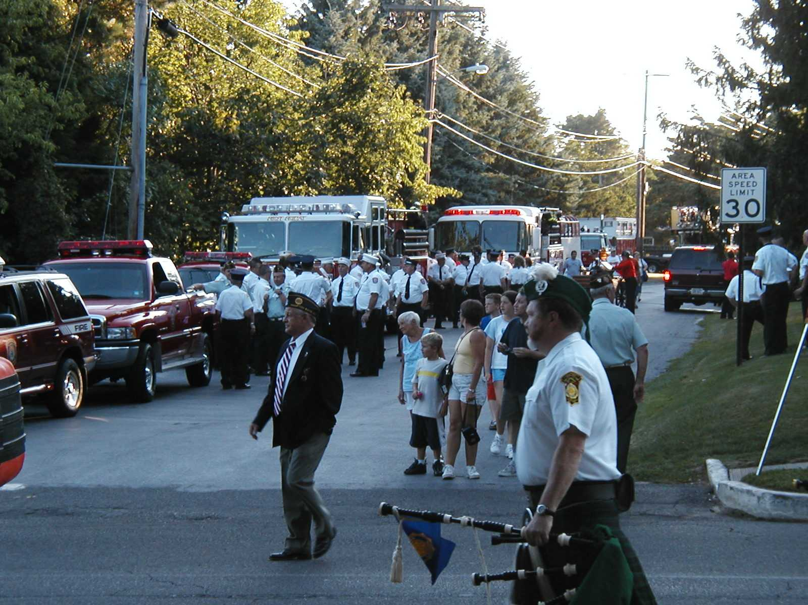
Parade Staging Area

Strategic Route Planning

The traffic flow plan must account for two types of traffic flow routes: corridor and local:

- Corridor flow routes include the freeways and major arterial roadways serving the planned special event venue.
- Local flow routes traverse the street system adjacent to the event venue and service a particular parking area or pick-up/drop-off point.
- A target point represents the point of connection between corridor and local flow routes, characterized by a freeway interchange or major arterial intersection.
  - In the driver’s mindset, reaching a target point during event ingress signals entrance into the local area surrounding the event site. At this point, the driver anticipates receiving information and directions on event parking and pick-up/drop-off areas.
  - During event egress, the driver’s objective involves reaching the nearest target point (e.g., freeway interchange) in order to access a familiar corridor flow route leading toward home or some other destination.
- On the day-of-event, the management of corridor flow routes typically involves surveillance and dissemination of traveler information regarding target point and local flow route operations. The traffic management team implements traffic control initiatives beginning at the target point and continuing along the local flow route.
  - Figure 6-30 displays a traffic flow plan that indicates, for reference by event patrons, various target points for access to individual venue parking areas.

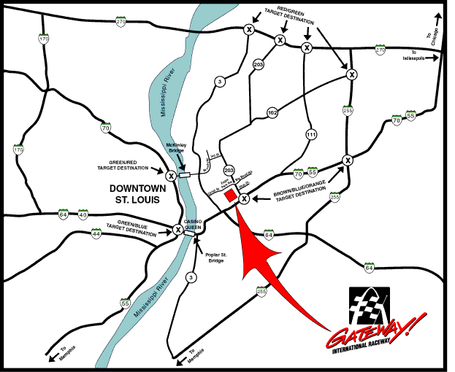Figure 6-30
Corridor Target Points (Graphic courtesy of Dover Motorsports, Inc.)

Table 6-23 indicates general considerations for developing traffic flow routes. Figure 6-31 shows one corridor flow route spawning, via two target points, three local flow routes destined to the same venue access point. The figure demonstrates how a traffic flow plan works to assure that traffic demand on the existing street system adjacent to an event venue does not exceed capacity on the day-of-event if signed and staffed appropriately.
Table 6-23
Traffic Flow Route Development
Considerations

CONSIDERATION
- Focus on ingress and egress operations separately.
- Avoid left-turn movements across traffic flow.
- Divert traffic flow routes from critical locations (e.g., other flow routes) that could create congestion.
- Develop multiple local flow routes, connected to one corridor flow route, as necessary to achieve optimum traffic distribution on the roadway system.
- Assign local flow routes to contingency overflow parking areas identified in the site access and parking plan.

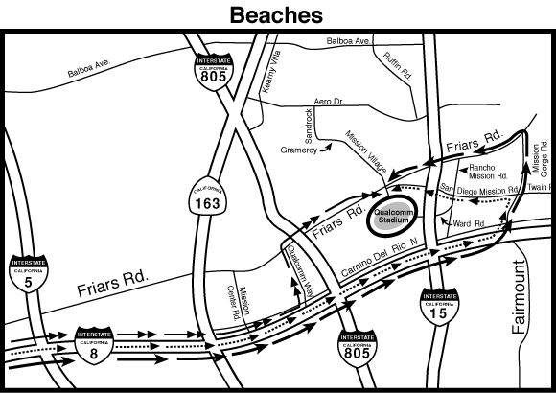

Figure 6-31
Multiple Local Traffic Flow Routes (Graphic courtesy of the City of San Diego.)

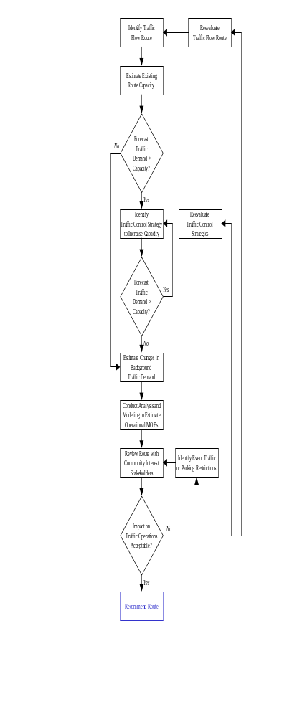Figure 6-32 describes a process for assessing corridor and/or local traffic flow routes. Traffic control strategies for increasing corridor route capacity include eliminating weaving areas or other ramp control tactics. Strategies for local routes include striping additional travel lanes to handle flow in the predominant direction, restricting turning movements, and revising traffic signal timing plans. The “Traffic Control Plan” section of this chapter describes these strategies and other mitigation alternatives in greater detail.

Aside from parking contingencies and the occurrence of severe congestion on the day-of-event, practitioners should maintain and promote the same flow routes identified in the traffic flow plan. These routes are generally pre-signed and communicated to event patrons and participants prior to the event. Measures of effectiveness for evaluating the performance of designated traffic flow routes, in additional to corresponding traffic control strategies, include: (1) time to regain free-flow operations and (2) time to clear parking areas.

Alternate Routes

The deployment of an alternate route plan marks a key traffic management strategy for minimizing the effect of non-recurring congestion, caused by a traffic incident or event-generated traffic demand, on traffic flow. It serves to reduce demand at a traffic incident site or bottleneck through the diversion of traffic from the mainline to parallel freeways, arterials, and streets. As part of traffic incident management efforts, some jurisdictions may maintain alternate route plans for freeway and arterial segments traversing a region.

Figure 6-32
Traffic Flow Route Assessment Process

An alternate route plan represents a contingency plan that stakeholders should consider developing for corridors serving a planned special event venue, where high-speed crashes or cargo spills may block travel lanes for a long duration. In other instances, an alternate route plan becomes a critical component of the overall event traffic management plan when roadway or bridge construction activities limit the capacity of mainline corridor flow routes. Transportation system operators should also promote travel choice alternatives, such as using other travel modes, as an option to driving alternate routes.

The process of developing alternate route plans and procedures for plan deployment requires a group endeavor involving all affected agencies, most of which likely comprise the event planning team and/or traffic management team. Table 6-24 lists the steps required in developing an alternate route plan. Practitioners should consult NCHRP Synthesis 279, Roadway Incident Diversion Practices, for state-of-the-practice information about the development and deployment of alternate route plans.⁽¹³⁾ Table 6-25 highlights numerous considerations in alternate route plan development, all of which are addressed in the cited synthesis report.

Table 6-24
Alternate Route Plan Development Process

STEP
- Identify mainline bottleneck or problem locations.
- Evaluate proposed alternate routes.
- Determine appropriate criteria for plan deployment.
- Achieve participating agency agreement on roles and responsibilities.
- Identify equipment and personnel resources required to deploy an alternate route plan.
- Establish guidelines for plan evaluation and updating.

The effectiveness of deploying an alternate route plan revolves around the accommodation of diverted traffic along the alternate route. It is essential that the diverted traffic encounter an equal or higher level of service on the alternate route compared with that on the mainline. As shown in Figure 6-33, alternate route plan deployment, particularly plans developed specifically for a planned special event, typically requires significant law enforcement resources for alternate route traffic management and operations surveillance. Technology applications for managing traffic on an alternate route, and reducing field personnel requirements, include the installation of dynamic route guidance signs controllable from a transportation operations center. Figure 6-34 shows a dynamic trailblazer sign. During the program planning phase, stakeholders managing recurring planned special events at permanent venues should evaluate the need for installing these devices along commonly used alternate routes serving the event venue.

Emergency Access Routes

Emergency access route planning involves designating street closures within the venue site area to connect the some or all of the following termini: (1) public safety (e.g., fire and emergency medical service) headquarters, (2) local hospital, (3) freeway or major arterial serving a regional hospital, and (4) location of staged ambulances and first-aid stations for on-site medical treatment.

Table 6-25
Alternate Route Plan Development Considerations
ITEM | CONSIDERATION

Alternate Route Selection
- Stakeholder Roles and Coordination | - Advance planning stakeholders and stakeholders involved in alternate route deployment  - Interagency agreements for advance planning and/or operations
- Types of Alternate Routes | - Freeway, street, and toll facility  - Secondary alternate routes
- Inventory Potential Alternate Routes | - Access, capacity, vehicle restrictions, traffic control, background traffic, pavement conditions, road geometrics, percentage of heavy vehicles, transit accommodation, and available surveillance  - Considerations in rural, urban, and metropolitan areas
- Alternate Route Evaluation | - Capacity analysis and modeling  - Traffic signal timing optimization
- Alternate Route Selection Criteria | - Road user and community impacts

Alternate Route Plan Development
- Alternate Route Plan Map | - Incident location limits, direction of routed traffic, ramp/street closures, traffic control resources, alternate route distance and capacity, alternate route regulations and restrictions, and emergency service stations
- Traffic Control Requirements | - Traffic control officers, temporary signs, and barricades
- Criteria for Alternate Route Plan Deployment | - Incident duration, number of lanes blocked, time of day, etc.
- Deployment Operations Plan | - Checklist for field supervisor and communications center supervisor

Road User Accommodation
- Motorist Information Resources | - Pre-trip and en-route  - Message sets  - Planned media release
- Traffic Management on Alternate Route | - Permanent trailblazers  - Technology applications

Figure 6-33
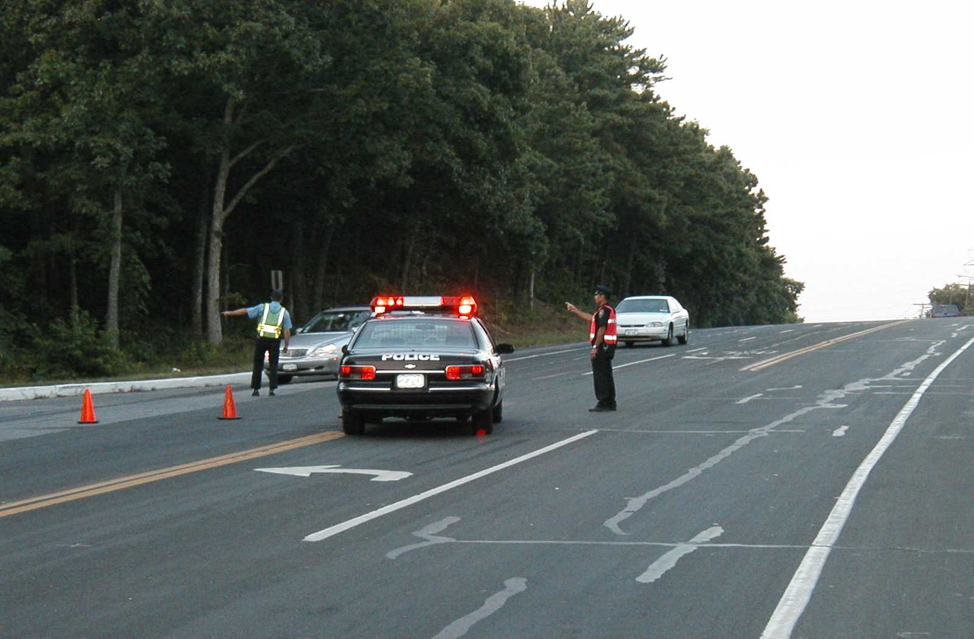
Background Traffic Diversion
Figure 6-34
Dynamic Route Guidance Sign (Photo courtesy of the Minnesota DOT.)
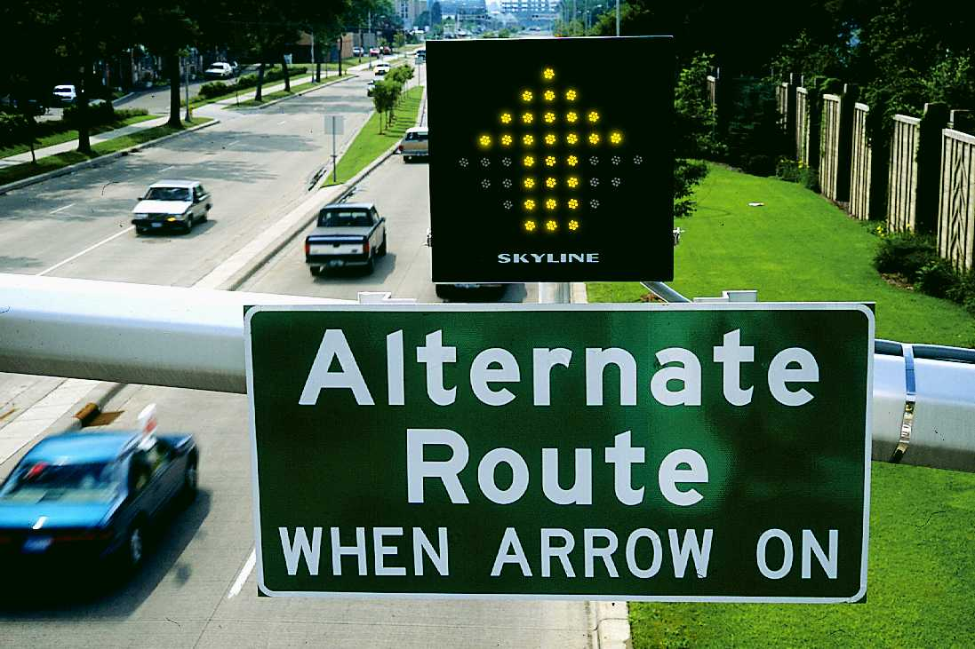
For large-scale planned special events, emergency access routes remain closed to all non-emergency vehicles. Traffic control officers staff each intersection along the route and permit side street traffic to cross the route when conditions permit. For smaller-scale special events, the emergency access route denotes a local flow route for emergency vehicles that may be utilized by general traffic under non-emergency conditions. Under an emergency scenario, law enforcement officers may escort emergency vehicles, using a rolling roadblock, via the designated access route. Emergency access routes should not traverse or intersect event patron traffic flow routes to/from the event venue and associated parking areas.

The provision of emergency access lanes along streets slated for closure in order to stage a planned special event allows unimpeded emergency vehicle access throughout the entire local street network impacted by the event. This particularly applies to street use event routes. Typical specifications for an emergency access lane involve delineating a 20 foot wide, paved curb lane within the existing roadbed (e.g., shoulder plus traveled-way).

Background Traffic
Accommodation

The composition of background traffic, or non-attendee motorists, traversing streets and highways in the vicinity of a planned special event venue include the following categories:

- Regional through traffic
  - Includes truckers and intra- or inter state travelers represent regional through traffic.
- Local through traffic
  - Includes commuters and area residents, some of whom may simply cruise local streets adjacent to the event.
- Neighborhood residents and businesses
  - Includes residents living in the immediate vicinity of the event venue that may incur impacts attributed to high traffic demand and temporary traffic control strategies.
  - Includes nearby businesses requiring accommodation for both employees and patrons.

Table 6-26 presents a range of passive (e.g., traveler information dissemination only) and aggressive (e.g., physical traffic control) tactics for accommodating background traffic during a planned special event.

Table 6-26
Tactics for Accommodating Background Traffic during Planned Special Events
USER GROUP | TACTIC | BENEFIT
Regional through traffic | - Freeway-to-freeway diversion beginning a significant distance upstream of an event venue. | - Maintains mobility.  - Reduces the level of background traffic on corridor flow routes serving the venue.
Local through traffic | - Arterial-to-arterial diversion | - Eliminates non-attendee exposure to venue site area.  - Discourages cruising around site area.  - Allows public to become familiar with route after repeated implementation.
Neighborhood residents and businesses | - Parking restrictions | - Permits resident access to on-street parking spaces.  - Permits employee and customer access to public parking areas.
Neighborhood residents and businesses | - Traffic control points | - Restricts neighborhood area access to residents and business employees.
Neighborhood residents and businesses | - Signing and alternate routes | - Directs customers to businesses and other traffic generators.

Freeway-to-Freeway Diversion

Transportation management system operators can implement freeway-to-freeway diversion through control of permanent changeable message signs and highway advisory radio.

Parking Restrictions

Parking restrictions accomplish the task of preventing event-generated traffic from deviating from local event traffic flow routes and traversing neighborhood residential and commercial areas.

Traffic Control Points

Road closures may impact customer access to businesses and other traffic generators. Figure 6-35 shows a sign diverting traffic destined to a major traffic generator located adjacent to a planned special event temporary venue.

Large-scale events may generate sufficient traffic demand to saturate the entire local street system adjacent to the event venue, causing undue congestion and blocking neighborhood access and circulation patterns. If this represents a potential concern during advance planning, then locate event parking areas a sufficient distance away from affected neighborhood areas and create traffic control points to prevent event-generated traffic from penetrating these areas. Residents and business employees would receive a pass allowing them access through the traffic control points.

Figure 6-35
Accommodation of Traffic Destined to
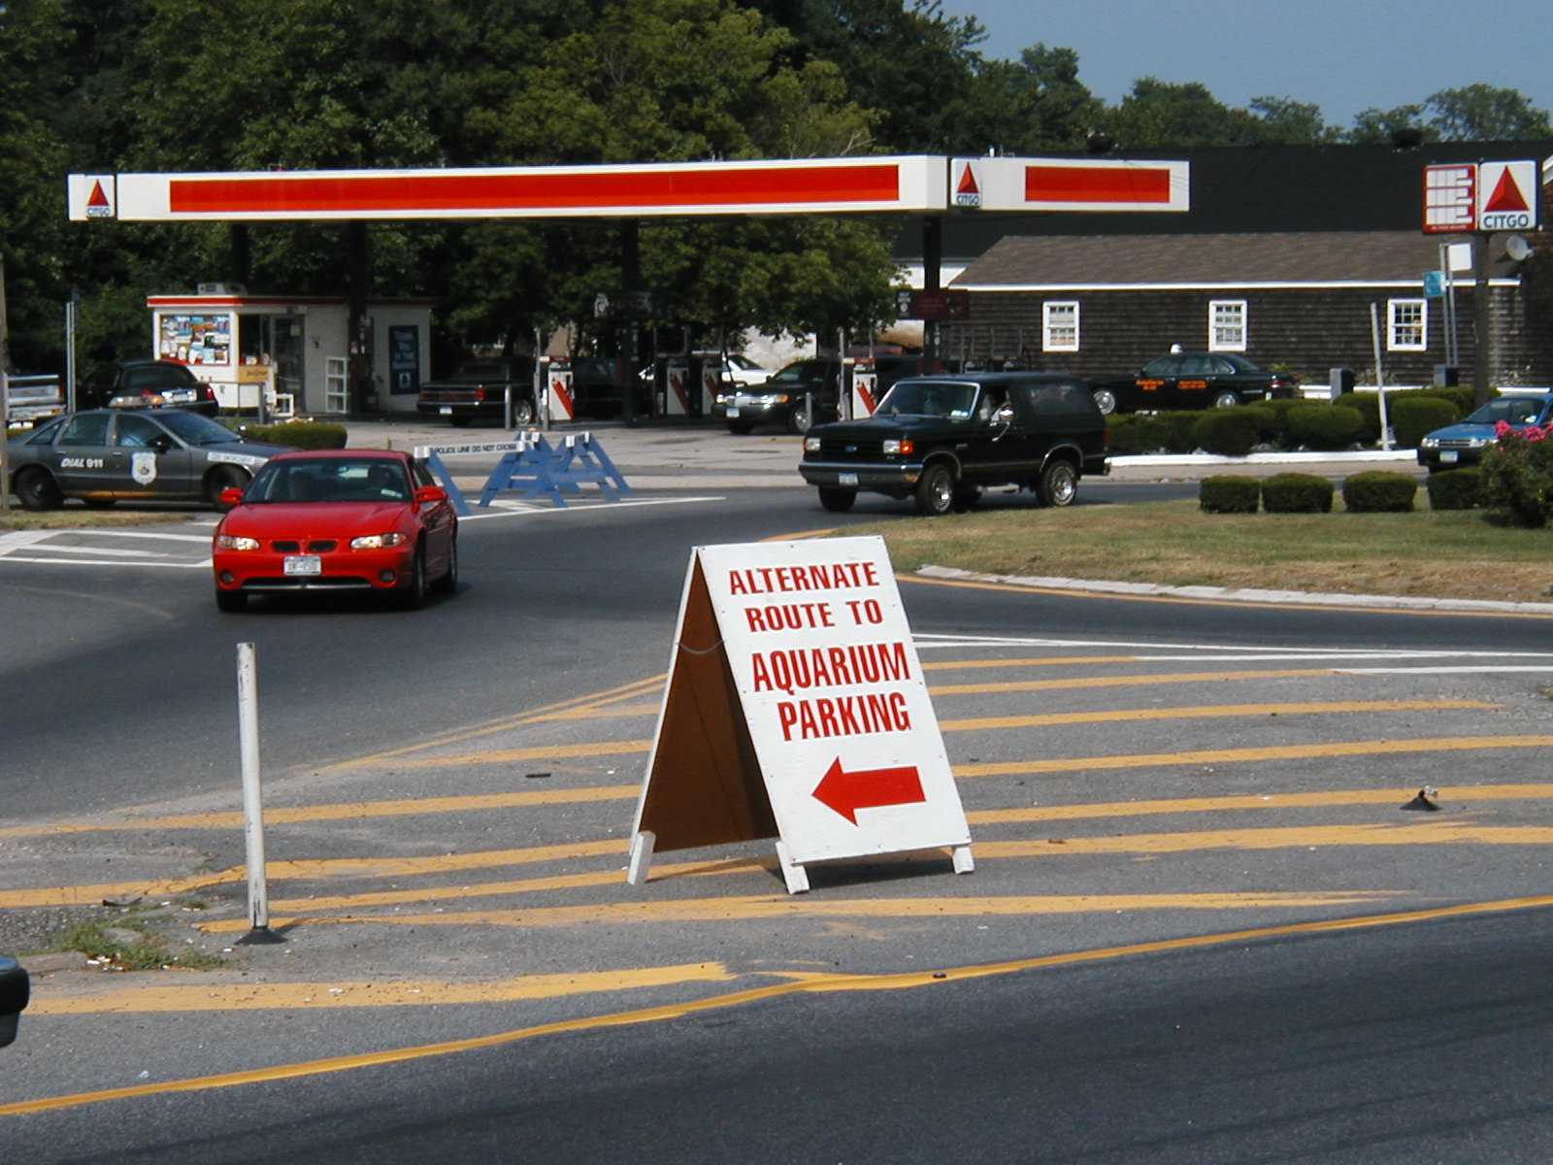
Major Generators
Arterial-to-Arterial Diversion

Arterial-to-arterial diversion applies to planned special events occurring in city downtown or commercial areas, where arterials and local streets adjacent to the event venue serve a significant volume of background traffic. In turn, the addition of event-generated traffic causes congestion and impacts commercial businesses (e.g., restaurants, hotels, retail stores). This tactic involves: (1) restricting commercial street access to businesses employees, customers, emergency vehicles, taxis, and transit buses and (2) deploying an alternate route to direct background through traffic and event-generated traffic around the restricted street.

Planned special event stakeholders in Atlanta, Georgia developed such an alternate route, entitled the “Blue Loop” to divert traffic away from restricted Peachtree Street during special events in downtown Atlanta.⁽¹⁴⁾ Stakeholders prepared the plan during the program planning phase in response to lessons learned from past planned special events that occur in the Atlanta downtown area and generate significant automobile traffic. They hope the term “Blue Loop” becomes an alert that city residents will recognize and understand that the alternate route is in effect. Traffic monitoring represents a key to Blue Loop operation, and the route deployment detail specifies several release points for diverting Blue Loop traffic to adjacent highways.

Street use events involving a parade or road race permit the traffic management team to reopen certain roadway sections after event participants pass, even if the event has not completed. Background traffic accommodation includes disseminating specialized traveler information, summarized in Table 6-27, prior to the event. The information provides non-attendee transportation system users a timeframe, relative to the parade/race pace and field length, that certain route sections will be closed. Otherwise, travelers may mistakenly assume that the entire street use event route will remain closed for the duration of the parade or road race.

Table 6-27
Pre-Trip Traveler Information for Street Use Events

ITEM
- Indicate the entire parade or race route coupled with participant staging and disbanding areas.
- Estimate, based on the event pace and length of the field, and specify times each roadway segment and intersection will be closed and reopened.
- State other traffic and parking restrictions in the vicinity of the event course.
- Organize information for easy reference using maps and reference numbers (for intersections and roadway segments).

Transit Accommodation

A traffic management plan that prioritizes bus flow to and from the venue site area positively influences the utility associated with transit and other travel choices involving express bus, charter bus, or shuttle bus transport. Transit agencies should operate on scheduled bus transit routes up until the last possible point to divert around a road closure required to stage a planned special event. This avoids user confusion and minimizes inconvenience to non-event attendees.

Table 6-28 lists tactics for accommodating scheduled and event-generated bus service.

Table 6-28
Bus Accommodation Tactics

TACTIC
- Exclusive bus route
- Exclusive/priority bus lane
- On-demand communication with TMC or command post

Exclusive Bus Route

Exclusive bus routes that cause a negligible impact to background traffic and adjacent neighborhoods represent the recommended bus accommodation tactic. Advantages of exclusive bus routes include: (1) use of the same route during ingress and egress, (2) increased mobility and travel time reliability, and (3) better venue station accommodations for riders as temporary stations may exist adjacent to bus routes, thus avoiding conflicts with event vehicle and pedestrian traffic.

Depending on roadway network layout, a special event traffic flow plan may feature an exclusive bus route from corridor target points and satellite parking areas direct to designated pick-up/drop-off areas adjacent to the venue. Other bus routes may only divert buses around known bottleneck locations. Figure 6-36 shows an exclusive bus route implemented for a major rural planned special event. An exclusive bus route must accommodate minimum overpass height requirements, vehicle weight requirements, and vehicle turning radii.
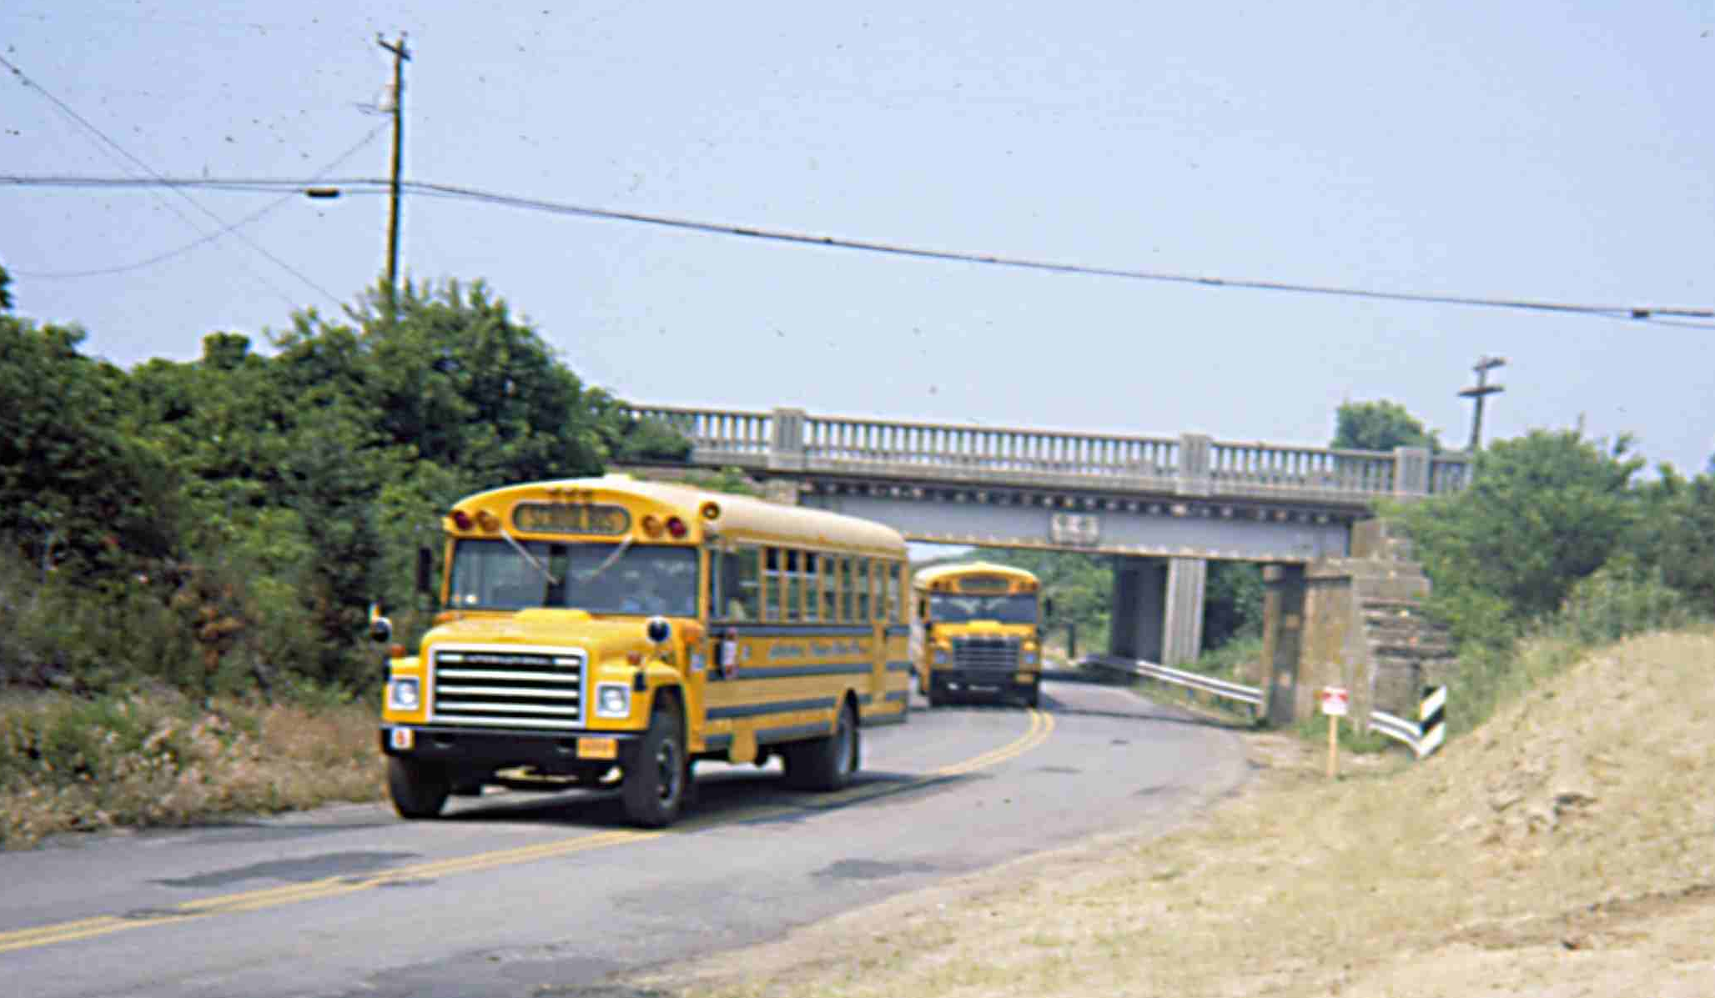
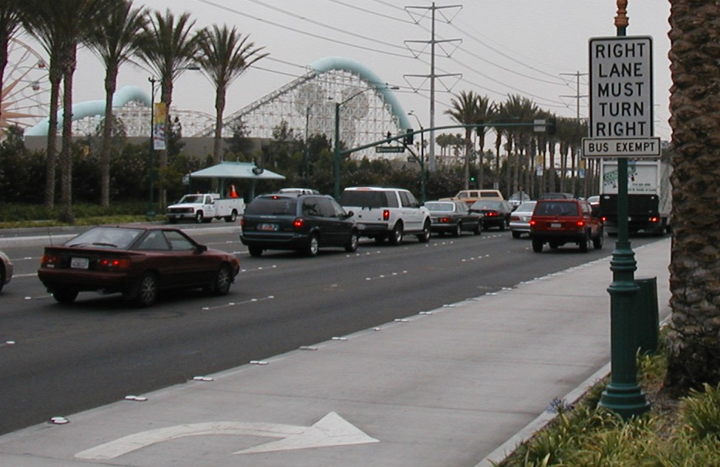
Figure 6-36
Exclusive Bus Route

Exclusive/Priority Bus Lane

An exclusive bus lane represents a travel lane for bus traffic only. Temporary applications include converting an existing roadway shoulder or travel lane for bus use during a planned special event. Table 6-29 summarizes drawbacks associated with the temporary operation of an exclusive bus lane. A bus priority lane is used by both buses and general traffic between intersections. However, at intersection approaches such as that shown in Figure 6-37, regulations limit general traffic to a turning movement, while buses can continue straight through the intersection and “jump” adjacent through-lane queues.

Table 6-29
Exclusive Bus Lane Limitations

LIMITATION
- Lane may obstruct access to mid-block driveways.
- Mid-block turning movements may create queues in adjacent through travel lanes.
- Congestion may occur upstream of the lane start, especially if the lane utilizes an existing travel lane.
- Shoulder lane use may eliminate area for emergency stops.
- Manned intersection control may be required to allow buses and cars to turn in front of the other.
- Maintenance of signs and lane delineators are necessary.
- Special enforcement requirements are needed.

Figure 6-37
Bus Priority Lane

On-Demand Communication

On-demand communication with a command center represents another bus accommodation tactic that the traffic management team may employ in conjunction with other previously discussed tactics. Bus operations supervisors or other traffic management team personnel, stationed at the TMC or event command post, monitor roadway surveillance sources (e.g., CCTV and field observers) in order to identify areas of congestion before a bus encounters it. When supervisors verify a traffic bottleneck affecting a bus route, they immediately notify bus operators and work to divert buses around the congested area.

Plan Specifications

The traffic flow plan serves stakeholders managing the planned special event in addition to event patrons and participants. The product of strategic route planning involves informing event patrons of best access routes to and from the planned special event. Stakeholders can communicate preferred route directions via: (1) event patron ticket mailings, (2) media public information campaigns, and (3) event, venue, or traffic information websites.

Table 6-30 contains a traffic flow plan development checklist.

Appendix I contains example traffic flow maps prepared for various planned special events. ⁽¹⁵⁾

Traffic flow plans should emphasize available express, charter, and shuttle bus services from regional park and ride lots and/or satellite parking areas. Driving directions should be accompanied by useful travel tips that coincide with the day-of-event operation of recommended traffic flow routes. Travel tips include accessing en-route traveler information and adhering to traffic control tactics.

Traffic Control Plan

Overview

Freeways represent corridor flow routes serving event patrons and participants destined to/from a planned special event from various parts of a region and beyond. These corridor flow routes connect to local, street-level flow routes that, in turn, serve event venue parking areas. A freeway interchange marks the point of connection, or target point, between corridor flow routes and local flow routes. Together, the three entities comprise the roadway system servicing a planned special event. The scope of traffic control expands and contracts, proportionally to system performance, during event ingress and egress.

The keys to successful transportation system management, including traffic and transit, during planned special events include:

- Real-time surveillance
- Open communications
- Planned response
- Rapid implementation

Planned response requires a detailed traffic control plan that facilitates a proactive traffic management team response to system deficiencies and unexpected events. The other keys depend on technology applications, such as remote surveillance and automated control of traveler information and traffic control devices, in addition to inter-jurisdictional coordination and collaboration.

Table 6-30
Traffic Flow Plan Checklist
ELEMENT | PROVISION
Event patron corridor flow route | - Indicate recommended freeway ramps, by route direction, to/from event venue or specific parking area.  - Indicate corridor target points representing a connection to local flow routes.  - State freeway or arterial lane assignments for event traffic (e.g., event traffic two right-lanes).  - Furnish information on roadway construction projects, as applicable, and indicate alternate routes.  - Indicate modified ramp control tactics (e.g., closures/additional lanes).  - Show freeway interchange configurations (and direction of travel) and exit numbers.  - State tolls, if applicable.
Event patron local flow route | - Show connection to corridor flow route.  - Indicate local streets that connect to freeway entrance/exit ramps.  - Indicate recommended flow route to/from general and reserved parking areas (minimum) or individual parking areas (recommended).  - Indicate one-way streets.  - Show all road segment closures.  - Specify permitted turning movements.  - Emphasize controlled turn areas (turns prohibited or only one turn allowed).  - List modified roadway striping (e.g., reversible lanes or contra-flow).  - Indicate event participant/VIP access routes.
Traveler  information | - Promote use of regional park & ride locations and event satellite parking areas.  - Indicate commercial radio and highway advisory radio frequencies with event travel information.  - Alert motorists of static and changeable message sign guidance along route.  - Stress importance of following route and adhering to traffic control officer instructions.
Traffic  management team  information | - Include contingency maps detailing routes to overflow parking areas.  - Provide written directions for diverting corridor flow routes via local street system.  - Indicate alternate routes for ingress and egress to same target point.
Other travel modes / user groups | - Show transit routes and state corresponding route number(s).  - Show preferred taxi routes.  - Indicate bicycle routes.  - Indicate pedestrian routes.
Other  considerations | - Provide information on both ingress and egress flow routes.  - Emphasize law enforcement endorsement of recommended routes and directions.  - State travel times (by mode of travel) and distances (e.g., from select origins)  - State when special traffic flow routes go into effect and terminate.  - Disseminate written ingress/egress driving directions.  - Indicate potential points of confusion (“do not take”) along recommended route (e.g., freeway exits, turning movements).  - Indicate heavy vehicle restrictions.  - Indicate expected congested/non-congested areas.  - Use callouts to highlight critical movements.  - Label all streets and freeways.  - Color-code recommended routes to specific parking areas.  - Emphasize new provisions (e.g., new road closures or route).  - Prepare maps for different venue events if parking plan varies.  - Show parking areas.  - Show venue gates.  - Draw map to scale.  - Show private property.  - Display landmarks.

Transportation system management typically involves state DOT operating freeways and county/local agencies operating streets and intersections along local flow routes. Planned special events place a premium on information sharing (e.g., CCTV feeds, traffic conditions, traffic incidents, etc.) between these agencies, through local/regional TMC operators and/or agency supervisors at the event command post. This information, and subsequent traffic management team collaboration, drives stakeholder selection and implementation of traffic control techniques.

Freeway Traffic Control

The main objective of freeway management during planned special events involves minimizing freeway mainline congestion. Freeway traffic control tactics implemented in response to local traffic flow or ramp operation degradation preserve freeway mainline operations. Freeway traffic control and management strategies for planned special events include traveler information dissemination and interchange operations.

Traveler Information

Traveler information disseminated upstream of freeway interchanges serving an event venue effectively: (1) introduces all freeway users to critical traffic management plan components affecting traffic flow in the vicinity of the event venue and (2) facilitates freeway lane management as motorists learn of temporary freeway ramp control tactics and/or downstream lane closures that warrant a lane-change. Under lane management, freeway operators strive to reduce turbulence at ramp junctions, weaving areas, and lane drops by alerting motorists to make necessary mainline lane-changes as soon as possible. This also reduces the level of uncertainty and potential indecision by drivers destined to the planned special event.

Common freeway operator methods of disseminating en-route traveler information to freeway users include use of:

- Changeable message signs
- Highway advisory radio
- Telephone information systems (e.g., 511 service)

The event planning team should develop CMS and HAR message sets specific to planned traffic management and control, during event ingress and egress, on the day-of-event. Supplemental planned message sets should exist for all special event contingency scenarios considered. The traffic management team can reference message boilerplates for other unexpected events such as traffic incidents. If stakeholders utilize 511 for planned special event travel management, then the event planning team should establish protocol for updating 511 recordings. This may involve coordinating with an agency office (e.g., state DOT headquarters) outside the region where the planned special event takes place. The overall advance planning effort improves traveler information accuracy and timeliness on the day-of-event.

En-route traveler information consists either of pre-event or day-of-event information. Prior to the event, permanent and portable CMSs located on freeways serving a planned special event can indicate that an upcoming planned special event may affect corridor travel or cite planned freeway ramp closures. In addition, CMS message sets can advise motorists to tune to an HAR frequency for a message containing additional, detailed information. Table 6-31 lists some HAR pre-event message considerations. These roadside traveler information device messages should appear a few days before the event, including one weekday to inform commuters that use periodically the freeway corridor on weekends. This strategy also informs visiting event patrons that arrive to the host city prior to the day-of-event.

Table 6-31
Highway Advisory Radio Pre-Event
Message Considerations

CONSIDERATION
- Planned special event(s) date, time, and location
- Road closure(s) location
- Road closure(s) date and time
- Access to event parking areas
- Traffic and parking restrictions
- Alternate routes and modes of travel

Table 6-32 indicates some day-of-event message considerations.

Table 6-32
Highway Advisory Radio Day-of-Event Message Considerations

CONSIDERATION
- Directions to local traffic flow routes serving traffic destined to a venue
- Road closure details
- Event traffic and parking restrictions

Table 6-33 provides a range of CMS message templates for planned special events. To obtain specific and detailed guidance on the operation of and/or message design for large permanent CMSs or portable CMSs, practitioners should consult the FHWA report Guidelines for Changeable Message Sign Messages.⁽¹⁶⁾ For example, Figure 6-38 shows a message displayed on a portable CMS positioned upstream of a freeway interchange serving event patron traffic.

Day-of-event HAR messages include directions on accessing local flow routes to a venue, road closure details, and event traffic and parking restrictions. Activation of HAR sign beacons should occur on the day-of-event only. By taking into consideration travel speed and HAR signal range, format HAR messages so that motorists can listen to each message at least twice. Ensure portable HAR coverage areas do not overlap with adjacent HAR signals.

Table 6-33
Changeable Message Sign Message
^{Template}

MESSAGE SET DISPLAY
Single Phase – All Freeway Users
- First line: traffic problem
- Second line: problem location
- Third line: recommended action
Single Phase – Specific User Group
- First/second line: user group (e.g., event patrons)
- Second/third line: recommended action
Two Phases – Specific User Group
- First phase: user group
- First/second phase: recommended action
- Second phase: additional information sources (e.g., HAR)

Figure 6-38
Portable Changeable Message Sign (Photo courtesy of the Wisconsin DOT.)
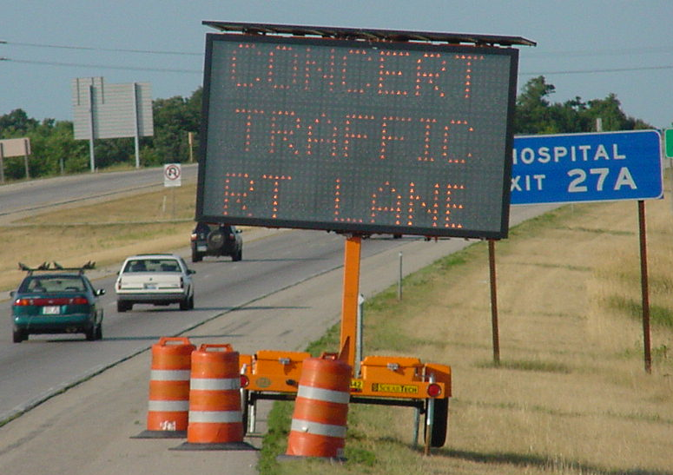
Interchange Operations

Management of freeway interchange operations for planned special events involves maximizing ramp capacity and preventing freeway mainline congestion. Interchange ramps adjoining a freeway and modified local event traffic flow route may represent a system bottleneck if operators fail to improve interchange capacity and operating efficiency. Traffic flow breakdowns can occur on ramps, at weaving areas, or at ramp junctions. Proactive interchange traffic control focuses on minimizing freeway mainline congestion and, during event egress, congestion spillback to local flow routes and adjoining event parking areas.

Table 6-34 presents interchange operations tactics for planned special events. Tactics such as ramp closures and rolling roadblocks represent short-term congestion mitigation measures deployed by the traffic management team on an as-needed basis. Other control tactics, such as the temporary elimination of a freeway weaving area shown in Figure 6-39, comprise the base traffic control plan for the planned special event and operate for a sustained period of time. Law enforcement officers can temporarily close ramps using their cruisers. However, other techniques that reduce valuable personnel requirements include using Type 3 barricades and traffic cones for longer closures. Figure 6-40 shows an example of reinforcing a barrier line, by deploying traffic cones coupled with pedestal-mounted signing, to prohibit late diverges from a freeway mainline. Freeway operators may develop new ramp metering plans based on forecasted traffic volumes and the location of controlling bottlenecks identified through analysis and modeling.

Freeway and interchange operations management during planned special events demands real-time surveillance and control capabilities. Outside of a permanent TMC, wireless and Internet connections allow the traffic management team remote access to CCTV in addition to CMS and HAR devices. As shown in Figure 6-41, freeway operators stationed at an event command post can view CCTV video at critical locations and, in turn, change CMS messages via a laptop computer or HAR messages through a cellular telephone call.
Street Traffic Control

The central traffic control strategy for local flow routes serving a planned special event involves emphasizing throughput. Tactics that increase street capacity include a combination of: (1) on-street parking restrictions, (2) vehicle travel on road shoulders, and (3) alternative lane operations. Streets connecting freeway/arterial corridor routes and venue parking areas characteristically serve a predominant directional traffic flow during ingress and the reverse flow during egress.

The following section examines alternative lane operation techniques for handling high-volume flow in one direction.

Alternative Lane Operations

Alternative lane operations comprise two categories:

- Reversible lane operation
- Contraflow operation

Reversible lane operation involves using one or more travel or auxiliary (e.g., two-way left turn lane) lanes for travel in the opposite direction. The street or highway operates as two-way; however, additional travel lanes serve traffic in the predominant direction of flow.

Contraflow operation involves converting a roadway corridor from two-way to one-way operation only.

Major metropolitan areas, such as Washington, D.C., use daily reversible lane (see Figure 6-42) and contraflow (see Figure 6-43) operation to efficiently handle commuter traffic to/from the downtown area.

Table 6-34
Interchange Operations Tactics for Planned Special Events
TACTIC | EVENT  TIME | APPLICATION | BENEFIT
Rolling road block | Ingress | - Initiate tactic on freeway mainline upstream of congested interchange ramp(s). | - Alleviates traffic demand at interchange, thus permitting street or ramp bottleneck to dissipate.
Rolling road block | Egress | - Initiate tactic on freeway mainline upstream of a congested ramp junction or weaving area.  - Use tactic to meter freeway mainline traffic demand without creating a secondary bottleneck upstream of the congested area. | - Reduces level of congestion at the primary bottleneck location.
Entrance ramp  closure | Ingress | - Initiate tactic on ramps in close proximity to and upstream of interchange target point for event traffic.  - Divert affected traffic to another downstream access point. | - Eliminates congestion caused by traffic merging with heavy freeway mainline traffic.
Entrance ramp  closure | Egress | - Initiate tactic as necessary to reduce freeway mainline congestion in the vicinity of closely-spaced entrance ramps. | - Reduces freeway mainline congestion or prevents congestion from occurring.
Exit ramp closure | Ingress | - Close ramp, as needed, to alleviate congestion on a downstream local flow route.  - Initiate only if a downstream exit ramp and local street system can handle diverted traffic. | - Reduces congestion on local flow route.
Exit ramp closure | Egress | - Initiate tactic at freeway interchanges connecting local traffic flow routes that have special egress traffic control measures in effect. | - Prevents traffic from accessing local flow routes in the direction of the event venue that operate in favor of egress traffic flow.
Elimination of weaving area | Ingress | - Close cloverleaf interchange entrance ramp to facilitate unimpeded diverge to access adjacent exit ramp. | - Eliminates weaving area congestion.  - Extends deceleration lane for traffic using exit ramp.
Elimination of weaving area | Egress | - Close cloverleaf interchange exit ramp and mainline right-lane to facilitate unimpeded merge with mainline. | - Eliminates weaving area congestion.  - Extends acceleration lane for traffic using entrance ramp.
Ramp  metering | Ingress | - Meter freeway entrance ramps upstream of interchange target point for event traffic. | - Reduces congestion caused by traffic merging with heavy freeway mainline traffic.
Ramp  metering | Egress | - Meter freeway entrance ramps downstream of interchange target point for event traffic | - Reduces congestion caused by traffic merging with heavy freeway mainline traffic.
Late  diverge  prohibition | Ingress | - Deploy traffic cones along barrier line extending upstream of exit ramp gore area. | - Reduces congestion at diverge ramp junction caused by motorists attempting to make a sudden lane-change to access an exit ramp.  - Improves safety.
Additional exit ramp lane | Ingress | - Cone an additional lane on exit ramps serving traffic destined to an event venue. | - Provides additional ramp storage capacity.  - Proves particularly effective if two-lane ramp traffic does not have to merge at downstream end of ramp.

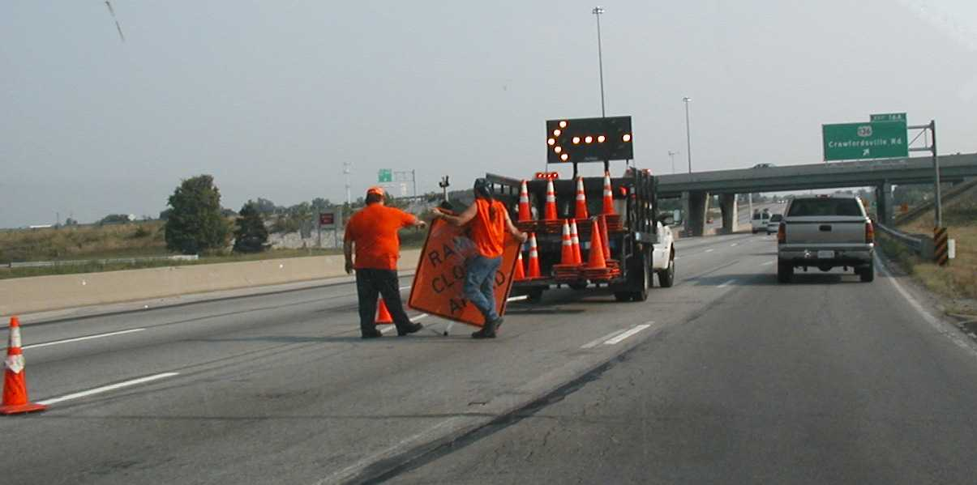
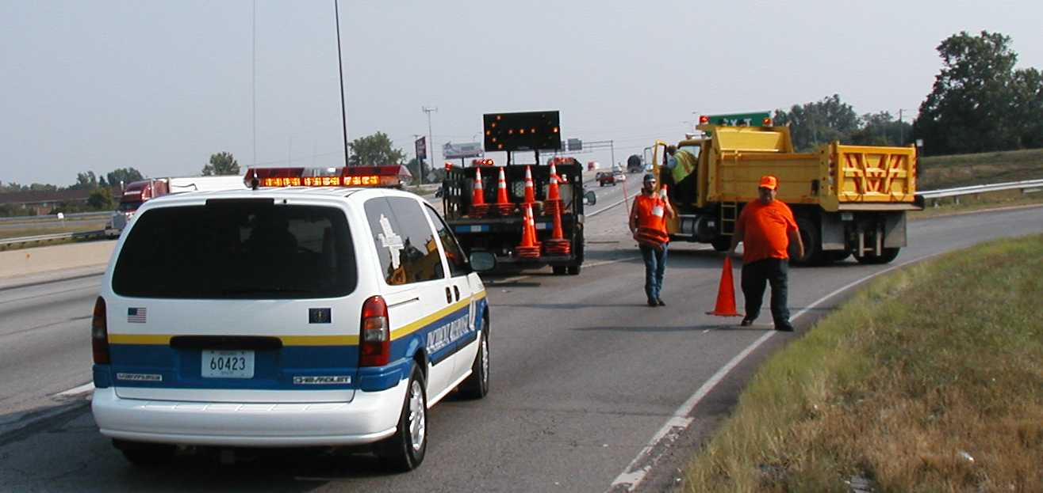

Figure 6-39
Temporary Elimination of Freeway
Weaving Area

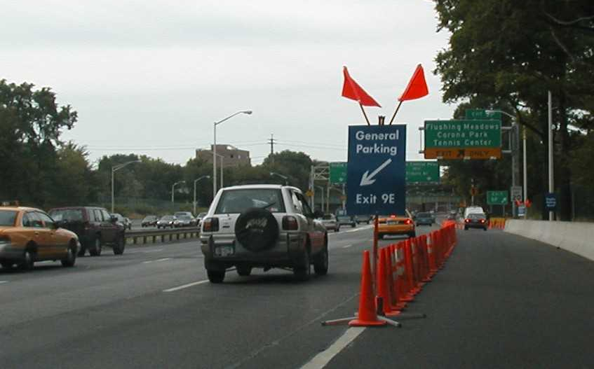

Figure 6-40
Prohibition of Late Freeway Diverge

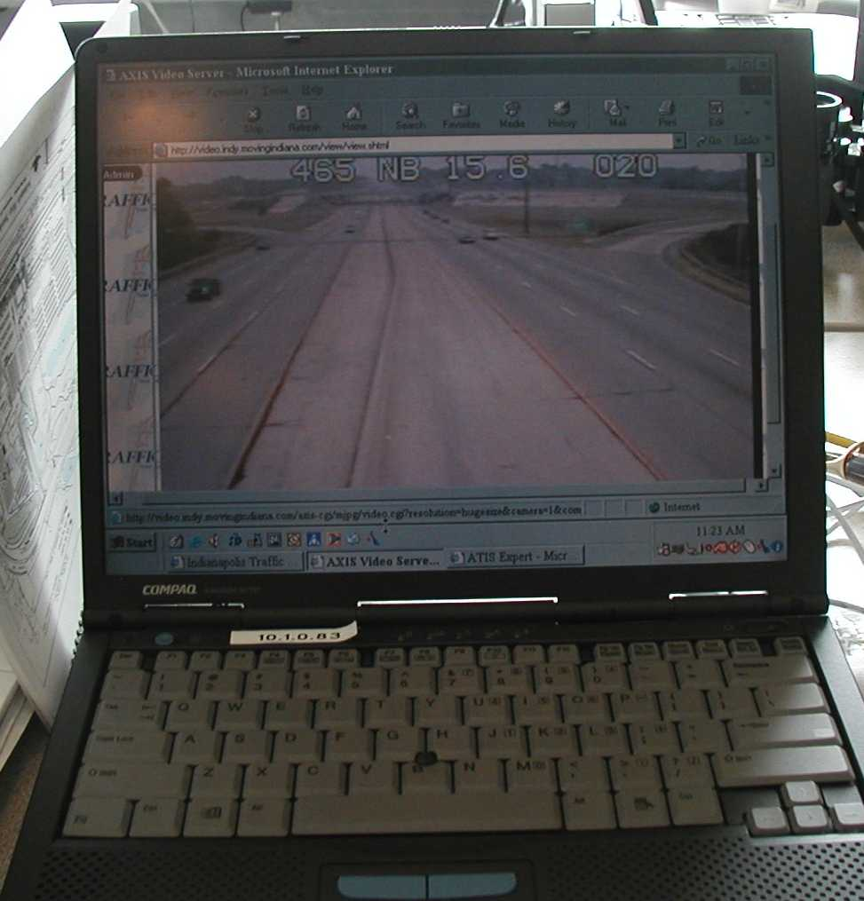
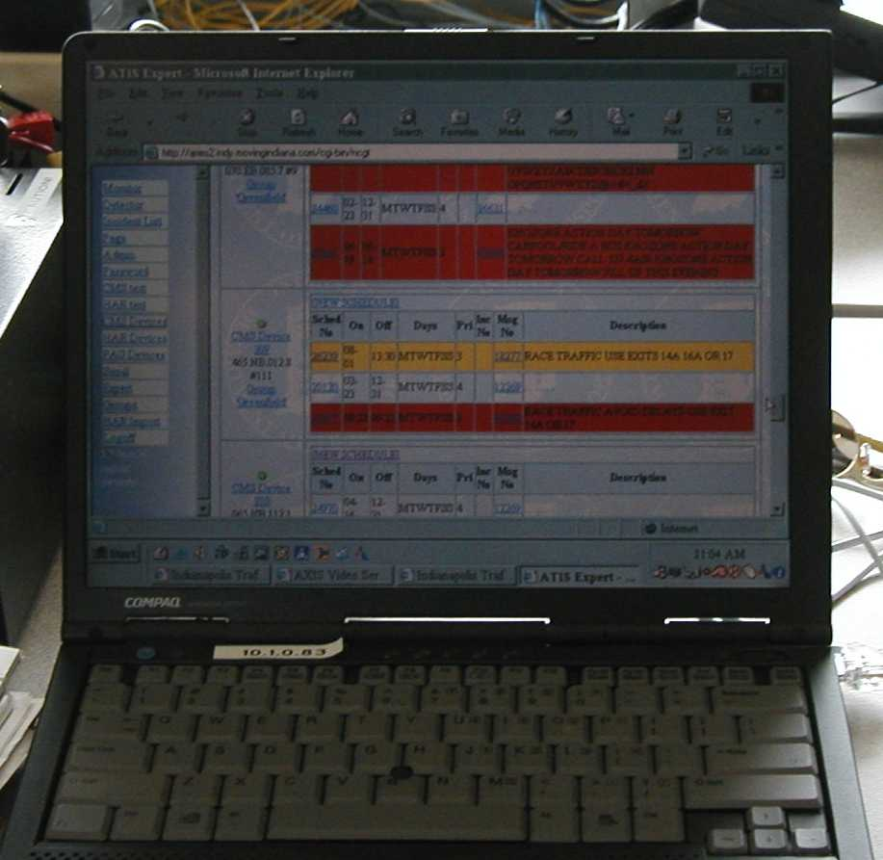

Figure 6-41
Remote Traffic Surveillance and Management

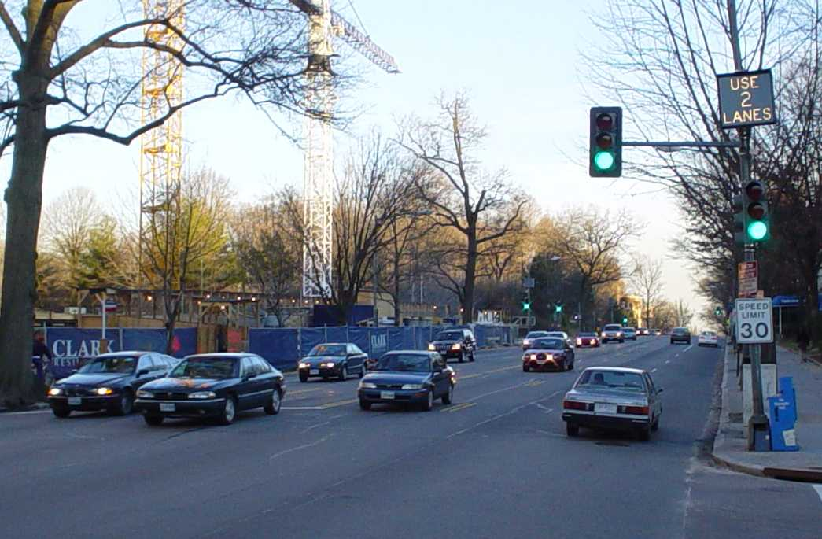
Figure 6-42
Daily Reversible Lane Operation

Figure 6-43
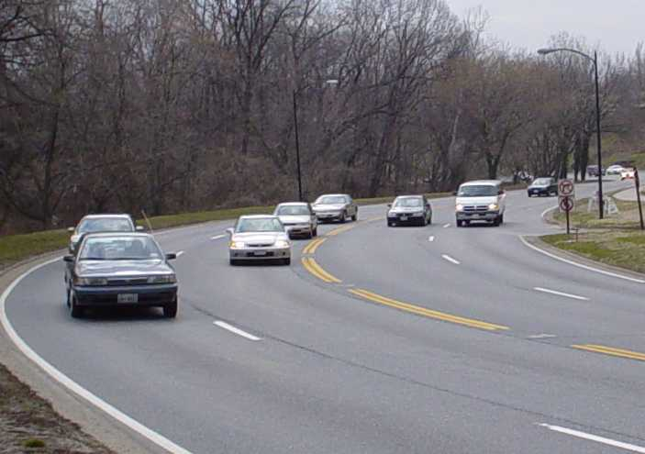
Daily Contraflow Operation

The application of alternative lane operations to streets during a planned special event creates an express route between an event venue and high-capacity freeway/arterial corridors. For instance, Figure 6-44 shows contraflow operation used during event traffic egress to facilitate rapid clearance of venue parking areas. An alternative lane operation for freeways involves designating an “express lane(s)” for through traffic. Median crossovers at section termini permit access to designated reversible lanes. In order to avoid congestion at the downstream merge point, right-lane traffic diverts upstream of the merge via an exit ramp to another freeway or arterial. Though rare, stakeholders may consider alternative lane operations for freeways or other divided highways in rural areas only.
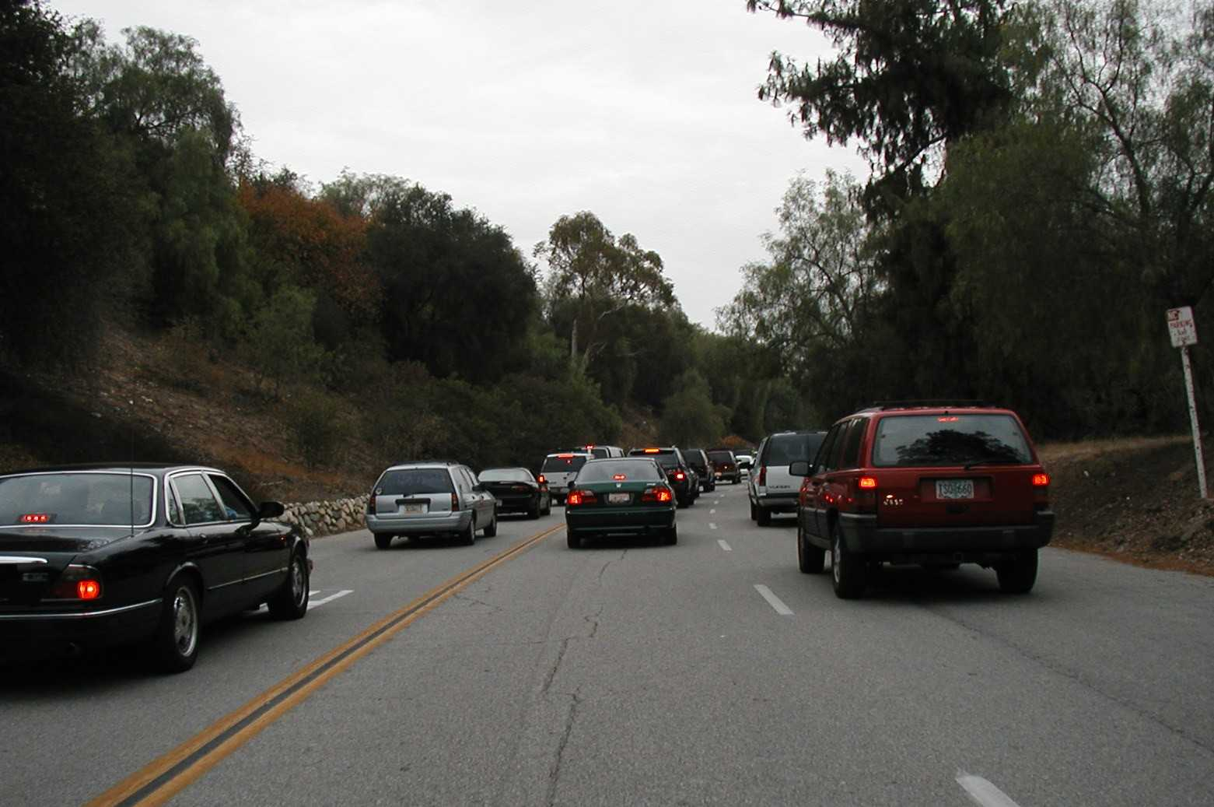
Figure 6-44
Contraflow Operation during Event Traffic Egress

Table 6-35 lists disadvantages of alternate lane operations on divided highways.

Table 6-35
Disadvantages of Divided Highway
^{Alternative Lane Operations}(17)

CONSIDERATION
- Signs, pavement markings, and safety features will not necessarily be visible to drivers traveling in the opposite direction.
- Safety appurtenances such as guide rail transitions, crash attenuators, and post support bases have not been designed to provide adequate protection at hazardous locations from the opposite direction of travel.
- Outbound contraflow operation prohibits inbound emergency vehicle access.
- Drivers will likely find operation confusing.
- Nighttime operation is difficult to manage.
- Cost to plan, design, and deploy operation is extensive.

Three key elements in developing an alternative lane operations plan include lane balance, markings, and enforcement. Key considerations regarding lane balance include:

- The success of any plan stems from achieving lane balance at the downstream terminus of a reversible lane or contraflow section. The number of lanes exiting an alternative lane section should not exceed the number of available receiving lanes at the end of the section. Otherwise, congestion will occur as a result of traffic merging at the section end.
- An alternative lane street section either terminates at a freeway interchange or street intersection.
- To effect lane balance, each lane in the alternative lane section must have a dedicated receiving lane. As a result, select travel lanes may become an exclusive turning lane at the end of the section.
- Temporary signing must inform motorists of lane destinations and restrictions before they enter an alternative lane section.

The following represent common methods of designating reversible lanes:

- Lane control signals
- Roadside signing
- Physical markings such as traffic cones and movable barriers

Figure 6-45 illustrates the use of lane control signals for temporary reversible lane operation in a roadway construction zone. These signals assist motorists in gaining a clear understanding of the scope of reversible lane operation in effect. Similar lane control signal applications apply to planned special events as well.

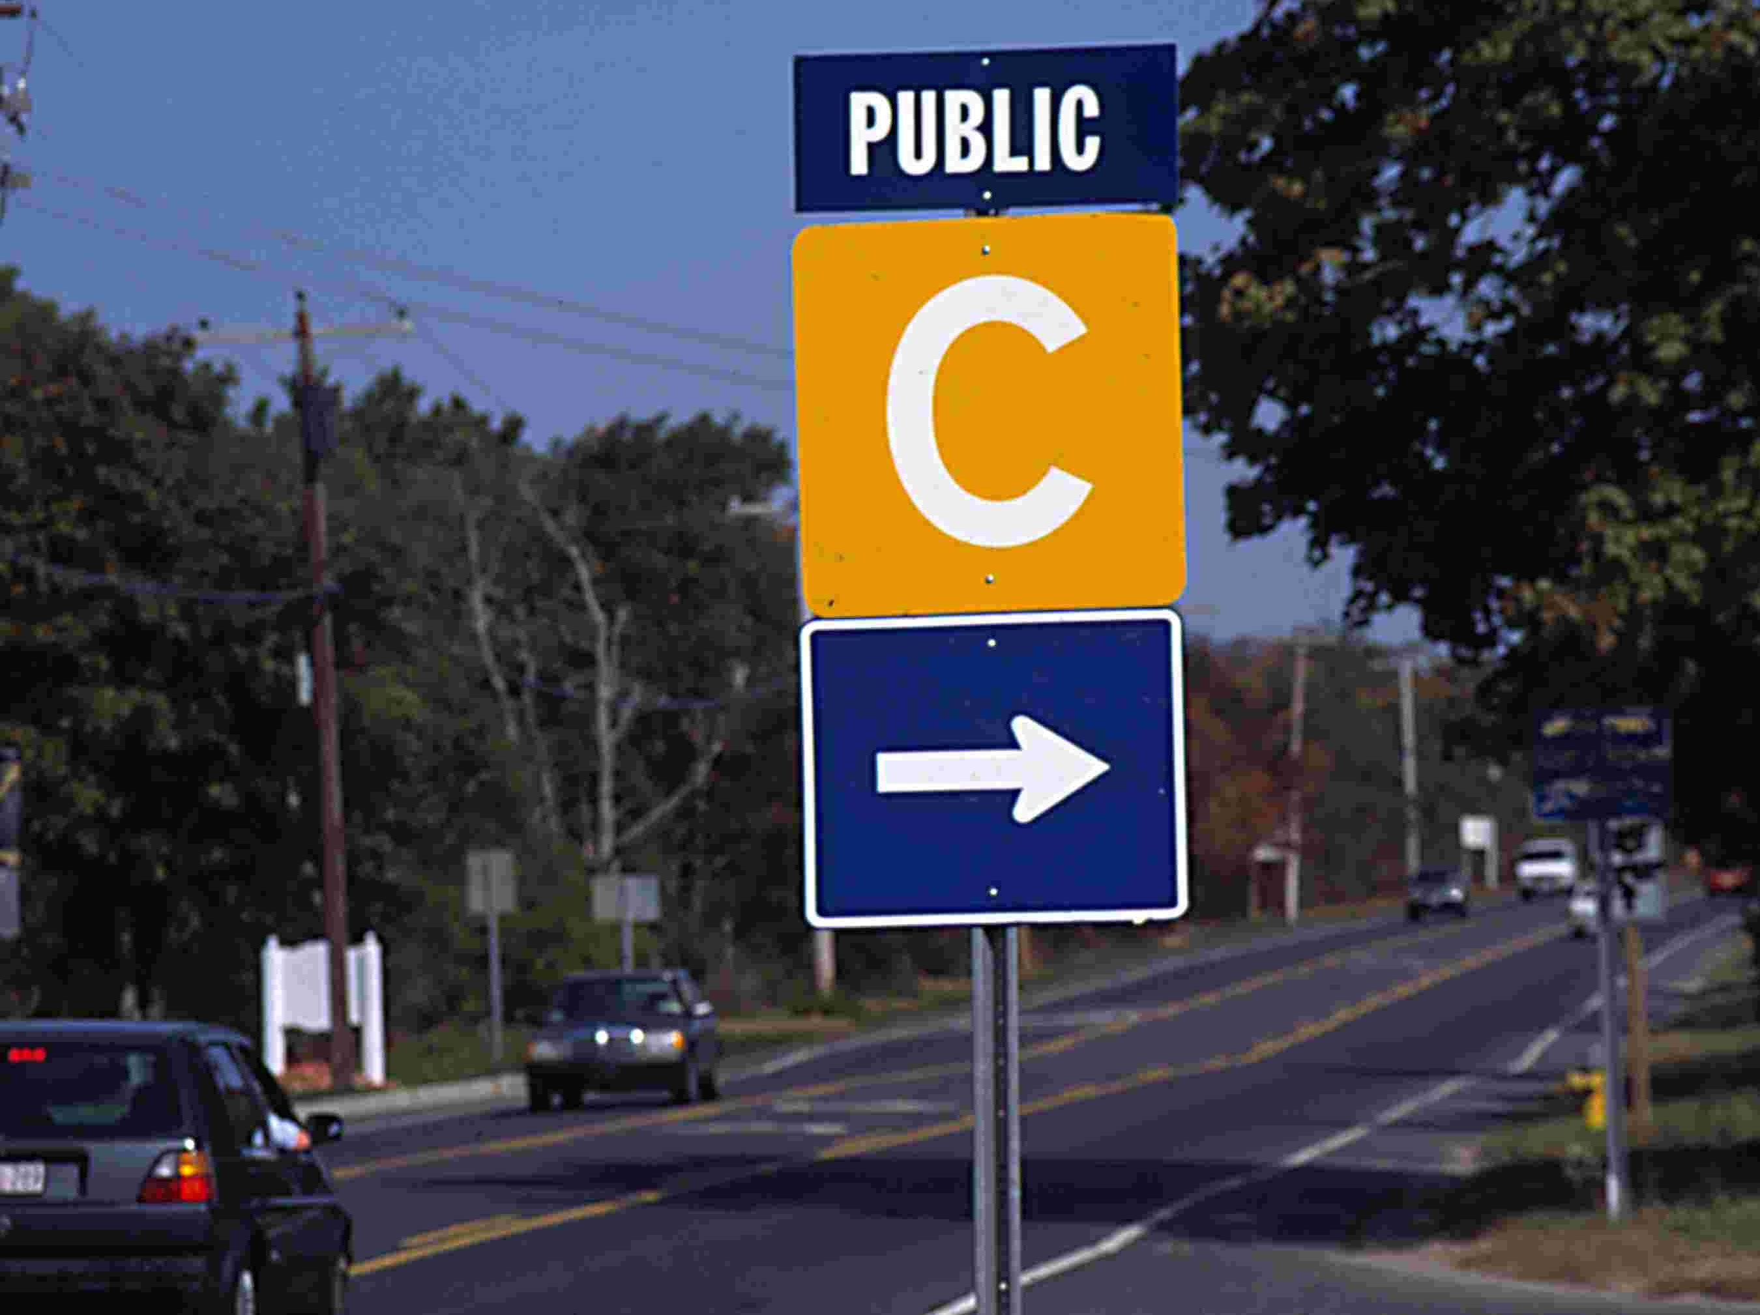
Figure 6-45
Temporary Reversible Lane Operation with Lane Control Signals

Reversible lanes require additional enforcement, particularly at section termini. Law enforcement should monitor section operation and ensure drivers maintain a relative safe operating speed. This applies even when the alternative lane section operates congestion-free. If traffic cones delineate travel lanes, then high-speed traffic may strike cones or cause them to blow over.

Management and Monitoring

The management of traffic traversing a local flow route on the day-of-event involves route guidance and monitoring of traffic control initiatives.

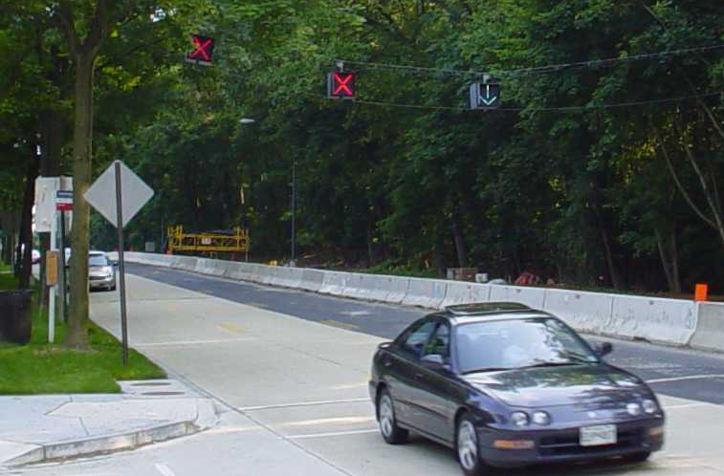
Aside from equipment quantity limitations, local street right-of-way and the presence of lateral obstructions may limit the placement of portable CMS at regular intervals along a local flow route to guide drivers. Instead, the event planning team should design special route marker signs for guiding motorists to venue parking areas and pick-up/drop-off locations. Each route marker may consist of a color-coded letter or symbol. Figure 6-46 shows an example route marker sign for a particular special event parking area. When erected along a local flow route, the route marker assemblies collectively trailblaze a route to the drivers’ destination of choice. As illustrated in Figure 6-47, signs that introduce each route marker should be placed on all freeway and arterial corridors serving the event venue. The event planning team must design and place all route marker assemblies in accordance with standards contained in the Manual on Uniform Traffic Control Devices. Sign fonts must be legible at free-flow travel speeds.

Figure 6-46
Route Marker Sign
Figure 6-47
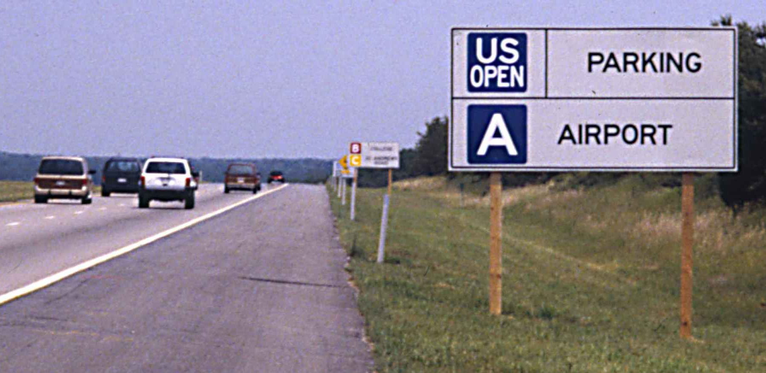
Introduction of Route Marker Sign Symbols

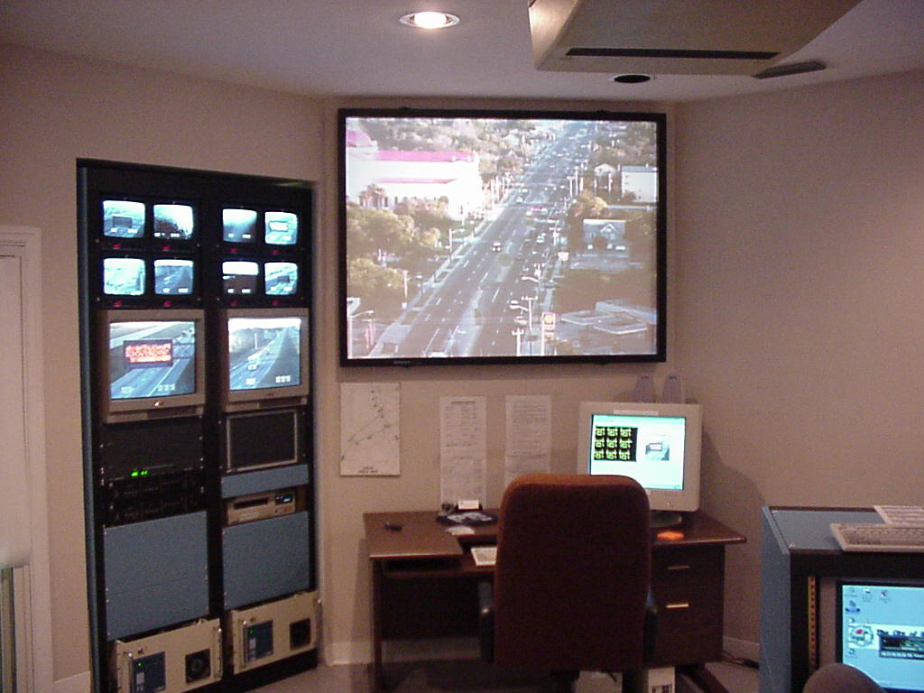
The street network surrounding a planned special event venue likely encompasses multiple jurisdictions. In turn, multiple traffic operations and/or law enforcement agencies, representing the local, county, and state level, may participate in street operations control and management on the day-of-event. The event planning team and traffic management team must ensure the traffic control strategies outlined in agency-specific plans complement one another, including contingency actions.

Some larger cities have installed permanent CCTV cameras for monitoring and managing high-traffic arterial operations. Figure 6-48 shows the Daytona Beach, FL TMC that has access to CCTV video for select streets traversing the city. In areas not covered by land-based CCTV, the traffic management team may alternatively utilize aerial surveillance to monitor street operations. The use of law enforcement aircraft allows on-demand surveillance of street corridors. If a TMC and/or event command post can not access video from the aircraft, then the aircraft should carry personnel involved in preparing the traffic management plan. Such personnel can best assess plan effectiveness and transportation system operation at potential problem areas identified during advance planning.

The deployment of a portable traffic management system(s) (PTMS) provides a traffic management team with the capability of monitoring traffic operations at critical roadway system locations in addition to disseminating updated traveler information at that location. Critical locations include target points connecting a corridor flow route and a local flow route or key driver decision points on the street network surrounding an event venue. Figure 6-49 shows a PTMS deployment. Table 6-36 lists typical PTMS components. Wireless communication via spread spectrum radio enables the traffic management team to view full-motion video from PTMS surveillance cameras.

Figure 6-48
Daytona Beach (FL) Transportation
Management Center (Photo courtesy of the Florida DOT.)

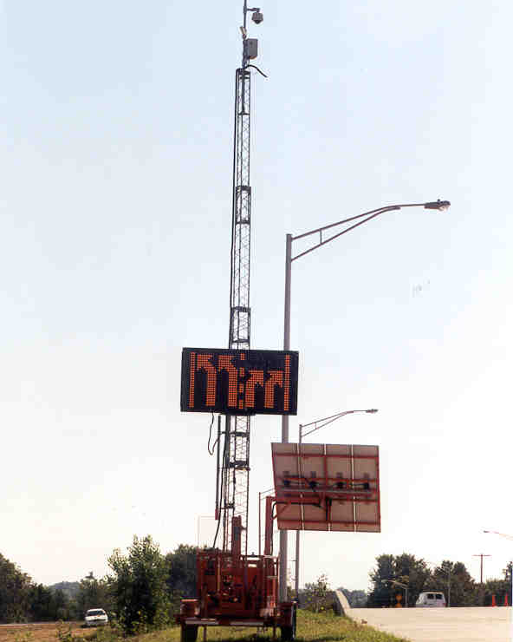

Figure 6-49
Portable Traffic Management System⁽¹⁵⁾
Table 6-36
Portable Traffic Management System
^{Components}

COMPONENT
- Surveillance camera
- Changeable message sign
- Highway advisory radio
- Detection devices
- Weather sensor
- Flood lights
- Power source (e.g., solar)

Intersection Traffic Control

A proactive approach toward developing strategies for controlling intersection traffic during a planned special event aims to:

- Increase intersection traffic handling capacity.
- Improve the orderly movement of traffic.
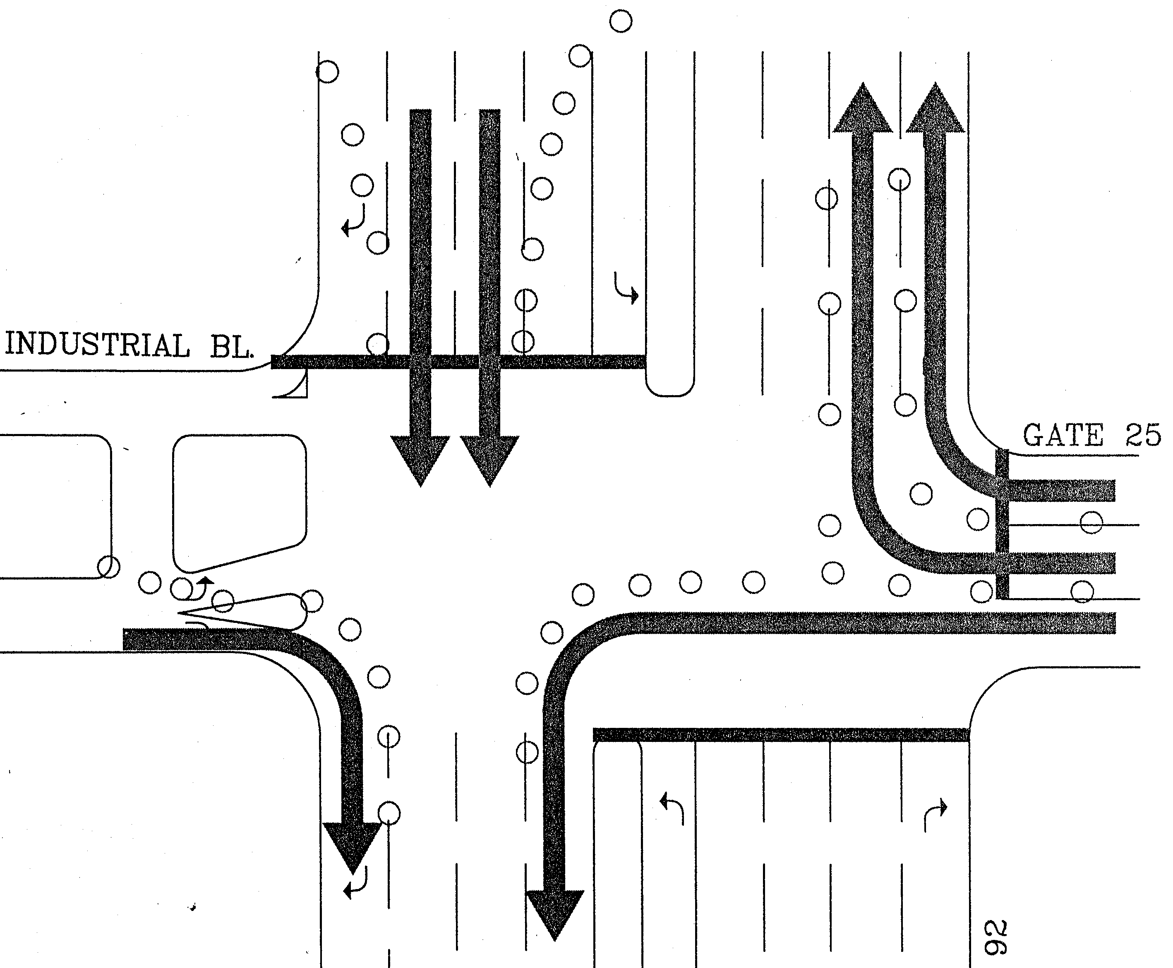
- Prevent crash occurrences.

The key to maximizing capacity involves simplifying traffic movements and minimizing the number of traffic signal phases. A typical 4-leg intersection has 32 conflict points. After prohibiting all left-turn movements and cross-street through movements, the same intersection has just 4 conflict points. As shown in Figure 6-50, lane channelization limits competing intersection traffic flow which, in turn, facilitates continual flow into a parking area access road or other road segment (e.g., alternative lane section).

Figure 6-51 presents an example, based on an intersection serving a Daytona International Speedway parking area, of achieving intersection turning movement lane balance. The plan shows three competing traffic flows that, with proper channelization applied, have unimpeded access to one receiving street segment. Given four receiving lanes, the channelization limited the number of approach lanes to four. When planning to use traffic cones or other channelizing devices for intersection traffic control, mark-out device locations prior to the event for fast and accurate placement on the day-of-event.

Figure 6-50
Elimination of Competing Intersection
Traffic Flow
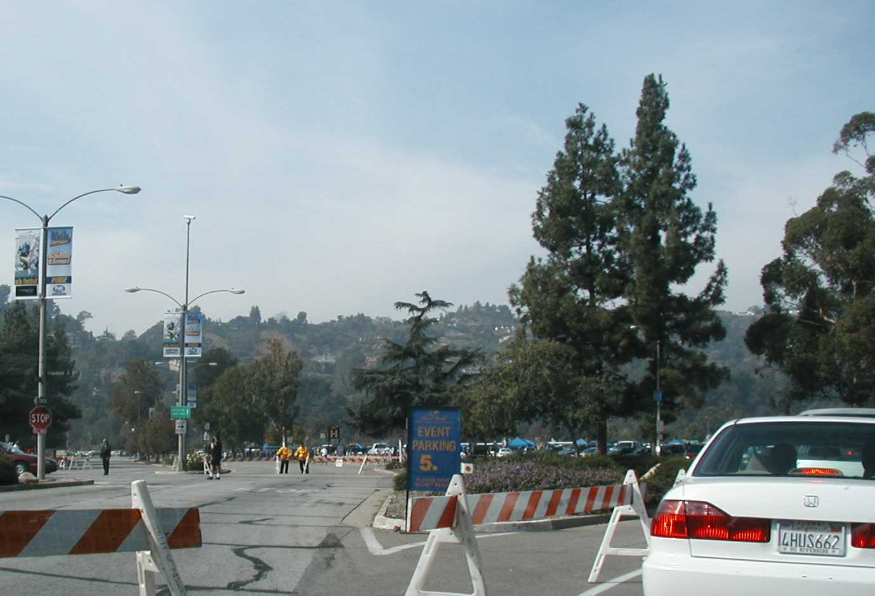
CCTV
Figure 6-51
Turning Movement Lane Balance⁽¹⁸⁾

Stakeholders can also reduce the number of competing intersection traffic flow movements by initiating a planned road closure. Figure 6-52 illustrates this tactic, where law enforcement blocked a venue ingress route to facilitate event traffic egress through an intersection.

Advance signing of permitted intersection movements improves the orderly movement of traffic. This particularly applies to cases when intersection operation on the day-of-event deviates significantly from daily operations. Figure 6-53 shows a high-visibility sign erected over an intersection approach contained in a planned egress route. Advance sign posting allows neighboring residents and local motorists to become familiar with planned day-of-event traffic control.
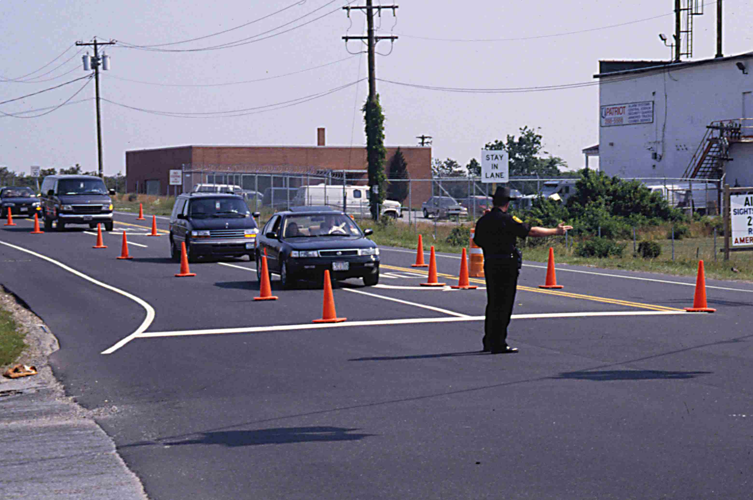
Figure 6-52
Road Block of Ingress Route to Facilitate Egress

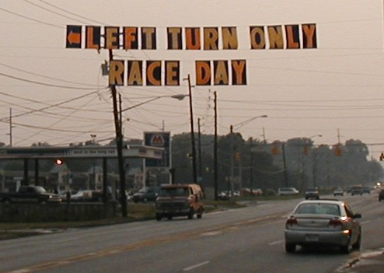
Figure 6-53
Intersection Advance Signing

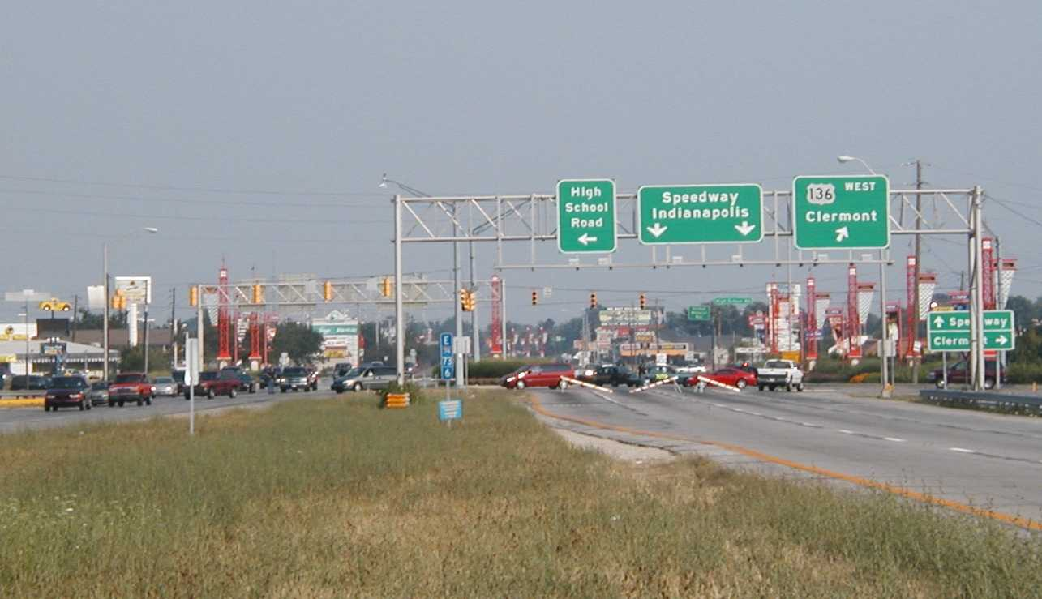
Traffic control officers have a large role in maximizing intersection operating efficiency. By using positive traffic control, as illustrated in Figure 6-54, officers guide motorists through an intersection. This minimizes headway between vehicles and reduces stops due to driver confusion, particularly at the downstream end of a reversible lane section. The officer commands a driver’s attention and works to control the speed of vehicles entering and departing the intersection, thus reducing rubbernecking.

Figure 6-54
Positive Traffic Control

Intersection traffic control changes from event ingress to egress operations. With regard to some street use events, particularly those involving a long event route and/or slow event pace, intersection traffic control complements a system of staged road closures along the event route. Law enforcement escorts the head and tail of the parade or street race. Traffic management team personnel deploy intersection traffic control a certain time (e.g., 15-30 minutes) before the head arrives and restores permitted intersection movements after the event tail clears.

Traffic Signal Operations

The significant change in traffic volume and flow patterns at street intersections in the vicinity of a planned special event venue during event ingress and egress mandates a review of traffic signal timing plans during the event operations planning phase. Except in isolated cases, traffic control officers should not manually control traffic signals on the day-of-event. Field decisions are difficult to make, and a manually controlled signal does not operate on a plan or in coordination with adjacent signals.

Advance traffic signal operations planning involve developing event traffic signal timing plans. Traffic signal timing plans should exist for a range of contingency scenarios that prioritize either major street or minor street traffic movements. Methods to increase time for a specific movement include: (1) selecting an existing plan with a longer cycle length to increase the normal favored phase, (2) implementing a custom plan favoring a minor street phase (3) deploying a contingency “flush” plan, consisting of an extra long phase or cycle, to facilitate movement through a corridor, and (4) increasing time for a movement through manual traffic signal system operator control. In traffic signal system-controlled corridors carrying high traffic volumes on the day-of-event, system operators may enact simultaneous coordination, where all signals within a single corridor turn green at the same time.

A successful traffic signal system management approach for planned special events involves providing a traffic signal system operator with access to real-time CCTV video of intersection operations. Appendix J contains sample protocol for the operation of a centralized traffic signal system, supplemented with permanent CCTV coverage at major intersections, in Anaheim, CA during a permanent venue event.⁽¹⁹⁾ If a real-time communication link to traffic signal controllers exist, then agencies can elect to mount a portable CCTV camera on a traffic signal pole, as shown in Figure 6-55, or other structure for day-of-event monitoring of intersection operations. Real-time monitoring ensures rapid implementation of appropriate timing plans and permits operator manual control as needed.

The traffic management team should include a traffic signal technician, available on the day-of-event for emergency maintenance. Also, the technician could facilitate timing plan downloads in the field, required for isolated signals or in the event that communications with a control center fail. The availability of a roving technician proves effective for making quick changes to traffic signal operations to meet user needs on the day-of-event. Prior to a planned special event, a technician should inspect traffic signals at critical locations, and operators should test traffic signal system control capabilities from the control center.

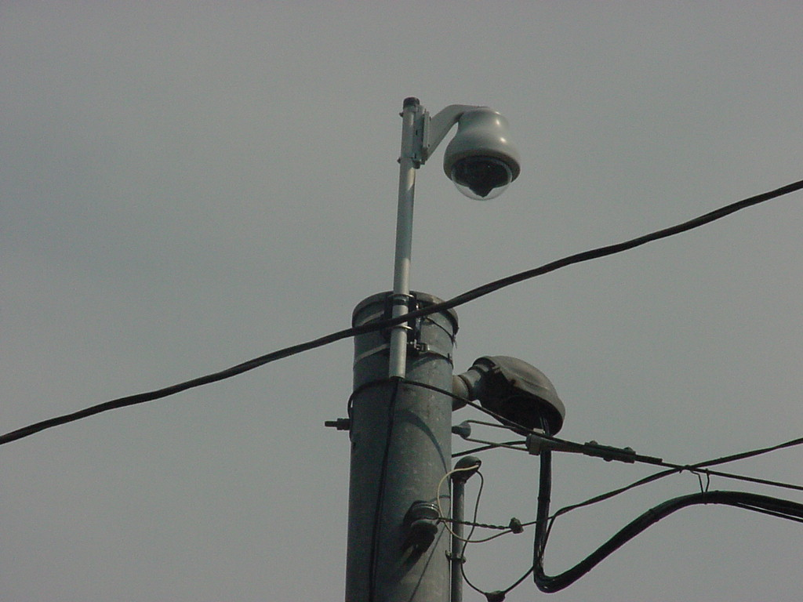
Figure 6-55
Portable CCTV Camera Mounted on Traffic Signal Pole⁽⁶⁾

Plan Specifications

The event planning team designs traffic control plans for use by the traffic management team and traffic control contractors. Table 6-37 contains a traffic control plan development checklist for freeway, street, and intersection management. Appendix K contains example traffic control plans and maps prepared for various planned special events.^{(18,20)} Because equipment demand varies on the day-of-event, traffic control plans should indicate equipment storage area locations and inventory remaining equipment available.

Table 6-37
Traffic Control Plan Checklist
ELEMENT | PROVISION
Freeway control plan | - Specify maintenance and protection of traffic per MUTCD guidelines (e.g., location of traffic control equipment, equipment quantities, and safety signs).  - Indicate ramp control and capacity modifications.  - Highlight exclusive traffic flows (e.g., unimpeded merge, etc.).  - Dimension weaving area, acceleration/deceleration lane lengths, ramp length.  - Indicate potential bottleneck locations for surveillance monitoring.
Street control plan | - Show closed road segments.  - Indicate directional lane control (e.g., alternative lane operations).  - Show one-way streets.  - Indicate number of ingress and egress lanes at each venue access point (e.g., parking areas, pick-up/drop-off points).  - Show street use event route.  - Indicate parking restrictions.  - Indicate location of command post(s).  - Integrate with signing plan (e.g., show route trailblazer signs).
Intersection control plan | - Specify maintenance and protection of traffic per MUTCD guidelines (e.g., location of traffic control equipment, equipment quantities, and safety signs).  - Show permitted pedestrian movements and crosswalk locations.  - Indicate approach lane designations and pavement markings.  - Indicate traffic control.  - Highlight exclusive/permitted traffic flows (indicate approach lane and corresponding receiving lane).  - State special regulations (e.g., turn prohibition, exclusive bus lane, resident/permit only movement).  - Show approach closures.  - Indicate parking restrictions.  - Indicate location of traffic control officers.  - Indicate location of equipment storage area at intersection.
Signing plan | - Show location of permanent/portable changeable message signs.  - Show location of permanent/portable highway advisory radio stations.  - Indicate CMS/HAR message sets.  - Default ingress and egress  - Contingency scenarios  - Show location of temporary static signs and message.  - Indicate location of dynamic blank-out signs.
Equipment location plan | - State number of traffic cones, drums, and barricades required at designated locations.  - Indicate equipment staging areas (e.g., shoulder, median, intersection corner)  - Indicate location of equipment storage areas.
Other considerations | - Provide plans for both ingress and egress operation.  - Indicate roadway construction zones.  - Include table of quantities.  - Show aerial map.  - Draw map to scale.  - Display landmarks.

En-Route Traveler Information Plan

Overview

The dissemination of traveler information for a planned special event is an integral part of operating and managing the transportation network. The following three issues must be considered in developing and maintaining the event plan:

- Stakeholders – The information needs of travelers extend well beyond an agency’s infrastructure and include other jurisdictions’ highway facilities, transit facilities, airports, etc. The private sector should also be an active partner in the traveler information process and must be included as a stakeholder.

- Evaluation – Care should be taken not to overestimate the benefits achieved by the implementation of information dissemination components in the plan. Specifically, it is important to recognize that travel patterns are quite dynamic and that some drivers will divert naturally when they encounter congestion regardless of whether or not they receive information beforehand about that congestion. A Washington, D.C. Advanced Traveler Information Systems (ATIS) study revealed:
  - If ATIS deployments are evaluated purely on time-savings, the benefits of ATIS will likely be grossly underestimated.
  - ATIS users value improved travel reliability. The value of improved on-time reliability is not easily nor directly monetized, but it is clear that many types of travelers can benefit from ATIS.
  - Improved reliability and predictability of travel are also likely good surrogates for reduced driver stress. From this common sense perspective, it is clear that the benefit of improved travel reliability and predictability from ATIS will outweigh whatever small return is generated from the monetization of aggregate travel time reductions.

- Performance Measures – In order to assess the extent to which the traffic management plan efforts within are meeting goals and objectives, a set of performance criteria and measures-of-effectiveness pertaining to these efforts must be identified. Relative to coordination and information dissemination, performance criteria have three different, yet interrelated, dimensions that are of interest:

  - Information credibility – An information dissemination tool must be credible to travelers if it is to be utilized and have an impact upon traffic operations. The following criteria define how credibility is established: (1) the information must be accurate, (2) the information must be timely, and (3) the information must be relevant to its intended audience.

  - Market penetration – Market penetration refers to the percentage of the potential audience reached by the information dissemination efforts. Performance criteria regarding market penetration may be appropriate for evaluating certain system goals and technologies, particularly those emerging as part of ATIS. It is expected that some technologies, such as in-vehicle dynamic route guidance, will require only limited market penetration in order to achieve operational benefits. Other technologies, such as information kiosks in major traffic generators, may require agencies to strive for as great a market penetration as possible in order to distribute the information to a wider audience and possibly attract private sector advertising and sponsorship.

  - Traveler response – Ultimately, the purpose of providing information to travelers is to effect some change in traveler behavior that will cause an improvement in safety or operations. Thus, performance measures are also needed to determine the extent to which information dissemination accomplishes this purpose. Changes in traveler mode, departure time, and route (if appropriate) are appropriate for evaluating the effectiveness of real-time, travel-related information. However, it may be very difficult and expensive to obtain actual data for these measures. Traveler opinions about the effectiveness of the information being provided can be another important evaluation measure.

  - It is important to recognize that because of the complex travel patterns of travelers at any point in the roadway, it may not be possible to adequately measure the overall effects of many types of information or dissemination modes upon traffic volumes, speeds, or delays. The day-to-day variances in travel patterns themselves may mask the effects of any information disseminated during a specific event such as an incident, particularly if the information is intended for a very specific audience (such as vehicles within a traffic stream destined for a specific downstream exit).

Information Needs

En-route traveler information can provide event patrons and other transportation system users with current roadway and transit information while traveling en-route. Information is typically provided via devices deployed along the side of the roadway, or from devices mounted on the dashboard of the vehicle. Along the roadway, changeable message signs and highway advisory radio messages typically provide information regarding an upcoming planned special event, including current conditions related to the special event such as traffic congestion, incident and construction locations, weather advisories, parking availability, and alternate routes. In-vehicle and personal mobile devices can provide a variety of en-route traveler information to both the traveler as well as transportation providers. Sophisticated route guidance systems can assist motorists in route planning as well as providing timely directions via a computer synthesized voice.

Static Signing

Static signs can be used for event management to inform travelers of an upcoming planned special event, to identify park & ride lots, and to guide motorists to particular locations. It is not uncommon for agencies to use static signing in special event management for the following purposes:

- Notify travelers of a future special event.
- Notify travelers of future facility changes for the event such as lane closures or occupancy restrictions.
- Identify special alternate routes for the event.
- Guide travelers to parking or park & ride lots.

Transportation incident responders utilize static signing in day-to-day operations to trailblaze motorists along an alternate route or venue access route. These are temporary signs, mounted on fold-away supports, along the shoulder of the roadway or at exit gores to direct motorists to alternate routes as a matter of typical traffic management or in response to an incident and redirecting of traffic.

Changeable Message Signs

One of the most fundamental technologies available for disseminating traffic-related information from the roadside is that of changeable message signs. CMSs are sometimes referred to as dynamic message signs or variable message signs. CMSs are programmable traffic control devices that can usually display any combination of characters to present messages to motorists. These signs are either: (1) permanently installed above or on the side of the roadway, (2) portable devices attached to a trailer, or (3) portable devices mounted directly on a truck and driven to a desired location. Portable CMSs are much smaller than permanent CMSs and are oftentimes used in special event situations, highway work zones, when major crashes or natural disasters occur, and emergency situations.

When installed, CMSs become a part of the total motorist information system. Thus the information presented on CMSs and the placement of the signs must be consistent and compatible with static signs. Highway signs – both static and dynamic – must project a message so that the driver can:

- Detect the sign,
- Read and understand the sign,
- Make appropriate decisions based on the information gained from the sign, and
- If necessary, initiate a control response, and complete the required maneuver.

CMSs perform a critical role in special event management. Such signs can furnish motorists with real-time information that advises them of a problem and in some cases, a suggested course of action. CMSs are also used to improve motorist safety and reduce traffic congestion and delay during events. CMSs can be used to manage traffic by displaying the following types of messages:

- Early warning messages give motorists advance notice of slow traffic and queuing ahead and are effective in reducing secondary crashes. When used in freeway work zones, early warning messages also give notice of new detours, changes in alternate routes, changes in lane patterns, special speed control measures, etc.

- Advisory messages provide motorists with useful information about a specific problem along their route. This information allows motorists to change their speed or path in advance of the problem area, or may encourage them to voluntarily take an alternate route to their destination.

- Alternate route messages influence motorists to travel to their chosen destination by using different routes than originally intended. The alternate route is one designated by the transportation agency. In cases when the freeway is physically closed as a result of construction, crash, or natural disaster, the motorists are notified that an alternate route must be used.

The most critical locations for installing permanent CMSs are in advance of interchanges or highways where drivers have the opportunity to take some action in response to messages displayed on CMSs. In many special event cases, permanent CMSs are already strategically located to advise event patrons of special conditions and non-event motorists of alternate bypass routes. Figure 6-56 shows a permanent CMS over an arterial located adjacent to a stadium venue and serving venue parking areas.

Figure 6-56
Permanent CMS Over Stadium Access Road
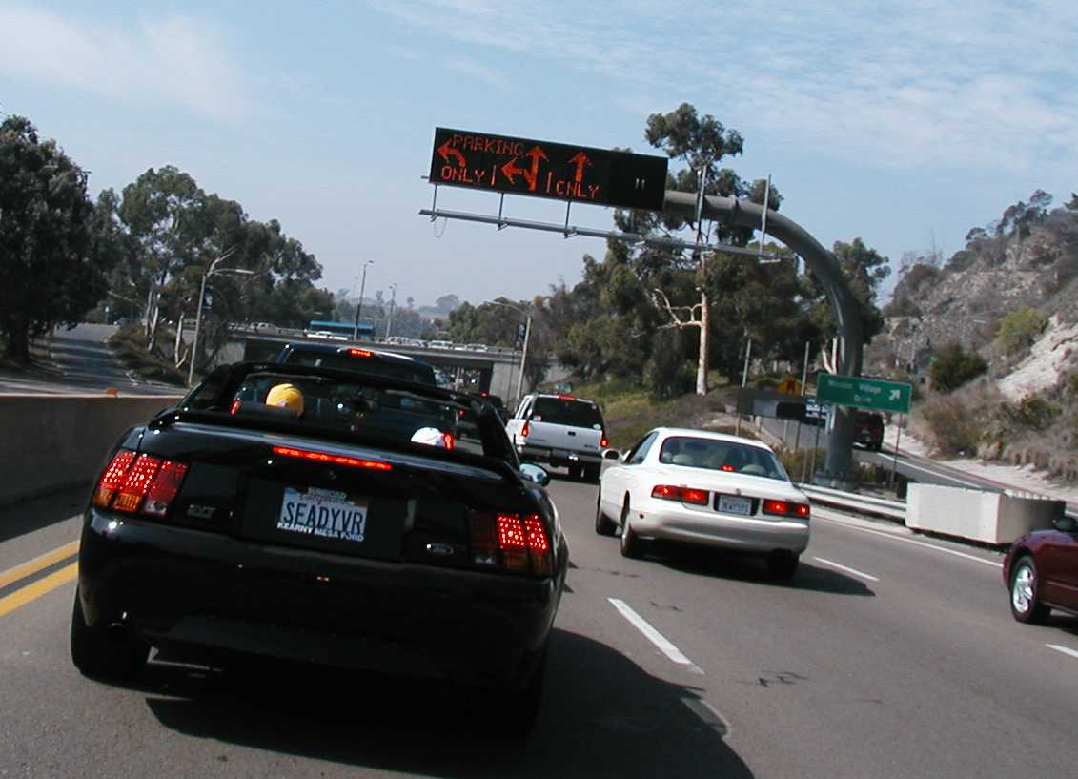
A CMS should not compete with existing roadway signs. In general, a CMS should be permanently installed at the following locations:

- Upstream from major decision points (e.g., exit ramps, freeway-to-freeway interchanges, or intersection of major routes that will allow drivers to take an alternate route)
- Upstream of bottlenecks, high-accident areas, and/or major special event facilities (e.g., stadiums, convention centers)
- Where regional information concerning weather conditions such as snow, ice, fog, wind, or dust is essential

Portable CMS

The use of trailer-mounted CMSs provides an agency with a great deal of flexibility. The signs, which are typically much smaller than permanent, over-the-road CMSs, are used most commonly for temporary applications. As such, portable CMSs are very suitable for special event management. They are usually diesel- or solar-powered and use wireless (cellular) communications to a central management point, making them a very attractive and flexible tool.

Portable signs are usually located at the side of the road and do not sit as high as an overhead sign, which can impair drivers visibility. Most are 3-line, 8 or 9-character signs, and although most have the capability of displaying multiple phases, they tend to be used with simple short messages to allow drivers to read and comprehend the message.

Highway Advisory Radio

Although not as widely used as changeable message signs, highway advisory radio is another means of providing highway users with information in their vehicles. Traditionally, information is relayed to highway users through the AM radio receiver in their vehicles. Upstream of the HAR signal, users are instructed to tune their vehicle radios to a specific frequency via roadside or overhead signs. Usually, the information is relayed to the users by a prerecorded message, although live messages can also be broadcast.

Highway advisory radio is an effective tool for providing timely traffic and travel condition information to the public. It has various advantages and disadvantages. Its most important advantage is that it can reach more travelers, or potential travelers, than the other roadside technology, changeable message signs. While CMSs reach only those motorists at a particular point, and can only convey a short message, HAR has the advantage of being able to communicate with any person in the HAR broadcast range. Furthermore, the amount of information that can be conveyed to the user is much greater. Its primary disadvantage is that it is restricted to low power, and this can lead to poor signal quality (since many outside forces affect the signal, such as weather) and, therefore, poor listener levels.

HAR is an element of the Federal Communication Commission’s (FCC) Traveler Information Systems (TIS) designation. They are permitted under strict FCC guidelines and regulations associated with technology and operations. They are licensed as a secondary user, which means simply that they cannot interfere with a primary user, i.e., a commercial broadcast station. As a secondary user, HAR broadcasts are restricted in signal strength, a level that limits their transmission range to no more than three or four miles from the transmitter. A number of technologies are available for HAR transmission, using both AM and FM bands.

Typically, HAR has been implemented using 10-watt AM transmitters. This is because, beginning in 1977, it was the only technology permitted by the FCC for traveler information. As such, this technology implementation has also proven to be the most effective. Other means involve very-low power AM transmission, where multiple transmitters are spaced closely together to form a large area of coverage. This application, however, has not proven very successful. As late as 2000, the FCC ruled to allow the use of low-power FM transmission for TIS. This technology has limited application to-date.

Urban areas typically present a unique set of challenges to HAR application, which can hinder downtown event management. Tall buildings present an obstacle to uniform transmission since the FCC restricts antenna height to approximately fifty (50) feet. High-power electric lines can incur noise on the transmission that negatively impacts broadcast quality.

Deployment Strategies

HAR can be broadcast in two ways: Point or Wide-Area coverage.

- In Point broadcast, a single transmitter is used to broadcast over a given area. This is typically used at diversion points in advance of areas of recurring congestion to notify motorists of queues and congestion. This type of implementation is popular with travelers because the information is specific to them. This is the most common application for HAR, and it typically utilizes 10-Watt transmitters. It is the simplest to manage in terms of equipment to maintain.

- Wide Area Broadcast transmits a signal to a larger coverage area using multiple synchronized transmitters. This is an effective strategy when a single message is applicable to a large coverage area and the coverage area is sufficiently large for a motorist to hear the longer message length. The fact that a long single message, that is pertinent to specific travelers for only a part of the message, is indeed a disadvantage. Studies have shown that travelers want brief, specific information, pertinent to their location and situation. They are not likely to listen for long periods of time until their information is broadcast. Technically, synchronization is difficult to accomplish between transmitters because both the time and repeated voice signal must be in sync.

Both of these applications are practical and viable for planned special event management.

Portable and Mobile Systems

Portable systems permanently installed on trailers and mobile systems installed on service or maintenance vehicles can be of value in providing timely dissemination of information to motorists during short-term deviations from normal highway conditions, or more specifically, during planned special events. These systems can be solar powered, generator powered, or battery powered.

Portable and/or mobile systems could be set up at decision points where a route guidance system directs motorists to an alternate route. This will increase motorist comfort level by reinforcing their confidence that they are following the alternate route instructions correctly.

HAR signs, indicating the frequency at which traffic information is available, are typically installed throughout each zone. These signs usually include flashing beacons that are activated only when a message of some predetermined level of importance is being broadcast and a legend reading (or similar) “TRAFFIC ALERT WHEN FLASHING.” This technique permits the system to continuously broadcast “default” messages in each zone during non-congestion periods, while alerting the motorist to an urgent/emergency message by turning on the flashing beacons. Thus the system prevents motorists from tuning to the HAR frequency only to hear the default message time and time again, situations that could negatively impact system credibility.

Changeable message signs can also be used to alert the motorist to the broadcast of a message of the utmost importance. These signs can be controlled through phone lines, or with cellular or paging technology, and can be solar powered with battery back up. They offer a great deal of flexibility, by allowing only the pertinent signs to be activated. For instance, while two signs (one in each direction) may be associated with a particular transmitter, only one would be activated for a downstream incident, thereby eliminating any loss in credibility due to providing a message that is not applicable to one of the directions of travel.

Media

The public has learned to depend upon the media to provide them with “almost” real-time traffic information. Commercial radio has proven to be a good means of providing travelers with traffic information both in and out of their vehicles. Traffic and roadway condition reports have become standard programming items on many commercial radio stations. Commercial radio has the best potential of reaching the greatest number of commuters, since most of them have radios in the vehicles they drive to and from work. It is not uncommon for planned special event stakeholders, including public agencies, to partner with a commercial radio station (or for a commercial radio station to sponsor a special event) to enhance the information dissemination related to the event and its transportation conditions. Care should be taken to ensure that the information disseminated reflects current traffic conditions and is credible.

Other Technology Applications

Other technology applications include:

- Cellular telephone-based systems
- 511
- In-vehicle displays
- Subscription services
- Personal data assistants

Telephone Based Traveler Information

An in-vehicle communication technology that has seen dramatic growth in the past few years is cellular telephones, which gives the motorist the ability to call special “hotline” systems for traffic information from within their vehicle. Originally, these systems allowed motorists and transit users to call for information to assist in pre-trip decisions from their homes. Information can now be accessed en-route via cellular telephone, and decisions can be made whether to alter travel routes. The creation of call-in systems has been a popular traffic impact mitigation strategy for many major urban freeway reconstruction projects in recent years.

This type of in-vehicle communication has the advantage over HAR of giving the motorist some control over the type and amount of information he/she wants to obtain through the touch-tone menus. In addition, it is also possible to generate two-way communication between the motorist and the information source.

Recommendations for establishing cellular telephone-based systems include the following:

- The call must be toll-free to users.
- The telephone number must be easy to remember and dial.
- The information must be concise.
- If a menu system is used, a long and tedious menu selection process should be avoided.
- A sufficient number of telephone lines should be provided to prevent the majority of users from receiving a busy signal.
- If a system is going to be used to gather information from users, there must be a method of ensuring the accuracy of the incoming information.
- “Official” use of tipster information should include procedures for verifying that information.
- If incident information is to be received, a human operator is recommended so that secondary questions can be asked to clarify confusing or unclear reports.

As with HAR systems, this technology also requires action by the motorist to access information. There are also significant operating costs associated with this technology, as any calls made using cellular telephones must be paid for by either the motorist, or a public agency, or else absorbed by the corporation providing cellular telephone communication capabilities in the region. Finally, there is some concern that cellular telephone usage while driving may degrade motorist attention and operating capabilities. Manufacturers have developed “hands-free” telephones that allow motorists to listen and talk without holding the telephone receiver, although the need to push the telephone buttons to go through a menu of information operations can defeat the “safety” purpose behind hands-free devices.

Many metropolitan areas established cellular “hotlines” for motorists to call in and report traffic incident information to the highway agency. Examples included #77 and *SP. However, the establishment of the 511 national traveler information number is envisioned to replace these already established numbers.

511

Understanding the importance of consistency and simplicity in providing telephone-based traveler information, in 1999, the U.S. Department of Transportation (USDOT) petitioned the FCC to designate a nationwide three-digit telephone number for traveler information. This petition was formally supported by 17 state DOTs, 32 transit operators, and 23 Metropolitan Planning Organizations and local agencies. On July 21, 2000 the FCC designated 511 as the national traveler information number.

Simply put, 511 represents an abbreviated three-digit dialing code that is a short cut to a ten-digit telephone number for obtaining traveler information from a telephone. In petitioning the FCC, USDOT had to demonstrate the need and benefits for such a number. To that end, the USDOT identified the following:⁽²¹⁾

Further benefits are realized. 511 puts a “face” on ITS and transportation operations, while increasing attention on the potential for traveler information services. With 511, transportation agencies can offer easier access to information via telephone, and have the same number work in multiple places. It is not uncommon for traveler information numbers to change across jurisdictional boundaries, creating confusion among motorists.

In-Vehicle Displays

A video display terminal (VDT) mounted in the dashboard is another form for communicating with motorists in their vehicles. This is primarily a private sector industry, which has not been used widely for information distribution. These systems can be used to provide motorists with route guidance and navigational information in one of two different formats. One approach is to present the driver navigation and route guidance information in the form of maps or equivalent displays. With these systems, a global picture of the traffic network can be provided. Recommended routes can be highlighted on the video map display as well. In another approach, simple symbolic signals (e.g., arrows, text instructions, or a combination of both) guide the driver along a recommended route. Some prototype systems use a variety of displays depending upon whether or not the vehicle is in motion, the functions selected, and level of informational and navigational displays available.

In-vehicle VDTs offer a number of advantages over available technologies in providing information to motorists while driving. These include the following:

- Travel information is more readily accessible to the driver (providing continuous access to current position, routing, and navigational information).
- Computer-generated navigational maps and displays are logical extensions of traditional forms of providing drivers with route guidance and navigation information.

Information can be displayed in text, graphics, or both and tailored to the needs and desires of each motorist. There are also limitations to in-vehicle VDTs. These include the following:

- Drivers have to take their eyes off the roadway in order to receive the information.
- In-vehicle VDTs present the driver with complex maps and diagrams that may create a potential to overload the driver with too much information.
- VDTs may also add to the visual clutter already inside the vehicle.

As technology continues to improve, the Head-Up Display (HUD) has become another alternative to in-vehicle VDTs for presenting visual navigational and route guidance information to motorists. Although originally developed for the aviation industry, several automobile manufacturers are beginning to develop HUDs for presenting vehicle status and navigational information to drivers.

A wide variety of options for displaying information may be available using HUDs. Through both icons and alphanumeric text, navigation and route guidance information may be projected directly into the driver’s field of view. This is expected to reduce the need for visual scanning between two information sources (the inside instrument panel and the outside environment) and the associated visual accommodation time.
Subscription Services

A number of private providers supply traveler information services on-demand as a subscription. Most notably, General Motors’ (GM) OnStar is a 24 hours a day, 7 days a week motorist assistance system installed in the vehicle. It provides a wide range of services to the driver, including concierge service, telephone service, remote unlocking of the car, and notification of air-bag deployment just to name a few.

Another feature OnStar provides is route guidance to motorists. Here, the motorist initiates a call from a button installed in the car, is connected to a live Onstar operator, and proceeds to ask for directions. The operator knows the vehicle’s location through OnStar’s automated vehicle location system and provides directions for the fastest route. OnStar currently uses a third-party wireless analog network and is moving to a digital technology, which will allow the service to be expanded to handheld devices as well. Presently, 53 current (2003) vehicle models are offered with OnStar, and GM intends to expand to 60 models by the end of 2003. Routing assistance is the most utilized service, and OnStar reports that it handles more than 220,000 routing calls per month.⁽²²⁾

Personal Data Assistants

Personal Data Assistants (PDAs) are the next higher level of sophistication in both off and on-roadway information dissemination technology. PDAs are computer products that have enough power to support applications such as time management and handwriting recognition. By adding radio frequency (RF) communications technology, PDAs allow users to interact directly with travel information systems. This interaction allows users to obtain route planning assistance, traffic information broadcasts, and other pertinent information. Through keypad entry, the user can log on to the information system, request pertinent information, and then log off. PDAs offer the user increased communication and information transmission/receiving power over alphanumeric pagers.

Plan Specifications

An en-route traveler information plan must be developed in concert with the traffic flow plan and traffic control plan. The success of any traffic management plan depends on disseminating correct information to motorists at the right time and location.

Items to be included in this plan include:

- Names of contact person(s) for each involved partner
- Protocols and methods to be utilized to coordinate
- Definition of each partner’s responsibilities regarding control and information exchange

Detailed plans are necessary that identify the facilities and resources to be used. For instance, what permanent CMS or HAR are to be used and what holes exist in the information dissemination strategy? Where will portable devices be required? Traveler information plans must include planned message sets for equipment and technology used to disseminate en-route traveler information, including static signs, changeable message signs, highway advisory radio, and telephone information systems.

As in the desktop exercise and modeling analyses, various scenarios must be examined, and as a result, specific tactical strategies will be developed. Of particular importance in planned special event management is the creation of information messages for the various devices available to the manager. This includes changeable message sign messages, highway advisory radio messages, Internet and PDA messages. Each of these must be developed for various scenarios, including contingency ramp closures, full parking lots, and emergency situations. The traveler information plan may also specify protocol for disseminating traveler information via the media.

Traffic
Surveillance Plan

A traffic surveillance plan can include:

- Closed-circuit television systems
- Field observation
- Aerial observation
- Media reports

Closed-Circuit Television Systems

Closed-circuit television systems have been used for many years to provide visual surveillance of the highway network. Control centers typically use CCTV systems for the following purposes:

- Detection and verification of incidents
- Monitoring traffic conditions
- Monitoring incident clearance
- Verifying message displays on changeable message signs

For fixed location CCTV systems, video cameras are permanently mounted either on existing structures along the roadway or on specially installed camera poles. This type of system consists of various components, including the following:

- Video camera unit
- Mounting structure (existing or installed)
- Controller cabinet housing the control equipment
- Communication system connecting camera to control center
- Video monitors and camera controls located in control center

CCTV systems allow operations personnel to visually monitor sections of roadway and to react directly to the actual conditions on the roadway. Since operators can lose interest if required to constantly view CCTV monitors, and may fail to notice incidents immediately after they occur, current systems are being designed to automatically position cameras at suspected incident locations (as signaled by incident detection algorithms) and to alert the operator.

Portable CCTV Systems

Portable CCTV systems can serve several purposes including the following:

- Short-term traffic monitoring in areas with non-recurring congestion (e.g., corridor serving a planned special event venue, work zone, critical incident, detours, etc.)
- Traffic monitoring at special traffic generators for planned special events
- Traffic monitoring along evacuation routes
- Determination of optimum camera location for fixed location CCTV systems

Portable CCTV systems are typically mounted in a light truck or van or on a trailer. Components of a portable system include the following:

- Camera with pan-tilt-zoom capability
- Telescopic boom
- Television monitor
- Video recorder
- Camera control unit for controlling pan, tilt, and zoom functions
- Generator for powering equipment; or battery power with solar charging
- Air compressor for operating telescopic boom
- Wireless communications (It should be noted that during planned special events, cellular capacity is strained, and as such, there is a risk of failing communications to portable surveillance systems with cellular communications.)

Figure 6-57 shows a portable CCTV camera, mounted on an overhead sign structure, used for freeway surveillance during a planned special event.
Figure 6-57
Portable CCTV Camera for Freeway
Surveillance

Temporary CCTV camera installation requires consideration of video image transmission, and limited communications options may exist. Telephone lines and cellular channels facilitate the transmission of compressed or slow scan video. The transmission of real-time motion video requires infrastructure such as fiber optic cable, coaxial cable, or wireless (e.g., spread spectrum radio).

Closed-circuit television surveillance is a very valuable planned special event management tool for observing real-time conditions related to special event corridors, alternate routes, parking and pedestrian conditions, as well as for a verification tool for messages placed on changeable message signs.
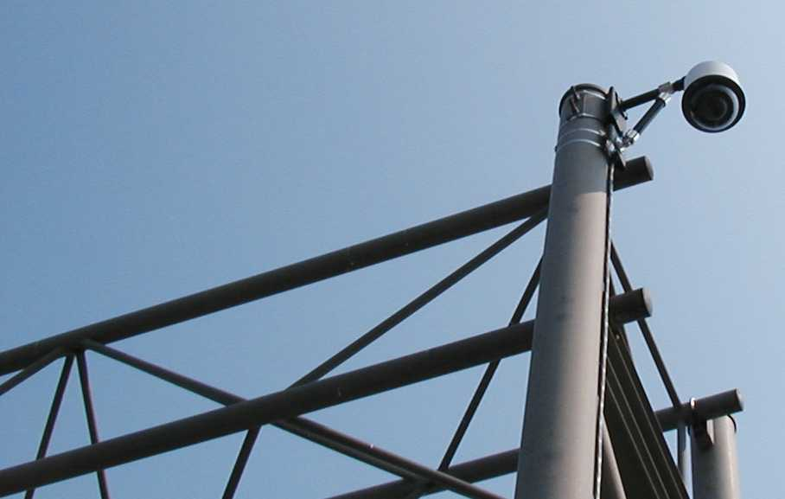

Field Observation

A common and efficient technique to observe the traffic conditions during a planned special event is to place human observers, or detectors, in the field, usually at critical locations. Normally, these observers have the role of monitoring conditions and reporting back to a central location for strategic assessment. These human detectors are gathering relevant information related to the event and using established protocol to communicate the information back to the central processing and coordination facility.

It is common to deploy these observers where technology is lacking and where they may perform an additional role in traffic management or traffic incident management (e.g., freeway service patrol operators). For instance, an observer may be placed at a critical pedestrian location, where besides reporting back to central command on the status of the location, the observer may serve the role of a traffic engineer by adjusting the signal timing to better accommodate the pedestrian volumes.

Aerial Observation

Aerial surveillance has long been used to monitor the operation of the surface transportation network. “Observers” in aircraft (fixed wing or helicopters) fly over freeways and streets and monitor conditions in real-time, using two-way radios to communicate with the TMC or with service patrols on the freeway. This approach can be relatively expensive when one considers the expense of leasing or operating an aircraft, although it does have the benefit of being able to cover a large area.

An emerging trend is the use of remote sensing via unmanned aerial vehicles, similar to airborne platforms/drones used by the military, and satellites. Information gathered from satellite, aircraft, and unmanned aerial vehicles can be used to estimate arterial and freeway traffic characteristics over long time scales and large geographic areas, including those where data were previously unavailable. The spatial coverage provided from air- and satellite-based sensors can potentially support the development of new metrics that better represent highway utilization and congestion.

Media Reports

As discussed earlier, the media needs to be a partner in the planned special event management and operations effort. Agreements must be in place that define their role within the plan, as well as what information needs to be communicated, both prior to and during the event.

The primary disadvantage of using the media relates to the accuracy of the information. Traffic reports often are transmitted only when normal scheduling permits. This may cause considerable time delays between when a condition changes and when the media reports it. Often, many problems go unreported or are cleared by the time they are reported on the radio and television. The accuracy of the information provided by commercial radio, for instance, is a function of the time between the broadcaster’s last communication with the incident reporting source and the number of incidents that have occurred and/or have been cleared during that time.

Some transportation agencies have made substantial efforts to improve coordination and cooperation between themselves and the media traffic reporters. For example, some agencies allow private traffic advisory services to place personnel in the TMC to obtain information on traffic conditions and expected agency responses in an accurate and timely manner.
TRAFFIC INCIDENT MANAGEMENT AND SAFETY PLAN

Overview

The occurrence of a planned special event that increases or disrupts the normal flow of traffic places a premium on the optimal use of existing facilities. A traffic incident and safety plan specifies crash prevention tactics and traffic incident quick clearance initiatives, some of which denote special provisions enacted just for the day-of-event. These traffic incident management techniques preserve two goals of managing travel for planned special events: (1) ensuring safety and (2) maximizing efficiency. In the event of a major traffic incident that blocks travel lanes for a prolonged duration, the traffic management team should refer to response procedures and guidelines contained in an established traffic incident management manual for the region.

Crash Prevention Tactics

Crash prevention tactics focus on improving driver awareness of surroundings and driver behavior. Table 6-38 lists crash prevention tactics applicable to planned special events.

Table 6-38
^{Crash Prevention Tactics}

TACTIC
- Portable lighting
- Congestion warning sign
- Public information safety campaign
- Enforcement

Portable Lighting

Portable lighting devices enhance driver understanding of traffic control and traffic flow patterns at night. As shown in Figure 6-58, the devices prove particularly useful at rural, unlit freeway interchanges or arterial target points that handle high-volume turning movements during event ingress and egress. Portable lighting makes traffic control officers more visible to approaching drivers, and in the vicinity of the event venue, the devices can spotlight pedestrian/vehicular conflict areas.

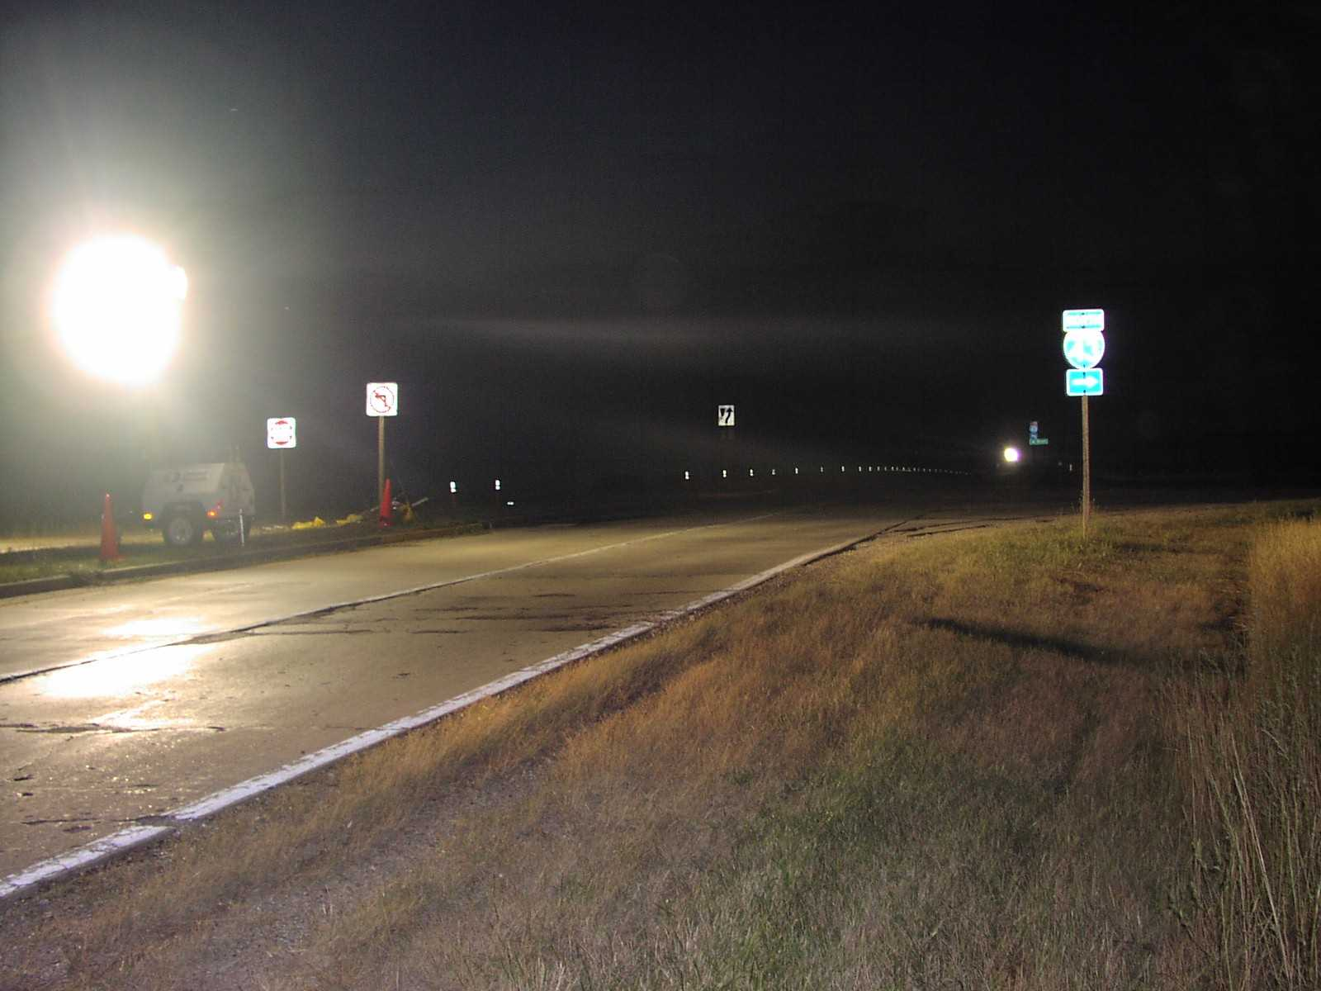
Figure 6-58
Portable Lighting (Photo courtesy of the Wisconsin DOT.)

Congestion Warning Signs

Congestion warning signs, placed upstream of known roadway bottleneck locations, alert drivers of demand-induced congestion on the day-of-event. The tactic aims to prevent rear-end crashes as a result of drivers encountering unexpected congestion. Stakeholders should strongly consider deploying congestion warning signs along event ingress and egress routes containing significant geometric curves. In order to control message display and preserve its credibility, consider deploying portable changeable message signs or static signs that hinge open, as shown in Figure 6-59.

Public Information Safety Campaign

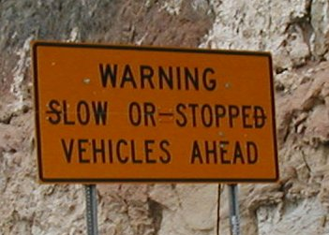
A public information safety campaign strives to change motorists’ behavior when traveling to and from a planned special event. Campaigns emphasize event traffic control and regulations, pedestrian safety, and vehicle operation. For example, the Louisiana DOT launched a $94,000 public information campaign in 2002 to reduce the number of crashes caused by drivers following too closely.⁽²³⁾ The campaign targeted spectators attending Louisiana State University football games through advertisements on radio stations carrying the games and advertisements in game-day football programs. The advertisements specified driver tips on how to avoid tailgating.

Figure 6-59
Congestion Warning Sign

Enforcement

Enforcement aims at preventing drivers from executing illegal and dangerous movements in an effort to bypass congestion and/or day-of-event traffic control. For instance, drivers attempting to access a freeway may travel past a congested entrance ramp serving egress traffic, make an illegal U-turn, and traverse an uncongested freeway entrance ramp from the opposite direction. The behavior of one motorist provokes other motorists to execute the same maneuver.

Service Patrols

Service patrols function to typically satisfy the incident detection, verification, response, and removal components of incident management in the event of a minor incident, such as a vehicle disablement or property-damage-only crash. Patrol operators strive to identify and remove debris or hazards impeding traffic flow, and they aid in the fast removal of immobilized or wrecked passenger cars blocking one or more travel lanes. Service patrol programs create a sense of security for motorists in addition to improving public relations for the service’s sponsor. Other examples of motorist assists that are typically offered free of charge include supplying fuel, changing flat tires, providing a jump-start, and calling private towing companies.

Service patrols can play a key role in traffic incident management for planned special events. The service has great versatility, and patrol operators can satisfy a wide range of traffic management team needs. For example, operators can assist in establishing day-of-event traffic control, performing traffic surveillance, and providing timely traffic condition reports from various remote locations. As shown in Figure 6-60, service patrols carry equipment to support traffic management at incident sites and congestion locations.

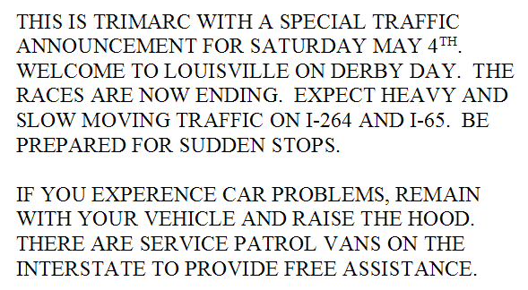
Table 6-39 indicates considerations in preparing a service patrol operations plan for a planned special event. To avoid having drivers abandon disabled vehicles or risk exposure to adjacent traffic flow, stakeholders should alert roadway users of service patrol operation on the day-of-event via roadside traveler information devices. Figure 6-61 shows a special event HAR message disseminating safety tips to drivers and promoting service patrol operation.
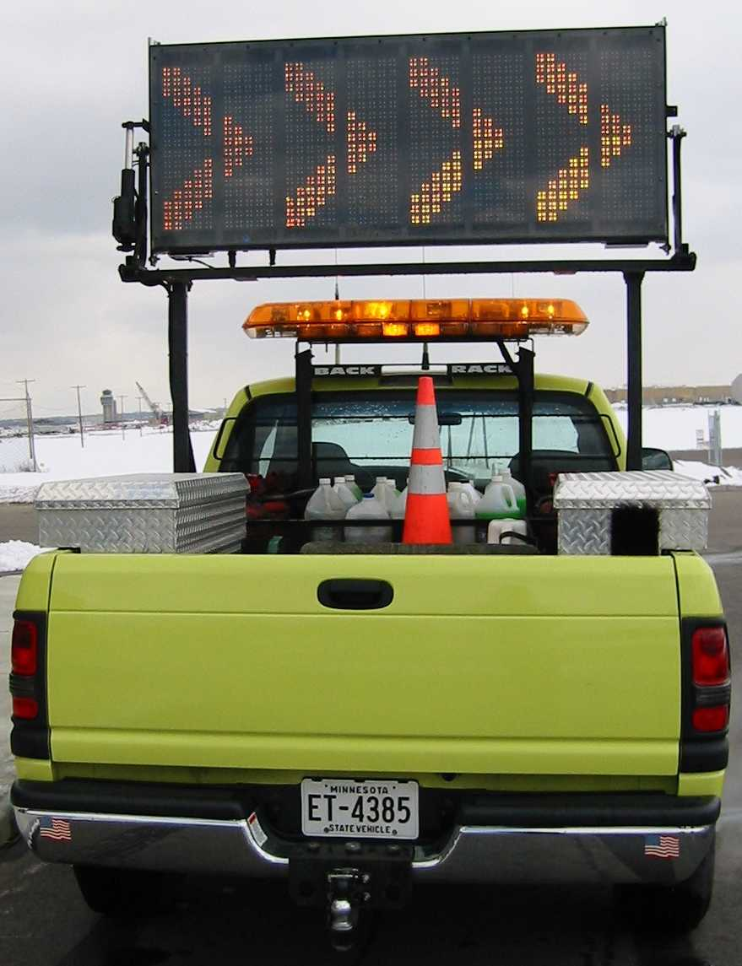
Figure 6-60
Service Patrol Vehicle (Graphic courtesy of the Minnesota DOT.)

Table 6-39
Service Patrol Operations Considerations

CONSIDERATION
- Number of service patrols deployed
- Time of operation
- Patrol routes and/or staging location
- Storage of towed vehicles
- Operator communication with TMC or event command center
Figure 6-61
Highway Advisory Radio Traveler Safety Message⁽²⁴⁾

Traffic Incident Quick Clearance Initiatives

Quick clearance is the practice of rapidly and safely removing temporary obstructions from the roadway.⁽²⁵⁾ Quick clearance practices increase the safety of traffic incident responders and victims by minimizing their exposure to adjacent passing traffic. A reduced probability of secondary incidents accompanies decreased congestion levels resulting from fast removal of lane-blocking obstructions.

A quick clearance practice consists of laws, policies, procedures, and infrastructure aimed at effecting the safe and timely removal of a traffic incident. Service patrols, as previously described, represent a quick clearance infrastructure component. Rapid clearance of traffic incidents during planned special event ingress and egress avoids significant impact to corridor and local traffic flow routes in addition to routes used by participants and VIPs.

The following quick clearance initiatives benefit traffic incident management in high-volume corridors, characteristic of planned special events: (1) vehicle/cargo removal laws and policies, (2) stakeholder open roads policy, and (3) public-private towing contracts. Vehicle removal laws require drivers to immediately move vehicles obstructing travel lanes. Also, agencies have authority to aggressively clear vehicles and spilled cargo without incurring unnecessary delay. Similar policies establish no stopping zones in highly traveled locations. An interagency open roads policy informs traffic incident responders of the urgent need to rapidly remove disabled or wrecked vehicles, spilled cargo, and debris that obstruct the normal flow of traffic, and the policy disseminates key guidelines to ensure a cooperative incident removal effort between agencies. Chapter 5 discusses contract towing service for planned special events.

Practitioners should consult NCHRP Synthesis 318, Safe and Quick Clearance of Traffic Incidents, for state-of-the-practice information about laws, policies, procedures, infrastructure, and technologies associated with developing a quick clearance practice and increasing the efficiency of traffic incident removal operations.⁽²⁵⁾

Quick clearance represented the overarching theme within the Utah DOT traffic incident management plan for the 2002 Winter Olympics. Table 6-40 summarizes some notable quick clearance strategies contained in the event traffic incident management plan. The table also states statistics and performance measures that conclude the Utah DOT, together with its partner law enforcement and transportation agencies, developed and deployed a successful quick clearance practice for the Olympics.

Table 6-40
Traffic Incident Quick Clearance for the 2002 Winter Olympics(26)

STRATEGY
- Staging of heavy-duty tow trucks throughout Olympic venue routes between 5:00 AM and 1:00 PM (ingress).
- Carrying of kits by incident responders to tow every type of bus used to transport people.
- Use of photogrammetry by law enforcement during incident investigations.
- Deployment of heavy service patrol coverage to reduce the number of abandoned vehicles and lessen security concerns.
EVALUATION STATISTIC
- 29 vehicles were removed from incident scenes on the athlete routes to facilitate traffic flow.
- 12 fatality or critical crashes were investigated by law enforcement using photogrammetry in under one hour, and in one case, police shot an incident scene with evidence markers within 30 minutes.
- A serious injury crash was cleared in 23 minutes because of excellent teamwork.
- Incident Management Team crews spent an average of 70 minutes at each crash scene during the Games, down from an average of 115 minutes prior to the Games.
- 2,306 motorists were assisted during the 17 days of the Games.
References

- Glazer, L.J. and R. Cruz, Intelligent Transportation Systems at the 2002 Salt Lake City Winter Olympic Games: Event Study – Traffic Management and Traveler Information, Utah Department of Transportation, Salt Lake City, Utah, April 2003, 160 pp.

- Burdette, D., “An Evaluation of Advanced Parking Information Systems at Airports,” Prepared for the 2001 Annual Meeting of the Transportation Research Board, National Research Council, Washington, D.C., January 7—11, 2001.

- Advanced Parking Information System Evaluation Report, Minnesota Department of Transportation, St. Paul, Mn., 2000, 52 pp.

- Gibson, P.A. and A.D. Rifkin, “An Integrated Event Parking and Circulation Management Plan for the Staples Center and the Los Angeles Convention Center,” Prepared for the ITE 2000 Annual Meeting and Exhibit, Institute of Transportation Engineers, Nashville, Tn., 2000.

- Dunn, Jr., W.M., “Traffic Management for 1995 U.S. Open,” Preprint No. 00131, Prepared for the ITE 2001 Annual Meeting and Exhibit, Institute of Transportation Engineers, Chicago, Il., August 19--22, 2001.

- The Dutchess County Fair Traffic Plan, New York State Department of Transportation, Presentation at the 2002 ITS New York Meeting, Saratoga Springs, Ny., June 5--7, 2002, 24 pp.

- McBride, J., Utah Department of Transportation, Personal Communication, July 14, 2003.

- Kelman, L., “World Youth Day 2002 – Transportation Planning and Operations,” Presented at the 82nd Annual Meeting of the Transportation Research Board, Washington, D.C., January 12—16, 2003.

- Highway Capacity Manual, Transportation Research Board, National Research Council, Washington, D.C., 2000.

- Shell Grand Prix of Denver – Parking and Traffic Management Plan, Prepared for the Grand Prix of Denver by URS Corporation, August 2002, 33 pp.

- Coffel, B. and F. Wambalaba, Tri-Met SETS Program, Tri-County Metropolitan Transportation District of Oregon, Portland, Oregon, 1995.

- Traffic Management for Special Events, Version 6, New South Wales Roads and Traffic Authority, Australia, February 2002, 82 pp.

- Dunn, W.M., R.A. Reiss, and S.P. Latoski, Roadway Incident Diversion Practices, NCHRP Synthesis 279, Transportation Research Board, National Research Council, Washington, D.C., 1999, 84 pp.

- Suggs, E., “Festival to Test New Traffic Plan,” Atlanta Journal-Constitution, April 8, 2003.

- Volz, M.A. and B.J. Nicholson, “Kansas Speedway Event Management Using ITS,” n.d.

- Dudek, C.L., Guidelines for Changeable Message Sign Messages, Federal Highway Administration, Washington, D.C., September 2002 (Draft), 256 pp.

- Wolshon, B., “’One-Way-Out’: Contraflow Freeway Operation for Hurricane Evacuation,” Natural Hazards Review, Vol. 2, No. 3, August 2001, pp. 105--112.

- Daytona Beach Traffic Engineering Speed Weeks 2002, City of Daytona Beach Public Works, 2002.

- Anaheim Special Event Manual, City of Anaheim Department of Public Works (Draft), Anaheim, Ca., 2002, 40 pp.

- Transport Management Plan: New South Wales Bush Fire Parade, Version 1, New South Wales Roads and Traffic Authority, Australia, February 2002.

- Schuman, R. and E. Sherer, “511 ‘101’,” 511 Deployment Conference, Scottsdale, Arizona, March 2002.

- “Inside ITS,” Volume 13, No. 7, April 1, 2003, p. 3.

- Anderson, A., “Program Will Try to Put the Brakes on Tailgating,” The Times-Picayune, September, 5, 2002.

- Derby Day Plan, Traffic Response and Incident Management Assisting the River Cities, May 2002.

- Dunn, W.M. and S.P. Latoski, Safe and Quick Clearance of Traffic Incidents, NCHRP Synthesis 318, Transportation Research Board, National Research Council, Washington, D.C., 2003, 143 pp.

- National Conference on Traffic Incident Management: A Road Map to the Future, March 11-13, 2002: Proceedings, American Association of State Highway and Transportation Officials, Washington, D.C., 2002.

THIS PAGE LEFT BLANK

